DNS :
Key Roles of DNS:
- Name Resolution (Domain to IP Conversion):
  - The main function of DNS is to convert a domain name into its corresponding IP address.
  - Example:
When a user types www.example.com, DNS resolves it to an IP address like 93.184.216.34.
- Simplifies User Access:
  - Users can remember simple names instead of complex numeric IP addresses.
  - This improves the usability and accessibility of network resources.
- Load Distribution (Load Balancing):
  - DNS can distribute traffic among multiple servers hosting the same service by assigning different IPs for the same domain name.
  - Helps in load balancing and fault tolerance.
- Redirection and Caching:
  - DNS servers can cache previous lookups to speed up access to frequently visited websites.
  - It can also redirect users to different servers for maintenance or regional access.
- Supports Email Delivery:
  - DNS includes MX (Mail Exchange) records that direct email messages to the appropriate mail servers.
- Security Functions:
  - DNSSEC (DNS Security Extensions) protects against spoofing and cache poisoning by validating DNS responses.
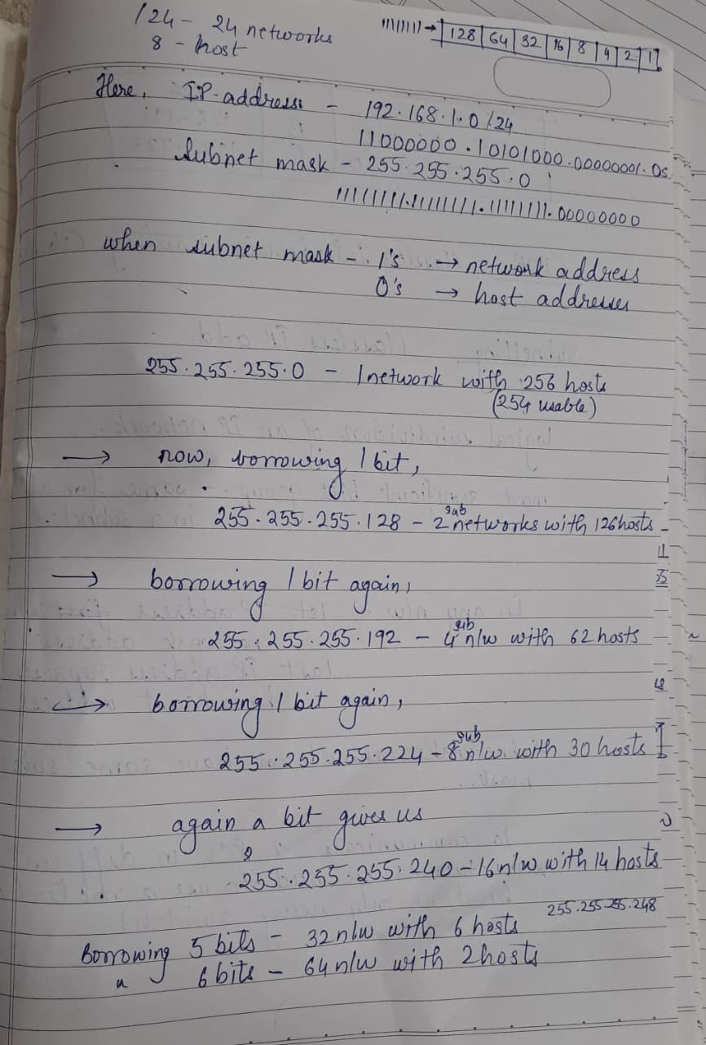

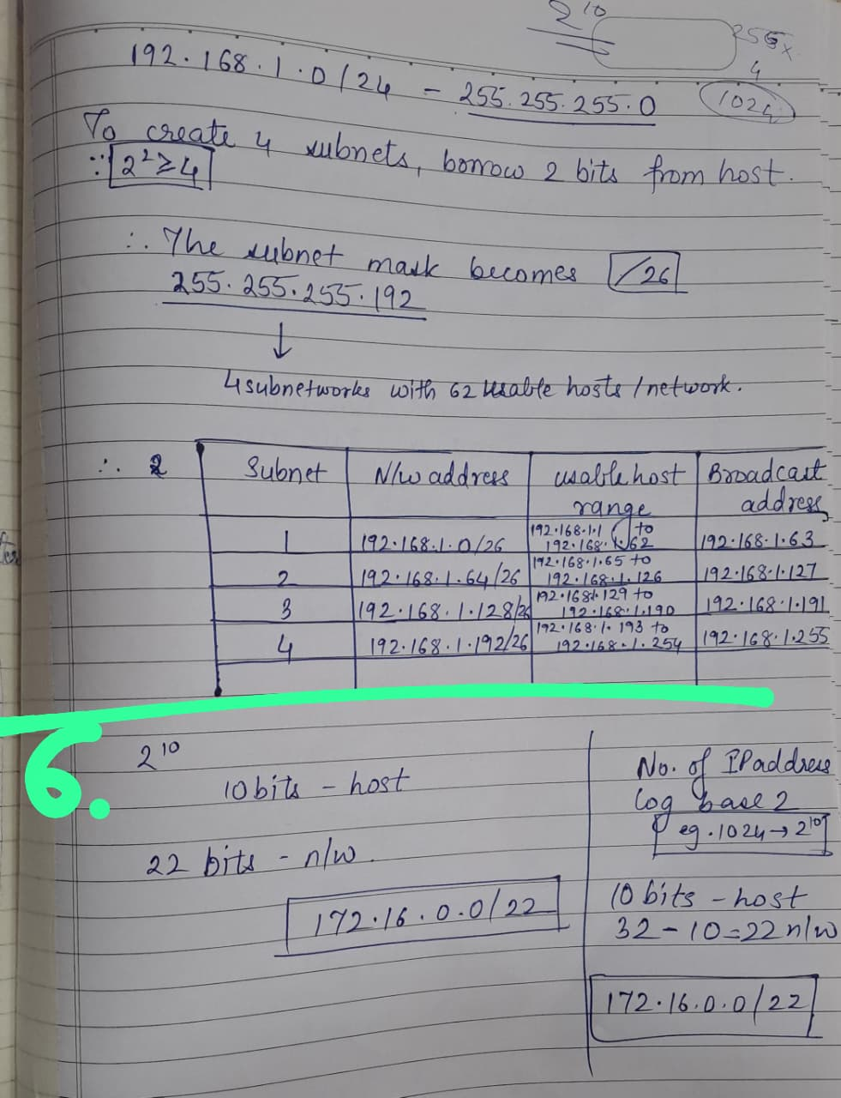

A hub is a basic networking device that operates at the Physical Layer (Layer 1) of the OSI model.
It simply repeats incoming signals to all connected devices — without any form of intelligent traffic control.
Because of this, it has several key limitations:

1. No Traffic Filtering or Management
- A hub broadcasts every incoming data packet to all ports, regardless of the destination.
- This leads to unnecessary traffic on all devices.
- Wastes network bandwidth.

2. Creates a Single Collision Domain
- All devices connected to a hub share the same collision domain.
- When two or more devices send data simultaneously, collisions occur.
- This causes data retransmissions and reduces network efficiency.

3. No MAC Address Learning
- Unlike a switch, a hub does not maintain a MAC address table.
- It cannot send data to a specific device — it just rebroadcasts.
- This increases network congestion.

4. No Full-Duplex Communication
- Hubs can only work in half-duplex mode.
- Devices cannot send and receive data simultaneously.
- This further slows down communication.

5. Limited Bandwidth Sharing
- The total available bandwidth is shared among all connected devices.
- Example: In a 100 Mbps hub, each of 10 devices effectively gets ~10 Mbps (when active).

6. No Network Segmentation or Security
- Hubs cannot segment networks (like VLANs).
- Data sent by one device can be seen by all others — no data privacy.
- Makes the network vulnerable to eavesdropping and broadcast storms.

Feature | Switching | Routing
Definition | Switching is the process of forwarding data within the same network (LAN) based on MAC addresses. | Routing is the process of forwarding data between different networks (LANs/WANs) based on IP addresses.
OSI Layer | Works at Layer 2 (Data Link Layer) | Works at Layer 3 (Network Layer)
Address Used | Uses MAC address to identify devices | Uses IP address to identify networks
Device Used | Performed by a Switch | Performed by a Router
Function | Connects devices within the same network (e.g., PCs, printers). | Connects multiple networks (e.g., LAN to WAN, or LAN to Internet).
Forwarding Decision | Based on MAC address table (learned from frames) | Based on routing table (learned from routing protocols or static routes)
Collision Domains | Each port on a switch has its own collision domain | Each router interface is a separate broadcast and collision domain

***What is the role of DHCP in a wireless network?
DHCP (Dynamic Host Configuration Protocol) is a network service that automatically assigns IP addresses
1. Automatic IP Address Assignment
- When a wireless device (like a laptop or smartphone) connects to a Wi-Fi access point (AP), it sends a DHCP Discover request.
- The DHCP server (often integrated in a router or dedicated server) responds with an IP address and network details.
- This process ensures users can connect seamlessly without needing to manually configure network settings.

2. Efficient IP Address Management
- DHCP keeps track of which IP addresses are assigned or free, preventing IP conflicts.
- When a wireless device disconnects, the DHCP lease can expire and the address is reused.

3. Simplifies Mobility
- Wireless clients often move between access points or subnets.
- DHCP supports automatic reconfiguration when a device roams — the client quickly receives a valid IP for the new subnet.

4. Centralized Configuration
- Network administrators can manage IP addresses, gateways, DNS, and other parameters from one central DHCP server.
- This is especially useful in large Wi-Fi networks (like campuses or offices).

5. Improves User Experience
- Users can join the wireless network easily — no need to set IPs manually.
- It supports plug-and-play connectivity, crucial in public Wi-Fi, hotspots, and enterprise WLANs.

⚙️ Role of a Web Server in Communication
1. Handling Client Requests
- The web server listens for incoming HTTP/HTTPS requests from clients.
- When a request is received (e.g., GET /index.html), it identifies the requested resource or file.

2. Processing and Delivering Content
- It fetches the requested resource from its storage or generates it dynamically using backend scripts (like PHP, Node.js, or Python).
- The server then sends the response back to the client — usually an HTML page, JSON data, or file.
3. Executing Server-Side Logic
- Web servers can interact with databases, APIs, and application logic to generate dynamic content.
- For example, in an e-commerce site, the server fetches user data or product details from a database before sending the page.

4. Managing Multiple Clients
- A web server can handle many simultaneous connections from multiple clients.
- It manages sessions, cookies, and authentication to maintain client–server interaction.

5. Ensuring Security
- Web servers implement HTTPS (SSL/TLS) encryption to secure data transmission.
- They manage user access, enforce authentication, and protect against attacks like SQL injection or cross-site scripting.

⚙️ How RIP Works Step by Step
Step 1: Initialization
- When a router using RIP starts, it sends a request message to all its neighbors.
- The request asks for the entire routing table from those routers.

Step 2: Periodic Updates
- Every 30 seconds, each router sends a RIP update message (broadcast or multicast) containing its entire routing table.
- This message includes:
  - Destination network address
  - Hop count (distance metric)
  - Next-hop information

Step 3: Receiving Updates
When a router receives a RIP update from a neighbor:
- It adds 1 to the hop count value for each network received (to account for the distance to the neighbor).
- It compares this new hop count with the existing entry in its routing table.

Step 4: Updating the Routing Table
The router updates its routing table using the Bellman-Ford algorithm:
- If the destination network is new → Add it to the table.
- If the destination network already exists but the new hop count is smaller → Update the route (use the better path).
- If the new hop count is greater → Ignore the update (existing path is better).

Step 5: Route Aging and Invalid Timer
Each RIP route has a timer associated with it:
- If a router doesn’t receive an update for a route within 180 seconds, the route is marked as invalid.
- After 240 seconds, the route is removed from the table.
This helps detect and remove unreachable routes.

Step 6: Triggered Updates
When a change occurs (like a link failure):
- The router immediately sends an update (without waiting 30 seconds) to inform neighbors.
- This is called a triggered update, improving convergence speed.
- Advantages of OSPF over RIP
⚙️ 1. Faster Convergence
- RIP: Takes a long time to detect network changes and update routes (due to 30-second update timers).
- OSPF: Detects changes immediately and recalculates routes using the Dijkstra (Shortest Path First) algorithm.
✅ Result: OSPF converges within seconds, while RIP may take several minutes.

⚙️ 2. No Hop Count Limitation
- RIP: Maximum hop count = 15 (networks more than 15 hops away are unreachable).
- OSPF: No hop count limit — it uses cost (bandwidth) as its metric.
✅ Result: OSPF can support large enterprise or ISP networks, while RIP is limited to small LANs.

⚙️ 3. Metric Based on Link Cost (Bandwidth)
- RIP Metric: Based only on hop count (number of routers between source and destination).
- OSPF Metric: Based on link cost, which depends on bandwidth and reliability.
✅ Result: OSPF chooses faster, more efficient paths, not just the one with fewer hops.

⚙️ 4. Hierarchical Network Design (Areas)
- RIP: Works as a flat network, meaning every router shares its full routing table with all others.
- OSPF: Supports hierarchical structure using Areas (e.g., Area 0 – Backbone, Area 1, etc.)
✅ Result: OSPF reduces routing table size, limits update traffic, and improves scalability.

⚙️ 5. Efficient Use of Bandwidth
- RIP: Sends the entire routing table every 30 seconds (even if no change occurs).
- OSPF: Sends updates only when a change occurs — and only for the changed link.
✅ Result: Less network congestion and better performance in OSPF.

⚙️ 6. Support for VLSM and CIDR
- RIP v1: Does not support Variable Length Subnet Masking (VLSM) or CIDR.
- RIP v2: Supports it, but with limitations.
- OSPF: Fully supports VLSM and CIDR for efficient IP address utilization.
✅ Result: OSPF allows flexible and efficient subnetting in modern IP networks.

Use Cases for BGP (Border Gateway Protocol) in Real-World Networks
⚙️
1. Internet Backbone Routing (Inter-AS Routing)
- BGP is the main routing protocol used across the Internet.
- It connects thousands of Autonomous Systems (AS) owned by ISPs, governments, and organizations.
- Each AS exchanges routes with others to advertise which IP prefixes it can reach.
✅ Example:
When you access www.google.com, your ISP uses BGP to find the best route through multiple ISPs to reach Google’s servers.

⚙️ 2. Multi-Homed Networks (Redundant ISP Connections)
- Enterprises often connect to multiple ISPs for redundancy and load balancing.
- BGP allows them to manage traffic across multiple Internet connections.
✅ Example:
A company connects to ISP-A and ISP-B.
If ISP-A fails, BGP automatically reroutes traffic through ISP-B.
Benefit: High availability and fault tolerance.

⚙️ 3. Large Enterprise Networks with Multiple Branches
- Enterprises with multiple regions or data centers use internal BGP (iBGP) to share routing information between routers inside their own AS.
- Combined with OSPF or EIGRP, iBGP ensures efficient interconnection between branch offices.
✅ Example:
A multinational company uses OSPF for local routing and iBGP to connect all regional offices through its private backbone.

⚙️ 4. Cloud and Data Center Connectivity
- Cloud providers (AWS, Azure, Google Cloud) and large data centers use BGP peering to:
  - Exchange routes between cloud regions.
  - Connect customer networks to cloud infrastructure.
  - Manage hybrid cloud connections (VPNs, Direct Connect, ExpressRoute, etc.)
✅ Example:
An enterprise connects its on-premises network to AWS using BGP over an IPSec VPN for dynamic route exchange.

Server Type | Primary Function | Protocol(s) | Example
DHCP Server | Assigns IP addresses automatically | DHCP | Router/Server in LAN
DNS Server | Translates domain names to IPs | DNS | Google DNS (8.8.8.8)
Web Server | Hosts websites and web apps | HTTP/HTTPS | Apache, Nginx
Email Server | Manages sending/receiving mail | SMTP, POP3, IMAP | Gmail, Outlook
File Server | Centralized file storage and sharing | FTP, SMB | Windows File Server
Authentication Server | Verifies user identity | RADIUS, TACACS+ | Active Directory
Proxy Server | Controls and filters Internet access | HTTP Proxy | Squid Proxy
NTP Server | Synchronizes device time | NTP | pool.ntp.org

Implement the RSA encryption and decryption processes in Python. Provide a step-by-step explanation of
how the algorithm works.
# Simple RSA Algorithm in Python

def gcd(a, b):
while b != 0:
a, b = b, a % b
return a

# 1. Key Generation
p = 61
q = 53
n = p * q
phi = (p - 1) * (q - 1)

# Choose e such that 1 < e < phi and gcd(e, phi) = 1
e = 17
# Calculate d such that (d * e) % phi = 1
d = pow(e, -1, phi)

print("Public key: (", e, ",", n, ")")
print("Private key:", d)

# 2. Encryption
msg = 65 # example message (as integer)
cipher = pow(msg, e, n)
print("Encrypted:", cipher)

# 3. Decryption
decrypted = pow(cipher, d, n)
print("Decrypted:", decrypted)

Public key: ( 17 , 3233 )
Private key: 2753
Encrypted: 2790
Decrypted: 65

1. Key Generation
- Choose two large prime numbers p and q.
- Compute n = p × q and φ(n) = (p−1)(q−1).
- Select public exponent e such that gcd(e, φ(n)) = 1.
- Compute private key d where d × e ≡ 1 (mod φ(n)).
- Public key: (n, e) Private key: (n, d)

2. Encryption
- Convert message m to a number (0 < m < n).
- Compute ciphertext:
$$c=m^{e}mod n$$

3. Decryption
- Compute plaintext:
$$m=c^{d}mod n$$
- Convert back to the original message.

4. Why It Works
Because e × d ≡ 1 (mod φ(n)), decryption reverses encryption:
$$(m^{e})^{d}mod n=m$$

5. Key Points
- RSA uses public key for encryption, private key for decryption.
- Security depends on difficulty of factoring large primes.
- Always use padding (e.g., OAEP) for real-world use.

