Scryfall HTML Web Scraping Lab Report
Data collection, cleaning, and price-premium analysis of Magic The Gathering cards

Abstract
This lab collected 1,492 Magic The Gathering card records from the public HTML pages of Scryfall, a card database and marketplace reference site. The project deliberately used page scraping rather than the Scryfall API. A Python scraper navigated search-result pages, extracted visible values from individual card pages, and saved a 25-column raw CSV. The data-cleaning pipeline produced 376 complete, de-duplicated, category-encoded records. Price analysis found a strongly right-skewed market: the median nonfoil price was $0.29 and the median foil price was $0.40, while a small number of high-value cards raised the means to $4.33 and $4.42 respectively. Foils were typically more expensive, although some cards had a negative foil premium.

1. Objective
The objective was to build an end-to-end web-scraping workflow: collect visible card information from a public website, clean it into an analysis-ready dataset, and use descriptive analytics to study nonfoil and foil prices. The workflow also preserves a mapping file so encoded categories remain interpretable.

2. Website and Data Collected
The source website was Scryfall (https://scryfall.com), specifically its public paper-card search pages and public card-detail pages. No API endpoint or JSON response was used. The scraper first visited search pages containing 60 card tiles, then followed each tile to its visible HTML detail page.
Data group | Examples collected from visible HTML
Identity | Card name, Scryfall print ID, Oracle ID, source URL
Card characteristics | Mana cost, type line, rules text, flavour text, power/toughness or loyalty, artist
Printing metadata | Set name and code, collector number, rarity, language, finishes
Market data | USD, EUR and TIX nonfoil prices; USD and EUR foil prices
Availability | Format legalities and high-resolution image URL

The raw file contains 1,492 records and 25 fields. Nonfoil USD prices were available for 1,484 cards (99.5%), while foil USD prices were available for 1,044 cards (70.0%). Missing foil prices are expected because not every printing has a displayed foil offer.

3. Scraping Method
The scraper was written in Python using requests for HTTP requests and Beautiful Soup for HTML parsing. It used a descriptive educational User-Agent, a 30-second request timeout, and a 0.2-second delay before each detail-page request. The default worker pool contained four concurrent detail requests, which keeps the process efficient while avoiding an uncontrolled request burst.
Step | Method used
1. Discover | Request each public search-result page and select card-tile links with CSS selectors.
2. Prevent repeats | Store card URLs in a set before scheduling detail-page requests.
3. Fetch details | Use ThreadPoolExecutor with four workers to retrieve each public card page.
4. Parse fields | Use CSS selectors for visible text; use regular expressions for price values and IDs embedded in public links.
5. Save | Write structured rows to UTF-8 CSV and log progress every 25 successful saves.

For example, the scraper reads the current-printing block for set information, scans visible legality entries into a semicolon-delimited field, and extracts numeric prices from displayed purchase links. A failed individual request is skipped and logged instead of stopping the entire collection run.

4. Data Cleaning Algorithm
The cleaning script does not overwrite the raw CSV. It creates a separate analysis dataset and a category lookup file. The algorithm processes each row in the following order:
- Normalize text by replacing non-breaking spaces and collapsing repeated whitespace.
- Normalize prices by extracting the numeric token with a regular expression, validating it with Decimal, and storing a plain decimal value.
- Standardize set codes to uppercase and normalize legality labels into format:status entries with lowercase underscore-separated statuses.
- Apply complete-case filtering: reject a row when any original source field is blank. Also reject later rows with a duplicate Scryfall print ID.
- Encode repeated categorical values as deterministic one-based integer IDs. Codes are assigned over sorted unique values and saved in scryfall_category_maps.csv.
Cleaning outcome | Result
Raw records | 1,492
Complete encoded records | 376
Removed as incomplete or duplicate | 1,116 (74.8%)
Raw categorical text | Preserved separately in the category-mapping file

This is a complete-case strategy, not imputation. It makes the cleaned records consistent for modeling, but it reduces the sample substantially because descriptive fields and price fields are often absent on public card pages.

5. Analytics Method
The analysis script reads the raw CSV, converts USD price columns to numeric values with invalid values coerced to missing, and calculates foil premium using the following formulas:
Foil premium (USD) = foil USD price − nonfoil USD price
Foil premium (%) = foil premium (USD) ÷ nonfoil USD price × 100
It then uses descriptive statistics (count, mean, standard deviation, minimum, quartiles, and maximum), ranks cards by nonfoil USD price, and outputs the top ten. For readability only, the overlapping price histogram caps both price series at their combined 99th percentile; summary tables retain uncapped values.

6. Results and Interpretation
Metric | Nonfoil USD | Foil USD | Foil premium USD
Available observations | 1,484 | 1,044 | 1,044
Mean | $4.33 | $4.42 | $1.58
Median | $0.29 | $0.40 | $0.12
75th percentile | $0.97 | $1.76 | $0.51
Maximum | $599.99 | $458.94 | $428.03

The price distributions are highly right-skewed: most cards cost less than one dollar, while a small set of collectible cards has prices in the hundreds of dollars. The mean is therefore much higher than the median. Among cards with both prices, the median foil premium is $0.12 (56.1%), and the average premium is $1.58. The much larger mean premium reflects high-value outliers.
The highest-priced nonfoil card in this sample was Ancestral Recall (2ED) at $599.99, followed by All Hallow's Eve (LEG) at $547.12 and Ali from Cairo (ARN) at $409.99. Some expensive cards did not have a displayed foil price. Negative premiums also occur: for example, Ancient Silver Dragon had a foil price below its nonfoil price in this capture, showing that foil status alone does not guarantee a higher market value.
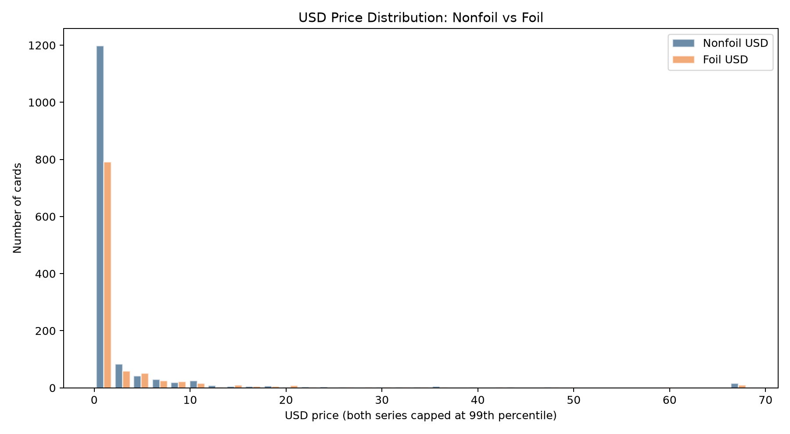
Figure 1. USD price distribution for nonfoil and foil cards. Both plotted series are capped at the 99th percentile for readability.
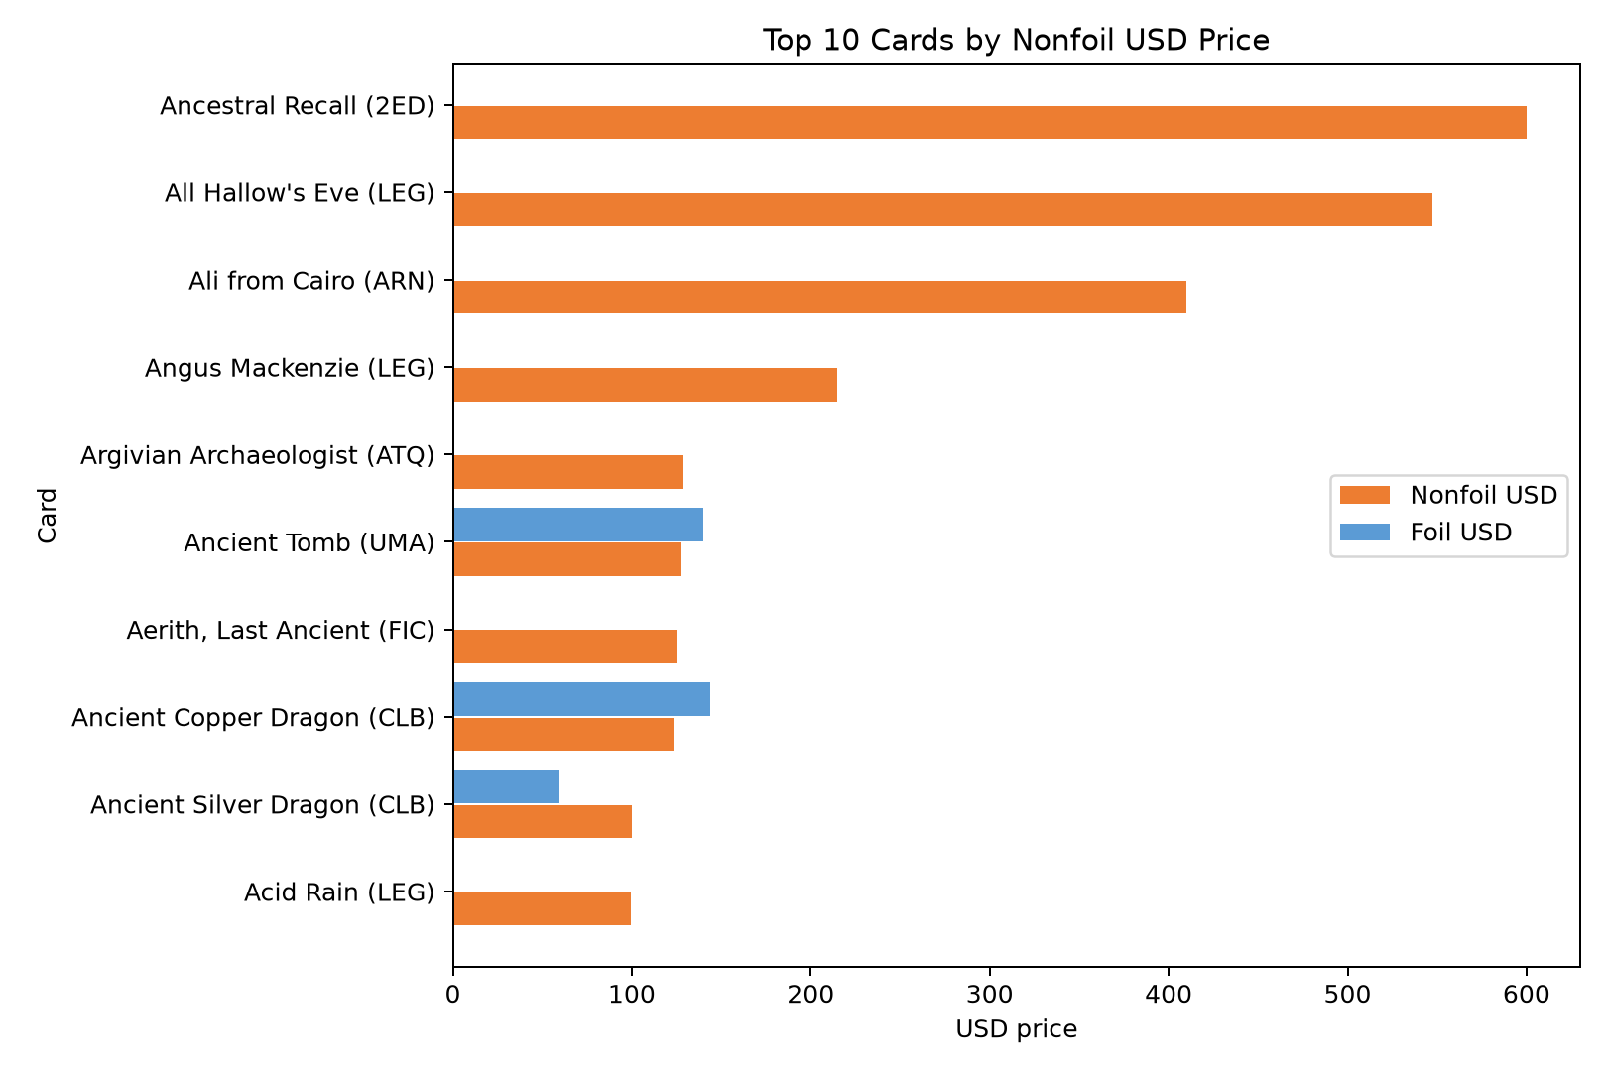
Figure 2. Ten highest-value cards by nonfoil USD price, with available foil prices shown alongside.

7. Limitations
- The collection is a snapshot of a changing website. Displayed market prices can change after scraping.
- HTML layout changes can break CSS selectors or alter the meaning of visible fields.
- Complete-case cleaning removes many records and can introduce selection bias toward fully populated pages.
- Foil prices are only analyzed where a visible foil value exists. Missing values were not interpreted as zero.
- The analysis is descriptive. It identifies distributional patterns but does not establish causal reasons for price differences.

8. Conclusion
The lab successfully implemented an HTML-only scraping pipeline for Scryfall card pages and converted the results into cleaned, encoded data for analysis. The analysis shows a low-price majority with a long high-value tail, and it indicates that foils generally carry a positive premium in the observed matched records. The project is reproducible through three scripts: scrape_scryfall_html.py, clean_scryfall_data.py, and analyze_price_premium.py.

Source and Reproducibility
Source website: Scryfall public HTML pages (https://scryfall.com). Local artifacts used: scryfall_cards.csv, scryfall_cards_clean.csv, scryfall_category_maps.csv, and the analysis_output summary files and charts. All counts and results in this report are calculated from the supplied project files.

