

# Company Profile

Address:

House # 1029 (1st to 7th Floor), Road # 9A, Avenue # 9, DOHS, Dhaka-1216.

Email: [support@clickthephoto.com](mailto:support@clickthephoto.com),

Web: [www.clickthephoto.com](http://www.clickthephoto.com),

+44 1416289734, Mobile: +8801958216621, 01958216625

Contents

Company Profile 1

Company Summary 4

Mission 6

Vision 6

Why Are We Exceptional? 6

Our Key Features 6

Amazingly Fast 7

Our Level Up 7

Satisfaction Guaranteed 7

Our Commitment 7

Quality Assurance 7

Innovation & Image Editing Support 8

Company Values 8

Our Services 8

The Company 9

Infrastructure 9

Dhaka Office Facility Infrastructure ( include Kallayapur facilties) 9

IT Infrastructure 9

Work Stations 9

Data Connectivity 9

Data Security 9

Company Strategy 9

Purpose: 10

Core values 10

Goals 10

Management of the Company 10

Chairman 11

Board of Directors 11

Executive Director 11

Head of Marketing 12

Head Of Accounts 12

Production Manager 12

Managerial Directors of the Company 13

Specialty 13

Research & Development 13

Our Commitment 13

Strength of the Company 13

Staff and Management Structure (Head Office& Corporate Office) 14

Organogram of the Company 15

Department of Dhaka Office 16

Finance Division 16

Planning Division 16

Training Division 17

Marketing Division 17

Production Division 17

Operation Division 18

Legal Division 18

Media & Public Relation 18

Welfare Division 19

Graphic Design 19

Digital Marketing 19

Domains 20

SEO (Search Engine Optimization) 20

Core Services for Click the Photo 20

Image Processing 20

Clipping Path 21

Background Removal 21

Photo Retouching 22

Jewelry Retouching 22

Image Masking 23

Color Correction 24

Shadow Making 24

E-commerce Image Editing 25

Ghost Mannequin 25

Photo Restoration 26

Bracketed Photo Editing 27

Real Estate Photo Editing: 27

Wedding Photo Editing: 28

Image Cropping and Resizing: 28

Conclusion 29

THANK YOU 29

# Company Summary

**Click The Photo** has started its Journey in 2012, and since then, it has been flying with excellent progress. Headquartered in the UK, we are specialized in image editing services and outsourcing as well. We have been expanding our services across the globe by incorporating our honest practices to ensure unparalleled quality and standard pricing with the best professional ethics.

By having an excellent team of graphic experts, located in the UK and some other countries, we serve round the clock with the highest professionalism to satisfy our valued clients.

**Click The Photo** is a unique platform for different sort of image editing services like Clipping Path, Background Removal, Photo Retouching, Jewelry Retouching, Image Masking, Color Correction, Shadow Making, Ecommerce Image Editing, Ghost Mannequin Service, Real Estate Photo Editing, Wedding Photo Editing, Image Cropping And Resizing, Headshot Retouching, Image Manipulation & Vector Conversion, etc. This is addressed as an “industrial powerhouse” to the clients because of our extraordinary services.

We are an occupied image editing firm with dedicated in-house developers, web designers, graphic designers, system admin, project managers, marketing, IT, outsourcing trainers, SEO experts & other administrative personnel.

Highlights of the company are given below:

|  |  |
| --- | --- |
| Certificate of Incorporation number | C-111691/13 |
| Trade License | 02-24061 |
| TIN number of the company | 716588356344 |
| Number of Branches | **Bangladesh Office:**  House # 1029, Road # 9A, Avenue # 9, Mirpur DOHS, Dhaka-1216.  **United Kingdom Office:**  2nd Floor, Bow House Bow Road 153-159 London E3 2SE |
| Number of Staffs | 250 |
| Number of Clients | More than 11,250 (International) |
| Email | [support@clickthephoto.com](mailto:support@clickthephoto.com) |
| Web | [www.clickthephoto.com](http://www.clickthephoto.com) |
| Service time | 24/7 hours Service |

Member : BASIS (Bangladesh Association of Software and Information Services)

E-mail : [info@clickthephoto.com](mailto:info@clickthephoto.com)

# Mission

To give the best service at a standard price, within the deadline.

# Vision

Our vision is to become a leading beacon in Photo Editing industry all over the world and to give a platform to everyone living in poverty.

# Why Are We Exceptional?

We rely on commitment and transparency. Our key target is to meet the clients’ preferences, timely delivery, quality, and proper follow-up. We have full-fledged supports for the work undoubtedly. There is no compromise in terms of quality and customer satisfaction. Finally, we care about our clients.

# Our Key Features

* **On-time delivery:** Time is money, especially in the world of image editing, that is why we value time.
* **Customer satisfaction:** Customers are our blood. So we put much more emphasis on them.
* **Round-the-clock service:** We love to work and serve our customers. For this reason, we render our services 24X7.
* **Efficient human resources:** Havingtrained up and efficient workforce we are always ready to serve our clients.
* **Continuous follow-up:** We have got strong follow-up team to provide the best services to our stakeholders.
* **Customized services:** We provide the services the way customers want from us.

# Amazingly Fast

Our standard turnaround is 24 hours. Our highly experienced photo editing team will process your images and work as per your requirement.

# Our Level Up

Working with us means that you will work with professional graphic designers and expert photo editors having vast experience in the industry.

# Satisfaction Guaranteed

Customer satisfaction is the key to our business. We work to assure the highest quality service for different projects.

# Our Commitment

“We believe in Commitment and Transparency” is a philosophy adopted by all **Click the Photo** employees. **Click the Photo** quality management program that has been formulated to ensure a commitment to quality is apparent to all employees, clients, design partners, and trade contractors. This commitment improves quality performance and ensures client and design team satisfaction.

Our approach is to focus on new ways of innovation thereby combining innovations and adoption while leveraging an organization’s current assets.

* Quality Assurance.
* Innovation & Image Editing Support.
* Graphics Designing.

# Quality Assurance

Successful quality projects is demonstrating a culture that embraces clear communication, effective problem solving, and a strong client builder relationship. Quality leadership offers value to both the organization and our customers by ensuring that each party’s expectation is met to the fullest extent possible. We place great emphasis on assuring the best quality of every image editing project we undertake.

# Innovation & Image Editing Support

Our technical leadership is the most successful strategy to competitive advantage and compresses our position since image editing processing and technology work hand in hand in the modern world. In each image editing project, we focus on innovation and instruction. Our well-developed production team creates an innovative action plan so that they can work smartly and deliver the project even before the deadline. We are committed to providing our image editing service at a competitive rate. On the support side, we provide interactive technical Support 24/7.

# Company Values

Successful multiplication project is demonstrating a culture that embraces clear communication, effective problem solving, and a strong client builder relationship. Quality leadership offers value to both the organization and our customers by ensuring that each party’s expectation is met to the fullest extent possible. We operate with a complete focus to maximize customer satisfaction. We develop and encourage an environment of mutual respect within the company and extending it to clients. We encourage commitment and personal learning of the workforce

# Our Services

* Clipping Path
* Background Removal
* Photo Retouching
* Jewelry Retouching
* Image Masking
* Color Correction
* Shadow Making
* E-commerce Image Editing
* Ghost Mannequin
* Photo Restoration
* Bracketed Photo Editing
* Real Estate Photo Editing
* Wedding Photo Editing
* Image Cropping & Resizing

# The Company

# Infrastructure

**Click the Photo** is not only prepared with a stream of talent where manpower is a concern, but it also has that infrastructure that assists them in achieving their targets efficiently. The company is prepared with the latest hard specified for different platforms and other related peripherals and uses up-to-date software for its efficient functioning.

# Dhaka Office Facility Infrastructure ( include Kallayapur facilties)

* Four floors each having14000 sq. ft. development center.
* Built with proper Power Backup in the case of emergency.
* Well decorated, neat and excellent sitting arrangement for the executives & staffs with the most modern pieces of equipments.

# IT Infrastructure

* 100 High-end workstations with a file share server.
* E-CAT6 cabling - Switches with GIGABIT interconnectivity.
* Windows 8.1 Server domain with Windows XP Professional

# Work Stations

* Redundant remote server for disaster recovery and backup.

# Data Connectivity

* High-speed Lease line, with DSL backup.

# Data Security

* Fire walled Proxy Server & SSL Encryption / VPN.
* Network Audit weekly.

# Company Strategy

Purpose: To have a hand in helping every company revolutionize its business processes in the image editing field.

Core values

We suppose in treating our customers with respect and faith. We grow through creativity, invention, and innovation. Success full multiplication project is demonstrating a culture that can embrace clear communication, effective problem solving, and a strong client builder relationship. Quality leadership offers value to both the organization and our customers by ensuring that each party’s expectation is met to the fullest extent possible. **Click The Photo** has a dream of evolving into a Global IT Company, ensuring that the solutions being delivered include best practices in image editing with the chosen area of technology. We operate with a complete focus to Maximize customer satisfaction. We develop and encourage an environment of mutual respect within the company and extending it to clients. We encourage commitment and personal learning of the workforce.

Goals

Today’s photographers are always busy because they are on the go with photography business. They have to find the client, build a relationship with the client, and also deliver the product on time. A photographer can't do all these activities in a single day, hence they look forward to hiring a third party for their post-production. Our company goal is to find potential clients and provide them the best quality service at an affordable rate. Our marketing team is 24/7 active to find clients from all over the globe, building relationships with them to earn work for the company. The goal is very simple and that is to establish our company at the top level of the image editing industry.

# Management of the Company

Mr. Masud Alam is the Managing director of the company. He has achieved the highest national and international professional Computer Certificate. He has also vast knowledge and experience in different corporate management. His experiences extend to the financial, legal, and corporate management of different companies. The Board of Directors headed by the chairman manages the overall affair of the Company and guides the Memorandum of Article of Association. **Click The Photo** management team consists of experts and innovators from a versatile stream of technology, business, and visionaries that lay the founding stone of the business. The team has built it from its initial phase to today’s business stance, with a full-fledged, completely owned set of varieties of operations. The presence of Click The Photo is known and recognized by its talented team, who put in their hard work and efforts to help **Click The Photo** attain a great height of success. With a mix of domain, technology, project management expert, we bring the complete team to every project we take on. Our team works with enthusiasm and a drive to be the best. Their innovative spirit and ambition to be the best encourage them to voice new ideas without any fear as ours is a company of minimal hierarchy and makes **Click The Photo** a congenial place to work.

# Chairman

Our chairman is an executive elected by our company's [board of directors](https://www.investopedia.com/terms/b/boardoftrustees.asp) that is responsible for presiding overboard or committee meetings. The chairman ensures that the meetings run smoothly and remain orderly, and works at achieving a consensus in board decisions. The position is different than that of the CEO.

# Board of Directors

Our Board of Directors is a recognized group of people who jointly oversee the activities of an organization which can be either a for-profit business nonprofit, organization, or a government agency. Such a board's powers, duties, and responsibilities are determined by government regulations (including the jurisdiction's corporation’s law) and the organization's own constitution and bylaws. These authorities may specify the number of members of the board, how they are to be chosen, and how often they are to meet.

# Executive Director

The Executive Director (ED) effectively supports and enables the business of the company. The way to do that is to understand how technology and management is going to impact the business and has to take necessary measures accordingly. The ED can measure effectiveness using the same metrics that are used to measure the business**.** The ED works to hit the goal as he has the following qualities-

* Overcoming Challenges
* Personal Management Style
* Working with the Team
* Working Style of Organization
* Building the Reputation in the Image Editing Industry
* Securing Funding
* Managing Technology Teams
* Establishing Goals
* Measuring Success

# Head of Marketing

The Head of Marketing is someone who manages the marketing of a business or product. They can be responsible for several services or a single service. The Head of Markting needs to have an extrovert, gregarious, and spontaneous nature. In concert with these traits, they need to be highly focused, detail-oriented, and very conscientious of meeting budget restraints and timelines. Marketing managers also determine the marketability of potential services. They test out the level of public interest for a new service. They also determine, in concert with other team members, pricing and product placement. They look for new markets that may require the company’s products or services. Head of marketing will perform complex service research, including thorough knowledge of the product’s strengths and weaknesses, before introducing the product to non-traditional marketplaces.

# Head Of Accounts

The Head of Accounts is a member from the senior executive team with responsibility for their company’s financial health. It is the responsibility of the Head Of Acconts to combine operational and strategic roles, manage accounting and financial control functions, and establish a financial strategy for the profitable long-term growth of the company. The Head of Accounts also support and develop a strategy to guide key business initiatives, according to Ernst & Young. To fulfill this dual role, the Head of Accounts must have the versatility and talent to meet a continually changing set of circumstances.

# Production Manager

Our business needs to finish the job on time. We value time more than anything else. The production manager is responsible to finish the entire job by maintaining the highest quality and deliver the work on time. Making action plans for smooth operation is also a core part of the production manager so that his subordinates can process image editing services effectively and efficiently. Workshop management, teaching, and training are secondary responsibilities for the production manager.

# Managerial Directors of the Company

The Directors of this Company are well experienced that is very helpful to keep the unit in respect to input procurement, qualitative & quantitative production quality control, and marketing. Chairman, Managing Director and HR managers are well educated and their experience in business in the minimum of five to twelve years. They form a true bond of friendship as well as professionalism that keeps the company alive and running. By keeping a keen eye and a vision to become the very best, they know what they are looking for

# Specialty

There is no compromise with the quality and commitments to finish the job in time. There are seven days in a week and three shifts in a day round the clock.

# Research & Development

**Click The Photo** provides innovative solutions to image processing demands, focusing on interactive photo editing and high-reliability services. The in-house Research and Development team is actively working and handle customization services.

# Our Commitment

Nothing is more important than our commitment to integrity. The quality of our reputation is just as important as the quality of our services. Our future is built on continuous innovation, but our day-to-day operations wouldn't be possible without our team members' commitment to conducting business with uncompromising integrity and professionalism.

# Strength of the Company

* Quality & timely deliveries as always delivered to the Client’s requirement
* After production Support
* 24 hours online support
* 3 Layer own cloud base hosting server
* Professionals with good academic background & thorough practical knowledge with specialization in one or more domains of the image editing field. Professionals whose talent, skill, hard work, commitment, and integrity are assets of the organization.
* The most dedicated team of professionals who are ready to give their best at any time.
* Free Trial within a short time without compromising quality even for a bit.
* Wide range of editors so that the client can get the dedicated style they are looking for.

# Staff and Management Structure (Head Office& Corporate Office)

Human Resources:

|  |  |  |
| --- | --- | --- |
| Category Name | Department | No. Person |
| Board of Directors | Director Top/Top Management | 05 |
| Corporate Analyst/Advisor | IT Department | 03 |
| General Manager | HR & Admin, Finance & Marketing | 03 |
| Consultant | Production Department | 05 |
| Head of Production | Production Department | 01 |
| Head of Marketing | Web Development & Software Department | 01 |
| Head of Trainer | Training Department | 01 |
| System Analyst and Analyst Programmers | Production Department | 07 |
| Programmers and Designers | Production Department | 10 |
| Manager | Production, HR & Admin, Finance & Marketing | 05 |
| Ass. General Manager | HR and Admin, Finance & Marketing | 05 |
| Online Marketing Team | Outsourcing Department | 40 |
| Hardware Engineer | Overall | 03 |
| Marketing Officer | Web Development & Software Department | 05 |
| Trainer Full Time | Trainer | 12 |
| Trainer Part Time | Production, Media and Education | 15 |
| Content Writer | Overall | 05 |
| Project Coordinator | Overall | 4 |
| Office Executive | Overall | 20 |
| Proofreader | Outsourcing (3 Shift) | 60 |
| Graphics Design | Outsourcing (3 Shift) | 60 |
| Peon/MLSS/Guard | Overall | 12 |
|  | Total = | 250 |

# Organogram of the Company

# Department of Dhaka Office

H.R and Admin Division-

Human Resources (H.R) Administrative Assistant Skills and Qualifications: Administrative Writing Skills, Verbal Communication, Maintaining Employee Files, Compensation and Wage Structure, Orienting Employees, Benefits Administration, Interviewing Skills, Professionalism, Organization, Teamwork, Supply Management. Human resources and general administration can be merged into a single position that combines employee development with office administration duties. This position is sometimes referred to as human resources administrator. It can serve as a bridge bringing employees and employers together on a range of matters such as job training, health benefits, company policy, and compensation, according to the Society for Human Resource Management.

Finance Division

Financial Division is responsible for providing financial guidance and support to clients and colleagues so they can make sound business decisions. The Head of Finance will need a good head for figures and for dealing with complex modeling and analysis, as well as a sound grasp of financial systems and procedures

Clear budgetary planning is essential for both the short and long term, and companies need to know the financial implications of any decision before proceeding.

Planning Division

The Planning Department works with employees and community leaders to build a consensus on how the company should grow, both in the short and long term. This is accomplished through the coordination of a variety of land planning functions that range from creating a vision for the future of the Company to reviewing all new development proposals to ensure they reflect this vision. The Planning Department is comprised of five divisions – Administrative, Community Development, Comprehensive Planning, Current Planning, and Planning Management Support.

Training Division

**Click The Photo** is a place where we create future leaders. People from different backgrounds come to **Click The Photo** to learn about advanced graphic design. The head of the product helps to take the training section so that trainee can build their career in the image editing industry. Our team not only helps them to grow but also teaches them how to survive in the competitive industry of image editing and graphics design.

Marketing Division

Good marketing division is people with an **excellent entrepreneurial mindset**. This allows them to think about marketing beyond the basic skill set needed to manage It., it is the marketing manager’s job to direct teams and team members to the finish line. At the end of the day, the success or failure rests solely on the project manager’s shoulders, and he or she is the one responsible for the result. The Head of Marketing **keeps knowledge & information flowing seamlessly**. They need both technical know-how and first-hand knowledge of the tasks they assign to others to keep moving forward. The marketing team is the heart of our organization because without effective marketing our company is not able to operate a single day. The marketing team is responsible for finding the clients, building relationships with them, and manage work for the company. Every day our marketing team builds the potential client lists so that we can achieve our mission, vision, and objectives.

# Production Division

After getting a job, the marketing team hands over the work to the production team, where the experienced head of the production makes the action plan for image editing. After completing the successful action place, the head of the department disburses the work within his/her team. Our production team is an efficient and hard-working team that can achieve any task before the deadline.

# Operation Division

Operation division is the bridge between the marketing team and production team, when they get any work they upload it into the server and hand over the work to the production team. They keep monitoring the production division from time to time. After getting the final work from the production team operation team is liable to send the file to the client. Keeping the relationship with the clients are also a core responsibility for the operating division. Sending the bill to the client is confidential work and the operation team is solely responsible for sending billing and getting payment.

Legal Division

This study attempts to describe the role of the company law department within the company, its relation to company management, and the employees who use the services of the company lawyers. It, furthermore, tries to explain that legal advice is only one part of the operation of a legal department in a business enterprise. Other important aspects are the legal costs, organiza­tional questions, and coordination problems within the department as well as the relationship of the company's legal department with the other departments in the enterprise, and, last but not least, the relationship between house counsel and outside counsel. The increasing volume of legislation and regulations in all industrialized -countries increased the number of company legal departments and company lawyers. All large companies now have their company legal department. Therefore, it seems appropriate to attempt to describe some aspects relating to this part of the legal profession, which is relatively new, and which has developed differently from country to country. The position of the company counsel and his relationship with the company and its em­ployees, his professional background, and his relationship with the Bar are important subjects that require further study.

Media & Public Relation

In the business world, public relations and media relations are often used interchangeably as they appear to be confusingly similar. But these are different business processes. Public relations are the act of maintaining, fostering, and improving relations between others and your business. On the other hand, media relation is a part of public relations limited to the company’s interaction with journalists, bloggers, editors, reporters, and others in the media business. Having public relations and media relations divisions, or at least a representative for each one, is essential for every business. To maintain the distinction between the two, we will consider the importance of public relations and media relations separately.

# Welfare Division

We provide consulting services for social organizations, commercial and industrial groups, co-ops, community development associations, and social welfare-oriented foundations. We oversee the issuance of living assistance to the underprivileged, medical subsidies, emergency rescue, disaster rescue, social insurance subsidies, workfare, public housing management, and residential counseling services.

Graphic Design

Clients prefer brands that understand design. To get that high-quality look many companies are so the design process is now more efficient, affordable, and reliable than ever. Business cards, banners, web themes, infographics, logo designs are some of the things that graphic designers in Bangladesh and the UK are doing for clients worldwide. A quality graphic designer knows how to produce designs that visually communicate the essence of the brand across all media.

Digital Marketing

Digital marketing is an umbrella term for all of your online marketing efforts. Businesses leverage digital channels such as Google search, social media, email, and their websites to connect with their current and prospective customers. The reality is, people spend twice as much time online as they used to 12 years ago. And while we say it a lot, the way people shop and buy has changed, meaning offline marketing isn’t as effective as it used to be. Marketing has always been about connecting with your audience in the right inbounds marketing place and at the right time. Today, that means that you need to meet them where they are already spending time: on the internet. Enter Digital Marketing in other words; any form of marketing that exists online. At Hub Spot, we talk a lot about an effective way to attract, convert, close, and delight customers online. The job of our digital marketing team is to use the social media platform effectively so that they can reach the maximum clients by doing digital marketing.

Domains

The domain name of our company is “**clickthephoto.com**”

SEO (Search Engine Optimization)

Search engine optimization (SEO) is the process of affecting the online [visibility](https://en.wikipedia.org/wiki/Discoverability) of a [website](https://en.wikipedia.org/wiki/Website) or a [web page](https://en.wikipedia.org/wiki/Web_page) in a [web search engine](https://en.wikipedia.org/wiki/Web_search_engine)'s unpaid results—often referred to as "natural", "[organic](https://en.wikipedia.org/wiki/Organic_search)", or "earned" results. In general, the earlier (or higher ranked on the search results page), and more frequently a website appears in the search results list, the more visitors it will receive from the search engine's users; these visitors can then be converted into customers.

# Core Services for Click the Photo

# Image Processing

* Clipping Path
* Background Removal
* Photo Retouching
* Jewelry Retouching
* Image Masking
* Color Correction
* Shadow Making
* E-commerce Image Editing
* Ghost Mannequin
* Photo Restoration
* Bracketed Photo Editing
* Real Estate Photo Editing
* Wedding Photo Editing
* Image Cropping & Resizing

# Clipping Path

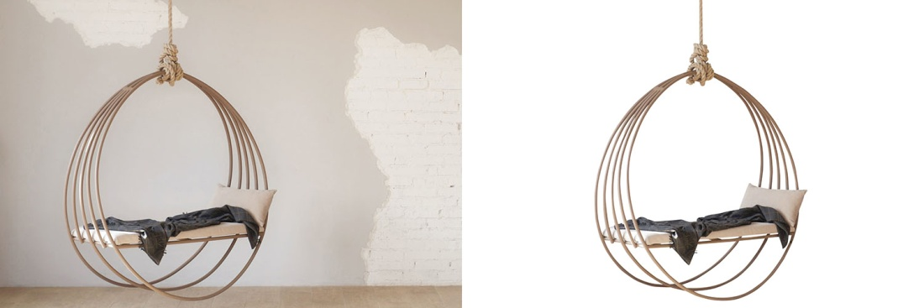

You may find many clipping path service providers around the world, but you don't know which one will be the best one for you. Almost all of them will call themselves the best in their business, but it's only your responsibility to find the best. So, before you give an order, please choose the best company that gives you the best service. Here, we will try to show you why our clipping path service is the best with visual presentation & facts. Importance of clipping path in E-commerce business: Clipping Path Service is very predominant for all types of web-based companies like E-commerce businesses, online shops, design shops, modeling agencies, etc. Actually, in modern days, almost each & every business sector uses clipping path services for better attention or promotion. They make banners, posters, ID cards using clipping path services. So, the demand for clipping path services will be high unquestionably. And that's the main reason for so many clipping path service companies being here.

# Background Removal

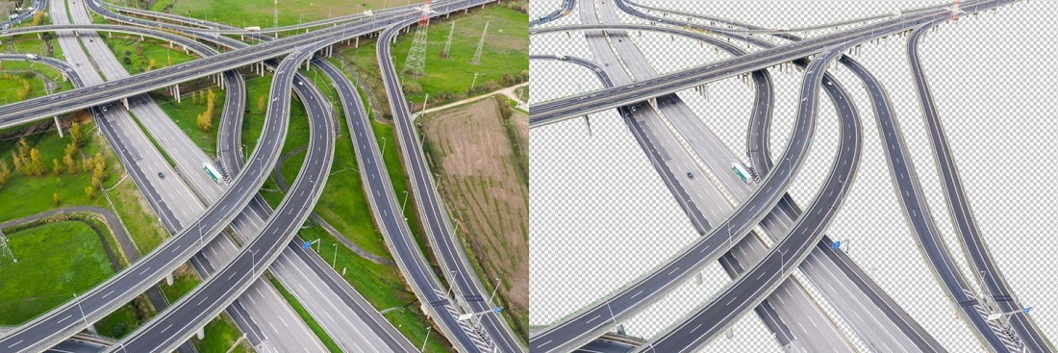

Background removal services are customarily used to cut-of of erasing or remove unwanted parts from the picture. Background removal service changes your actual photo background & placed a new brand background that suits or is needed for the image. To get the best output, not only background removal is essential, masking, retouching, shadow balancing, color correction also plays a vital role. Especially when it comes to e-commerce type businesses they always have to think about the best. But good is not enough there. The reason behind it, the competition is going on. Everyone comes in this area with excellent quality. So no matter what happens, you don't skip the quality management. To get the best quality, all you need to do is work with the best service provider company. And that is what we exactly do. No matter what happens, we don't compromise our work quality at any cost.

# Photo Retouching

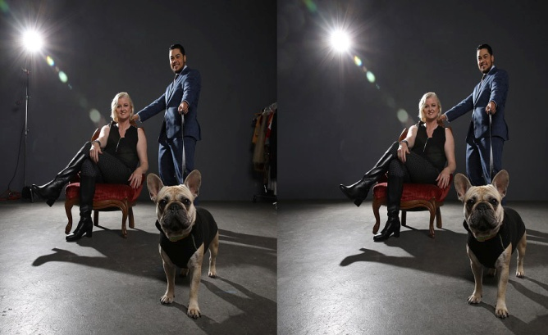

Photo retouching is fundamental when it comes to editing an image. A perfect retouch on a specific image gives a dynamic look, making it very appealing and admirable. To give an idea about it working, removing any wrinkles/marks on the face or the clothing, adjusting & smoothing the face tone, enhancing natural colors, fixing the background & stray hair then giving the subject a shiny glow while keeping its originality, and a lot more as per the customer's requirements.

# Jewelry Retouching

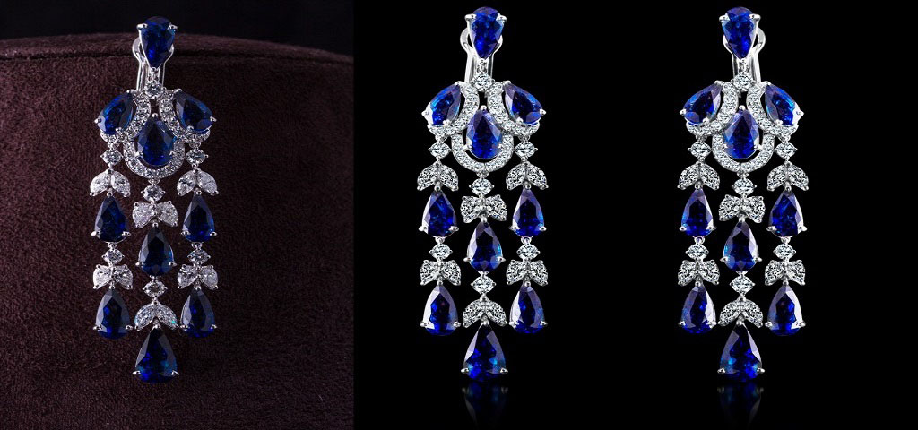

Whenever photographers work with jewelry product photos, professional retouching is essential for the higher sales around the era of web-based markets having image catalogs. Click The Photo offers the most effective Photoshop Jewelry Retouching or Jewelry Photo Editing service that is one of the most complex compared with other commercial image editing or retouching. Our jewelry photo editing services focus just not only on a high-end part of big companies or re-sellers, requiring the top focus to details for their catalogs, quality, but also on beginning artists, promoting their non-professional photos. Our Jewelry photo editing professionals have practical experience in editing for multiple products like wedding rings, bangles, earrings, necklaces, pendants, anklets, Charms, Brooches, watches, etc.

# Image Masking

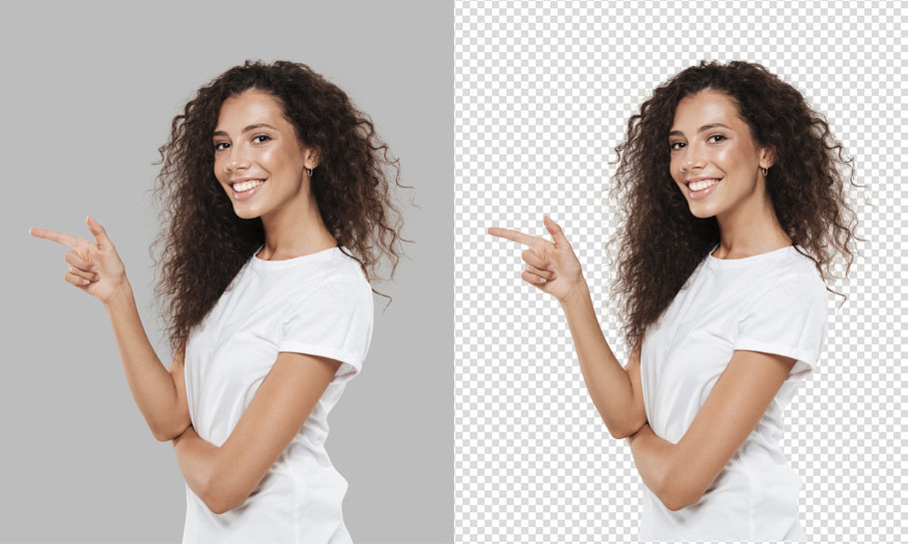

Right now, almost 38% of consumer wants their photos to background as white. That's their basic need when they edit photos. But when you are a professional photographer, usually you don't get enough time to edit your entire photo to deliver in time with good quality. Without taking help, you won't be able to make every client happy. That's why for the sake of your good growing business, you need to take help from masking services.

# Color Correction

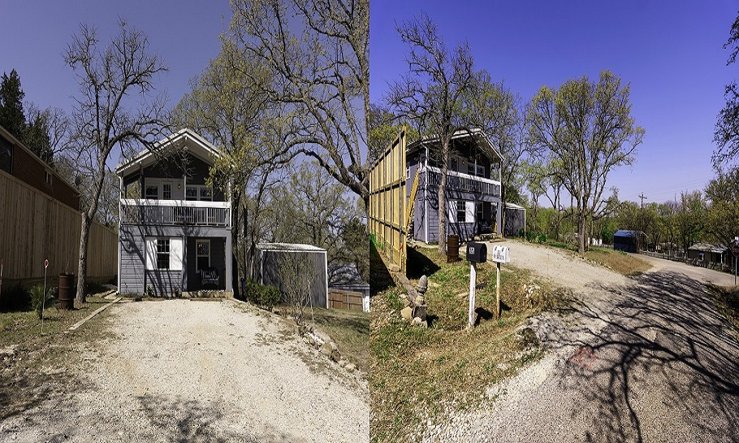

Color correction is a type of photo manipulation done in the post-production stage. It is about adjusting the exposure, color grade, and white and black levels to give an image a lively and warm look. This photo manipulation is done to complement a vision to make it more attractive and indulging. Color correction is done using color gels, filters, and other tools to enhance the image's color tone. Moreover, it can change an object's color in an image for more variations in the product line. For example- a picture of a red shoe is taken, which needs color variations. Here, the color-changing service can do the magic in changing the shoe color to green, black, orange, etc. Similarly, color-changing services are used to alter the color of the eye, hair, or dress of a model quickly without having to click photos in different outfits every time.

# Shadow Making

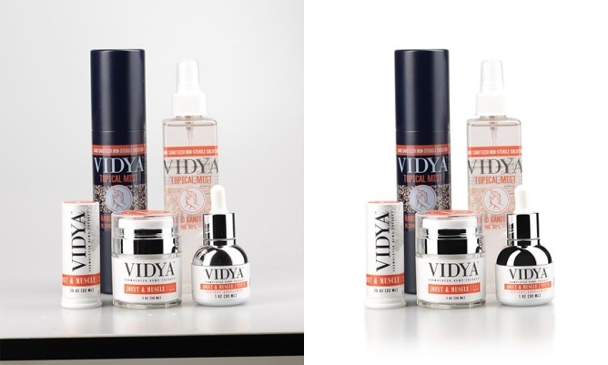

In some cases, the photographic condition results in improper shadows that diminish its beauty. However, shadow optimization service is useful in optimizing e-commerce product photos which increase sales while business scopes for the businessmen. Shadow-making service is essential in creating such vibes. Product photos need to have ideal shadows to attract customers. But certain things like improper lighting, bad weather, and the size of the products often make the photos look dull. It also creates improper shadows. To make the product photos more appealing, a Photoshop shadow-making service is a must.

# E-commerce Image Editing

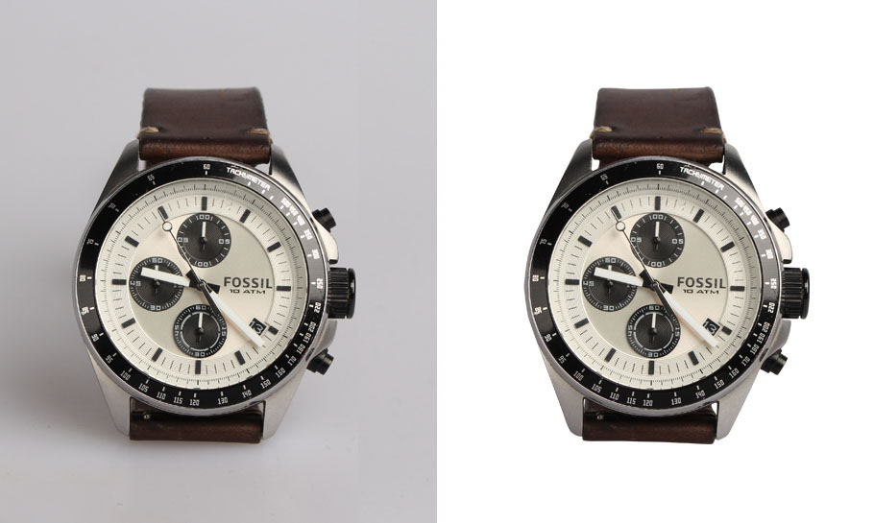

The easiest way to make the most profit from the sale of your online products is by using the best quality images. But where can you get such pictures? This is where our best e-commerce product image solution can be helpful. You don't have to scour the internet for hours in search of quality photos or even wish you had the best camera to capture those products because we have a way out.

# Ghost Mannequin

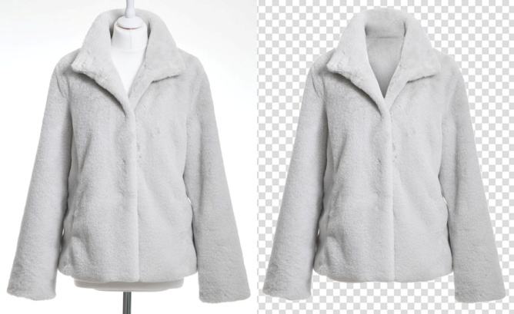

A Ghost Mannequin editing service is the process of removing the Mannequin or doll that is used for advertising your products. The face, neck, legs of the manikin, or lay figure can be cut out, and as such, all that is left is the clothing itself. The best part is that the material takes the Mannequin's shape to give your products a more appealing look.

# Photo Restoration

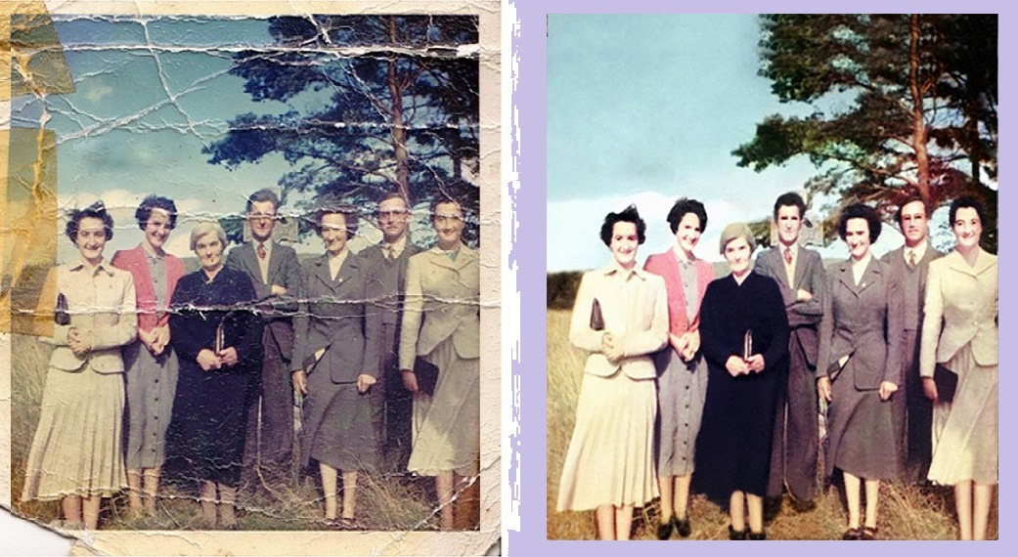

To recover photos with their full blossom and multiplication, we need to work on black and white options to color, brightness, contrast, dust, spots, scratches, shadow, light effect, re-sizing, and image border by Photoshop. Making your photographs look new and fresh is called a photo restoration service. It is the process of restoring a digital copy of a picture that has pale away into a worse reign than the genuine. We are one of the best photo restoration companies that offer high-quality restoration and photo enhancement services at a very affordable cost. We are using sophisticated technology like pen tablets (Wacom) to provide (near zero) non-destructive photo restoration. It doesn't matter whether it is an old, vintage, damaged, blurred photo shot with abnormal exposures, lost pixels, any other deformity. But we have a team and technology to restore them with high-quality restoration service.

# Bracketed Photo Editing

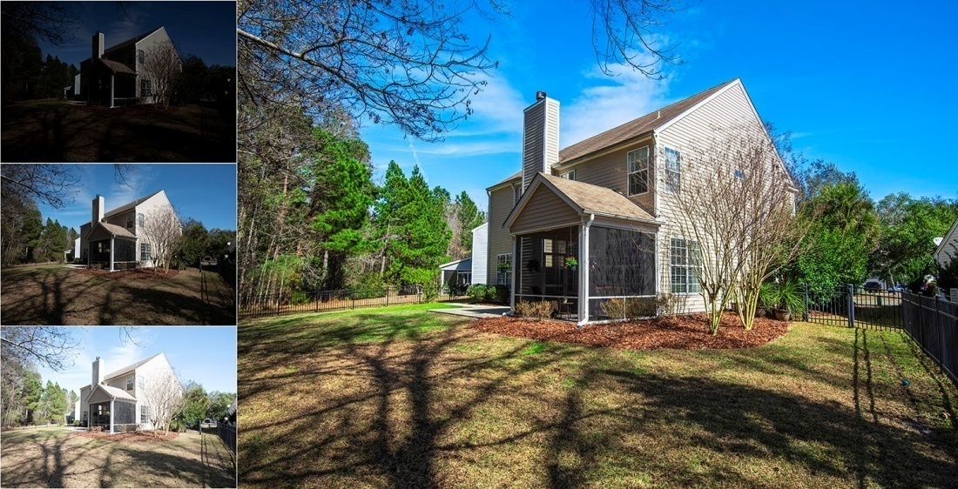

Bracketing is taking the same photo more than once using different settings for different exposures. Why would you do this? Say you’re photographing a mountain landscape. The grass would require one set to be properly exposed; the mountains would require another and the sky yet another. But you can only choose one setting for one photo.

# Real Estate Photo Editing:



Real estate photo editing service makes your business photos look enticing by eliminating unwanted backgrounds and objects. It is also useful in exterior and interior decoration of the real estate property, which adds live people, 3D prototype, etc. Real estate photos are crucial in real-life customer conversion. Real-life shooting can be interrupted for several natural conditions. Photographers need to capture and deliver perfect images to satisfy their clients. And the real estate agencies need to use those photos to attract customers and make sales. Again, real estate agencies may need customized images to meet the client’s demand. So, both of them need real estate photo editing services to conduct business smoothly.

# Wedding Photo Editing:

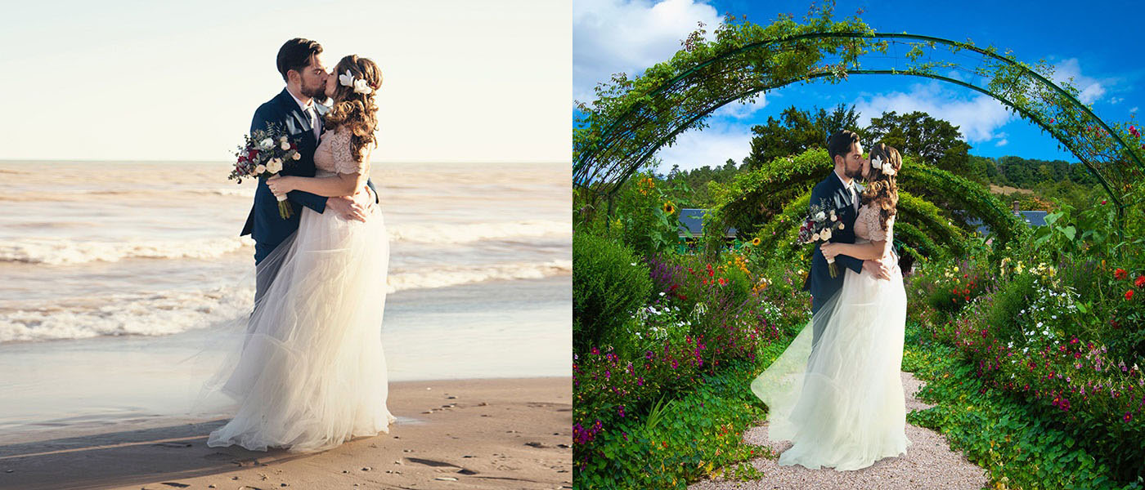

Wedding photo editing service sorts out the drawbacks of the wedding photos and rectifies them to present well-furnished and gorgeous images. It adds/removes objects, corrects color, and retouch photos to make them look outstanding. Do your wedding captures look gloomy for insufficient light, bad weather conditions, and guests' tiredness? Or say your photos have dust; skin looks spotty, unwanted elements or persons obstructing images' beauty, etc. If yes, you might want to use a wedding photo editing service to make them gorgeous.

# Image Cropping and Resizing:



Crop and resizing service is quite popular in e-commerce categories where the images need to crop to eliminate the unwanted parts. Resizing services optimizes the sizes of the photos to make them suitable for different platforms. A raw image needs a lot of work to make it look desirable. And, if it is related to e-commerce products, you need unique idea resizing services. A raw image may carry unwanted elements, aligned in a disorganized way, or the central part of the image may get out of focus. Image cropping, cutout, and resize service come to play in these cases. To give the photo a good look and shape, they come in handy. Photo cutout service is essential for contextualizing the product photos.

# Conclusion

Click the Photo is a **prominent** interactive company working for leading **Photography agencies, Digital Advertising firms, software development, IT Solutions, web development, and e-commerce shop** worldwide and conducting and arranging training programs locally. You will be able to differentiate us from other service providers in terms of commitment, quality, time management, proper follow-up, and at a very competitive price.

Our professional and expert designers are eager to provide the services in an excellent way for Photography Agencies, Advertising Agencies, Digital Marketing Companies, Photo Studios, Online Retail Shops, Brand Development, Pre-Press companies, and whoever works with photos. Three layers Quality Assurance Process assures you state of art quality service with zero errors.

THANK YOU