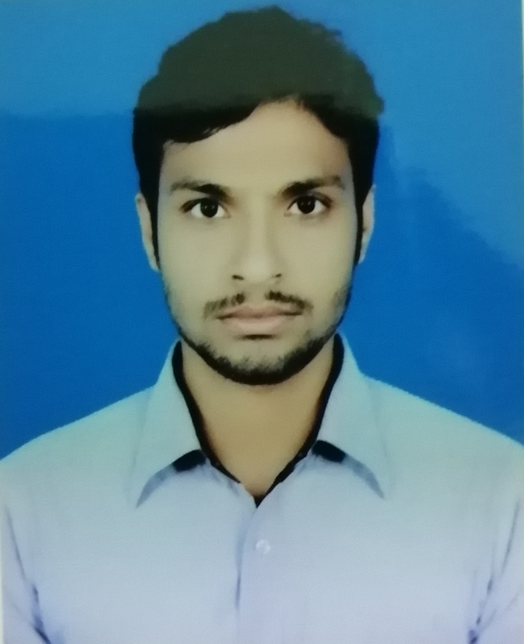
MD SAIFUL ISLAM
AI Researcher & Developer
Phone : +8801773559379
Email : saifulbrur79@gmail.com
Github : https://github.com/saiful79

CARRIER OBJECTIVE
Individual with exceptional research skills and ability to communicate complex concepts across disparate business units. Seeking the job of an Artificial Intelligence Engineer to utilize experience and background in model construction, development and deployment.

EXPERIENCE

Semanticslab, Rangpur — AI Researcher & Developer

September 2018- Present
Working with development teams to ensure accurate integration of machine learning models and construct AI solution for the particular task .On the other hand work closely with software engineering and product management teams to frame problems, both from an engineering and business perspective.

EDUCATION

Begum Rokeya University, Rangpur — BSc. in CSE CGPA

JANUARY 2012 - JUN 2016 3.18 (out of 4)

Sundargonj D.W Degree college, Sundargonj — HSC GPA

PASSING YEAR 2012 5.00 (out of 5)

Fazlul Haque High School, Sundargonj — SSC GPA

PASSING YEAR 2010 4.94 (out of 5)

SKILLS
ARTIFICIAL INTELLIGENCE AND MACHINE LEARNING
- Excellent Knowledge in linear algebra, differential calculus and probabilistic modeling.
- Dexterous in understanding complex theories and reproducing the results of contemporary machine learning research works.

DEEP LEARNING ARCHITECTURE & FRAMEWORKS
- Working experience with Tensorflow, Keras and Pytorch API.
- Creating of CNN based image classification model from scarch and execute state-of-the-art CNN backbone network model like VGG,Inception, Xception, Resnet, DenseNet, NASNet etc for image classification.
- Sequence processing and language modeling with RNN, LSTM, GRU etc.
- Audio and Speech processing with KALDI.
PROGRAMMING LANGUAGE AND TOOLS
- Python, C/C++, Java, Scikit-learn, Opencv, Gensim, NLTK, Numpy, Scipy, Pandas, json, csv etc.
WEB DEVELOPMENT
- Capable of full stack Django development and can integrate with AI predictive model.
- Other framework have little experience like as laravel but expert on raw PHP codding and have good experience on wordpress.
TOOLS
- Python, php, HTML, CSS, Javascript, JQuery.

RESEARCH & PROJECT
SEMANTICS AND INSTANCE SEGMENTATION
Task 1 : Classify all of object that are instance of this frame and segment object based on model classification. The network architecture like as feature extractor + RPN + FPN +classification layer.(NOTE : Instance segmentation)
Task 2 : Segment object semantically use Encoder and decoder method and classify.

TEXT RECOGNITION FROM IMAGE DOCUMENT
The text recognition is basically decode word or sentence or character from image document using CNN+RCNN with CTC loss function and rearrange the decoding text like as image arrangement.
Github: https://github.com/saiful79/image-text-recognition

TEXT DETECTION

Scene Text Detection to segment text word from image document. this model was created based on ICDAR2015+2013 dataset.
Github: https://github.com/saiful79/Text-Detection

HUMAN FACE DETECTION & IDENTIFICATION
Human face detection and identification.
Github: https://github.com/saiful79/Face_Recognition_using_Keras_and_vggface2

HUMAN EYE DISEASES DETECTION
This model detect anomaly of a human retina images using Generative Adversarial Network.

HUMAN ACTION RECOGNITION & BEHAVIORS IDENTIFICATION
Detect human action using spatial and Temporal neural network. The spatial and temporal basically based CNN model network but temporal network find out action trajectory for accurate action prediction.

SEMANTICS TEXTUAL SIMILARITY
Semantic Similarity Between two sentences or text using Bi-LSTM Neural Network.

DIALOGUE GENERATION
SeqtoSeq netwrok use for dialogue generation and integrate Reinforcement learning(RL) into it so that it can learn lear it training.

MULTI -LANGUAGE TOKENIZER(BANGLI)
Natural Language Processing Toolkit For Bengali Language
Github: https://github.com/saiful79/BNTT

OTHERS
- web crawler
- English pos tagger
- Machine Translator create using AI
- AI conceptual search etc.

LANGUAGE
- English-Fluent(Speaking, reading, Writing)
- Bangla-Fluent(Speaking, reading, Writing)

EXTRA-CURRICULAR ACTIVITIES
- Playing

HOBBIES
- Innovating new technology
- Playing football
- Traveling.

PERSONAL DETAILS
Date Of Birth : 15/05/1995
Nationality : Bangladeshi
Marital Status : Unmarried
Father’s Name : MD. Nurul Haque
Mother’s Name : Morjina Begum
Residence : Moniram kazi, Falgacha, Sundargonj, Gaibandha, Bangladesh

