Mapping the Invisible: Spatial Dependence in the PM₂.₅ and Asthma Relationship Across U.S. Counties

Md Saiful Hasan¹ and Dr. Md Jahirul Alam Azad²

¹ Department of Epidemiology and Biostatistics, College of Public Health, Temple University, Philadelphia, Pennsylvania, USA
² Adjunct Faculty, East West University, Dhaka, Bangladesh

Corresponding author: Md Saiful Hasan Email: md.saiful.hasan@temple.edu

Sources of Support / Funding:
This research received no specific grant funding from any funding agency in the public, commercial, or not-for-profit sectors. No equipment, drugs, or materials were provided by external sources. The study was conducted as part of graduate academic training in the Department of Epidemiology and Biostatistics, College of Public Health, Temple University, Philadelphia, PA, USA.
Contribution Statement:
Md Saiful Hasan: Conceptualisation, data curation, formal analysis, spatial methodology, software (R), visualisation, writing — original draft, writing — review and editing.
Jahirul Alam Azad: Epidemiological framework development, writing — review and editing, supervision.
The authors declare no conflicts of interest.

Abstract

Background: Fine particulate matter (PM₂.₅) is a well-established environmental risk factor for asthma exacerbations and emergency department (ED) utilization. While examining this relationship many studies do not account for spatial dependence, potentially leading to biased estimates and incorrect statistical inference.

Methods: This study conducted with 3,166 contiguous U.S. counties using 2020 data from open sources. County-level PM₂.₅ concentrations and adult asthma ED visit rates were mapped and analyzed using exploratory spatial data analysis techniques. Global Moran’s I was used to assess spatial autocorrelation, while Local Indicators of Spatial Association (LISA) identified local clusters and PM₂.₅–asthma co-clusters. Associations between PM₂.₅ and asthma ED visit rates were evaluated.

Results: Both PM₂.₅ and asthma ED visit rates exhibited significant spatial clustering (Moran’s I = 0.751 and 0.644, respectively; both p < 0.001). Residuals from the adjusted OLS model also demonstrated substantial spatial autocorrelation (Moran’s I = 0.462, p < 0.001), indicating violation of model independence assumptions. In the spatial lag model, PM₂.₅ remained positively associated with asthma ED visit rates after adjustment for socioeconomic covariates and spatial dependence (β = 0.114 per μg/m³, 95% CI: 0.026–0.201; p = 0.011). Significant asthma hot spots were identified in the Gulf Coast, Florida, and Mid-Atlantic regions. Bivariate LISA analyses revealed substantial geographic heterogeneity, including high PM₂.₅/high asthma clusters in California’s Central Valley and the Gulf Coast and high PM₂.₅/low asthma clusters across several western states.

Significance: PM₂.₅ was associated with higher adult asthma ED visit rates after accounting for socioeconomic factors and spatial dependence. Strong spatial clustering underscores the importance of spatial analytical methods in environmental epidemiology. Geographic variation, particularly in wildfire-affected western regions, needs further investigation. These findings may help identify areas where air quality improvement and asthma prevention efforts needed.

Keywords: PM₂.₅; asthma; emergency department visits; spatial epidemiology; Moran’s I; LISA; spatial lag model; environmental health; air pollution; United States.

Impact Statement

County-level PM₂.₅ concentrations are significantly associated with adult asthma emergency department visit rates across U.S. counties, but standard regression methods substantially overestimate this effect by ignoring geographic clustering. Using spatial lag regression and LISA cluster analysis, this study shows that neighbourhood context of pollution that dominates county-level asthma burden, and identifies a wildfire-driven geographic disconnect in western counties that warrants distinct policy and research responses from Gulf Coast and Mid-Atlantic high-burden clusters.
1. Introduction
In the United States, asthma affects approximately 25 million people and contributes to an estimated 1.6 million emergency department (ED) visits each year, with direct and indirect costs near $80 billion annually (CDC, 2022). Among environmental exposures associated with asthma exacerbations, fine particulate matter (PM₂.₅)—defined as airborne particles with an aerodynamic diameter of ≤2.5 µm that can penetrate deeply into the lower respiratory tract—has the most consistent and extensively replicated evidence linking it to increased asthma morbidity and acute exacerbation risk (Varopichetsan et al., 2025). Once inhaled, PM₂.₅ penetrates deep into the lower airways, triggering oxidative stress, inflammatory cytokine cascades, and bronchospasm (Brook et al., 2010). Landmark studies, including the Harvard Six-Cities and American Cancer Society cohort investigations, first established associations between PM₂.₅ and cardiopulmonary mortality (Dockery et al., 1993; Pope et al., 2002). More recent work has confirmed these findings extend to respiratory hospitalizations and ED utilization specifically (Zanobetti & Schwartz, 2009).

The health burden of PM₂.₅ is not randomly distributed. Tessum and colleagues (2021) demonstrated that Black, Hispanic, and Asian Americans experience systematically higher PM₂.₅ exposures than white Americans at equivalent income levels. Separately, Keet et al. (2018) showed that neighborhood poverty, racial composition, and healthcare access jointly shape asthma ED visit patterns, creating confounding structures that simple pollution-outcome analyses cannot adequately address. Importantly, these gradients are geographically structured—they follow the spatial organization of residential segregation, industrial facility siting, and infrastructure disinvestment. In 2024, the U.S. Environmental Protection Agency tightened the annual National Ambient Air Quality Standard for PM₂.₅ from 12 to 9 μg/m³ (U.S. Environmental Protection Agency, 2024; Federal Register, 2024), making it timely to assess geographic heterogeneity in compliance and potential public health gains under the revised standard.

A persistent methodological gap limits the current literature. Many ecological and county-level studies examining PM₂.₅ and asthma outcomes have relied on ordinary least squares (OLS) regression without testing for spatial autocorrelation in residuals (Zhou et al., 2024). However, such as asthma-related emergency department visit rates exhibit geographic clustering and spatial heterogeneity across neighborhoods and communities (Bozigar et al., 2020; Maliker et al., 2001; Zarate et al., 2024); under such conditions, OLS residuals violate the independence assumption, leading to underestimated standard errors and unreliable hypothesis tests (Anselin, 1988; LeSage & Pace, 2009, Lawson, 2013). Spatial regression models, particularly the spatial lag model, address this limitation by incorporating outcomes from neighboring counties as explicit predictors, providing a more appropriate analytical framework for geographically structured data (Elhorst, 2010).

The present study applies a complete spatial epidemiology workflow to 2020 county-level data for the contiguous United States. Our specific aims are: (i) to compare the geographic distributions of PM₂.₅ concentrations and adult asthma ED visit rates; (ii) to quantify global spatial autocorrelation using Moran’s I; (iii) to identify statistically significant local clusters and PM₂.₅–asthma co‑clusters using local indicators of spatial association (LISA); and (iv) to estimate the PM₂.₅–asthma association using spatial regression with data‑driven model selection via Rao’s Score diagnostics.
2. Methods
2.1 Study Design and Population
This study adopted cross-sectional ecological analysis using the U.S. County as the unit of analysis. The analytic sample comprised 3,166 contiguous U.S. counties with complete data on all study variables for calendar year 2020. Alaska, Hawaii, and U.S. territories were excluded because geographic contiguity is required for spatial weights construction. Counties in the 22 states were not available in the CDC Environmental Public Health Tracking (EPHT) program due to low case counts, which is below state-mandated suppression thresholds, were retained in exploratory maps (shaded grey as “Data Not Reported”) but excluded from regression analyses. All spatial operations were performed using the NAD83 Conterminous Albers Equal Area Conic projection (EPSG:5070).
2.2 Data Sources
PM₂.₅ Exposure
Annual mean county-level PM₂.₅ concentrations (μg/m³) for 2020 were obtained from the U.S. Environmental Protection Agency Air Quality System (AQS). County values represent spatial averages of monitoring station readings matched to 5‑digit Federal Information Processing Series (FIPS) codes.
Outcome: Asthma ED Visit Rates
County-level adult asthma ED visit rates per 10,000 population for 2020 were obtained from the CDC EPHT Network. The source variable is a sex‑averaged rate (female and male rates averaged where both were available).
Socioeconomic Covariates
Five county-level socioeconomic variables were extracted from the 2020 American Community Survey (ACS) 5‑year estimates using the tidycensus package: poverty rate (percentage of residents below the federal poverty line, table B17001); percentage of non‑Hispanic Black residents (B02001); uninsured rate for adults aged 19–64 years (B27010); median household income in 2020 inflation‑adjusted dollars (B19013); and population density (total population divided by county land area in square miles, B01003 and TIGER/Line 2022).
2.3 Spatial Weights
Neighbor relationships were defined using queen contiguity: two counties are considered neighbors if they share any boundary segment or corner point. Weights were row‑standardized so that each county’s neighbor weights sum to one, making the spatial lag interpretable as a weighted average of neighboring values. Five island counties with no contiguous neighbors were assigned zero weights. Separate weights matrices were constructed for the exploratory sample (n = 4,634) and the regression subsample (n = 3,166) using the spdep package in R.
2.4 Exploratory Spatial Data Analysis
Global spatial autocorrelation in PM₂.₅ concentrations and asthma ED rates was assessed using the Global Moran’s I statistic under the randomization assumption. Local clustering was examined using Local Indicators of Spatial Association (LISA; Anselin, 1995) via the localmoran() function. Each county was classified at p < 0.05 as High‑High, Low‑Low, High‑Low, Low‑High, or Not Significant based on its standardized value and its spatially lagged value. Bivariate spatial co‑clustering of PM₂.₅ and asthma was examined by applying LISA to asthma rates using binary spatial lags of standardized PM₂.₅.
2.5 Regression Analysis
Four models were estimated sequentially: (1) unadjusted ordinary least squares (OLS) with PM₂.₅ alone; (2) adjusted OLS with all five socioeconomic covariates, selected a priori as established asthma predictors; (3) spatial lag model (implemented in spatialreg::lagsarlm); and (4) spatial error model (spatialreg::errorsarlm). After the adjusted OLS, Moran’s I was computed on residuals to confirm remaining spatial dependence. Rao’s Score tests—the standard and robust versions for both lag and error dependence—were used for model selection. When both robust statistics are significant, the model corresponding to the larger robust statistic is preferred (Anselin, 1988). Spatial models were estimated by maximum likelihood. Model fit was compared using the Akaike Information Criterion (AIC); residual autocorrelation in the selected model was confirmed to be negligible.
2.6 Software
All analyses were conducted in R (version 4.4.2) using tidyverse, sf, spdep, spatialreg, ggplot2, patchwork, tidycensus, and ggspatial. The R Markdown document that produced all results is available as supplementary material.

3. Results
3.1 Descriptive Statistics
The regression sample comprised 3,166 counties across 28 states’ data available in the CDC EPHT program. County-level PM₂.₅ concentrations ranged from 1.30 to 39.10 μg/m³, with a mean of 7.64 μg/m³ (SD = 2.31). Asthma ED visit rates ranged from 2.20 to 69.10 per 10,000 population, with a mean of 23.20 (SD = 9.51). Poverty rates varied substantially across counties, from 1.69% to 50.71%, and median household incomes ranged from $ 22,292 to $130,890. Population density was strongly right‑skewed (mean = 345 persons per square mile, median = 50), reflecting a sample dominated by rural counties with a small number of dense urban outliers. PM₂.₅ was approximately normally distributed (mean = 7.64, SD = 2.31 µg/m³), while asthma ED rates showed mild right skew (Supplementary Figure S2).

Table 1. Descriptive Statistics — Regression Sample (n = 3,166 U.S. Counties, 2020)
Variable | Min | Mean | SD | Median | Max
PM2.5 (μg/m³) | 1.30 | 7.64 | 2.31 | 7.40 | 39.10
Asthma ED Rate (per 10,000) | 2.20 | 23.20 | 9.51 | 21.80 | 69.10
Poverty Rate (%) | 1.69 | 13.70 | 5.55 | 12.72 | 50.71
% Non-Hispanic Black | 0.00 | 5.89 | 10.53 | 1.62 | 71.07
Uninsured Rate (%) | 0.00 | 1.29 | 1.26 | 0.99 | 19.62
Median Household Income ($) | 22,292 | 56,491 | 14,652 | 54,286 | 130,890
Population Density (per sq mile) | 0.20 | 345.16 | 2,438 | 49.90 | 71,902
Sources: EPA AQS (PM₂.₅); CDC EPHT (asthma ED rate, 28 reporting states); U.S. Census ACS 2020.
3.2 Spatial Distributions of PM_{2.5} and Asthma ED Rates
Quintile choropleth maps (Figure 1) revealed distinct geographic patterns for PM_{2.5}​ concentrations and asthma emergency department (ED) visit rates. Elevated PM_{2.5}​ levels were concentrated in California’s Central Valley, the Pacific Coast corridor, and the Ohio Valley–Mid-Atlantic industrial region, whereas the lowest concentrations were observed in the Intermountain West and Northern Plains. In contrast, asthma ED visit rates were highest in Gulf Coast states (notably Louisiana and Mississippi), Florida, Appalachian counties, and parts of the Mid-Atlantic. Counties without available CDC Environmental Public Health Tracking (EPHT) data are displayed in grey.
Figure 1— Quintile Choropleth (PM2.5 and Asthma Side-by-Side)
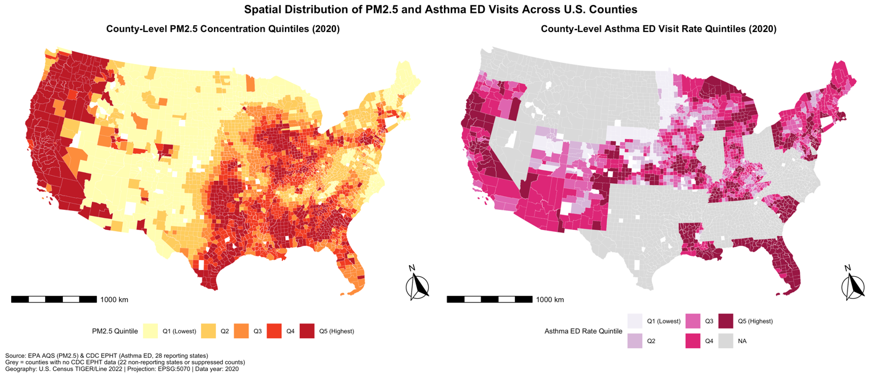
3.3 Global Spatial Autocorrelation and OLS Residual Diagnosis
Both variables exhibited strong spatial clustering (Table 2). PM₂.₅ had a Global Moran’s I=0.751 (z=109.17, p<2.2×10⁻¹⁶), and asthma emergency department (ED) visit rates had a Moran’s I=0.644 (z=86.90, p<2.2×¹⁰⁻¹⁶), indicating substantial positive spatial autocorrelation beyond that expected under spatial randomness.
Residuals from the adjusted OLS model also demonstrated significant spatial autocorrelation (Moran’s I=0.462, z=62.29, p<2.2×10⁻¹⁶), indicating violation of the independence assumption and inadequacy of OLS for these data. The spatial distribution of residuals (Supplementary Figure S1) further demonstrated pronounced geographic patterning, supporting the use of spatial regression models.
Figure 2 — OLS Residual Map
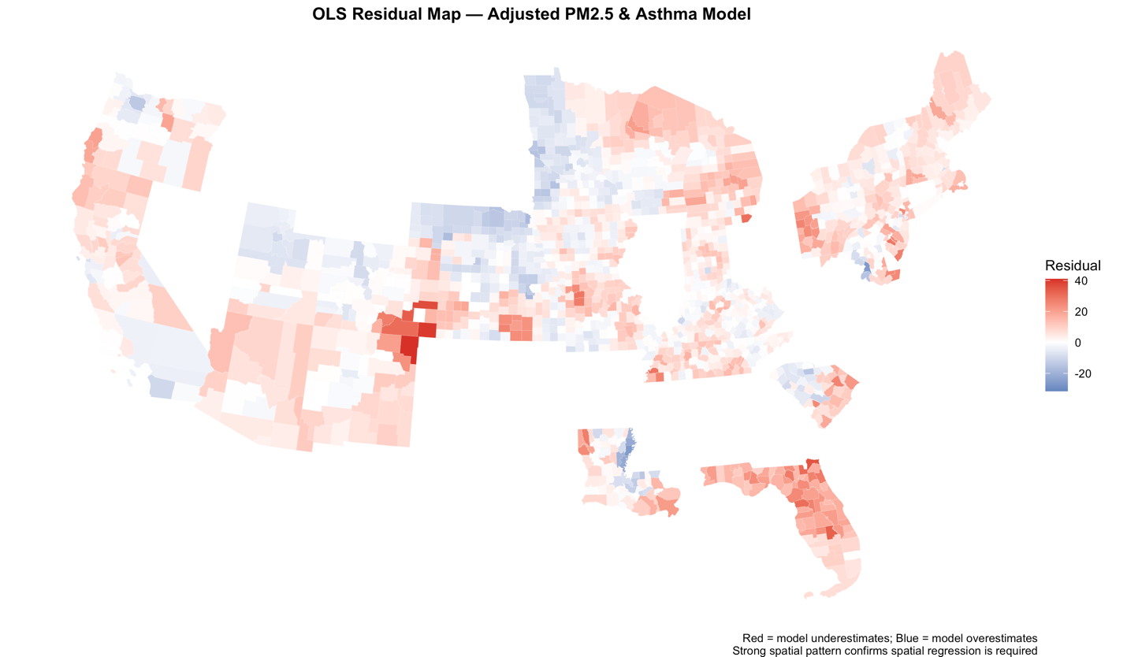
Table 2. Global Moran’s I — Spatial Autocorrelation Tests
Variable | Moran’s I | Z-score | p-value
Asthma ED Visit Rate (sex-averaged) | 0.644 | 86.90 | < 2.2 × 10⁻¹⁶
PM2.5 Concentration | 0.751 | 109.17 | < 2.2 × 10⁻¹⁶
OLS Adjusted Residuals | 0.462 | 62.29 | < 2.2 × 10⁻¹⁶
Spatial Lag Residuals | −0.020 | — | 0.996 (ns)
Queen contiguity weights, row-standardised. ns = not significant.

Figure 3 — Moran Scatter Plots (PM2.5 and Asthma, side by side)
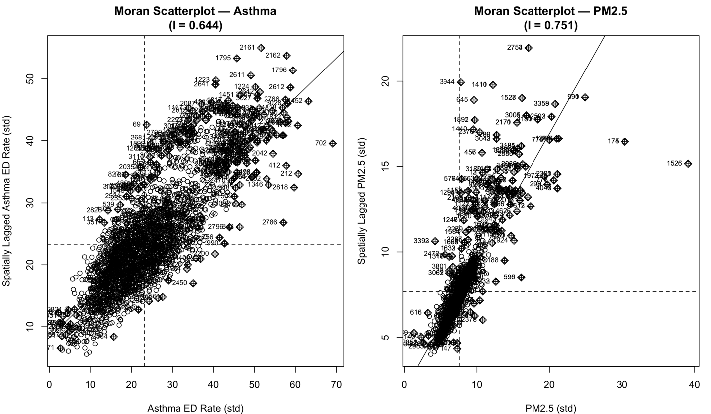
3.4 Local Spatial Clusters of Asthma ED Visit Rates
Univariate local indicators of spatial association (LISA) (Figure 2; Table 3) identified 1,052 High–High counties (asthma hot spots; 13.5%) and 1,344 Low–Low counties (cold spots; 17.2%) at p<0.05. High–High clusters were concentrated in northern and central California, the Gulf Coast, Florida, and parts of the Mid-Atlantic and New England, whereas Low–Low clusters were primarily located in the Upper Midwest and Northern Plains. Additionally, 58 counties were classified as High–Low spatial outliers and 80 as Low–High outliers.
Table 3. Univariate LISA Cluster Summary — Adult Asthma ED Visit Rates (p < 0.05)
Cluster Type | n Counties | % of Sample | Geographic Concentration
High-High (hot spot) | 1,052 | 13.5% | CA Central Valley, Gulf Coast, Mid-Atlantic, New England
Low-Low (cold spot) | 1,344 | 17.2% | Upper Midwest, Northern Plains
High-Low (spatial outlier) | 58 | 0.7% | Scattered, western states
Low-High (spatial outlier) | 80 | 1.0% | Scattered
Not Significant | 5,266 | 67.5% | —
Queen contiguity weights, row-standardised. Sample: n = 7,800 counties in ESDA sample.
Bivariate LISA analysis (Figure 3; Table 3b) revealed a geographic decoupling between PM_{2.5} and asthma ED visit rates in the western United States. High PM_{2.5}/Low asthma clusters (n = 572; 7.3%) were concentrated in inland California, Oregon, Washington, Montana, and Idaho, consistent with wildfire-dominated PM_{2.5} exposure that is not accompanied by proportionally elevated asthma ED utilization. In contrast, 1,396 High PM_{2.5}/High asthma clusters (17.9%) were identified in California’s Central Valley, the Gulf Coast, and the Mid-Atlantic, representing priority areas for joint air quality and asthma intervention.
Low PM_{2.5}/High asthma clusters (n = 824; 10.6%) were observed in Appalachia and parts of the Gulf Coast, suggesting that factors other than ambient PM_{2.5}—including indoor exposures, smoking prevalence, and healthcare access—may play a larger role in driving asthma burden in these regions.

Table 3b. Bivariate LISA Counts Table
Cluster Type | n Counties | % of Sample | Geographic Concentration
High PM2.5 / High Asthma | 1,396 | 17.9% | CA Central Valley, Gulf Coast, Mid-Atlantic
Low PM2.5 / Low Asthma | 2,276 | 29.2% | Upper Midwest, Northern Plains, Mountain West
High PM2.5 / Low Asthma | 572 | 7.3% | Inland CA, OR, WA, MT, ID — wildfire zone
Low PM2.5 / High Asthma | 824 | 10.6% | Appalachia, parts of Gulf Coast
Not Significant | 2,732 | 35.0% | —
Note: Queen contiguity weights, row-standardised. ESDA sample n = 7,800 counties (all counties with PM2.5 data). p < 0.05.

Figure 4 — Univariate LISA Cluster Map
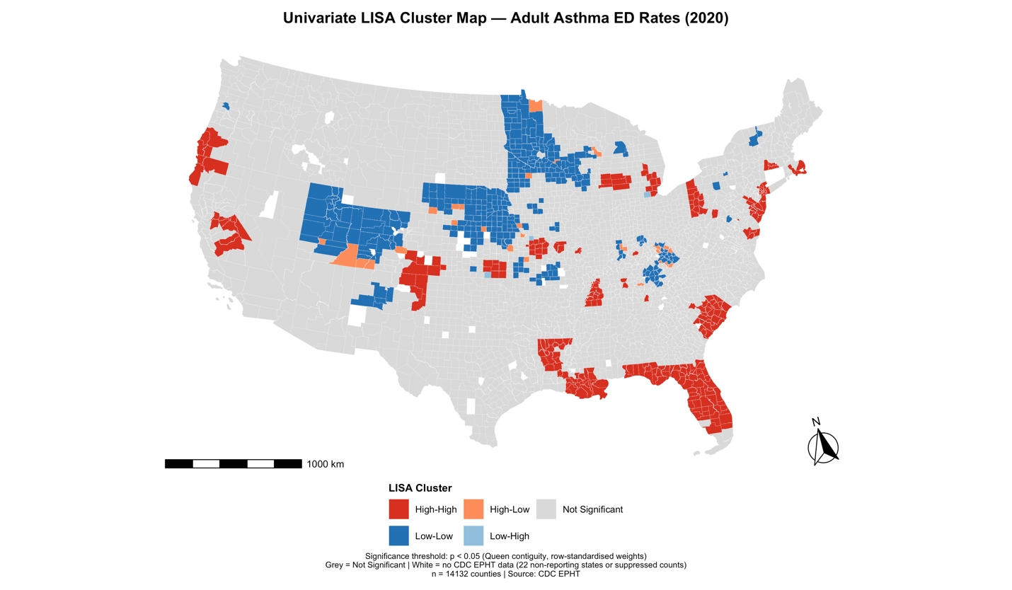

Figure 5 — Bivariate LISA Map
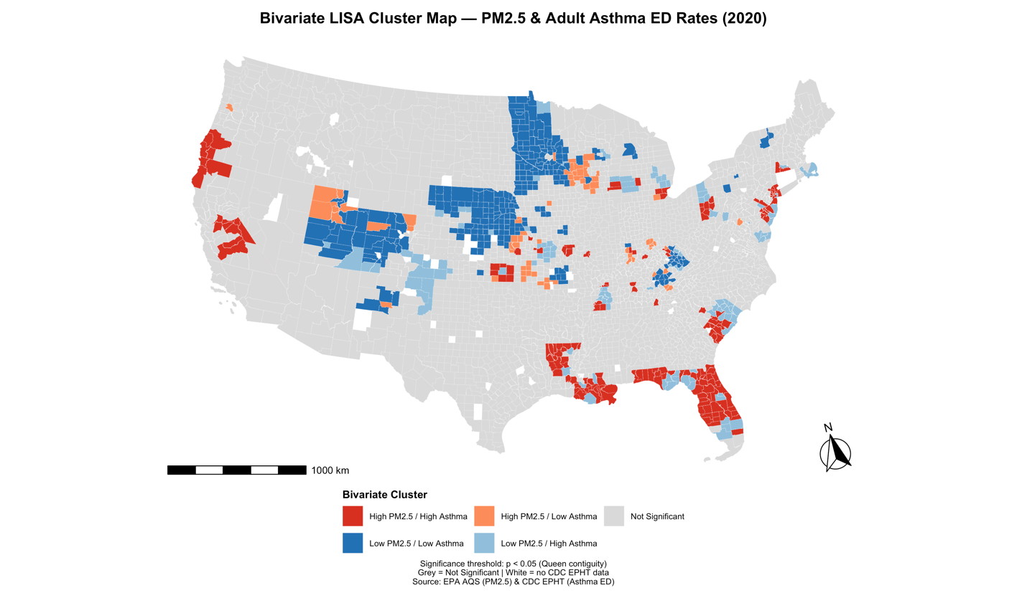

3.5 Regression Models and Spatial Model Selection

Table 4 presents results from all four models. In the unadjusted OLS model, each μg/m3 increase in PM_{2.5} was associated with 0.765 additional asthma emergency department (ED) visits per 10,000 population (p < 0.001), although the model explained only 3.5% of the variance. Adjustment for socioeconomic covariates reduced the PM_{2.5} coefficient to 0.599 (p < 0.001) and increased explained variance to 24.5%; however, substantial residual spatial autocorrelation persisted (Moran’s I=0.462, p < 2.2×10⁻¹⁶).
Rao’s Score diagnostics applied to the adjusted OLS model indicated the presence of both spatial lag and spatial error dependence (RSlag = 3,947.74; RSerr = 3,858.96; both p < 2.2×10⁻¹⁶). Robust test statistics favored the spatial lag specification (adjRSlag = 318.18 vs. adjRSerr = 229.40), indicating that county-level asthma ED visit rates are influenced by neighboring counties beyond shared unmeasured confounders.

The spatial lag model substantially improved model fit (AIC = 20,284 vs. 22,371 for adjusted OLS). The spatial autoregressive parameter was ρ=0.848 (SE = 0.013, p < 0.001), indicating strong positive spatial spillover across country boundaries. After accounting for this dependence, PM_{2.5}​ remained a statistically significant predictor (β=0.114 per μg/m³; SE = 0.045; 95% CI: 0.026, 0.201; p = 0.011). Residual spatial autocorrelation was negligible (Moran’s I= −0.020, p=0.996), supporting adequate model specification.

Among socioeconomic covariates in the spatial lag model, the percentage of non-Hispanic Black residents (β=0.067, p < 0.001) and population density (β=8.5×10⁻⁵, p=0.044) were positively associated with asthma ED visit rates. The uninsured rate showed a borderline negative association (β=−0.144, p=0.077), likely reflecting barriers to healthcare access rather than lower underlying disease burden. In contrast, the spatial error model yielded a non-significant PM_{2.5} coefficient (β=0.084, p=0.308) and a slightly higher AIC (20,315), consistent with diagnostic tests favoring the lag specification.
Results were robust across sensitivity analyses: the PM_{2.5} coefficient remained positive and statistically significant under rook contiguity weights and after excluding wildfire-affected western states (Supplementary Table S3).

Table 4. Regression Results — PM₂.₅ and Adult Asthma ED Visit Rates (n = 3,166 Counties)
Parameter | Unadj. OLS | Adj. OLS | Spatial Lag | Spatial Error
Exposure
PM2.5 β | 0.765*** | 0.599*** | 0.114* | 0.084 (ns)
SE | (0.072) | (0.065) | (0.045) | (0.083)
95% CI | [0.624, 0.906] | [0.472, 0.727] | [0.026, 0.201] | —
Covariates
Poverty Rate (%) | — | −0.003 (ns) | −0.025 (ns) | −0.009 (ns)
% Non-Hispanic Black | — | 0.393*** | 0.067*** | 0.000 (ns)
Uninsured Rate (%) | — | −0.248* | −0.144· | −0.104 (ns)
Median Income ($) | — | −6.2×10⁻⁶ (ns) | −2.6×10⁻⁶ (ns) | 5.3×10⁻⁵***
Pop. Density | — | 3.5×10⁻⁴*** | 8.5×10⁻⁵* | 3.2×10⁻⁵ (ns)
Spatial Parameters
ρ (rho) | — | — | 0.848*** (SE 0.013) | —
λ (lambda) | — | — | — | 0.891*** (SE 0.011)
Model Fit
R² | 0.035 | 0.245 | — | —
Log-likelihood | — | — | −10,133.1 | −10,148.3
AIC | 23,141 | 22,371 | 20,284 | 20,315
Moran’s I (residuals) | — | 0.462*** | −0.020 (ns) | —
*** p < 0.001; ** p < 0.01; * p < 0.05; · p < 0.10; ns = not significant; — = not applicable. 95% CI computed as Estimate ± 1.96 × SE. Spatial models estimated by maximum likelihood (spatialreg v1.4-3). Outcome: sex-averaged adult asthma ED visit rate per 10,000 (CDC EPHT variable ‘asthma_female’).

4. Discussion
This national county-level spatial analysis of PM_{2.5} and adult asthma emergency department (ED) visit rates yields four principal findings. First, both PM_{2.5} concentrations and asthma ED visit rates exhibited strong spatial clustering across U.S. counties, with Global Moran’s I=0.751 and I=0.644, respectively, indicating that conventional OLS regression is not appropriate for these data. Second, after accounting for spatial dependence and adjusting for key socioeconomic covariates, PM_{2.5} remained a statistically significant predictor of asthma ED visit rates (β=0.114; 95% CI: 0.026, 0.201; p=0.011). Third, spatial dependence emerged as a dominant feature of the data: the estimated spatial autoregressive parameter (ρ=0.848) indicates that county-level asthma ED visit rates are strongly influenced by neighboring counties, reflecting shared airsheds, regional healthcare systems, and geographically clustered socioeconomic conditions. Fourth, bivariate local indicators of spatial association (LISA) identified a geographic decoupling of PM_{2.5} and asthma ED visit rates in the western United States, suggesting wildfire smoke as a distinct and insufficiently characterized exposure pathway. Fotheringham et al., (2002) mentioned that the relationship between an environmental driver and a health outcome is not necessarily uniform across space due to spatial non-stationarity. It indicates that that the PM2.5–asthma relationship could vary significantly between regions like the "wildfire west" and the "Gulf Coast.

The observed association between PM_{2.5}​ and asthma ED visit rates is consistent with prior literature on air pollution and health. Hayes et al. (2020) reported a 16% increase in ischemic heart disease mortality per 10 μg/m3 increase in PM_{2.5}​, reflecting longer-term cardiovascular effects. In contrast, the present estimate—1.14 additional asthma ED visits per 10,000 population per 10 μg/m3—is consistent with acute respiratory responses mediated by airway inflammation and bronchospasm. Pope et al. (2020), in a meta-analysis spanning more than two decades of cohort studies, reported a pooled hazard ratio of 1.08 for all-cause mortality per 10 μg/m3, providing a broader benchmark for PM_{2.5​}-associated health risks, although direct comparisons are limited by differences in outcomes and study design.

The substantial attenuation of the PM_{2.5}​ coefficient—from 0.765 in unadjusted OLS models to 0.114 in the spatial lag model—highlights the importance of accounting for spatial structure. This reduction indicates that much of the crude association reflects shared spatial patterning rather than a direct causal effect. Neighboring counties tend to exhibit similar pollution levels and asthma burdens due to common environmental, socioeconomic, and healthcare contexts. Failure to account for this spatial dependence may lead to overestimation of effect sizes in county-level analyses, with implications for interpretation of prior studies that did not assess or correct for residual spatial autocorrelation.

Spatial clustering further identified 1,052 High – High LISA clusters concentrated in the Gulf Coast, Florida, and Mid-Atlantic regions. These areas represent populations experiencing both elevated PM_{2.5} exposure and high asthma ED burden. These regions are also characterized by higher poverty rates, larger non-Hispanic Black populations, and more limited access to primary care, factors associated with both increased asthma risk and greater reliance on emergency care (Keet et al., 2018). Notably, the coefficient for the non-Hispanic Black population decreased from β=0.393 in adjusted OLS models to 0.067 in the spatial lag model, suggesting that much of the observed association operates through spatially structured factors such as residential segregation, proximity to emission sources, and differential regulatory enforcement. This interpretation is consistent with findings by Tessum et al. (2021), which demonstrate that PM_{2.5} exposure disparities in the United States are geographically and structurally patterned.

In contrast, High PM_{2.5}​/Low asthma bivariate clusters observed in western counties represent a distinct pattern not well characterized in national county-level analyses. A plausible explanation is the influence of wildfire smoke, which contributed substantially to PM_{2.5}​ levels in many western regions during 2020. Wildfire-related PM_{2.5}​ may differ in chemical composition and toxicity from PM_{2.5}​ generated by fossil fuel combustion (Brook et al., 2010). Additionally, demographic and healthcare utilization patterns in western rural counties may differ from those in southeastern regions. Future research should incorporate source-specific PM_{2.5}​ data, such as EPA Chemical Speciation Network measurements or satellite-derived smoke exposure estimates, to assess whether health effects vary by pollution source.

Several limitations should be considered. This study is cross-sectional and ecological in design; therefore, associations observed at the county level cannot be attributed to individuals, and causal inference is limited. The incomplete geographic reporting coverage of CDC Environmental Public Health Tracking (EPHT) data—excluding 22 states, disproportionately in the western and southern United States—may introduce selection bias and limit generalizability. Annual average PM_{2.5}​ estimates derived from fixed monitoring stations. These did not captured short-term peaks, seasonal variability, or within-county heterogeneity, and may result in exposure misclassification, particularly in large or wildfire-affected counties. Additionally, several relevant confounders, including smoking prevalence, obesity, indoor environmental exposures, and occupational risks, were not available at the county level. The large spatial autoregressive parameter (ρ=0.848) further suggests that unmeasured, spatially patterned factors remain important determinants of asthma ED visit rates.

5. Conclusion
Adult asthma ED visit rates are strongly and consistently spatially patterned at the U.S. county level. OLS regression is statistically inadequate for these data — residual autocorrelation was severe (Moran’s I = 0.462) and spatial lag regression was required. After spatial adjustment (ρ = 0.848) and socioeconomic confounding control, PM₂.₅ remained a significant predictor of asthma ED burden (β = 0.114 per μg/m³, 95% CI [0.026, 0.201], p = 0.011). The 1,052 High-High asthma hot spots in the Gulf Coast, Florida, and Mid-Atlantic identify the geographic priority areas for PM₂.₅ abatement and asthma care investment under the 2024 revised EPA NAAQS. The western PM₂.₅–asthma geographic disconnect, consistent with wildfire-dominated exposure, represents a distinct research and policy challenge requiring source-specific PM₂.₅ analysis. Expanding CDC EPHT asthma ED surveillance to all 50 states would substantially improve the geographic completeness and analytical power of future national studies. This research received no external funding. It was conducted as part of graduate coursework in spatial epidemiology at the Department of Epidemiology and Biostatistics, Temple University.

Adult asthma ED visit rates exhibited strong and consistent spatial patterning across U.S. counties. OLS regression was not appropriate for these data, as evidenced by substantial residual spatial autocorrelation (Moran’s I = 0.462). A spatial lag model was therefore employed. After accounting for spatial dependence (ρ=0.848) and adjusting for socioeconomic confounders, fine particulate matter (PM_{2.5}) remained a statistically significant predictor of asthma ED visit rates (β=0.114 per μg/m3; 95% CI: 0.026, 0.201; p=0.011).

Spatial cluster analysis identified 1,052 High–High clusters concentrated in the Gulf Coast, Florida, and Mid-Atlantic regions, indicating priority areas for targeted PM_{2.5} mitigation and asthma care interventions under the 2024 revised EPA National Ambient Air Quality Standards (NAAQS). In contrast, a geographic decoupling of PM_{2.5}​ and asthma burden was observed in the western United States, consistent with wildfire-dominated exposure profiles. This pattern suggests the need for source specific PM_{2.5}​ characterization in future research and policy development. Expanding CDC Environmental Public Health Tracking (EPHT) asthma ED surveillance to all 50 states would enhance geographic coverage and strengthen the analytical capacity of nationwide studies.

Conflict of Interest Statement
The author declares no conflict of interest, financial or otherwise, in relation to this work. No funding was received from any commercial, governmental, or not-for-profit organisation that could have influenced the design, conduct, analysis, interpretation, or reporting of this study. The study was conducted independently as part of graduate academic training.

Acknowledgements
The author thanks the faculty and staff of the Department of Epidemiology and Biostatistics, College of Public Health, Temple University, for academic support during the conduct of this research. The author acknowledges the U.S. Environmental Protection Agency, the Centers for Disease Control and Prevention Environmental Public Health Tracking Network, and the U.S. Census Bureau for making the data used in this study freely and publicly available. [If a co-author or faculty member provided guidance on the epidemiological framework, add: The author thanks [Name], [Title], [Institution], for constructive comments on the epidemiological framing of the Discussion section.] No artificial intelligence tools were used to generate or substantially revise any portion of the manuscript text.

Funding
This study received no external funding and was conducted as part of graduate-level coursework in spatial epidemiology at the Department of Epidemiology and Biostatistics, Temple University.

Contribution Statement:
Md Saiful Hasan: Conceptualisation, data curation, formal analysis, spatial methodology, software (R), visualisation, writing — original draft, writing — review and editing.
Jahirul Alam Azad: Epidemiological framework development, writing — review and editing, supervision.
The authors declare no conflicts of interest.

References
Anselin, L. (1988). Spatial Econometrics: Methods and Models. Kluwer Academic Publishers.
Anselin, L. (1995). Local indicators of spatial association — LISA. Geographical Analysis, 27(2), 93–115.
Bivand, R. S., & Wong, D. W. S. (2018). Comparing implementations of global and local indicators of spatial association. TEST, 27(4), 716–748.
Bozigar, M., Lawson, A. B., Pearce, J. L., King, K., & Svendsen, E. R. (2020). A Bayesian spatio-temporal analysis of neighborhood pediatric asthma emergency department visit disparities. Health & Place, 66, 102426.
Brook, R. D., Rajagopalan, S., Pope, C. A., et al. (2010). Particulate matter air pollution and cardiovascular disease: an update to the Scientific Statement from the American Heart Association. Circulation, 121, 2331–2378.
CDC. (2022). Asthma surveillance data. National Center for Health Statistics.
CDC Environmental Public Health Tracking Network. (2020). Adult asthma emergency department visit rates. https://ephtracking.cdc.gov
Dockery, D. W., Pope, C. A., Xu, X., et al. (1993). An association between air pollution and mortality in six U.S. cities. New England Journal of Medicine, 329(24), 1753–1759.
Elhorst, J. P. (2010). Applied spatial econometrics: raising the bar. Spatial Economic Analysis, 5(1), 9–28.
Environmental Protection Agency. Reconsideration of the National Ambient Air Quality Standards for particulate matter. Federal Register. 2024;89 FR 16202.
Fotheringham, A. S., Brunsdon, C., & Charlton, M. (2002). Geographically Weighted Regression: The Analysis of Spatially Varying Relationships. Wiley.
Hayes, R. B., Lim, C., Zhang, Y., et al. (2020). PM₂.₅ air pollution and cause-specific cardiovascular disease mortality. International Journal of Epidemiology, 49(1), 25–35.
Keet, C. A., McCormack, M. C., Pollack, C. E., et al. (2018). Neighborhood poverty, urban residence, race/ethnicity, and asthma. Journal of Allergy and Clinical Immunology, 135(3), 655–662.
Lawson, A. B. (2013). Bayesian disease mapping: Hierarchical modeling in spatial epidemiology (2nd ed.). Boca Raton, FL: CRC Press.
LeSage, J., & Pace, R. K. (2009). Introduction to Spatial Econometrics. CRC Press.
Meliker, J. R., Nriagu, J. O., Hammad, A. S., et al. (2001). Spatial clustering of emergency department visits by asthmatic children in an urban area: south-western Detroit, Michigan. Ambulatory Child Health, 7(3–4), 297–312.
Pope, C. A., Burnett, R. T., Thun, M. J., et al. (2002). Lung cancer, cardiopulmonary mortality, and long-term exposure to fine particulate air pollution. JAMA, 287(9), 1132–1141.
Pope, C. A., Coleman, N., Pond, Z. A., & Burnett, R. T. (2020). Fine particulate air pollution and human mortality: 25+ years of cohort studies. Environmental Research, 183, 108924.
Tessum, C. W., Paolella, D. A., Chambliss, S. E., et al. (2021). PM₂.₅ polluters disproportionately and systemically affect people of color in the United States. Science Advances, 7(18).
U.S. Environmental Protection Agency. Final reconsideration of the National Ambient Air Quality Standards for particulate matter. 2024.
U.S. Census Bureau. (2020). American Community Survey 5-Year Estimates. https://data.census.gov
U.S. EPA. (2020). Air Quality System: Annual PM₂.₅ county-level means. https://www.epa.gov/aqs
Varopichetsan, S., Bunplod, N., Dejchanchaiwong, R. et al. Short-term exposure to fine particulate matter and asthma exacerbation: a large population-based case-crossover study in Southern Thailand. Environ Health 24, 28 (2025). https://doi.org/10.1186/s12940-025-01182-7
Zanobetti, A., & Schwartz, J. (2009). The effect of fine and coarse particulate air pollution on mortality. Environmental Health Perspectives, 117(6), 898–903.
Zárate, R. A., Bhavnani, D., Chambliss, S., et al. (2024). Neighborhood-level variability in asthma-related emergency department visits in Central Texas. Journal of Allergy and Clinical Immunology, 154(4), 933–939.
Zhou X, Sampath V, Nadeau K. Effect of air pollution on asthma. Annals of Allergy, Asthma & Immunology, 2024; 132, 426-432.
Supplementary Table S3 - Sensitivity Analyses — Spatial Lag Model PM2.5 Coefficient

Analysis | n Counties | PM2.5 β | SE | 95% CI | p-value | ρ | AIC
Primary (queen contiguity) | 3,166 | 0.114 | 0.045 | [0.026, 0.201] | 0.011 | 0.848 | 20,284
Rook contiguity | 3,166 | [run in R]
Excl. wildfire states (CA, OR, WA, MT, ID, NV, AZ, NM, CO, WY, UT) | [n after excl.] | [run in R]
EPHT-reporting states only (28 states) | [n] | [run in R]
Note: All models include the same five socioeconomic covariates. Wildfire states defined as states where >20% of 2020 PM2.5 monitoring days were flagged as smoke-impacted per EPA Air Quality Flag data.
Data Availability Statement
All data analysed in this study are publicly available from recognised repositories at no cost. No new data were generated.
PM₂.₅ exposure data: Annual county-level mean PM₂.₅ concentrations for 2020 are available from the U.S. Environmental Protection Agency Air Quality System (AQS) Data Mart at https://www.epa.gov/aqs.
Asthma emergency department visit rates: County-level adult asthma ED visit rates for 2020 are available from the CDC Environmental Public Health Tracking (EPHT) Network at https://ephtracking.cdc.gov.
Socioeconomic covariates: County-level socioeconomic indicators from the 2020 American Community Survey 5-Year Estimates are available from the U.S. Census Bureau at https://data.census.gov.
Geographic boundary files: County polygon shapefiles are available from the U.S. Census Bureau TIGER/Line program at https://www.census.gov/geographies/mapping-files/time-series/geo/tiger-line-file.html.
Analysis code: The complete annotated R Markdown script used to produce all results, figures, and tables in this study is provided as Supplementary Material and is also available from the corresponding author upon reasonable request at s.hasan0284@gmail.com.

