PROJECT REPORT ON DIU PROJECT ORGANIZER
by
SAJEDUR RAHMAN
ID: 161-15-7128

MD. SHIFUL ISLAM
ID: 161-15-7550

AND

MD. ABU NASER RIFAT
ID: 161-15-7017

This Report Presented in Partial Fulfillment of the Requirements for the Degree of Bachelor of Science in Computer Science and Engineering

Supervised By
MS. ZAKIA ZAMAN
Lecturer
Department of CSE
Daffodil International University

Co-Supervised By
RUBAIYA HAFIZ
Lecturer
Department of CSE
Daffodil International University



DAFFODIL INTERNATIONAL UNIVERSITY
Dhaka, Bangladesh
December 2019

APPROVAL

This Project titled “DIU PROJECT ORGANIZER”, submitted by Sajedur Rahman, Md. Shiful Islam and Md. Abu Naser Rifat to the Department of Computer Science and Engineering, Daffodil International University, has been accepted as satisfactory for the partial fulfillment of the requirements for the degree of B.Sc. in Computer Science and Engineering and approved as to its style and contents. The presentation has been held on *date*.

Board of Examiners

(Name) Chairman
Designation
Department of CSE ^{[Font-12]}
Faculty of Science & Information Technology
Daffodil International University

(Name) Internal Examiner
Designation
Department of CSE
Faculty of Science & Information Technology
Daffodil International University

(Name) External Examiner
Designation
Department of -------
Jahangirnagar University

Declaration

We hereby declare that, this project has been done by us under the supervision of Ms. Zakia Zaman, Lecturer, Department of CSE Daffodil International University. We also declare that neither this project nor any part of this project has been submitted elsewhere for award of any degree or diploma.
Supervised by:

Ms. Zakia Zaman
Lecturer
Department of CSE
Daffodil International University

Co-Supervised by:

Rubaiya Hafiz
Lecturer
Department of CSE
Daffodil International University

Submitted by:

Sajedur Rahman
ID: 161-15-7128
Department of CSE
Daffodil International University

Md. Shiful Islam
ID: 161-15-7550
Department of CSE
Daffodil International University

Md. Abu Naser Rifat
ID: 161-15-7017
Department of CSE
Daffodil International University

ACKNOWLEDGEMENT

First, we express our heartiest thanks and gratefulness to almighty God for His divine blessing makes us possible to complete the final year project/internship successfully.

We really grateful and wish our profound our indebtedness to Ms. Zakia Zaman, Lecturer, Department of CSE Daffodil International University, Dhaka. Deep Knowledge & keen interest of our supervisor in the field of “Web Development” to carry out this project. Her endless patience, scholarly guidance, continual encouragement, constant and energetic supervision, constructive criticism, valuable advice, reading many inferior drafts and correcting them at all stage have made it possible to complete this project.

We would like to express our heartiest gratitude to Prof. Dr. Syed Akhter Hossain, Head, Department of CSE, for his kind help to finish our project and also to other faculty member and the staff of CSE department of Daffodil International University. We would like to thank our entire course mate in Daffodil International University, who took part in this discuss while completing the course work.
Finally, we must acknowledge with due respect the constant support and patients of our parents.

Abstract

Project Organizer is a web application where information about all projects, thesis, and internships of Daffodil International University is stored in an organized way so that anyone can get that information. This web application is mainly developed because there is no organized information available about projects, thesis, and internship at our university. So, with the help of this web application students can find that information easily. From the front-end part, this website interacts with the user and from the back-end, it provides data that is required or called. Students can get the full idea about project, thesis, and internship visually because with the help of different kinds of chart data is visualized. By using this web application student can find data so easily and fast. Because data is categorized in a way so that users can get the required data smoothly and in a small amount of time.

TABLE OF CONTENTS

CONTENTS |  | PAGE
Approval |  | i
Board of examiners |  | i
Declaration |  | ii
Acknowledgements |  | iii
Abstract |  | iv
List of figures |  | viii-ix
CHAPTER
CHAPTER 1: INTRODUCTION |  | 1-2
1.1 Introduction |  | 1
1.2 Motivation |  | 1
1.3 Objectives |  | 1-2
1.4 Expected Outcomes |  | 2
CHAPTER 2: BACKGROUND |  | 3-5
2.1 Introduction |  | 3
2.2 Django |  | 3-4
2.3 Comparative Studies |  | 4
2.4 Related Works |  | 4
2.5 Challenges |  | 4-5
CHAPTER 3: SOFTWARE REQUIREMENTS SPECIFICATION |  | 6-9
3.1 Introduction |  | 6
3.2 Overall Description |  | 6
3.2.1 User |  | 6
3.2.2 Admin |  | 6
3.2.3 Superadmin |  | 6-7
3.3 Use Case Diagram |  | 7-8
3.4 ER Diagram |  | 9
CHAPTER 4: DESIGN SPECIFICATION |  | 10-18
4.1 Introduction |  | 10
4.2 Front-end Design |  | 10-17
4.3 Back-end Design |  | 18
CHAPTER 5: IMPLEMENTATION AND TESTING | 19-20
5.1 Introduction | 19
5.2 Unit Test | 19
5.3 Integration Test | 19
5.4 System Test | 20
CHAPTER 6: FUTURE SCOPE AND CONCLUSION | 21
6.1 Introduction | 21
6.2 Conclusion | 21
6.3 Further Developments | 21
REFERENCES |  | 22
APPENDICES |  | 23-26
Appendix A: Project Reflection |  | 23-25
Appendix B: Related Diagram |  | 26

LIST OF FIGURES

FIGURES | PAGE NO.
Figure 3.3.1: Use case diagram | 8
Figure 3.4.1: E-R diagram | 11
Figure 4.2.1: Dashboard for user | 12
Figure 4.2.2: Department list for user | 12
Figure 4.2.3: Project category for user with pie chart | 12
Figure 4.2.4: Category wise project list | 13
Figure 4.2.5: All project list for user | 13
Figure 4.2.6: Number of project and thesis with respective supervisor | 14
Figure 4.2.7: Question section for the user | 14
Figure 4.2.8: Admin login | 15
Figure 4.2.9: Form input | 15
Figure 4.2.10: Input form for admin | 16
Figure 4.2.11: Superadmin login form | 17
Figure 4.2.12: Superadmin control panel | 17
Figure 5.5.1: Step by step testing process | 20
Figure A.1: Home Page Code | 23
Figure A.2: Home Page Code | 23
Figure A.3: Home Page Code | 24
Figure A.4: Home Page Code | 24
Figure A.5: Heidisql Login | 25
Figure A.6: Data Storing in MySQL Database | 25
Figure B.1: User and admin’s operation | 26

CHAPTER 1
INTRODUCTION

  - Introduction
The main focus of this project is to reduce the time to find required data. With the help of this project student can find the information that they want to know about project, thesis and internship. They can get to know that what kind of project, thesis and internship previously done in our university. After browsing this website student should have the compete idea about project, thesis and internship and they can decide what is going to appropriate field for them. In our university a lot of interesting things are previously done, so by using this website student can get to know those interesting topics like IoT, Blockchain, Machine Learning, Artificial Intelligence and so on.

  - Motivation
After getting the mail form the university about project or thesis, students got confused and start think what kind of project or thesis should they choose. Because they don’t have any idea about project or thesis in that time. This was an initiative to build a full functional website where all the project, thesis and internship information will be available for the student so that they can get a crystal-clear idea about project, thesis and internship which is previously done by our alumni. By getting idea student can easily choose that what kind of area will be appropriate for him or her.

1.3 Objectives
Smooth user experience: Because Django is insanely fast that is why it will ensure very smooth and great experience for user.

Easy to use: Because of simple user interface and simple design pattern its make very easy to use this web application. Its also ensure a good user experience because user can easily interact in this web application.

Organize data: In this website data is so organized that user can find data very easily. Data is categorized in a proper manner so that user don’t face any kind of trouble to find data.

Smooth visualization of data: With the help of bar chart, line chart, pie chart user can get idea about any kind of information instead of reading pdf file.

  - Expected Outcome
As previously briefed that this project is mainly for those students who don’t have any idea about project and thesis and want to get idea about it. Those confused students can browse our website and can get crystal-clear idea about project and thesis which is previously done in our university. They can browse this website and find any kind of project and thesis. By using different kind of chart, data visualized in such a way that anyone who want to know about anything they don’t have to read boring pdf file or web page, they can see the visualization of data with the help of those chart. With the help of chart, it become so easy to know about any kind of project, thesis or industrial attachment.

CHAPTER 2
BACKGROUND

2.1 Introduction
In this chapter, we discuss the technologies we used in this web application. This chapter briefs the related works with this project and comparative studies including project management, database, development platform, and programming language. During the implementation of this project we have applied some software development technique to boost up our development. We have used our previously gained software design knowledge to implement this project. Some developing based YouTube channel helped us a lot, by watching those tutorials we have learned a lot. Some times documentation is not enough to learn the technology, many things are not very clearly understandable in the documentation that is why video tutorial is also a great way to learn the software development.

  - Django
Django is a python-based web framework. Which is mainly used to design, maintain and deploy web application. Unlike others framework Django works little bit differently. Instead of Model View Controller (MVC) architecture it uses Model Template View (MTV). It has an Object Relational Mapper (ORM) that connects data models and relational database. By defining a class in model.py it creates a field in database. In view.py directory user interface designed to interact with user and HTTP request is mainly handled by using this web templating system (“View”). Web templating view also use regular expression to maintain URL. Because python is very human readable and easy programming language it makes very easy to make website with Django and maintain it. Django removes all the complexity to design, deploy and maintain website. So, it is very much possible to design a website and deploy it within short time period by the help of Django which is not possible for another framework like Django. It’s also a database driven web framework that means while developing, developers doesn’t need to take headache about database, because Django comes with a built-in database called SQLite and it’s very easy to connect any database like MySQL, PostgreSQL. Because of all this advantage and flexibility this project is completed by Django. In a word Django is a developer friendly web framework. It’s a framework for a developer who has very short deadline to complete his/her project. By using this framework it’s become very easy and stress free to design, deploy and maintain website.

  - Comparative Studies
During the development of this project we learned different kind of technology and applied it.
Some of this include-

Project Management: It is very important to developing a project because efficient project management ensures that the project is completed within a previously fixed time. We tried to use efficient project management to complete this project.
Database: In this project we have used MySQL database in the back-end to store data and fetch data whenever its required.
System analysis: With our previous experience of software engineering we have used software engineering methodology to implement this project.
Development platform: To develop this project we have used Django framework which is a framework of python
Programming Language: We have used python version 3 to implement this project.

  - Related Works
Till now we don't know anyone who works with this kind of project. Our university only provides us a lengthy pdf file from where finding required data is very tough and time-consuming. To find the required data from our university we are the first group who took initiative and implement the web application. So far, we didn't find any kind of work which is related to our project.

2.3 Challenges
a. Data Entry: In this project there is many category and sub-category and to enter data in those categories is going to be very difficult. Also, our university has huge amount of data about project, thesis and internship, entering this huge amount of data is going to very time consuming and tough.

b. Learning curve: As a student we had a lot of work beside the implementation of this project, we had to attend our class regularly in university, so it was very difficult to learn all those technologies and implement it.

c. Bug: During the implementation of this project we faced a lot of bug to solve those bugs we passed very tough and frustrating time. Sometimes a simple bug took a whole day to solve.

d. Brainstorming: As told before we were completely new to those technology and didn’t have any idea about those technology, so it took a lot of brainstorming to combine those totally different kinds of technology.

e. Lack of resource: As Django is not very old web framework and here in Bangladesh there are not so many people or organization who work with Django so it doesn’t have that much community that can help. Even there were not enough help in stack overflow.

CHAPTER 3
SOFTWARE REQUIREMENTS SPECIFICATION

3.1 Introduction
This chapter represents specific role of superadmin, admin and user. It also visualizes who and how this web application is maintained. And to access any data what kind of requirement user must follow. It describes how admin can enter data by providing his username and password to confirm his identity. It also shows user can’t change any data only they can browse this web application with the help of use case diagram.

3.2 Overall Description
This web application will have three access are one for the user, one for the admin and another for the superadmin. This web site is also responsive and can be accessed by mobile device. Admin will be able to take certain action which is only authorized by superadmin. In the below it is described in details who can perform which kind of actions.
3.2.1 User
- While browsing this website dashboard will be the first thing which user can see. In dashboard a user can see three different kind of bar chart for the project, thesis and internship. This bar chart actually visualizes the data in a way so that user don’t have to read any kind of pdf file. They just can browse this site and see those data visually. User can also see the supervisors list in the supervisor menu bar. In this bar all the supervisor list will appear with their respective department. User also can see the project, thesis and internship category and ask any question by providing his/her email address.

3.2.2 Admin
- Admin can add, edit or delete data if superadmin give him/her such kind of authority. Admin can enter data in project, thesis or internship category.

3.2.3 Superadmin
- Superadmin can appoint or inactive anyyone in the project panel. S/he can
monitor those data which is entered by general admin. And obviously superadmin can enter data in any section or category.

3.3 Use Case Diagram
Diagram which is shown below it represents the entire use case of this project. This diagram visualizes the authority of superadmin, admin and user. What a superadmin can do with this web application it visualizes by this diagram. From the diagram it is clearly seen that superadmin is all in all in this web application. A superadmin has full power to delete or inactive any of the general admin. Super admin can give authority to any general admin as superadmin in his\her absence. So, superadmin is the main controller in this web application. A general admin can add data to project, thesis, internship, supervisor category and superadmin can monitor it. A user only can visit or browse this website, user can’t add, edit or delete data. User can ask any question by providing his\her email with question in FAQ section. So, this diagram is the overall overview of this project.
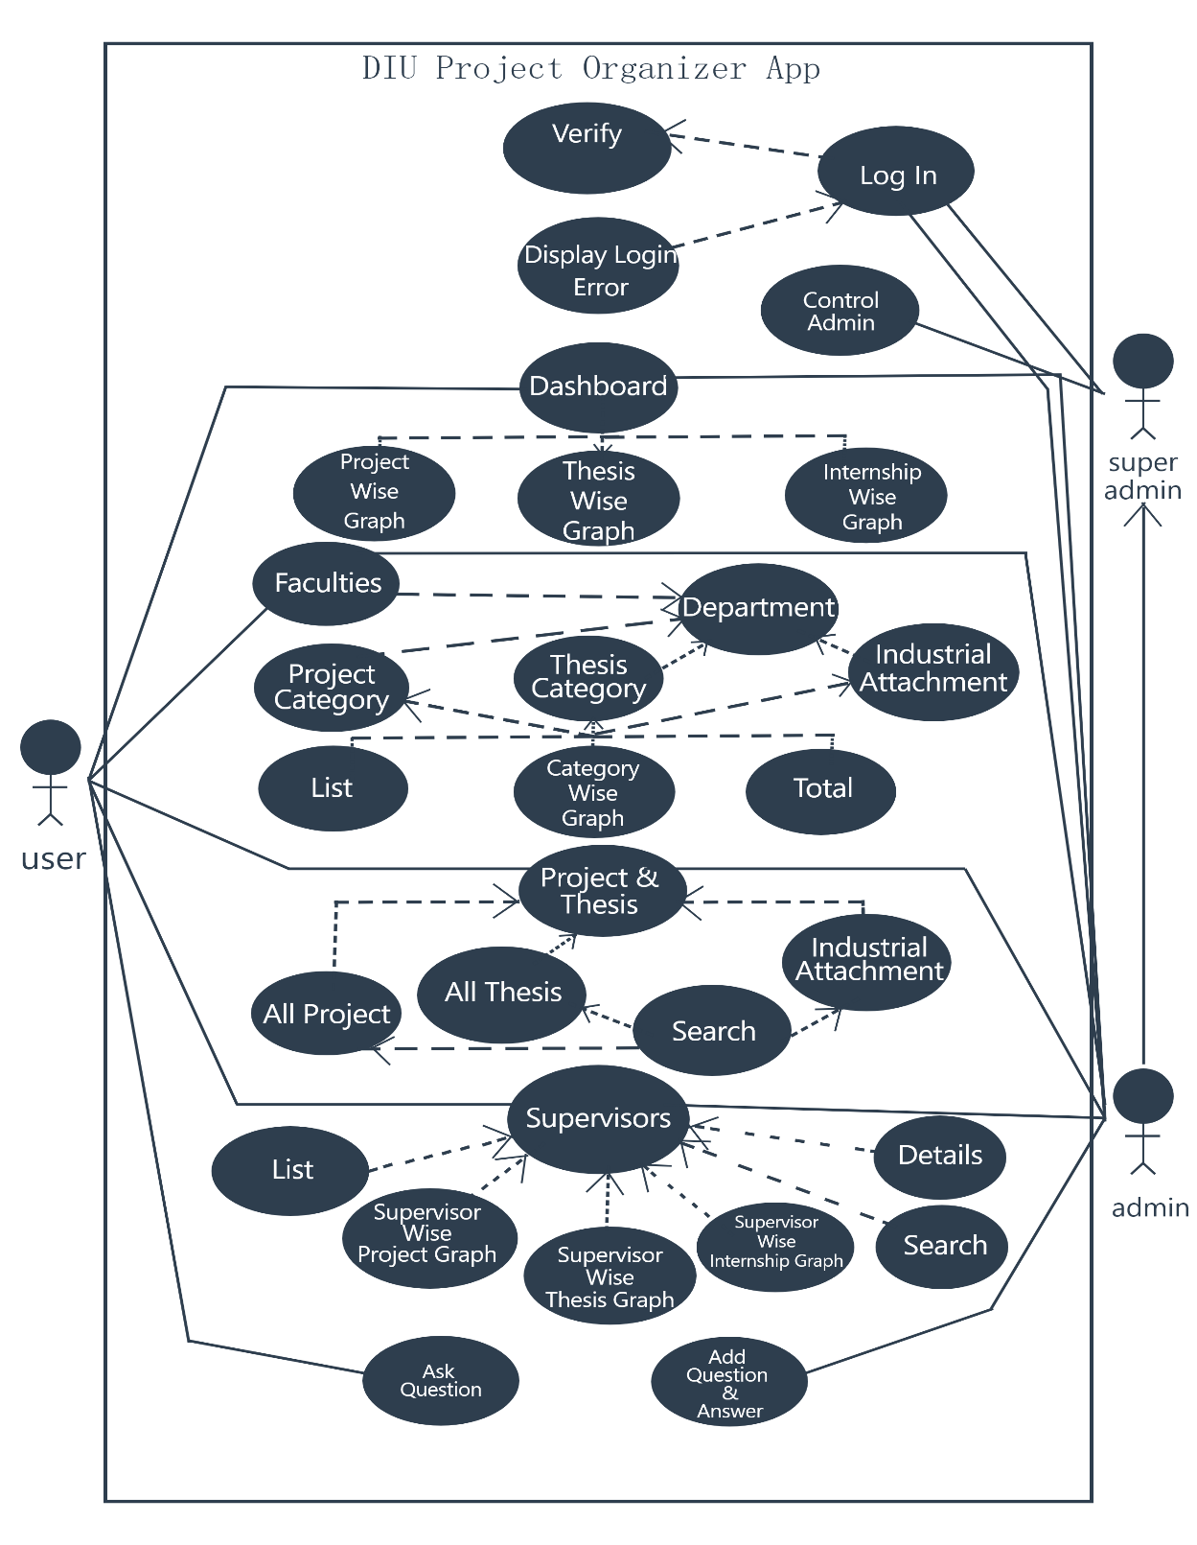
Figure 3.3.1: Use case diagram

3.4 ER Diagram
Entity relationship diagram is a visualization of database connection. It represents the relationship between different data table in database. ER diagram is an abstract data model. It is mainly developed for databases where how each entity connected with each other with different kind of relationship like generalization and specialization. ER diagram does not define the business process but it analyzes data to define and describe what is important to process in an area of business.

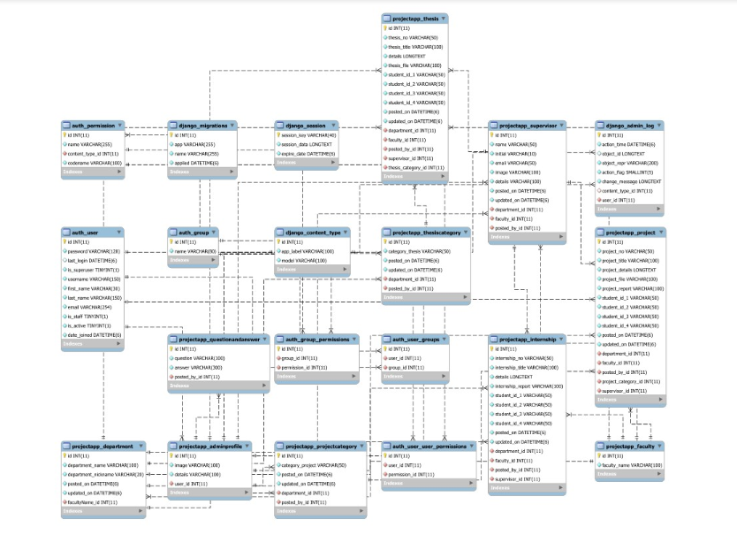

Figure 3.4.1: E-R diagram
CHAPTER 4
DESIGN SPECIFICATION

4.1 Introduction
This chapter explain how User Interface (UI) of this project has been designed. User interface is a place where user will interact with this web application. From the beginning of this project this was the main focus of us is that User Interface (UI) of this web application should be simple but organized and smooth so that user can easily use and can be benefited by browsing this web application. This chapter also explain how Back-end of this web application has been designed and the process behind the design. Because without the good and organized Back-end it is impossible to provide good service and experience to user. Back-end always play a vital role in web application. So, it is very much necessary to ensure an organized and proper Back-end.

4.2 Front-end Design
The front-end is almost everything in a web application. It’s a place where user interact. So, it’s very important to design a beautiful User Interface (UI). Because only Back-end can’t ensure good user experience. In this project we used Hyper Text Markup Language (HTML5), Cascading Style Sheet (CSS3), Bootstrap4, jQuery to design the User Interface. To design chart JavaScript has been used. Some useful JavaScript plug in is being used to implement chart and display data visually.

Figure 4.2.1 is the dashboard of our web application which will be appear when user will browse our website.

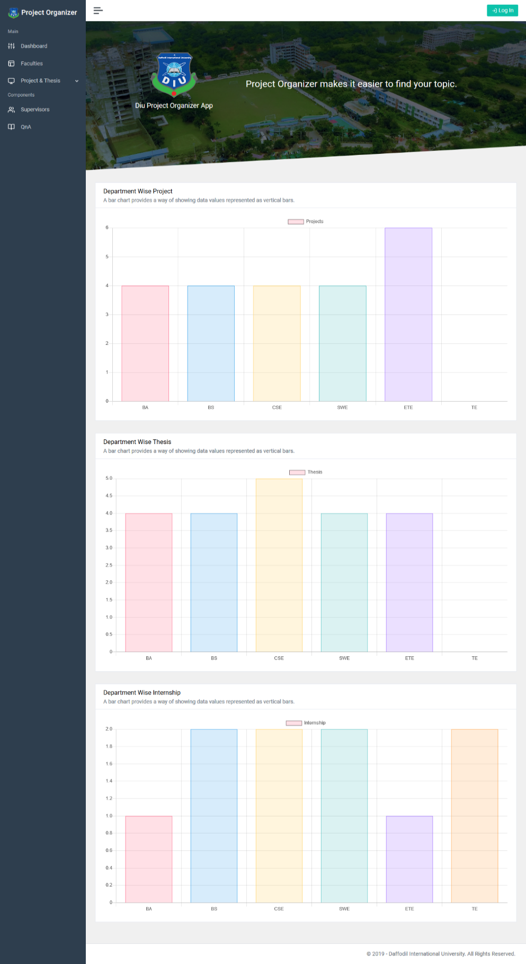

Figure 4.2.1: Dashboard for user

Figure 4.2.2 is the faculty list and 4.2.3 show how our web application visualize data with pie chart.

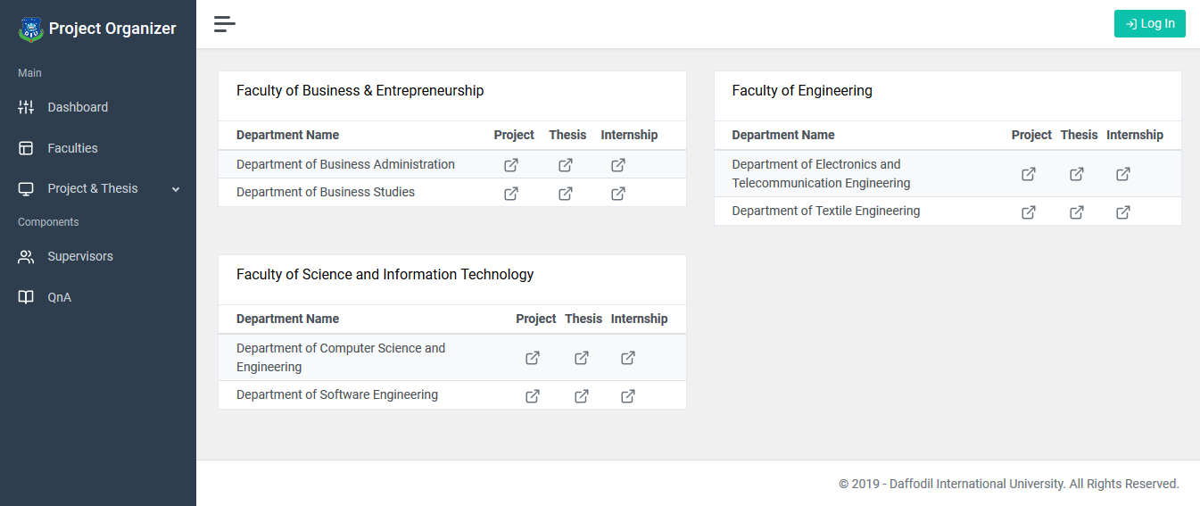

Figure 4.2.2: Department list for user

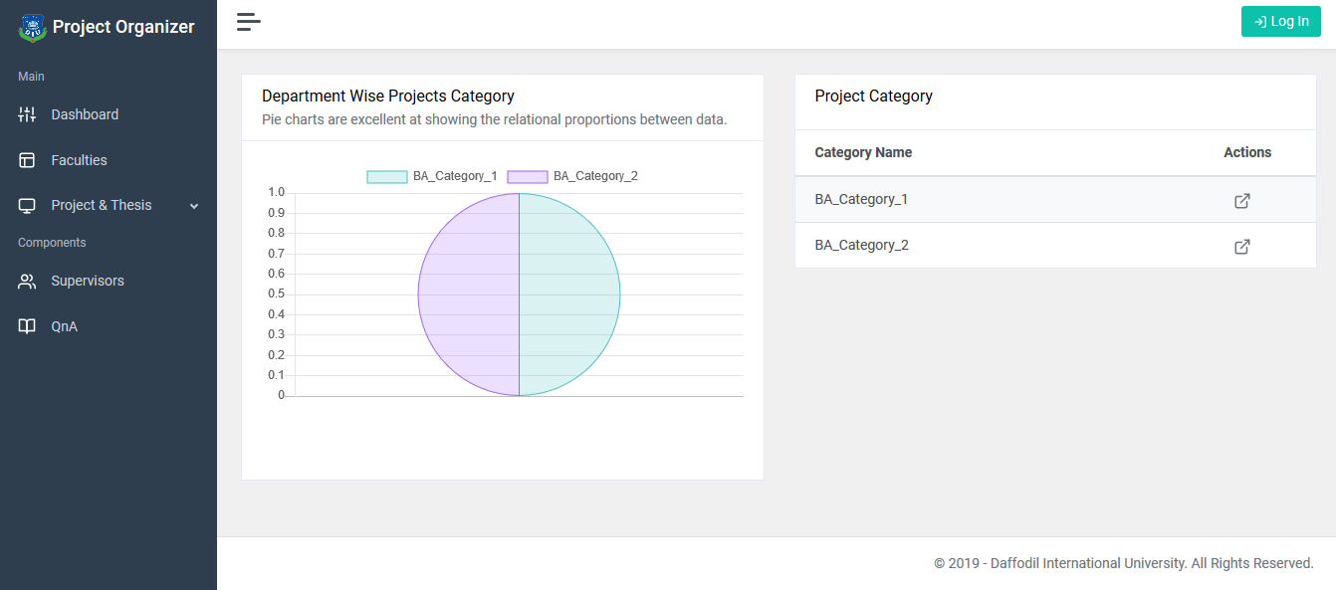

Figure 4.2.3: Project category for user with pie chart
Figure 4.2.4 shows how category wise project is shown in our project and 4.2.5 shows how all the project list appears for user.

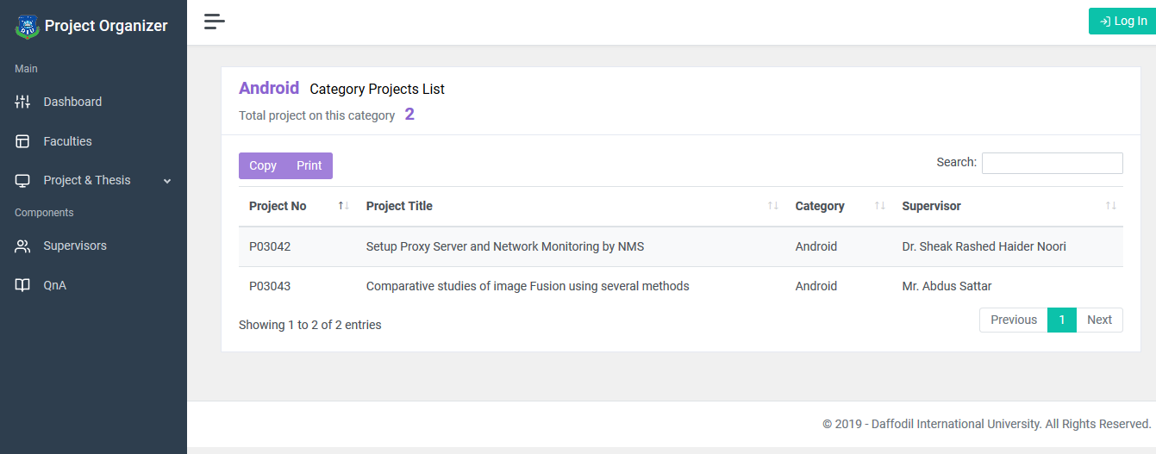

Figure 4.2.4: Category wise project list

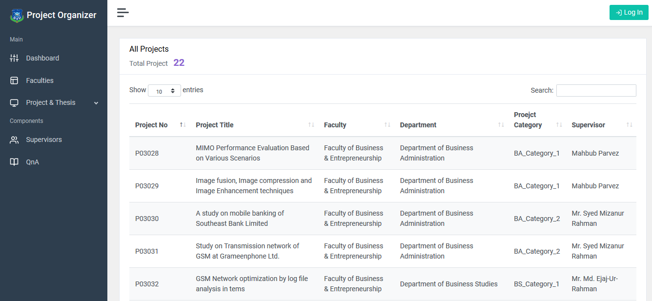

Figure 4.2.5: All project list for user

Figure 4.2.6 shows how number of project and thesis is visualized with the help of chart.

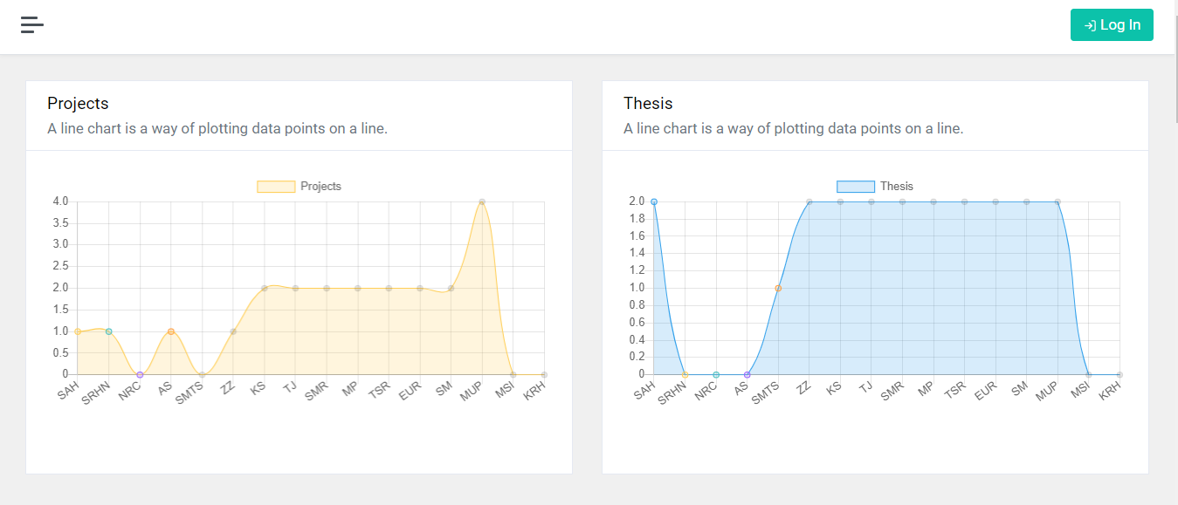

Figure 4.2.6: Number of project and thesis with respective supervisor

Figure 4.2.7 is the page where user can ask question.

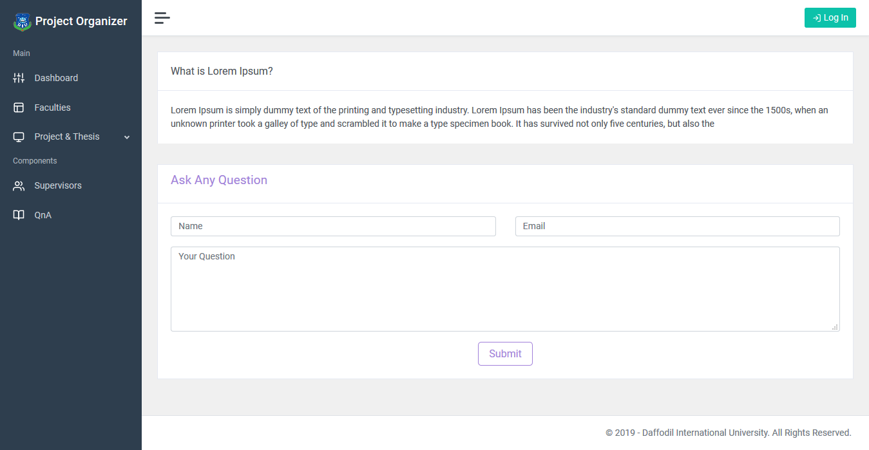

Figure 4.2.7: Question section for the user
Figure 4.2.8 is showing the admin login page and figure 4.2.9 is showing different kind of form.
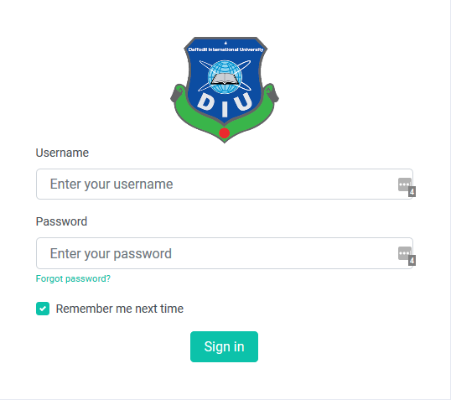

Figure 4.2.8: Admin login
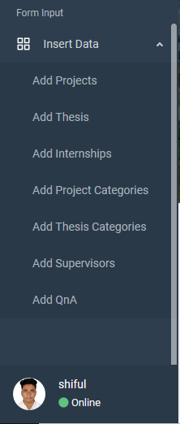

Figure 4.2.9: Form input

Figure 4.2.10 shows how an admin input form looks like.

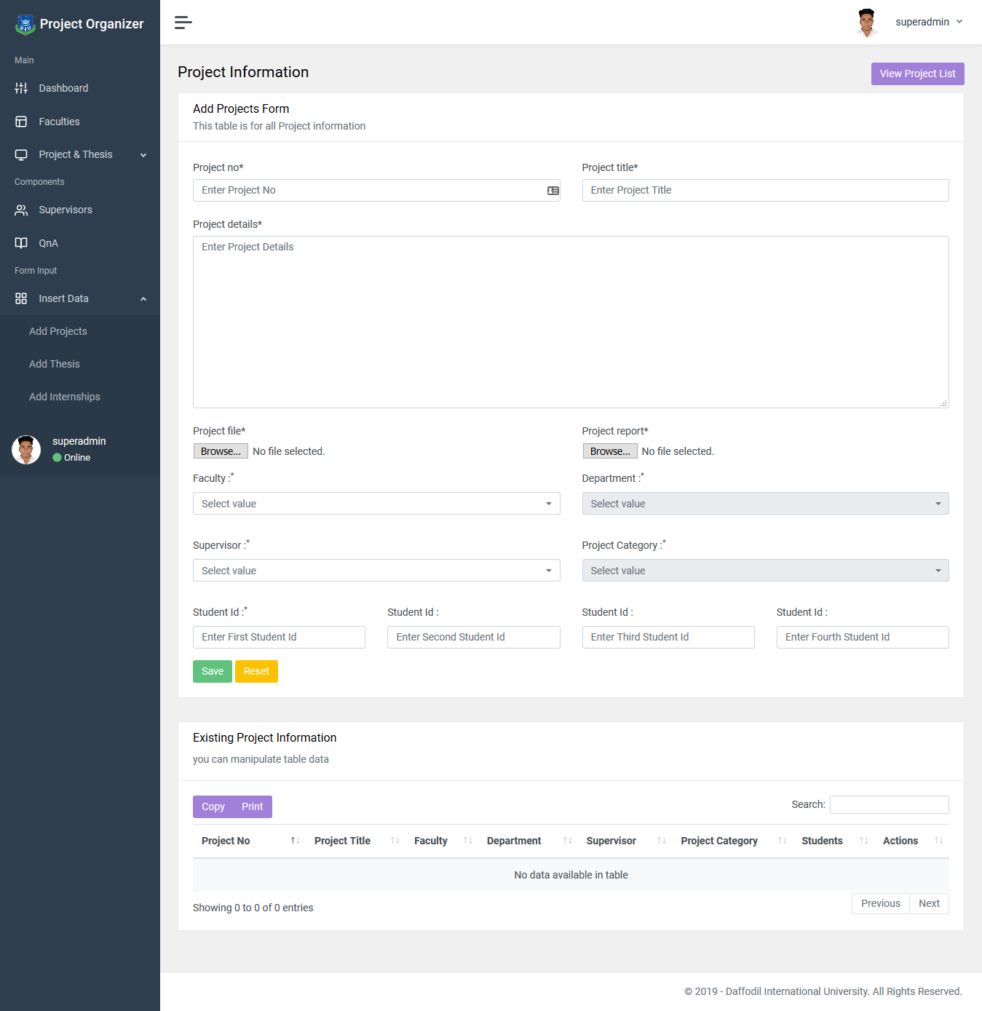

Figure 4.2.10: Input form for admin

Figure 4.2.11 shows the Superadmin login form and 4.2.12 shows Superadmin control panel.

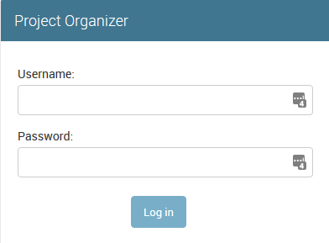

Figure 4.2.11: Superadmin login form

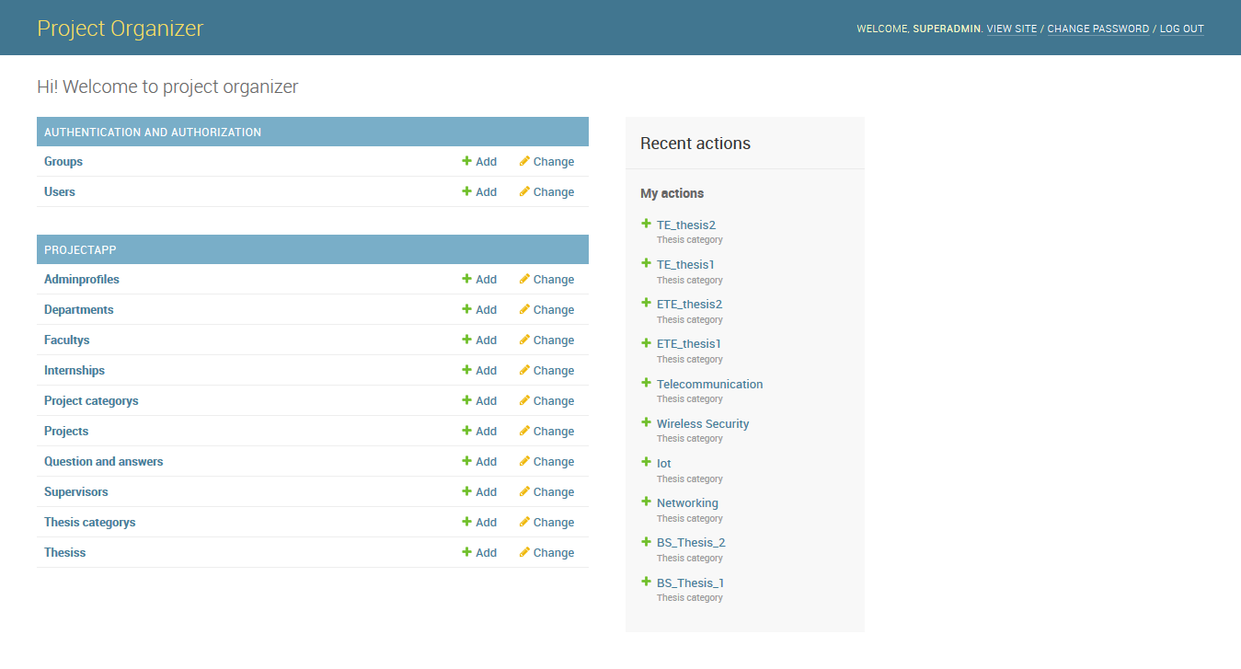

Figure 4.2.12: Superadmin control panel

4.3 Back-end Design
With the help of Back-end data can be inserted, edited, deleted or manipulated into database. Back-end is mainly a server-side thing that control web application without showing the complexity to user. User only can experience front-end part and back-end is mainly give front-end functionality. Without the back-end front-end can’t be functional.

CHAPTER 5
IMPLEMENTATION AND TESTING

5.1 Introduction
This chapter shows how our web application response in production. How well it’s interacted with user and give smooth experience with the help of front-end and back-end.
It’s also shows how this web application store user’s data in database. This visualize how front-end take data and how back-end store it in database. By giving demo or real-world data we tested our web application and all the test case with its result shown with picture. We also tested either our web application is being able to take those demos or real-world data and handled it properly or not.

5.2 Unit Test
It’s a testing method where each component of web application tested separately. It’s a process to verify each component works individually. The goal of unit testing is to isolate each part of the program and show that the individual parts are correct. By applying unit test bug can be fixed early phase in development.

5.3 Integration Test
It’s an opposite process of unit testing. Rather than testing individual component in integration test all the things are combined. Here, all the developed modules are coupled together to test. In integration testing developed materials are tested together. Testing performed to expose defects in the interfaces and in the interactions between integrated components or systems.

5.4 System Test
It is a level of software testing where a complete and integrated software is tested. The purpose of this test is to evaluate the system’s compliance with the specified requirements. System test is performed on a complete integrated system to evaluate the system completely. It’s a testing where whole system is evaluated fully.

5.5 Acceptance Test
It’s a testing where system is tested for acceptability. Acceptance testing is a test conducted to determine if the requirements of a specification or contract are met. The anticipated result of a successful test execution:
- test cases are executed, using predetermined data
- actual results are recorded
- actual and expected results are compared, and
- test results are determined.

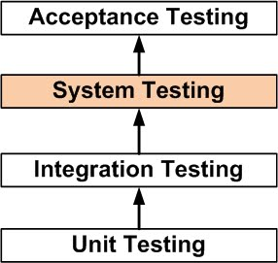

Figure 5.5.1: Step by step testing process

CHAPTER 6
FUTUTRE SCOPE AND CONCLUSION

6.1 Introduction
This chapter discuss about the future scope for the development of this web application and conclusion.

6.2 Conclusion
The reason behind this project’s idea is to help some certain group of people by providing some organized data. This project is made to help students so that they can get idea about project, thesis and don’t get confused. There is no intention to monetize this web application and make money. It’s a non-profitable work. And it became possible because of our extreme gratitude towards our beloved university and its honorable teacher.

6.3 Further Developments
Nothing is perfect in this world, so does our project has some limitation. And it is also very much possible to work with this project in future. We implemented this project only for Daffodil International University (DIU) but it can be extended by implementing for all the universities in all over the Bangladesh. If it can be implemented all the universities in Bangladesh it can be so helpful for the students, researcher and teacher that they can know what is happening and what kind of things are being done by the students of Bangladesh. It can be an Organize database so anyone can cross check their project or thesis paper so that if they want, they can collaborate with each other.

REFERENCE

[1] Learn about Django, available at << https://en.wikipedia.org/wiki/Django_(web_framework) >>, last accessed on May 2, 2019
[2] Learn about security, available at << https://docs.djangoproject.com/en/2.2/topics/security/>>, last accessed on October 1, 2019
[3] Learn about Django project, available at << https://docs.djangoproject.com/en/2.2/intro/>>, last accessed on July 7, 2019
[4] Learn about creating chart, available at << https://www.chartjs.org/>>, last accessed on June 12, 2019
[5] Learn about testing, available at << http://softwaretestingfundamentals.com/system-testing/>>, last accessed on August 3, 2019

APPENDICES
APPENDIX A: PROJECT REFLECTION
- HTML, CSS and JavaScript Based code:

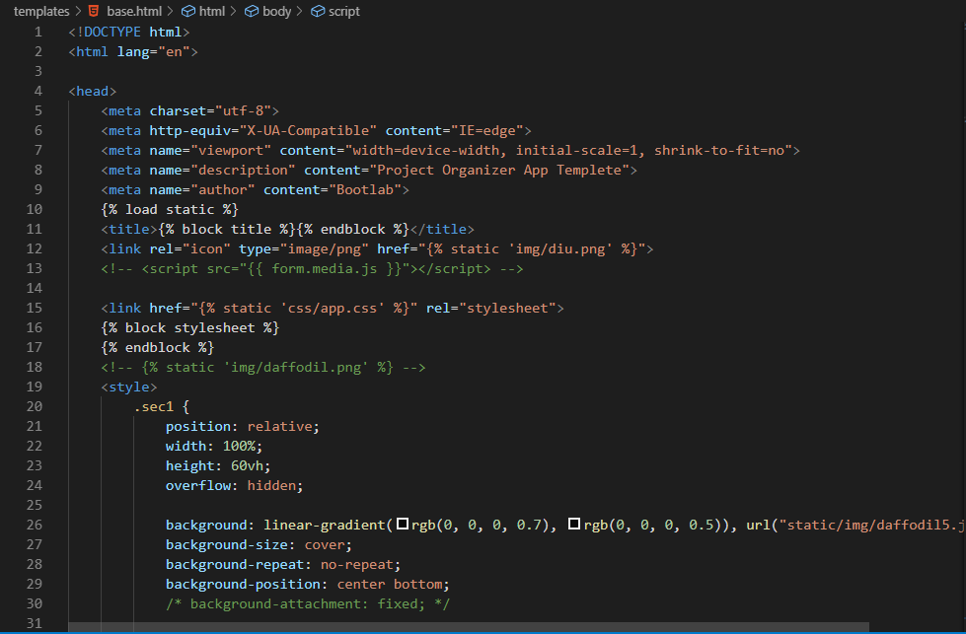

Figure A.1: Home Page Code
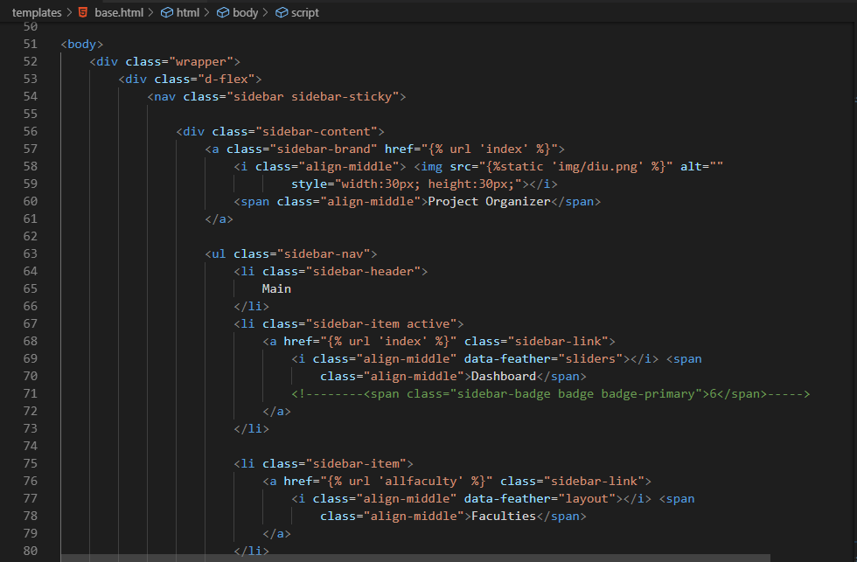

Figure A.2: Home Page Code

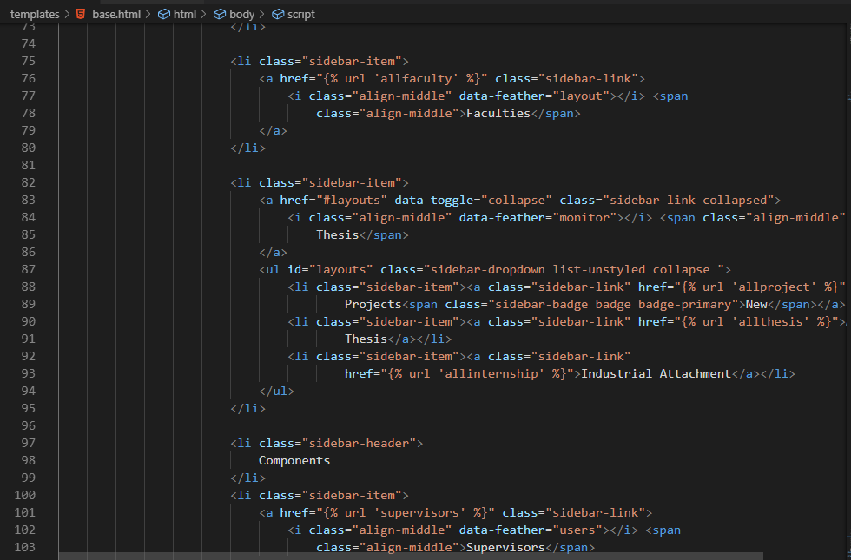

Figure A.3: Home Page Code

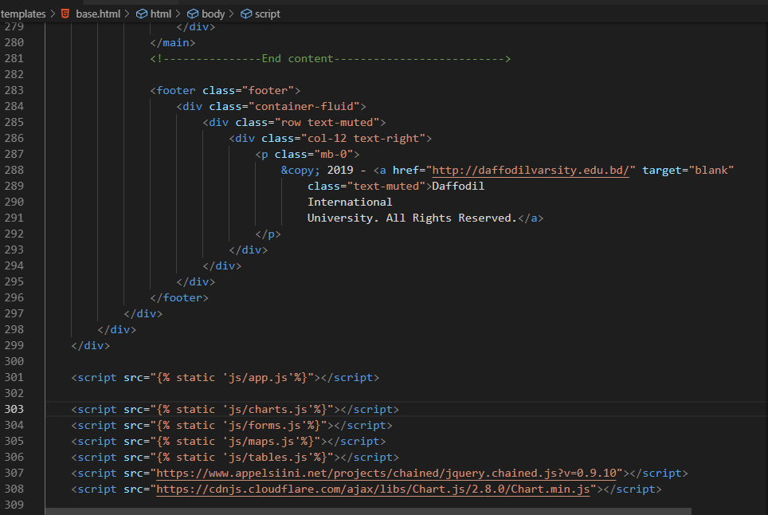

Figure A.3: Home Page Code

Figure A.5 shows how Heidisql Login interface looks like and figure A.6 shows the data stored in MySQL.

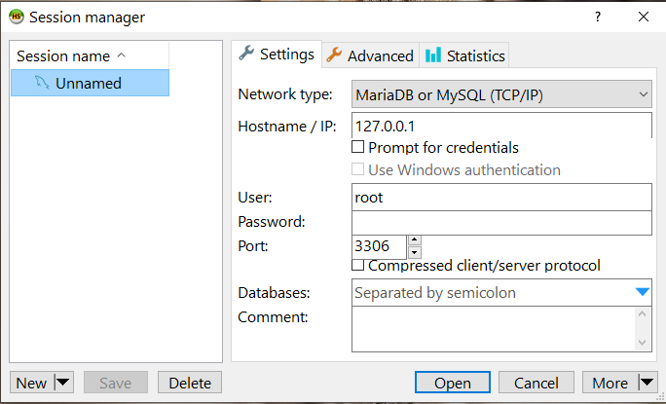

Figure A.5: Heidisql Login
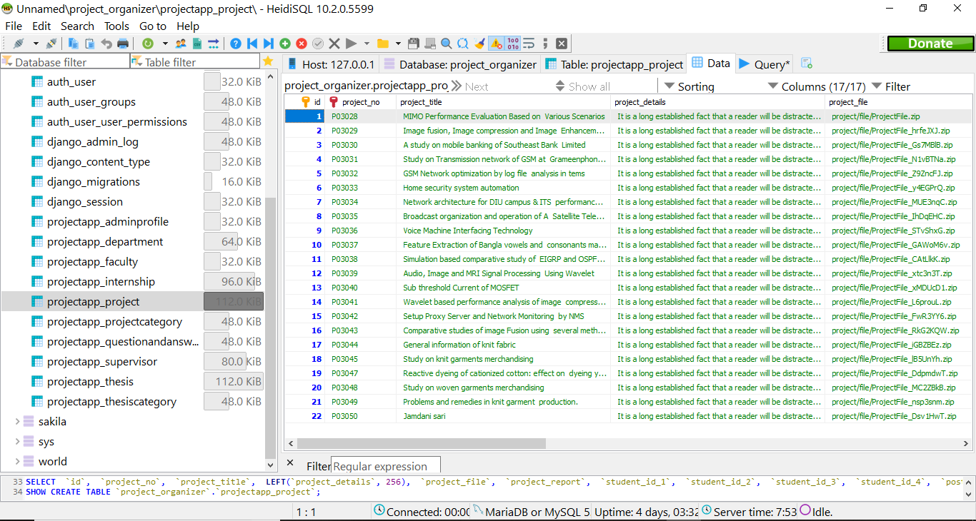

Figure A.6: Data Storing in MySQL Database
APPENDIX B: RELATED DIAGRAM
Figure B.1 Shows what kinds of operation user and admin can perform.

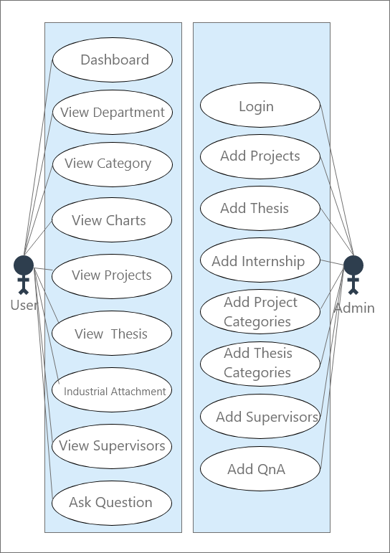

Figure B.1: User and admin’s operation

