Starting with the Vista website

‌

Change the main animal homepage picture to something else. In fact, the iguana that you were using on the LLL page would be OK to use on the Vista page as the opening animal. Or something similar. **[DONE]**

‌

On the homepage, the brands need to be changed. It looks like there are four of them. Please make the first one Zoo Med. Make the second one Exo Terra. Make the third one Arcadia and the fourth one Zilla. Please make sure to let your developer know to Google the name of the company and the word Reptile to make sure they are getting the correct logo. For example, the Fluker consulting is not the company that sells us Reptile products. **[DONE]**

The cricket prices on the homepage are incorrect. **[DONE].**

Please change that but also make sure that is accessible by us once the admin is working so we can adjust those as needed. **[DEVELOPMENT END].**

‌

Under the Vista catalog, the gigantic word catalog can be completely removed or just drastically reduced in size.. People click on the catalog so they know they are in the catalog. **[DONE]**

‌

I would like to be able to add or remove catalog categories on this page and I’m sure we can but just making sure that that’s the case. **[DEVELOPMENT END].**

‌

Under the reptile supplies again, the gigantic name of the category either needs to be drastically reduced or removed. Once you are within that category It’s a bit redundant. **[DONE]**

‌

The image behind the light fixtures category is a brand that we do not carry. Same thing for the thermometers and thermostats category. We can address all of these once we see the entire website as currently. I can’t see all of the categories so I’m sure we will need to update these at some point. **[DONE]**

‌

We talked about making the category is a little bit smaller so we had four per section and not three. Also, we talked about making the sidebar continuous to be able to navigate. **[DEVELOPMENT END].**

‌

We talked about putting the ad to cart buttons on the actual product instead of having to click on the view more button to then add it to the cart. **[DONE]**

‌

‌

In the shopping cart view, we talked about reducing the font size and the image size drastically so if somebody has 80 products in their shopping cart, it won’t be 25 pages worth of stuff to scroll through. **[DONE]**

On the checkout/**Add to cart** page, there is an option to print. On our current website, this basically takes the shopping cart items, put it into a black-and-white condensed format that the customer can print out.

**[QUERY]. Note: Please look into the Add to Cart pages for both website you will find it their**

‌

On the shipping charges and animal, packing fees and tax, we need to be able to change that on the administration side if necessary. Sometimes we run shipping sales and of course shipping charges go up as years go on and tax rates change. **[DEVELOPMENT END].**

‌

On the check out Vista page it has contact information and then shipping address but I do not see the billing address. If they are logged into their account theoretically this should already auto fill, but just want to make sure there will be a billing address as well. **[DONE]**

‌

On the LLL homepage, the email address displayed should be [customercare@LLLReptile.com](mailto:customercare@LLLReptile.com)

**[DONE]**

‌

The text description underneath the main logo above the explorer more button should be expanded to include our entire paragraph from our homepage. **[DONE]**

‌

On the date underneath the satisfied customers, can you please list that as month and then day and then year. Right now it is listed as day then month then year. **[DONE]**

‌

We talked about adding the subscribe to our newsletter button as a default, already checked button on the checkout page. They can uncheck the box if they do not want to subscribe. It should have something where if you move your mouse over it it should give you a pop-up description, letting the customer know that we send a monthly newsletter with specials and events. **[DONE]**

‌

On the bottom of the homepage, there is a little about us. That can be removed. I would rather see that removed and then the social media links underneath. It moved to the right underneath the contact info category. So those three sections would be centered on the bottom of the homepage. I think that would look better and make more sense. **[DONE]**

‌

The actual street address can be removed from the homepage. Our main warehouses are not open to the public as they are not retail stores. That information can be found on the return page if a customer is going to be returning something, but I do not want that on the homepage. . **[DONE]**

‌

We do not have blogs so underneath the quick links on the bottom of the homepage that can be removed. . **[DONE]**

‌

On the LLL catalog page, the word catalog is definitely better than on the Vista page, but it can still be shrunk down a little bit, and the start of the categories should be moved up just a touch right underneath the branch that the chameleon is sitting on. . **[DONE]**

‌

Most of the rest of these things are the same thing I mentioned on Vista. Making the categories for per section. Making the sidebar links continue as you scroll down the page. **[DONE]**

‌

I really like how each of the category pictures has our logo embedded somewhere in it although some of them do not. If we can make that on all of them before we launch, that would be great. **[DONE]**

‌

On the animals, page and product page there should be a link just like there is right now on our website that says click here to view our out of stock inventory and sign up to be notified when they become available. **[DONE]**. Again reference our current website as that is something we definitely need. On the administration side, we have buttons to be able to archive the Animals and products if they are out of stock, and then they end up in this hidden category which still keeps them visible to google. This is unbelievably important as people searching for a very unique animal that we have carried in the past will still come across our website because the animal does not disappear from our inventory. The only thing that happens if you view the animals that are out of stock is it does not show a current price. Prices change all the time, and sometimes these animals can be out of stock for a couple of years where prices change drastically. Again, please reference our website and how that feature currently functions **[DEVELOPMENT END]**

‌A few more notes and we are set to move forward. Some of these I mentioned, some are analyzing stuff that will already change

‌

LLL home page

-We don’t need a customer photo at the top of the Satisfied customers section **[DONE]**

-the options at the top of the home page are “ordering, shipping, return”? Those titles are vague, are those going to be links to instructions, or policies, or something else? **[DONE]**

-I don’t see a quick link to Locations here, I think we should have one. Also, remove "blogs" **[DONE]**

‌

‌

LLL Animals

-same note here. Are the descriptions going to be editable? If not we should re-write some of these before they post. **[DEVELOPMENT END].**

Also, why is our logo on every photo? **[REMOVED].**

-I’m not a fan of the veiled chameleon photo on the top of this page either. Is there a way we can pick a better or more impressive photo or change that out ourselves when we feel like it? " **[DONE]**

‌

LLL Cart & Check out

-same notes as vista cart below.

‌

LLL Spiders page

-are the previous “long descriptions” going to be listed here all on one page under the item? It has an “add to cart” button here, so does that mean you don’t have to click on the item itself to get more info first? I’m ok with it being all on one page, but if that’s the case we need to make sure we can put the “long description” info all there as well so people can’t add animals to their cart without reading all the info on them first. **\*Valid point here as we we need customers to see full animal descriptions before adding to their cart in case there are notes on that animal like scars, missing a tail, etc.**

**[ADDED POP-UP]**

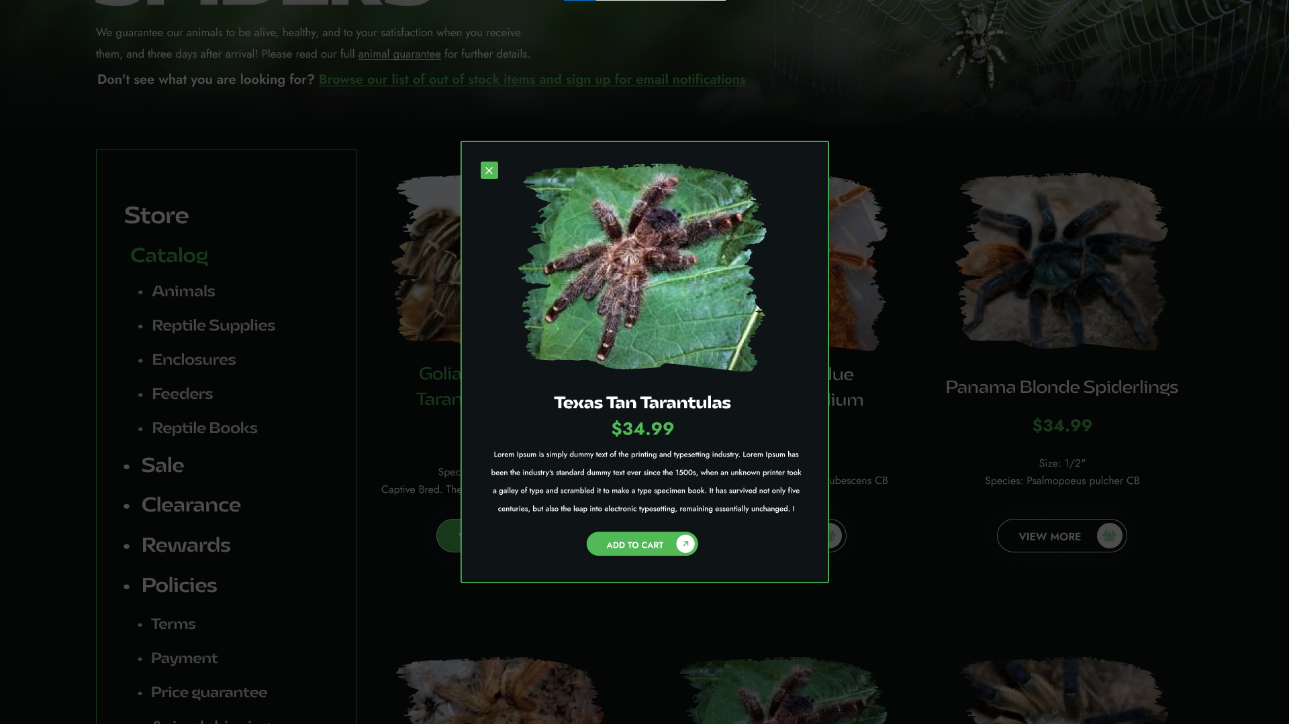

‌

‌OVERALL- I want to make sure we have the option to edit things like home page sales, shipping charges, prices, photos, just like before. I like the paint brush look of the photos on the category headings, but on the actual animals themselves its kind of distracting unless it's just the category picture - that's ok. But for each animal - we would want our images and the option to blow them up larger by moving your mouse over them (or similar) as we do now. **[DEVELOPMENT END].**