

**American International University-Bangladesh (AIUB)**

**Faculty of Science and Technology (FST)**

**Department of Computer Science (CS)**

**SDPM Group Project, Fall 2023**

**Project Title:**  **Mobile App for Local Business Promotion and Customer Engagement System**

**Section: D**

**Submitted by**

|  |  |
| --- | --- |
| Name | ID |
| Md. Ahsanul Mostakin | 19-41342-3 |
| Saiful, Islam | 20-42585-1 |
| Mouri Kamal | 20-42447-1 |

**Submitted to:** Md. Anwarul Kabir, Associate Professor, CS

**Table of Contents**

**Title** **Page** 1. Introduction 3

2. Project Title 3

3. Objectives 3

4. Justification 4

5. Systems Overview 4

6. Stakeholders Analysis 5

7. Feasibility Study 5

8. Systems Component 6

9. Process Model 7

10. Efforts Estimation 9

11. Activity Diagram 10

12. Risk Analysis 11

13. Budget for the project 12

14. Conclusion 13

**1.0 Introduction:**

The purpose of this document outlines the details of a project aimed at developing a mobile application dedicated to promoting local businesses and enhancing customer engagement. The primary audience for this document includes project managers, developers, stakeholders, and potential investors. The objectives of this document are to provide a comprehensive understanding of the project's goals, scope, and feasibility.

# 2.0 Project Title:

Mobile App for Local Business Promotion and Customer Engagement.

# 3.0 Objectives:

**Overall Objective**: To develop a mobile application that empowers local businesses to reach new customers, engage them in meaningful interactions, and ultimately foster a thriving local economy.

**Specific Goals:**

* Increase visibility and awareness of local businesses.
* Drive customer engagement through interactive features and personalized recommendations.
* Facilitate direct communication between businesses and customers.
* Offer exclusive deals and promotions to incentivize customer loyalty.
* Gather valuable customer data to improve business operations and marketing strategies.
* Contribute to the growth and sustainability of local communities.

# 4.0 Justification:

The Local Boost mobile app aims to address the growing need for a platform that facilitates the promotion of local businesses. This system will benefit both businesses and consumers by

creating a centralized space for promotions, fostering community connections, and driving economic growth at the local level.

# 5.0 Systems Overview:

The system will include features such as user profiles, business profiles, a newsfeed of local promotions, loyalty programs, and a seamless communication channel between businesses and customers. The use case diagram illustrates the interaction between users, businesses, and the application.

*Use Case Diagram*

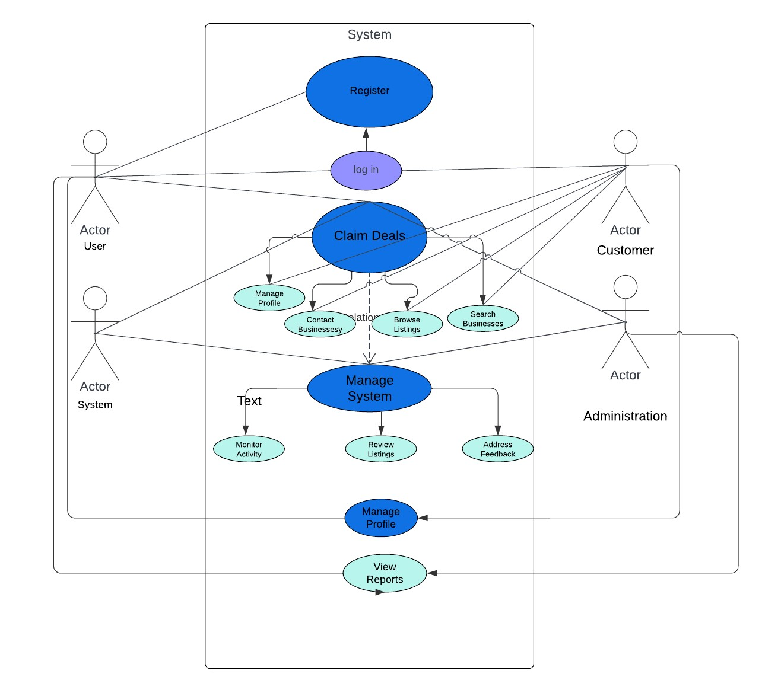

# 6.0 Stakeholders Analysis:

**Primary Stakeholders:**

* **Local Businesses:** Owners and managers who stand to benefit from increased visibility, customer engagement, and revenue.
* **Customers:** Individuals seeking convenient access to local businesses, exclusive deals, and personalized recommendations.

**Secondary Stakeholders:**

* **Investors:** Entities interested in supporting innovative solutions that contribute to local economic growth.
* **Local Governments:** Organizations responsible for fostering vibrant local economies and communities.
* **Technology Providers:** Companies offering services and infrastructure that support the development and operation of the mobile app.

# 7.0 Feasibility Study:

**Technical Feasibility:**

* Existing technologies and frameworks can be utilized to develop the app for both iOS and Android platforms.
* Scalable architecture can accommodate future growth and expansion of features.
* Access to development resources and expertise is available to ensure successful implementation.

**Financial Feasibility:**

* Development costs can be minimized through open-source technologies and efficient development practices.
* Revenue can be generated through subscription fees for businesses, targeted advertising, and partnerships with local organizations.
* The potential for increased customer engagement and sales for local businesses provides a strong financial incentive for adopting the app.

# 8.0 Systems Component:

The Local Boost mobile app can be broken down into the following components:

1. **User Interface (UI):** The visual elements of the app, including profiles, newsfeed, and navigation.
2. **User Authentication:** Secure login and registration processes to ensure user data privacy.
3. **Business Profiles**: A dedicated space for local businesses to showcase their products/services and create promotional content.
4. **Promotion Engine:** A system to manage and display promotions, discounts, and loyalty programs.
5. **Communication Module:** In-app messaging and notifications to facilitate interaction between businesses and users.
6. **Analytics and Reporting:** Tools to track app usage, user engagement, and the effectiveness of promotions.
7. **Backend Infrastructure:** Servers, databases, and APIs to support the functionality of the app.

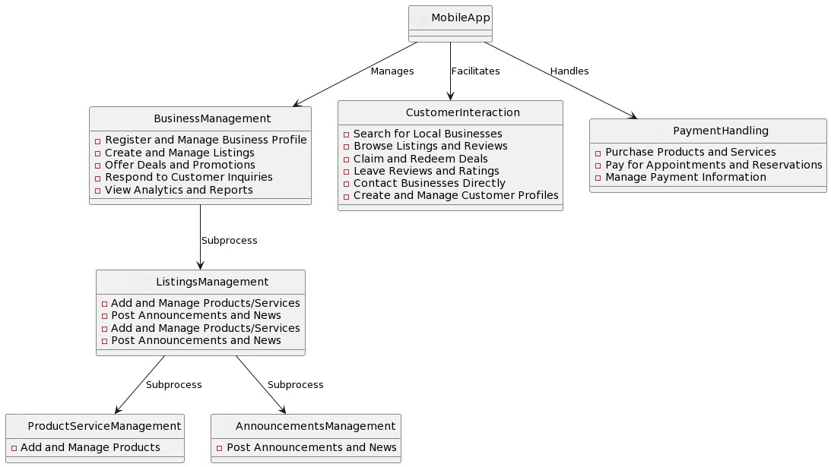 **Fig 1: Structure of the project**

# 9.0Process Model:

**Selection Criteria for Process Models:**

* **Project Size and Complexity:** Consider the size and complexity of the mobile app project.
* **Client Involvement:** Determine the level of client involvement and the need for frequent feedback.
* **Flexibility and Change Tolerance:** Assess the likelihood of changing requirements during the project.
* **Risk Tolerance:** Consider the level of uncertainty and risk associated with the project.
* **Time-to-Market:** Evaluate the urgency and pressure to deliver the product quickly.

Designing a process model for a mobile app focused on local business promotion and customer engagement involves outlining the key steps and functionalities that the app will provide. Below is a simplified process model to guide you through the development stages:

1. **Market Research:**
   * Identify the target audience and local businesses.
   * Analyze competitors and understand market trends.
   * Define the unique selling propositions (USPs) for your app.
2. **Requirements Gathering:** 
   * Identify key features and functionalities based on market research.
   * Define user roles (e.g., business owners, customers, administrators).
   * Gather technical requirements (platforms, devices, etc.).

1. **Customer Interaction:**
   * Enable customers to discover local businesses through the app.
   * Implement features for customers to rate and review businesses.
   * Allow customers to save their favorite businesses and receive notifications for special offers.

1. **Customer Support:**
   * Include a customer support system for users and businesses.
   * Implement feedback mechanisms to gather user opinions and suggestions.

1. **Analytics and Reporting:**
   * Integrate analytics tools to track user engagement and app performance.
   * Provide businesses with insights into customer behavior and promotion
2. **Testing:**

Conduct thorough testing, including functional, usability, and security testing.

Gather feedback from beta testing to make improvements.

1. **Marketing and Promotion:**
   * + Develop a marketing strategy to promote the app to businesses and customers.
     + Utilize various channels, such as social media, to increase awareness.
2. **Maintenance and Updates:**
   * + Regularly update the app to add new features, improve performance, and fix bugs.
     + Provide ongoing customer support and address user feedback.

# 10.0Efforts Estimation:

Estimating the effort for a mobile app focused on local business promotion and customer engagement involves considering various factors. Here are some key areas to focus on for effort estimation:

1. **Feature Development:**
   * + **Description:** Estimate the effort required to develop the core features of the app, such as business listing, user profiles, geolocation services, and promotional tools.
     + **Considerations:** Break down features into smaller tasks, evaluate complexity, and factor in potential dependencies.
2. **UI/UX Design:**
   * **Description:** Estimate the time and resources needed for designing the user interface (UI) and ensuring a positive user experience (UX).
   * **Considerations:** Evaluate the complexity of the design, the need for custom graphics, and the overall visual appeal of the app.
3. **Integration with External Services:**
   * **Description:** Assess the effort required to integrate external services, such as payment gateways, social media platforms, or third-party APIs.
   * **Considerations:** Consider the complexity of integrations and potential challenges in ensuring seamless communication with external services.
4. **Geolocation Services:**
   * **Description:** Estimate the effort for implementing and testing geolocation services, which are crucial for features like locating nearby businesses.
   * **Considerations:** Account for different use cases, accuracy requirements, and potential challenges related to device compatibility.
5. **Customer Engagement Tools:**
   * **Description:** Estimate the effort needed for implementing customer engagement features, including notifications, reviews, ratings, and personalized promotions.
   * **Considerations:** Evaluate the complexity of building tools that enhance customerbusiness interactions and satisfaction.
6. **Testing and Quality Assurance:**
   * **Description:** Estimate the time required for various testing phases, including unit testing, integration testing, user acceptance testing, and quality assurance.
   * **Considerations:** Include efforts for testing on different devices, browsers, and operating system versions.
7. **Security Measures:**
   * **Description:** Assess the effort needed to implement security measures to protect user data and ensure compliance with data protection regulations.
   * **Considerations:** Consider the level of sensitivity of user information and potential security threats, and allocate time for security testing.
8. **Documentation and Training:**
   * + **Description:** Estimate the time required for creating documentation, including design documents, user manuals, and technical documentation. Additionally, allocate time for any necessary training sessions.
     + **Considerations:** Ensure that comprehensive documentation is created to facilitate future maintenance and support.

# 11.0 Activity Diagram:

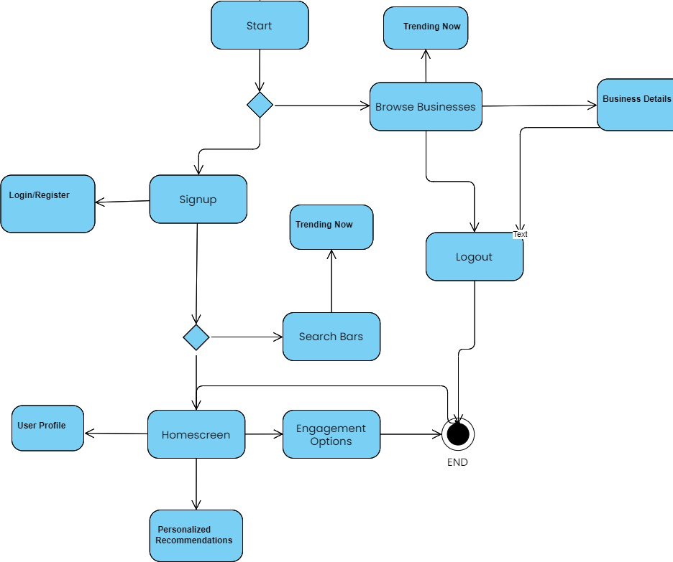

# 12.0. Risk Analysis:

Risk analysis is a crucial aspect of software development project management, and it involves identifying, assessing, and mitigating potential risks that may impact the success of the project. Here are some major risk factors to consider in the context of developing a mobile app for local business promotion and customer engagement:

1. **Identify Risks:** 
   * + **Technical Risks:**
     + Potential issues with integrating geolocation services.
     + Compatibility challenges with various mobile devices and operating systems.
     + Security vulnerabilities in the app.
     + **Business Risks:**
     + Changes in local business regulations affecting app features.
     + Unpredictable market changes impacting user engagement.
     + Competitor actions affecting user adoption.

1. **Develop Risk Mitigation Strategies:** 
   * + **Risk Avoidance:**
     + Eliminate the risk by avoiding certain features or technologies.
     + **Risk Mitigation:**
     + Implement measures to reduce the impact or probability of a risk.
     + For example, regular security audits to mitigate security risks.
     + **Risk Transfer:**
     + Shift the risk to a third party, such as through insurance or outsourcing.
     + **Risk Acceptance:**
     + Acknowledge the risk and have a plan to manage it if it occurs.
2. **Communication and Stakeholder Involvement**:
   * Communicate identified risks to all stakeholders, including developers, business owners, and end-users.
   * Involve stakeholders in risk analysis and decision-making processes.
3. **Regularly Review and Update:**
   * Regularly review the risk register to update risk assessments based on project progress.
   * Consider new risks that may emerge during development.

1. **Testing and Quality Assurance:** 
   * Implement thorough testing and quality assurance processes to identify and address potential technical risks early in the development lifecycle.

1. **User Adoption and Feedback:** 
   * Recognize the risk of low user adoption or negative feedback.
   * Implement strategies for ongoing user engagement and satisfaction.

1. **External Dependencies:** 
   * Identify risks associated with third-party services or dependencies.
   * Have backup plans or alternative solutions in case external dependencies fail.

# 13.0. Budget for the project:

Estimating the average budget for a mobile app focused on local business promotion and customer engagement involves several factors. The costs can vary based on the complexity of features, the geographic location of the development team, the platform(s) targeted (iOS, Android, or both), and other considerations.

1. **Basic App (Single Platform):**
   * **Development Team:** 3000000 - 5000000 (Taka)
   * **UI/UX Design:** 1000000 - 2000000 (Taka)
   * **Testing/Quality Assurance:** 500000 – 1000000 (Taka)
   * **Total:** 4500000 – 8000000+ (Taka)

1. **Medium-Complexity App (Single Platform):**
   * **Development Team:** 5000000 - 10000000 (Taka)
   * **UI/UX Design:** 1500000 - 3000000 (Taka)
   * **Testing/Quality Assurance:** 1000000 - 1500000 (Taka)
   * **Integration with External Services:** 500000 - 1500000 (Taka)
   * **Total:** 8000000 – 16000000+ (Taka)
2. **Highly Complex App (Multi-Platform):**
   * **Development Team:** 10000000 - 20000000+ (Taka)
   * **UI/UX Design:** 3000000 - 5000000 (Taka)
   * **Testing/Quality Assurance:** 1500000 - 2500000 (Taka)
   * **Integration with External Services:** 1500000 - 3000000 (Taka)
   * **Marketing and Promotion:** 1000000 - 2000000 (Taka)
   * **Legal and Compliance:** 500000 - 1500000 (Taka)
   * **Total:** 17500000 - 34000000+ (Taka)

# 14.0 Conclusion:

In conclusion, the development of a Mobile App for Local Business Promotion and Customer Engagement is a dynamic and multifaceted undertaking that demands careful consideration and strategic project management. With an emphasis on promoting local businesses and enhancing customer engagement, the project involves navigating through technical complexities, security concerns, and the ever-evolving landscape of user expectations. The success of such an applies not only in the innovative features and seamless functionality it offers but also in the effective management of risks, ongoing user feedback, and a commitment to staying attuned to the local market dynamics. A collaborative and agile approach to software development project management, coupled with a keen understanding of user behavior, market trends, and regulatory compliance, is pivotal for the successful delivery and sustained impact of a Mobile App tailored for local business promotion and customer engagement.