

**American International University- Bangladesh**

**CSC 2209: Object Oriented Programming 1 (JAVA)**

**CO1 Evaluation**

**Project Summary Report**

**Summer 18-19**

**Group No: B06**

**Project Title: CAR RENTAL SYSTEM**

|  |  |
| --- | --- |
| Student Name | Student Id |
| KADER KHAN | **17-35035-2** |
| SATTER TAMIM RIMON | **17-35073-2** |
| ISLAM,SAIFUL | **17-34994-2** |
|  |  |

**Introduction:**

*Write the answer of why you are doing this project? (No more than 60 words)*

**User Category:**

There are two types of Users here. They are:

* Type 1
* Type 2

**Feature List:**

In this project the “User Type 1” has the following features:

* Feature 1
* Feature 2
* .
* .
* .
* Feature N.

In this project the “User Type 2” has the following features:

* Feature 1
* Feature 2
* .
* .
* .
* Feature N.

**GUI Description:**

Give a screen shot of some GUIs and write a very small description (Maximum 40 words) for each of the GUIs.

**Database Table Description:**

Give a screen shot of the database table structures.

**Class Diagram:**

Draw a class diagram of your project here. You can draw then in a paper and add the image of the paper.

**Tools Used:**

To develop this project we have used the following:

* Tool1
* Tool2
* .
* .
* .
* Tool N

**OOP and Java Concepts Used:**

* Concept 1: Explain in no more than two sentences.
* Concept 2: Explain in no more than two sentences.
* .
* .
* .
* Concept N: Explain in no more than two sentences.

**Impact of this Project:**

What impact this project will have on the society and economy?

How will people be benefitted from your project?

(Maximum 80 words)

**Limitations and Possible Future Improvements:**

(Maximum 80 words)

***[Note: Make sure that your report is maximum 6 pages (including coverpage). Print the report and do NOT even think ofSpiral binding.]***

Car Rental System

*INTRODUCTION :  
  
Now a days ,Car Rental System is getting more and more popular through out the World . Among all of the Development Countries , Car Rental System plays a significant role . As Bangladesh is one of the Developing countries, it is our motto to introduce our people to these new systems which are blessing for our country and make our everyday life more comfortable . And this system make renting car more simple and easier.  
  
*USER CATEGORY :  
  
There are three types of Users here.They are :  
1. MANAGER  
2. RECEPTIONIST  
3. CLARK  
  
*FEATURE – LIST :  
  
In this project the “MANAGER” has following features :  
1.Manages all Employee ,Worker,Mechanic,Clark,Receptionist,Car,Driver.  
2. Can Get all employeeid,name,salary,job type,join date and information from database.  
3. Can Search,Load,Insert,Update,Delete any Employee and Information.  
4.Can Change Password.  
  
In this project the “RECEPTIONIST” has following features :  
1. Booking and Checking Car-Status .  
2. Can Get all Car info,id,brand,reservation Date and number of seat.  
3. Can Change Password.  
  
In this project the “CLARK” has following features :  
1. Manages Worker,Mechanic,Driver,clark,employee.  
2. Can Get all Employee id,name,salary,job type,join date and information .  
3. Can Search,Load,Insert,Update,Delete any Mechanic and Information.  
4. Can Change Password.

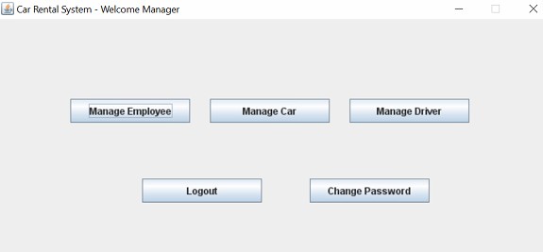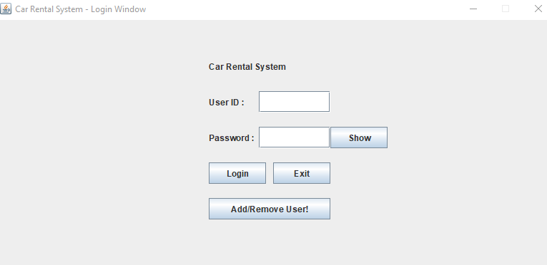GUI – DESCRIPTION :  
  
1.Login Window  
  
   
  
  
  
  
  
  
  
  
From this Login-window ,Manager,Clark and receptionist can login to there homepage portal.As they are the user here,they can do their acts according to their accessibility.   
  
2.Manager –Homepage  
  
  
  
  
  
  
  
  
Manager login from login window.After Login Another window will open and it is manager homepage.Manager will do acts according to his accessibility.Here Manager Manages everything .For example –Manager manage employee,manage car,manage driver and change password.   
  
3.Manager – Manage Employee  
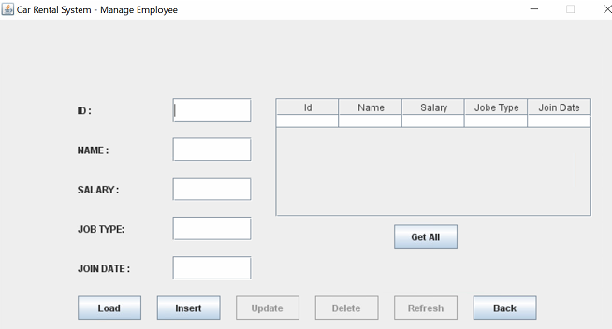Here from Manage employee,manager can get all employeeid,name,salary,job type,join date from database.Manager can search,load,insert,update,delete any employee and information.

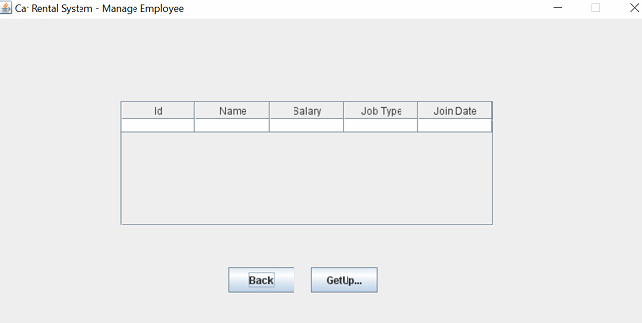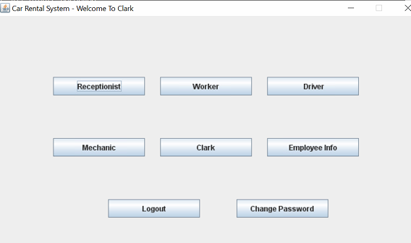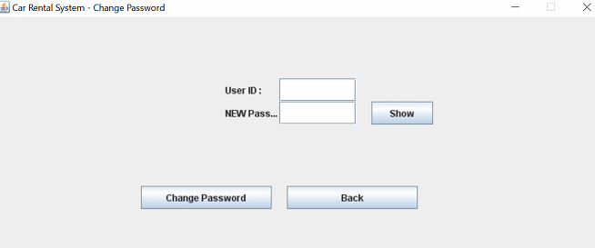4.Change Password  
  
  
  
  
  
  
  
  
  
From Change Password window from manager homepage ,Manager can change his password by replacing new password.Besides From Clark and Receptionist can also change their password from their specified window.  
  
5. Clark - Homepage  
  
  
  
  
  
  
  
  
  
By login from Login window,Clark open his homepage and do act according to his accessibility.  
  
6.Manage Employee  
  
  
  
  
  
  
  
  
  
  
From clark Panel,Clark also can manage employee along with the side of manager.Clark can see employee information.

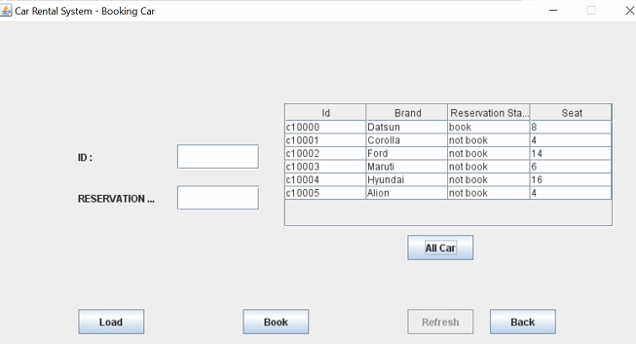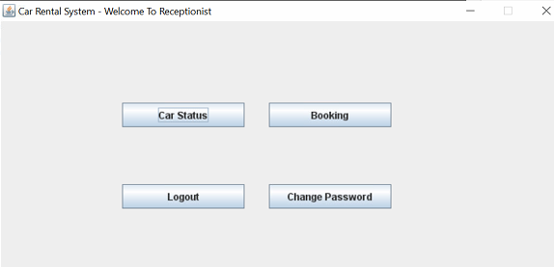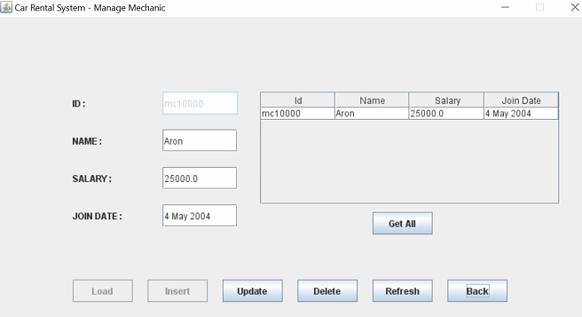7.Manage Mechanic  
  
  
  
  
  
  
  
  
  
From Clark-window,Clark also can manage mechanic,get info,load,insert,update,delete as like manager.  
  
8.Receptionist – Homepage  
  
  
  
  
  
  
  
  
  
From Login-window,Receptionist can log into his homepage and do acts according to his accessibility.  
  
9.Receptionist – Booking Car  
  
  
  
  
  
  
  
  
  
  
From Booking car window,Receptionist can get all car info,id,brand,reservation Date and number of seat.

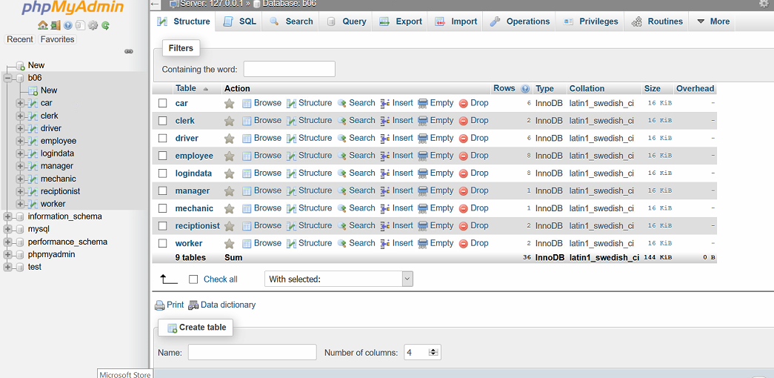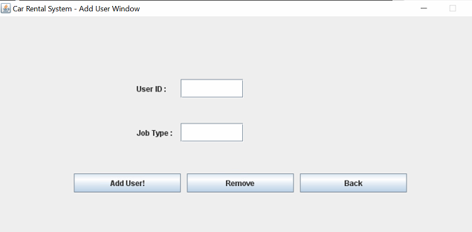10.Add User Window  
  
  
  
  
  
  
  
From Login-window by pressing Add/Remove User,Add user window is opened.A user can add or remove new id and job type.   
  
  
  
  
DATABASE-TABLE-DESCRIPTION :  
  
  
  
  
  
  
  
  
  
  
  
  
  
  
  
Here a Database is created According to the name b06.Here are 9 tables ,named- car,clerk,driver,employee,login data,manager,mechanic,receptionist and worker.Each table is contained with different types of data and information.

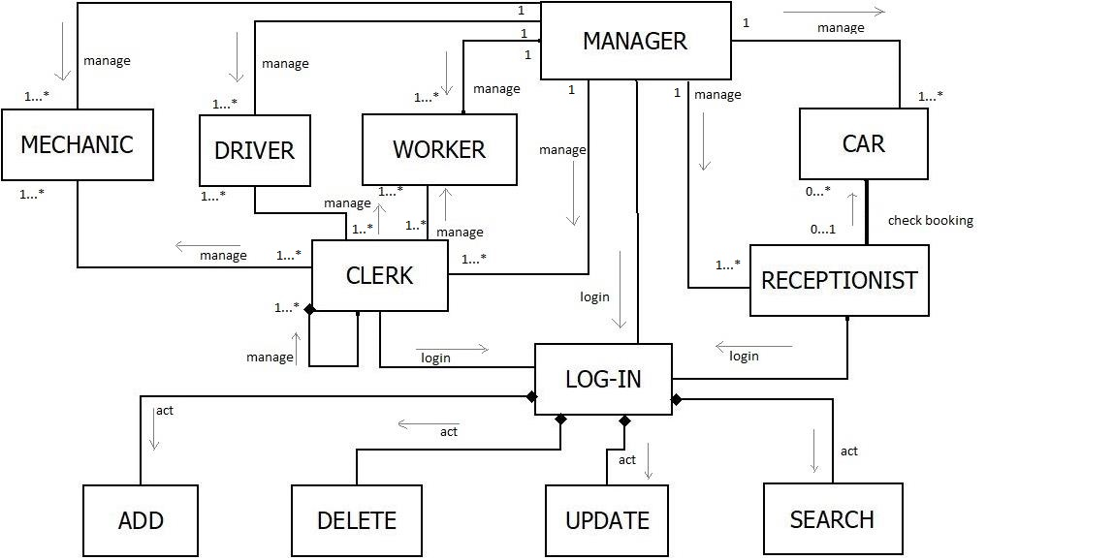

*TOOLS :  
  
1. Notepad ++  
2. Xamp  
3. JDK  
4. JRE  
5. SQL  
  
*OOP and JAVA CONCEPTS USED :  
  
1. Concept 1 : Encapsulation .Encapsulation is occurred here by using the access modifiers(public,private,package,protected)  
  
2. Concept 2 : Inheritance . Inheritance is occurred here by extends classes from same and different packages.  
  
3. Concept 3 : ArrayList concept is used here.  
  
4. Concept 4 : Abstract concept is used here by hiding class method.  
  
5. Concept 5 : Interface . Interface concept is used by in herited by another interface.  
  
6. Concept 6 : G U I ( Graphics User Interface) concept is used here For designing and creating GUI.  
  
7.Concept 7 : DatabaseConnection and sql is used here for connecting with database for tables data.  
  
  
*IMPACT OF “CAR –RENTAL-SYSTEM” :  
  
 As Bangladesh is a developing country , it will be beneficial to use Car Rental System.This will create a big employment sector in our country . It will Impact good to our country economy. As here is big scope for jobs ,here have some positions like clerk , mechanics , workers , receptionist .Renting cars as drivers is helping to earn money for living . Besides car rental system is very simple and user friendly to use for any car rental company.Data and information is very easy to get . Adding , inserting ,updating and collecting any data and information is very simple in this system .

LIMITATIONS & POSSIBLE FUTURE IMPROVEMENTS :  
  
Car Rental System is benefitial for any Development and developing country . We have to introduce this system to people and tell them about this system’s Benefits. Time and money is the biggest limitation for the improvement. As it is new , Many car rental company would not agree to purchase and use this system . With the pace of time ,we need to do more improvement for this system and adding more facilities which are making the system more useable and In future it will come with more important features.