

**East West University**

**Project Report**

**Operating System**

**CSE-325**

**Modified Hilzer’s Barbershop problem**

**Submitted by-**

Name: Md Saiful

ID No: 2019-2-60-040

Name: Md Jekrul Islam

ID No: 2016-2-60-046

Section: 02

**Submitted to-**

Yeasir Rayhan

Lecturer

Department of CSE.

East West University

**Submission Date: 3 - June -2021**

Modified Hilzer’s Barbershop problem

William Stallings presents a more complicated version of the barbershop problem, which he attributes to Ralph Hilzer at the California State University at Chico. Our barbershop has three chairs, three barbers, and a waiting area that can accommodate four customers on a sofa and that has standing room for additional customers. Fire codes limit the total number of customers in the shop to 20.

A customer will not enter the shop if it is filled to capacity with other customers. Once inside, the customer takes a seat on the sofa or stands if the sofa is filled. When a barber is free, one of the customers from the sofa is served (whoever gets to the chair first) and, if there are any standing customers, one of them takes a seat on the sofa whoever gets the chance first. When a customer’s haircut is finished, any barber can accept payment, but because there is only one cash register, payment is accepted for one customer at a time. The barbers divide their time among cutting hair, accepting payment, and sleeping in their chair waiting for a customer.

In other words, the following synchronization constraints apply:

• Customers do the following functions in order: enter the Shop, sit on sofa, sit in the barber chair, pay, exit shop.

• Barbers do the following: they cut hair and accept payment.

• Customers cannot enter the shop if the shop is at capacity.

• If the sofa is full, an arriving customer cannot sit on the sofa until one of the customers on the sofa sits in the barber chair.

• If all three barber chairs are busy, an arriving customer cannot sit in the barber chair until one of the customers in a chair pays for the hair cut

• The customer has to pay before the barber can accept payment.

• The barber must accept payment before the customer can exit shop.

Write code that enforces the synchronization constraints for Hilzer’s barbershop.

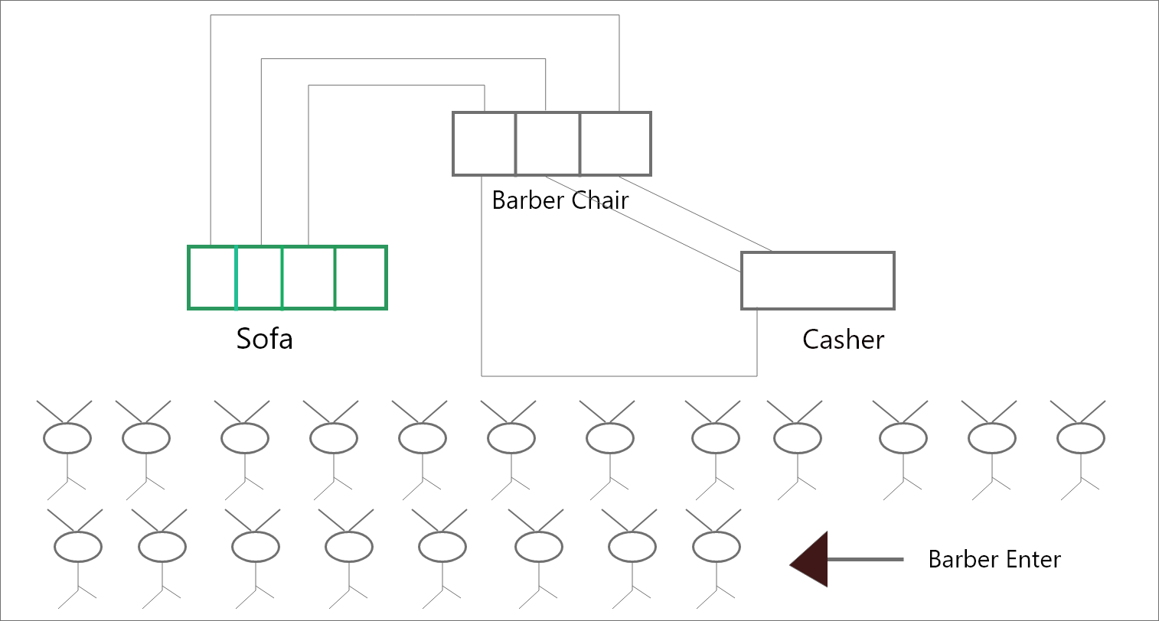

Figure: Problem Scratch

Problem Solve statement:

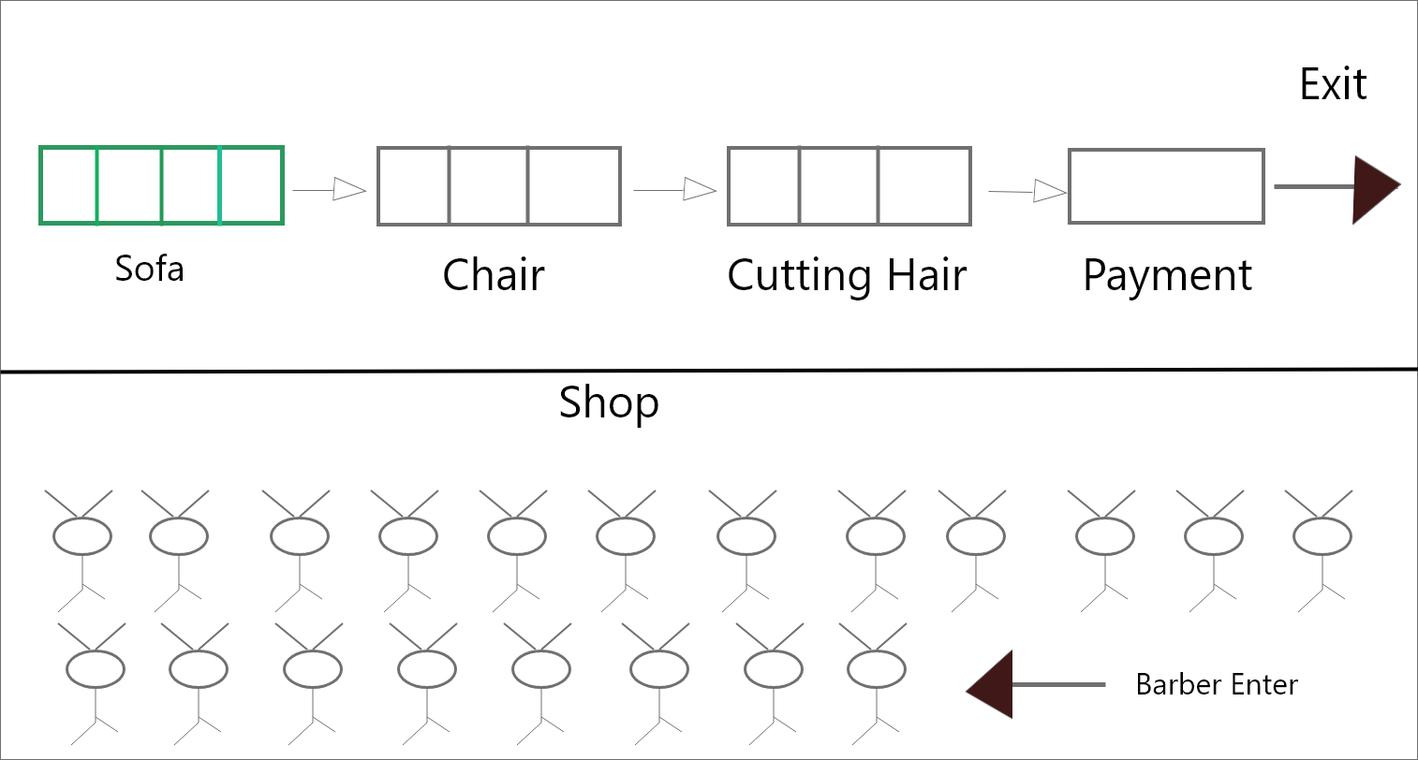

Figure: Solving Scratch

**Using semaphore:**

sem_t empty1; //using for shop

sem_t empty2; //using for sofa

sem_t empty3; //using for chair

sem_t barber_ready; // using for barber ready

sem_t finished; // using haircut is complete

sem_t payment; // Customer pay bill

sem_t receipt; //receipt for payment

**Buffer use:**

queue<int> shop; // Enter all customer

queue<int> sofa; //Enter 4 customer seat sofa at a time

queue<int> chair;//Enter 3 customer seat chair at a time

queue<int> barbr;// Enter 3 customer seat chair at a time and cutting hair

queue<int> paymnt;// Enter 1 Customer payment at a time

**Mutex_Lock:**

Using lock for avoid critical section.

For Example, pthread_mutex_t lock1;

pthread_mutex_t lock2;

For detail, check this link:

**Project Code link:** [**https://github.com/saifulislamsarfaraz/CSE325_Operating_System_Lab_Process/blob/master/Project_CSE345/8.cpp**](https://github.com/saifulislamsarfaraz/CSE325_Operating_System_Lab_Process/blob/master/Project_CSE345/8.cpp)

**Output:**

