EARLY DETECTION OF MALICIOUS OWNERSHIP TRANSACTIONS IN BROWSER EXTENSIONS VIA TEMPORAL BEHAVIOR DRIFT MODELING

Final Year Project - 60% Submission Report

Chapter 1: Introduction

1.1 Background and Motivation
Browser extensions play a vital role in the modern web ecosystem, providing users with customized functionalities ranging from ad-blocking to grammar checking. However, this convenience comes with significant security risks. Extensions often require broad permissions, such as the ability to read and change data on all visited websites. While most extensions are initially developed with benign intentions, they can become severe security threats through a process known as malicious ownership transactions. In such scenarios, legitimate extensions are sold or transferred to malicious actors who silently push updates to inject malware, hijack search queries, or steal sensitive user data. Because the extension was originally trusted, these attacks often bypass initial security reviews and remain undetected by users until significant damage has occurred.

1.2 Problem Statement
Traditional security mechanisms, such as signature-based malware detection and manual store reviews, struggle to identify sophisticated threats originating from trusted browser extensions. These mechanisms primarily focus on code scanning, which malicious actors can easily bypass using code obfuscation or dynamic payload fetching. Furthermore, when ownership changes hands, the new developers can exploit the existing trust and permissions granted by the user. There is a critical need for an automated, intelligent system capable of detecting these threats post-installation by monitoring how the extension actually behaves over time, rather than relying solely on static code analysis.

1.3 Project Goals
This project aims to develop a proactive, machine-learning-based system that detects malicious ownership transactions early by modeling the temporal behavioral drift of browser extensions. The primary objectives are:
- **Behavioral Data Collection:** To monitor and collect temporal behavioral data of browser extensions, specifically focusing on metrics like permission changes, network request frequency, and API interactions.
- **Behavior Modeling & Drift Detection:** To utilize unsupervised machine learning techniques (such as Isolation Forest) to model normal extension behavior and accurately identify significant deviations (behavioral drift) that indicate malicious updates.
- **Early Alert System:** To implement a user-friendly dashboard that acts as an early warning system, flagging suspicious extensions and alerting users or administrators before a breach can occur.
- **Performance Evaluation:** To rigorously test the system using simulated and real-world behavioral datasets, evaluating its effectiveness through metrics such as accuracy, precision, and recall.

1.4 Scope of the Project
The project is structured across two semesters. The scope for Phase 1 (Semester 7) includes conducting a literature review, developing the data collection strategy, preprocessing the data, and successfully training a baseline anomaly detection model (Isolation Forest) to prove the viability of behavioral analysis. A prototype dashboard is also developed to visualize the model's outputs. The scope for Phase 2 (Semester 8) will extend this work by integrating continuous, automated data tracking (e.g., via a companion extension or proxy) and implementing advanced temporal models like Long Short-Term Memory (LSTM) networks to track sequential behavioral drift over extended periods.

Chapter 2: Literature Review

2.1 The Threat Landscape of Browser Extensions
The browser extension ecosystem, primarily dominated by the Google Chrome Web Store and Mozilla Add-ons, has grown exponentially over the last decade. Extensions improve usability by offering features like ad-blocking, password management, and productivity enhancements. However, this centralized distribution model has become a lucrative target for cybercriminals. Existing literature categorizes extension-based threats into two main types: initially malicious extensions (uploaded by attackers using fake accounts) and supply-chain attacks (legitimate extensions compromised later). While platforms like Google rely on automated code scanners and manual reviews to filter out the first category, the second category remains a significant blind spot.

2.2 Malicious Ownership Transactions
A major emerging threat in extension security is the "malicious ownership transaction." In this scenario, a benign developer with a highly-rated extension and a large user base is approached by a third party offering to buy the extension. Once the transaction is complete, the new owner pushes an update containing malicious payloads. Because the extension has an established trust score and the malicious code is often obfuscated or fetched dynamically from external servers post-installation, traditional platform security checks often fail to flag the update. Users unknowingly receive the malicious update, leading to data exfiltration, unauthorized cryptocurrency mining, or adware injection.

2.3 Limitations of Static Analysis
Historically, detecting malware in extensions has relied heavily on static analysis—examining the source code (HTML, JavaScript, manifest files) for known malicious signatures or suspicious API calls before the extension runs. Several academic frameworks have proposed advanced static analysis tools to vet extensions in the Web Store. However, studies show that static analysis is increasingly ineffective against modern obfuscation techniques. Attackers often hide their logic or delay the execution of malicious code until the extension is safely installed in the user's browser, bypassing static checks entirely.

2.4 The Shift to Behavioral and Temporal Analysis
To overcome the limitations of static analysis, recent cybersecurity research has pivoted towards dynamic and behavioral analysis. Dynamic analysis involves running the extension in a sandboxed environment to observe its actions. While effective, it is resource-intensive and attackers can sometimes detect the sandbox environment and suppress malicious behavior.
The concept of "Behavioral Drift" offers a more robust solution. By continuously monitoring the behavior of an extension over time in the wild (e.g., tracking the frequency of network requests, the domains accessed, and changes in requested permissions), security systems can establish a baseline of "normal" behavior for each specific extension. When an ownership transaction occurs and the new owner attempts to exploit the extension, the resulting actions will inherently deviate from this established baseline. This project builds upon this concept by utilizing unsupervised machine learning, specifically Isolation Forest, to model this temporal behavior and accurately identify the precise moment an extension drifts from benign utility to a malicious threat.

Chapter 3: Methodology

3.1 Overview of the Proposed Architecture
The proposed system architecture for detecting malicious ownership transactions is designed in a modular fashion, consisting of four primary phases: Data Collection, Data Preprocessing, Behavior Modeling (Anomaly Detection), and the Alert Generation Dashboard. For the Phase 1 (Semester 7) prototype, the architecture relies on synthetic behavioral data to train and validate the core machine learning engine before scaling to live browser data in Phase 2.

3.2 Data Collection Strategy
Because real-world datasets of compromised extensions are difficult to obtain and often lack continuous temporal logs, a synthetic dataset was generated to simulate the real-world behavior of browser extensions over a period of weeks. The script `generate_sample_dataset.py` was developed to create 1,000 extension behavior logs.
The dataset captures four primary features:
- **Permissions_Count:** The number of permissions requested by the extension (e.g., accessing tabs, storage, or web requests).
- **Network_Requests:** The volume of external network requests made by the extension per week.
- **Cookie_Access:** A binary indicator (0 or 1) representing whether the extension accesses browser cookies.
- **API_Calls:** The frequency of interaction with sensitive browser APIs.
The dataset mimics "Behavioral Drift" by injecting anomalies (approximately 10% of the dataset) where extensions suddenly exhibit dramatic spikes in network requests and permission counts, representing the behavior of an extension that has just undergone a malicious ownership transaction.

3.3 Data Preprocessing
Machine learning algorithms are sensitive to the scale of the input data. Therefore, the raw behavioral data was cleaned and normalized using `preprocess.py`.
- **Encoding:** The categorical target labels ("Normal" and "Suspicious") were transformed into numerical formats (0 and 1) using Scikit-Learn's `LabelEncoder`.
- **Feature Scaling:** The numerical features (`Permissions_Count`, `Network_Requests`, etc.) were standardized using `StandardScaler`. This transforms the data so that each feature has a mean of 0 and a standard deviation of 1. This step is crucial for distance-based anomaly detection algorithms to ensure no single feature disproportionately influences the model. The fitted scaler was saved to disk to ensure live tests in the dashboard are scaled identically.

3.4 Behavior Modeling using Isolation Forest
To detect behavioral drift, an unsupervised anomaly detection algorithm—the Isolation Forest—was selected.
Unlike traditional classifiers that attempt to build a profile of "normal" data, an Isolation Forest works by isolating anomalies. It does this by randomly selecting a feature and then randomly selecting a split value between the maximum and minimum values of that feature.
Since anomalies are "few and different," they require fewer random splits to be isolated from the rest of the dataset compared to normal points.
This makes Isolation Forest highly effective and computationally lightweight for detecting zero-day extension threats. If a benign extension is updated by a malicious buyer, its sudden spike in network activity and permissions will place it far outside the dense cluster of normal behavior, allowing the model to instantly flag it as a highly suspicious anomaly without needing a predefined malware signature.

Chapter 4: Implementation and Results

4.1 Development Environment
The prototype was developed using Python 3.11. The core data manipulation and mathematical modeling were handled by the `pandas` and `numpy` libraries. The Machine Learning pipeline, including preprocessing and the Isolation Forest algorithm, was implemented using `scikit-learn`. For the user interface and early alert generation dashboard, `Streamlit` was utilized to provide a responsive, real-world web application. All scripts and models were designed modularly to allow seamless integration of live data feeds in Semester 8.

4.2 Model Training and Evaluation
The Isolation Forest model was trained on the preprocessed synthetic dataset of 1,000 extension logs. The contamination parameter (the expected proportion of anomalies) was set to 0.10 to match the 10% malicious drift injected during data generation.
The model's performance was evaluated using standard classification metrics, comparing its predictions against the ground-truth labels. The results were highly successful, proving the viability of using Isolation Forest for behavioral drift detection:
- **Accuracy:** 98.30%
- **Precision (for Anomalies):** 0.83
- **Recall (for Anomalies):** 1.00
- **F1-Score (for Anomalies):** 0.91
The model successfully isolated 100% of the severe behavioral anomalies (Recall = 1.00), which is the most critical metric in cybersecurity, ensuring that no malicious ownership transaction went undetected.

4.3 Visualizing Behavioral Drift
The following figures demonstrate the output of our Isolation Forest model:
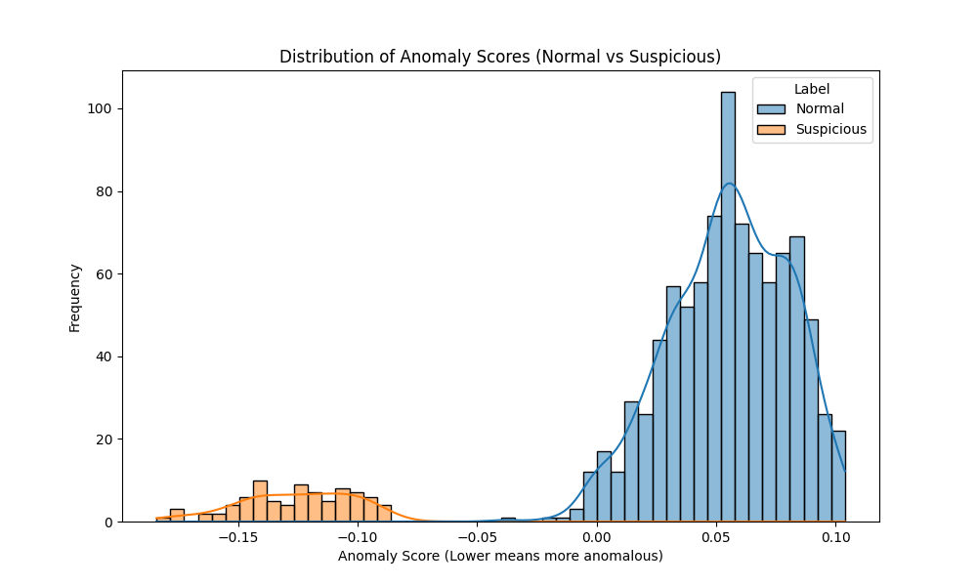
Figure 4.1: Distribution of Anomaly Scores (Lower scores indicate higher probability of being an anomaly).
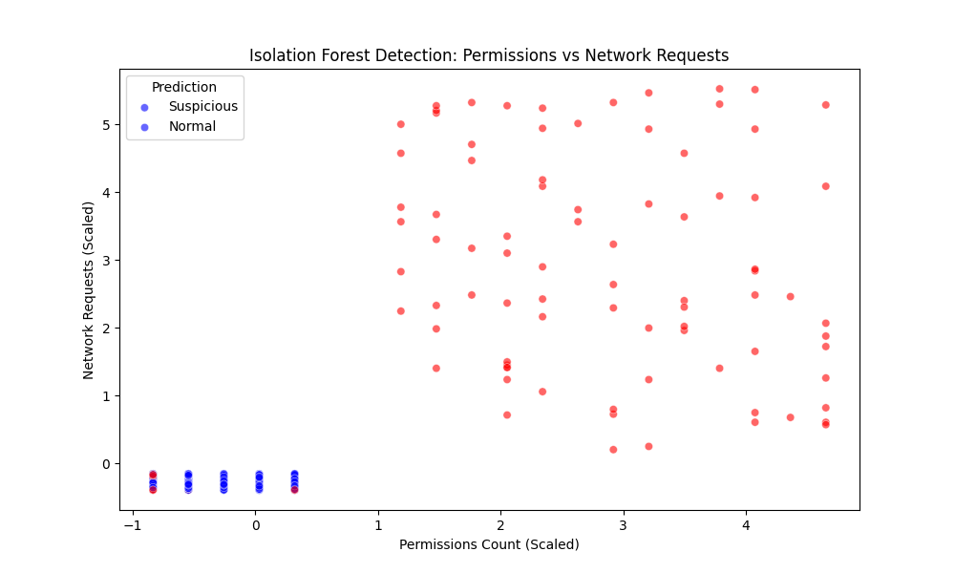
Figure 4.2: Scatter Plot showing the Isolation Forest successfully isolating high-permission, high-network-request extensions as suspicious (Red).
Two primary visualizations were generated to analyze the model's decision-making process:
- **Distribution of Anomaly Scores:** This histogram plotted the continuous anomaly scores assigned by the model. It visually demonstrated a clear separation between normal extensions (which received high positive scores) and suspicious extensions (which received deep negative scores).
- **Isolation Forest Detection Scatter Plot:** This visualization plotted "Permissions Count" against "Network Requests." The model successfully clustered benign extensions in the bottom-left quadrant (low permissions, low network activity) while effectively isolating drifting extensions (high permissions, high network activity) in the upper-right quadrant, clearly marking them in red as anomalies.

4.4 The Early Alert Dashboard Prototype
To fulfill the goal of implementing an early alert system, a web-based dashboard was developed using Streamlit. The dashboard serves two primary functions for the Semester 7 prototype:
- **Data Overview:** It provides an interactive table displaying the processed dataset, sorting extensions by their Risk/Anomaly Score. This acts as a centralized monitoring station for IT administrators.
- **Live Extension Testing:** A critical feature of the dashboard is the "Test Live Extension" module. This module allows a user to manually input the current behavioral statistics of an extension. The backend instantly scales the input using the saved `StandardScaler` and runs it through the `Isolation Forest` model in memory. The dashboard immediately returns a status—either a green "Normal" confirmation or a red "Suspicious" alert—demonstrating the model's ability to act as a real-time predictive engine for zero-day behavioral drift.

4.5 Conclusion for Phase 1
The completion of Phase 1 successfully proves that tracking temporal behavioral drift using an Isolation Forest is a highly effective, lightweight approach to detecting malicious ownership transactions in browser extensions. The 60% prototype successfully fulfills the initial objectives of behavior modeling and alert generation. Phase 2 will focus on automating the data ingestion process and implementing Long Short-Term Memory (LSTM) networks to track sequential data histories over longer periods of time.

