PENETRATION TESTING
A thick client is a computing workstation that includes most or all of the components essential for operating and executing software applications independently. Thick clients are applications which are deployed locally on our systems. Such as Skype/ outlook.
Thick clients refer to the applications that run on user's machine. Client handles most of the business including validations, holding temporary data.
ARCHITECTURAL VIEW OF THICK CLIENT APPLICATIONS
2-tier applications
A typical setup where a client and a database interacts with each other. Here the bulk of processing and operations are performed on the client side, while the database operations and queries once executed makes the data processed and stored on the database.
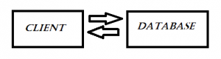
3-tier applications:
This is the alternate and well-structured 3-tier architecture. Here the client server has three components
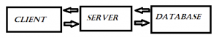
The bulk of processing is done at the server side while the queries are performed at client side with requests.
Reference link: http://blog.securelayer7.net/thick-client-penetration-testing-1/
SECURITY TESTING OF A THICK CLIENT
The security testing of thick clients can be divided into 3 parts:
- Dynamic Testing (fuzzing, traffic interception, injections).
- System Testing ( checking for logs, data files, registry threads, process threads)
- Static Testing (reverse engineering, binary analysis)

DYNAMIC TESTING:
Input Validation (Fuzzing user input fields)
Here our main goal is to test all the input parameters for different types of attacks which include:
- SQL injection
- Command injection
- Malicious input acceptance.
SQL injection is one of the prime attacks you can carry onto a thick client’s database. Do note performing thick client SQL injection needs patience and is a time consuming task. You need to iterate multiple queries with a mix and match by observing response to each of them.
Some good links for a collection of sqli payloads:
- https://github.com/fuzzdb-project/fuzzdb/tree/master/attack/sql-injection/payloads-sql-blind
- http://pentestmonkey.net/cheat-sheet/sql-injection/mysql-sql-injection-cheat-sheet
You can crawl the net for multiple payloads to find the one which is appropriate for the application you are testing.
File Upload: Here our goal is to attempt to upload malicious files which can be injected into the application input request which can lead us to shell upload/ malicious code execution.
Here you can simply check for all the browse buttons and check the file upload logic.
Buffer Overflow
Here our goal is to examine C / C++ programmed thick clients majorly to test the memory functions deployed which will allow us to check how the buffer overflow vulnerabilities and memory violations. (Buffer overflow is discussed in detail later)
Secure traffic analysis (protocols)
The testing for this case involves checking whether encryption is applied for sensitive data on the wire or not (example: clear text data transmission is vulnerability)
Business logic validations
This has multiple sub test cases which can involve privilege escalation, price tampering, authorization bypass etc.
Error handling/ Info Leakage
Tester tries in this case to extract verbose error messages which may give information about underlying framework, application code and log details.
Session management
Test cases on session validity/ expiration/ fixation come under this method.
Forced URL access via browser
Many a times, configuration URLs can be directly connected via the web browser
Log tampering
Most of the applications we test do not validate the timestamp directly accepting the local system time from user, performing malicious transactions via changing the system time leads to inconsistency of the application logs.

INTERCEPTING THE REQUESTS IN BURP SUITE
We have two types of applications:
Proxy aware: Proxy aware are those applications which has settings in the application itself to route through IP address and ports for the purpose of logging in the application as well as transmit and receive data.
Proxy unaware: In this case where the application does not have such settings, you have to redirect the traffic from the application to your system to the actual server.
We shall now discuss the traffic interception in burp:
Initially, if the domain name and the IP have been provided by the client, we do not need to find the IP and the domain name using the Process Monitor.
- Otherwise, we will need Process Monitor (SysInternal Tools). We will add the process (Executable file), into the process monitor.
- Add this process to the process monitor as shown below:
- Click on filter option in the menu bar and add the given process say (SEGuide.exe)
- Now we can simply check the network activity, to get the domain name and the target of the given process. We’ll note it down for further processing. Say for SEGuide.exe, we noted it down as lsbsas.axa-uk.intraxa:8591 and 8561
- Corresponding to these domain name and targets, we will ping in command prompt to find their respective IP addresses. The command goes like: ping lsbsas.axa-uk.intraxa. Say, the obtained IP’s are 10.188.33.113 and 10.188.33.114 respectively.
- Now we’ll open Wireshark and will see the request packets to find the domain name in the host header. Add the filter ipaddrv4 <obtained IP’s>
- Right click and follow the stream (follow TCP), if at all we are getting the clear text data in the network packet, this is a High Vulnerability: Unencrypted Network Connection.
- So, we now know the domain name, IP addresses and the protocol.
- For HTTP protocol, we’ll do the normal interception.
- For non HTTP protocols, we use burp’s non HTTP protocol extension (noPE).
- We’ll go to the extender, add noPE (download it’s jar file first).
- Under the noPE proxy tab, we’ll go to the Server Configuration-à Non-HTTP Proxy Settings. In Server address, we’ll give the obtained IP and both the ports are 8561.
- We’ll now have to make an entry into the host file (Modifying your hosts file causes your local machine to look directly at the Internet Protocol (IP) address that you specify. Modifying the hosts file involves adding two entries to it. Each entry contains the IP address to which you want the site to resolve and a version of the Internet address. Refer to the link below for making necessary changes to the host file. <ipconfig> tab domain name
https://support.rackspace.com/how-to/modify-your-hosts-file/
- Now intercept the request in burp suite.
If, on intercepting the request, we get the data in normal/plain request response, then we can carry forward the vulnerability tests like privilege escalation, etc. If it is encoded, then cannot tamper the requests and carry the dynamic testing.
--------------------------------------------------------------------------------------------------------

BUFFER OVERFLOW
The temporary storage areas in the memory are also known as buffers. When the application can be tricked (usually due to coding errors) into storing more data than the buffer can hold, it overflows into adjacent buffers. This Buffer Overflow can lead to a wide range of issues, including data corruption, segmentation faults, exceptions and more.
The probability of this vulnerability differs from language to language, but C, C++ and Assembly are considered most susceptible due to their outdated memory management capabilities. Advanced hackers can initiate Buffer Overflows with specially crafted malicious payloads to cause application crashing, data theft or even give them remote access.
We’ll now discuss about Buffer Overflow exploit:
Links to read from:
http://www.cis.syr.edu/~wedu/Teaching/IntrCompSec/LectureNotes_New/Buffer_Overflow.pdf
The above link will help us learn about the PC architecture and how this buffer overflow vulnerability can be exploited with the following three ways:
Injecting the malicious code: We need to be able to inject the malicious code into the memory of the target process. This can be done if we can control the contents of the buffer in the targeted program. For example, if the program gets the input from a file. We can store the malicious code in that file, and it will be read into the memory of the targeted program.
Jumping to the malicious code: With the malicious code already in the memory, if the targeted program can jump to the starting point of the malicious code, the attacker will be in control.
Writing malicious code: special type of malicious code, shellcode, can be written.
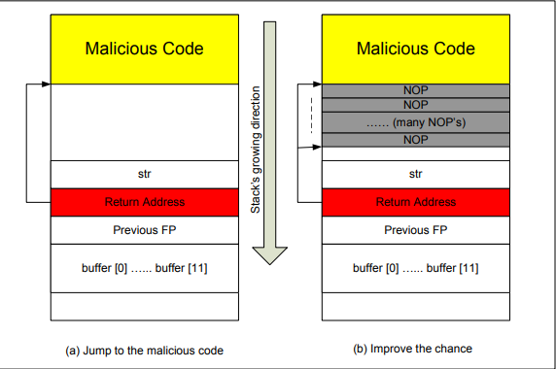
To jump to the malicious code that we have injected into the target program’s stack, we need to know the absolute address of the code. If we know the address before hand, when overflowing the buffer, we can use this address to overwrite the memory that holds the return address. Therefore, when the function returns, it will return to our malicious code.
The challenge is to find where the malicious code starts. You can try several values. Stack usually starts at the same address. Stack is usually not very deep: most programs do not push more than a few hundred or a few thousand bytes into the stack at any one time. – Therefore the range of addresses that we need to guess is actually quite small.
Now, that we have known what actually buffer overflow is and how it can
exploited, we will now learn about buffer overflow passive check.
Link to be referred to:
https://github.com/NetSPI/PESecurity
We will execute the following commands to check for various flags. All this has been illustrated in the images below.
- Import the module: Import-Module .\Get-PESecurity.psm1
- Check a single file: PS C:\> Get-PESecurity –directory C:\Windows\System32\
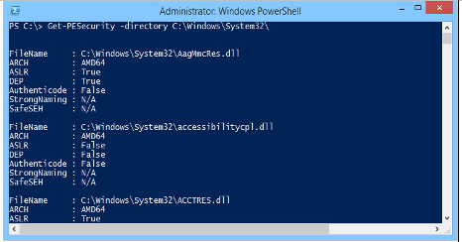

SYSTEM TESTING:
In System Testing, we will check for various logs, registry files, configuration files and process threads either manually or using some automated tools. (SysInternal Tools).
1. SENSITIVE DATA IN THE REGISTRY :
“Sensitive data in registry” is one of the most common vulnerabilities seen in Windows desktop applications. Developers often use the registry as a storage location for their client-side data storage needs.
Let’s analyze SASGuide and see if it is storing any sensitive data in the registry.
regshot is a popular tool for analyzing registry modifications. This tool comes handy in understanding registry changes in Windows machine before and after a specific instance. It is hard for us to check the new registry entries added/modified without the help of such tool.

After downloading, launch regshot, and take the 1st shot by clicking the 1st shot button. Make sure that you did not start SASGuide yet. Also take note that HTML Document is selected in regshot as shown in the figure below.
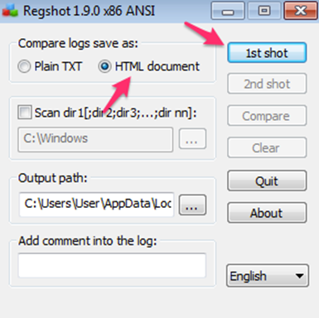
After taking the 1st shot, launch SASGuide application.
Now, to see if any changes are made to the registry after running SASGuide, let’s take another copy of registry by clicking the 2nd shot button shown below.

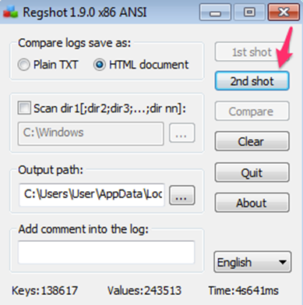
After taking this 2nd shot, we can compare these two shots by clicking Compare button shown in the figure below.
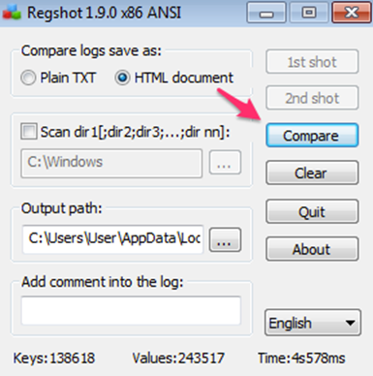
Let’s click Compare in the above figure and observe the HTML output, which will be loaded automatically. This looks as shown in the figure below.
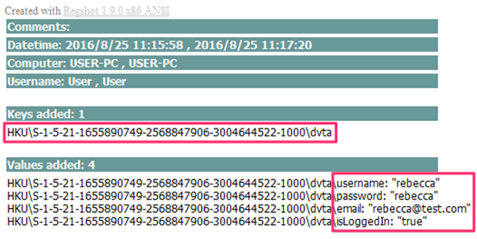
If at all there is some sensitive data found (as in the above figure), it can be reported accordingly.
- STRING BASED ANALYSIS:
In this case, we will need a tool called “Process Explorer”. This comes as a part of Windows SysInternal Suite
We’ll simply right click on the application and go to Properties as shown below.
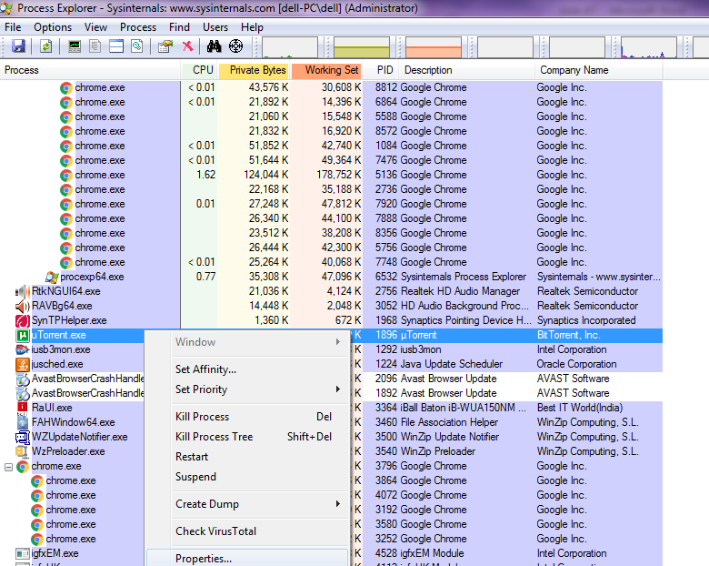
Next, we’ll select Strings tab and click on memory. Now apply the required filters and try searching some sensitive data.
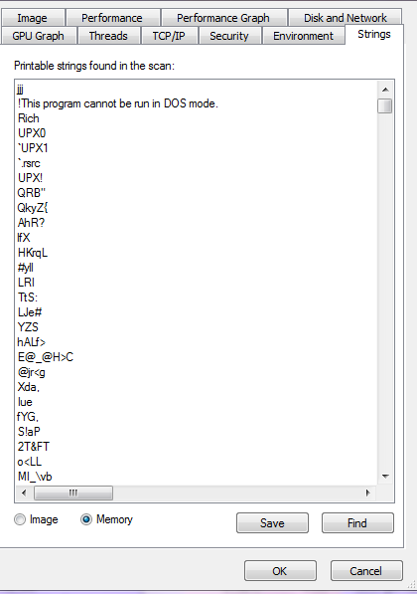

- CONFIGURATION FILE CHECK
During installation, a two tier thick client application stores a configuration file locally on the machine containing the database IP, port, username and password locally. An attacker might get access to this configuration file containing the database connectivity details. He might then directly connect to and compromise the database.
A thick client application writing/storing application logs containing sensitive details like user accounts, trading details, last login date and time, etc… on the user machine. An attacker can get access to this machine and steal the user specific details written on to the log files.
We can simply check the configuration files from the installation folder and look for some sensitive data.

3. MEMORY ANALYSIS USING WINHEX
All applications, be it web based or thick client applications, temporarily store data into the memory (Random Access Memory) for further processing. An application might store sensitive data like user credentials or encryption keys into the memory and store them until they get written by other data. An attacker may run a memory reading tool like WinHex in the machine to analyze the entire memory content used by the application. Simply, go to task manager and create the dump file of the application, then read it. Search for password if at all, they can be reported at once.

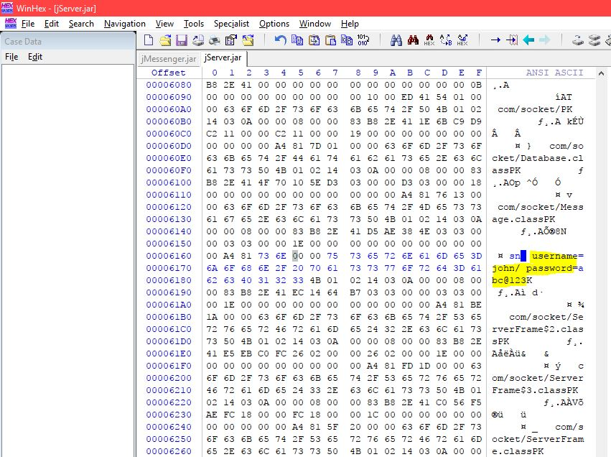

- CHECKING FILE PERMISSIONS
For checking file permissions, we will use AccessEnum and select the directory for which we want to find the read/write permissions as shown below.

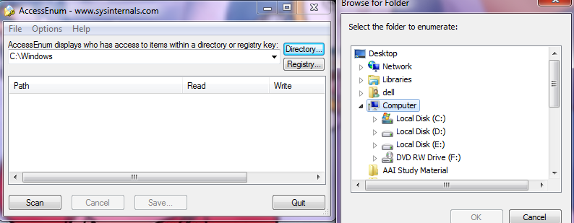

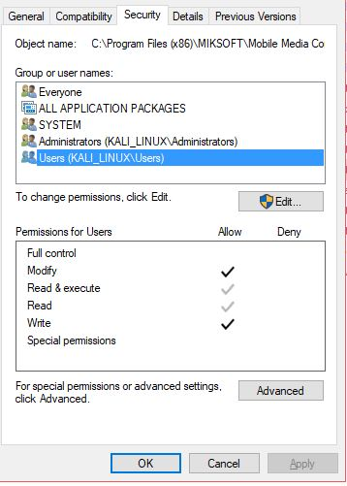

STATIC TESTING

In Thick Clients majority of the business logic resides in the client application, thus it is important to identify any backdoor that might be present on the client-side logic. To analyze the client-side logic we need to view the source code of the Thick Client application and the best bet is to decompile them to see the business logic.

Initially to carry out the static testing, we will first need to know the technology and the framework used in the application development. For that we need to use CFF Explorer.

JetBrains dotPeek is a decompiler tool that allows the users to view the source code of Thick Clients developed in .Net framework. This includes the Applications developed in C# and Visual basic. We will simply drag and drop the application .exe file into dotPeek and can find the decompiled code as illustrated below.

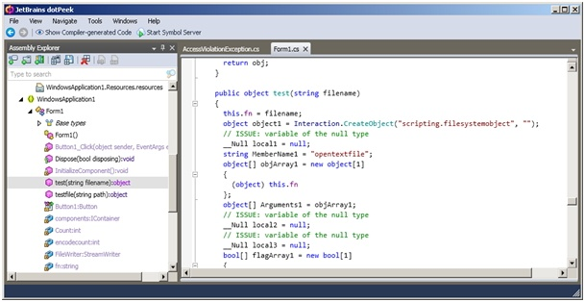
The first thing that we will check is that whether Code Obfuscation is in place or not. Code obfuscation ensures that if the application is decompiled, the actual source code is not revealed and it makes code recompilation a very difficult process.
Now, since we have obtained this decompiled code, we can further save this in a folder and then perform source code analysis using an automated too, VCG (Visual Code Grepper).
Later on, we will check for false positives from the obtained list of vulnerabilities.

DLL HIJACKING

DLL Hijacking is an attack that exploits the way some Windows applications search and load Dynamic Link Libraries.
Most Windows applications will not use a fully qualified path to load any required DLLs. An attacker can place a fake DLL for a known program in a location that is searched before the real DLL’s location and almost guarantee that the malicious DLL is loaded, resulting in whatever code the attacker wants to run running!
When programs are not written to specify the exact location of a required DLL, Windows will search for the DLL by name in a specific order. For instance, let’s say that the application, SASGuide.exe requires a DLL named version.dll that is usually in the Windows system directory. If the application does not specify the exact path for version.dll, Windows will search for the DLL in the directory from which the application has been loaded first.
If a malicious hacker has placed his own version of version.dll(calc.dll) in the same directory as SASGuide.exe, then that DLL will be loaded instead of the real DLL. Windows just tries to find the first file that has the same name and does not verify if the file is actually the one that is required.
If the vulnerable application tries to load an external DLL from the same location, the attack will most likely be successful.

ROOT CAUSE:
This vulnerability occurs if the software to be executed from a directory other than the protected directories either software has been installed to a non-default directory or alternatively software is being executed via a network share.
The way that Windows loads DLLs then, is to search the following directories in this order:

EXPLOIT SCENARIO:

- 1. Download calc.zip from the link below: https://github.com/Cracked1/AppSec/blob/master/calc.zip
- We will now put this DLL along with SASGuide.exe into the new folder in the downloads folder.
- Rename this new folder as SASGuide.
- Now open the application and monitor it using the process monitor (Show file activity)
- Apply the given filter (Result name is NOT FOUND)
- Apply another filter (Process name is SASGuide.exe)
- We'll now get a list of all the DLLs that are not found in the given downloads folder path.
- Say version.dll is not found.
- We'll now go to the new folder SASGuide.exe and rename this calc.dll to version.dll.
- Now, the next time we open this SASGuide.exe, a calculator will popup.

This means we have put our own version of version.dll in the same directory as that of SASGuide.exe,so this DLL got executed instead of the real DLL. Because windows, just tries to find the first file that has the same name as the application does not specify the exact path for version.dll so application will search for the DLL in the directory from which the application has been loaded first.

REMEDIATION:
Ensure that all installed software goes into the protected directory C:\Program Files or C:\Program Files (x86). If software cannot be installed into these locations then the next easiest thing is to ensure that only Administrative users have “create” or “write” permissions to the installation directory to prevent an attacker from deploying a malicious DLL and thereby breaking the exploitation.

REFERENCE LINKS :
Below mentioned are some of the important links that can be referred :
https://resources.infosecinstitute.com/practical-thick-client-application-penetration-testing-using-damn-vulnerable-thick-client-app-part-1/#gref
https://www.paladion.net/blogs/thick-client-testing-toolkit-part-1-introduction
https://www.paladion.net/blogs/thick-client-testing-toolkit-part-2-tools-testing-techniques-interception-testing-2
https://www.paladion.net/blogs/thick-client-testing-toolkit-part-3-tools-testing-techniques-interception-testing
https://www.paladion.net/blogs/thick-client-testing-toolkit-part-4-tools-testing-techniques-local-storage-memory-testing
https://www.paladion.net/blogs/thick-client-testing-toolkit-part-5-tools-testing-techniques-decompiling-reverse-engineering-2
https://parsiya.net/blog/2018-07-15-dvta---part-1---setup/
http://blog.securelayer7.net/thick-client-penetration-testing-1/
http://blog.securelayer7.net/thick-client-penetration-testing-2-traffic-analysis/
http://blog.securelayer7.net/thick-client-penetration-testing-3javadeserialization-exploit-rce/
http://blog.securelayer7.net/static-analysismemory-forensics-reverse-engineering-thick-client-penetration-testing-part-4/
http://blog.securelayer7.net/static-analysismemory-forensics-reverse-engineering-thick-client-penetration-testing-part-4/
http://niiconsulting.com/checkmate/2015/12/thick-client-application-security-testing/
http://securitywarrior9.blogspot.com/2017/08/intro-to-thick-client-penetration.html
http://securitywarrior9.blogspot.com/2017/08/traffic-analysis-for-thick-client.html
http://securitywarrior9.blogspot.com/2017/08/java-deserialization-exploit-to-rce.html
http://securitywarrior9.blogspot.com/2017/08/memory-forensics-static-testing-and.html
http://securitywarrior9.blogspot.com/2018/01/thick-client-penetration-testing.html
DLL HIJACKING
https://resources.infosecinstitute.com/dll-hijacking/#gref
https://resources.infosecinstitute.com/dll-hijacking-attacks-revisited/#gref
https://www.sans.org/cyber-security-summit/archives/file/summit-archive-1493862085.pdf
BUFFER OVERFLOW
http://www.cis.syr.edu/~wedu/Teaching/IntrCompSec/LectureNotes_New/Buffer_Overflow.pdf
https://blogs.technet.microsoft.com/srd/2010/12/08/on-the-effectiveness-of-dep-and-aslr/
https://github.com/NetSPI/PESecurity

