C is Middle-Level Programming Language
Due to its ability to support both low-level and high-level features,It is both an assembly-level language, i.e. a low-level language, and a higher-level language. Programs that are written in C are converted into assembly code, and they support pointer arithmetic (low-level) while being machine-independent (high-level)

What are basic data types supported in the C Programming Language?
Each variable in C has an associated data type. Each data type requires different amounts of memory and has some specific operations which can be performed over it. It specifies the type of data that the variable can store like integer, character, floating, double, etc. In C data types are broadly classified into 4 categories:

Primitive data types:
Primitive data types can be further classified into integer, and floating data types.

Void Types:
Void data types come under primitive data types. Void data types provide no result to their caller and have no value associated with them.

User Defined data types:
These data types are defined by the user to make the program more readable.

Derived data types:
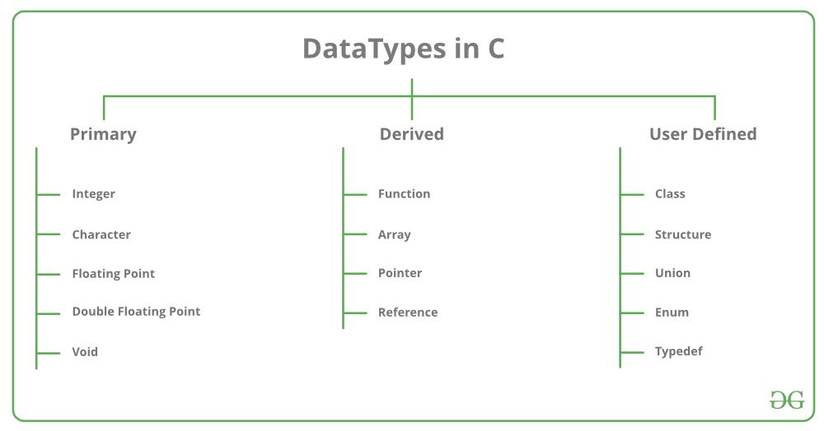
Data types that are derived from primitive or built-in data types.

Tokens
Tokens are identifiers or the smallest single unit in a program that is meaningful to the compiler. In C we have the following tokens:
Keywords: Predefined or reserved words in the C programming language. Every keyword is meant to perform a specific task in a program. C Programming language supports 32 keywords.
Identifiers: Identifiers are user-defined names that consist of an arbitrarily long sequence of digits or letters with either a letter or the underscore (_) as a first Character. Identifier names can’t be equal to any reserved keywords in the C programming language. There are a set of rules which a programmer must follow in order to name an identifier in C.
Constants: Constants are normal variables that cannot be modified in the program once they are defined. Constants refer to a fixed value. They are also referred to as literals.
Strings: Strings in C are an array of characters that end with a null character (‘\0). Null character indicates the end of the string;
Special Symbols: Some special symbols in C have some special meaning and thus, they cannot be used for any other purpose in the program. # = {} () , * ; [] are the special symbols in C programming language.
Operators: Symbols that trigger an action when they are applied to any variable or any other object. Unary, Binary, and ternary operators are used in the C Programming language.

Preprocessor Directives
In C preprocessor directives are considered the built-in predefined functions or macros that act as a directive to the compiler and are executed before the program execution. There are multiple steps involved in writing and executing a program in C. Main types of Preprocessor Directives are Macros, File Inclusion, Conditional Compilation, and Other directives like #undef, #pragma, etc.

malloc() and calloc()
calloc() and malloc() library functions are used to allocate dynamic memoryDynamic memory is the memory that is allocated during the runtime of the program from the heap segment. “stdlib.h” is the header file that is used to facilitate.

Memory Leak
In C programming memory leak occurs when we allocate memory with the help of the malloc() or calloc() library function, but we forget to free the allocated memory with the help of the free() library function. Memory leak causes the program to use an undefined amount of memory from the RAM which makes it unavailable for other running programs this causes our program to crash.

Dangling Pointer
Pointers pointing to deallocated memory blocks in C Programming are known as dangling pointers i.e, whenever a pointer is pointing to a memory location and In case the variable is deleted and the pointer still points to that same memory location then it is known as a dangling pointer variable.

pointers and their uses
Pointers are used to store the address of the variable or a memory location. Pointer can also be used to refer to another pointer function. The main purpose of the pointer is to save memory space and increase execution time. Uses of pointers are:

To pass arguments by reference
For accessing array elements
To return multiple values
Dynamic memory allocation
To implement data structures
To do system-level programming where memory addresses are useful

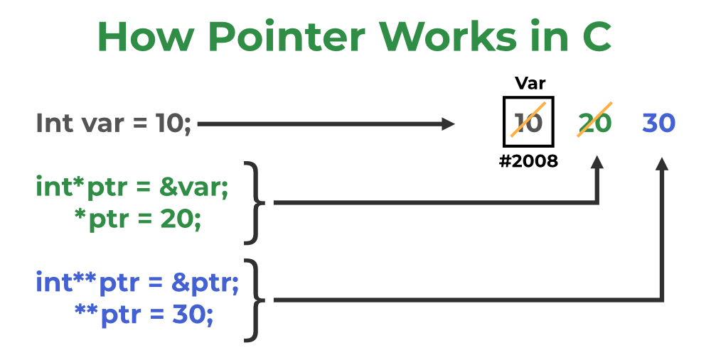

Type Casting:
In typing casting, a data type is converted into another data type by the programmer using the casting operator during the program design. In typing casting, the destination data type may be smaller than the source data type when converting the data type to another data type, that’s why it is also called narrowing conversion.
float x;
byte y;
….
y=(byte)x;

Type conversion :

In type conversion, a data type is automatically converted into another data type by a compiler at the compiler time. In type conversion, the destination data type cannot be smaller than the source data type, that’s why it is also called widening conversion. One more important thing is that it can only be applied to compatible data types.

int x=30;
float y;
y=x; // y==30.000000.

header files and their uses?
C language has numerous libraries which contain predefined functions to make programming easier. Header files contain predefined standard library functions. All header files must have a ‘.h’ extension. Header files contain function definitions, data type definitions, and macros which can be imported with the help of the preprocessor directive ‘#include’. Preprocessor directives instruct the compiler that these files are needed to be processed before the compilation.
There are two types of header files i.e, User-defined header files and Pre-existing header files. For example, if our code needs to take input from the user and print desired output to the screen then ‘stdio.h’ header file must be included in the program as #include<stdio.h>. This header file contains functions like scanf() and printf() which are used to take input from the user and print the content.

Macro
In C programming, a macro is a construct that allows you to define a short, reusable code snippet. It is created using the #define directive, which associates a name with a replacement text. When the code is compiled, the preprocessor replaces every occurrence of the defined macro with its corresponding replacement text.

#include <stdio.h>

// Macro definition
#define AREA(l, b) (l * b)

// Driver Code
int main()
{
// Given lengths l1 and l2
int l1 = 10, l2 = 5, area;

// Find the area using macros
area = AREA(l1, l2);

// Print the area
printf("Area of rectangle"
" is: %d",
area);

return 0;
}



