
Mianwali

Web Development
Students Name | Saifullah Khan
Roll Number | Bscs201916
Date | 6/2/2022
Assignment | Final Project
Project Name | Online Ticketing

Table of Contents
1:- History:- 3
2:- Abstract:- 3
3:- Tools:- 3
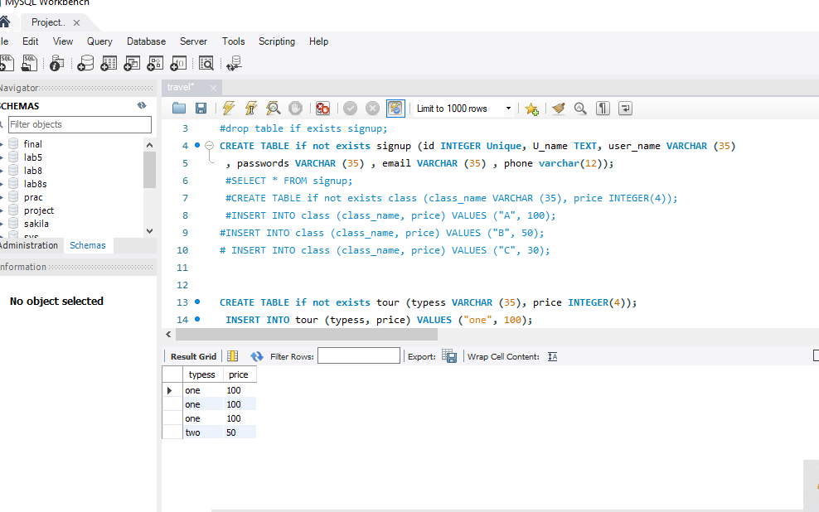 4
4:- Application:- 4
4.1:-Signup: 4
4.2:- Login: 5
3:- Booking page:- 6
5:- Testing and validation:- 7
5.1:- Frontend:- 7
5.2:- Backend:- 9
6:- Remaining Work:- 10

Travellers

1:- History:-
The era in which we are living the success of a person keenly depend upon its time management of the work. So the most important thing in today world is time. If we do work efficiently and quickly and also secure the resources then we can survive in this world.
In previous days when there is no internet, no online services. People's usually go for ticket office to book tickets for their tours. There are many problems during this process. First of all there is no guarantee that ticket can be provided by the company second is that the company is closed for that day. The distance from the office is matter a lot.
Then came the internet. The distances become shorter the world become global village. The internet provide many facilities like online banking, online shopping, uber, online food delivery and online travel planes and details and methods to book hotels online.

2:- Abstract:-
The application upon which i am working is online ticketing app. Where user can buy or book tickets for the international flights for some of the countries.

3:- Tools:-
1:- Html & Css & for views
2:- JavaScript (jQuery) for views handling, testing and validation
3: -Jason for transferring data between applications and views and views and applications.
4: -Mysql as a database which stores the information that is required.
5:- Flask is used to handle the background.
A glimpse to the database

4:- Application:-
Landing page:-
The first view or the landing page pf my application is login or signup page where user need to signup of he is not register on the application server otherwise of he just do the login. In the signup he provides information which includes

4.1:-Signup:

1: - First Name

2: - Last Name

3: -Username

4: - Email

5: - Password

6:- Phone Number

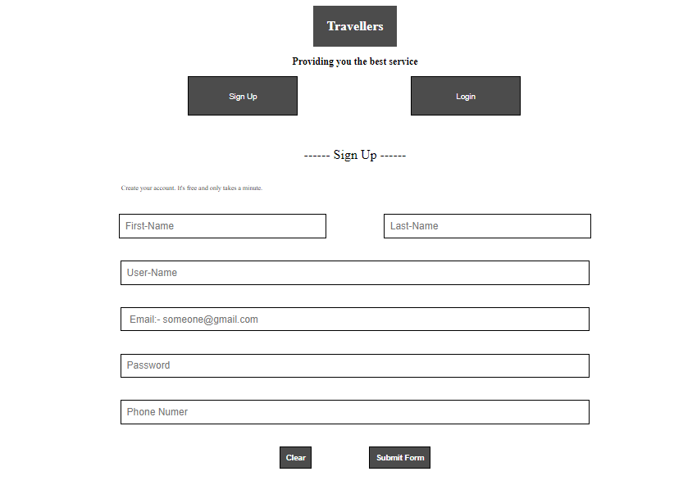
Figure 1:- Signup

In the login form I just ask user to enter 2 values for login.

4.2:- Login:

1:- Username

2:- Password

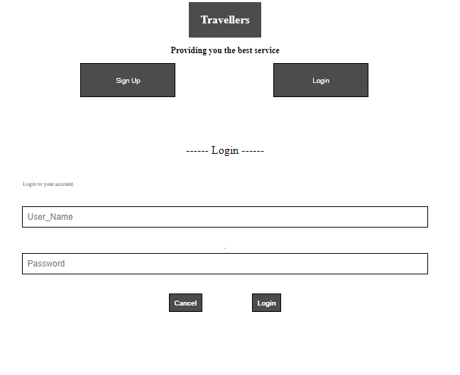
Figure 2:- Login

3:- Booking page:-
It contain all the necessary information required to get from the user when the user want to book the tickets.

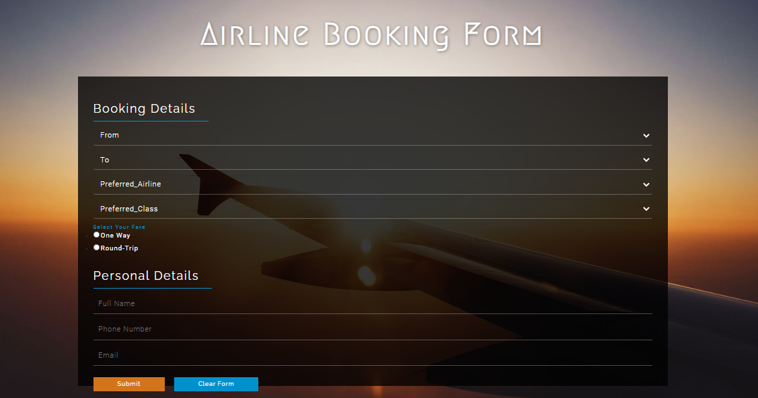
Figure 3:- Ticket Booking Page

5:- Testing and validation:-
The other features which i introduced in the application i have done the front end validation.
I do different type of front end validation on different fields of the forms. For example i do not accept the registration until user provide all the information. Provide right credentials like number should be valid if it is only provide 11 digits. Done same with the login page and ticket booking page. I also done the back end testing using user data and database of the server.

5.1:- Frontend:-

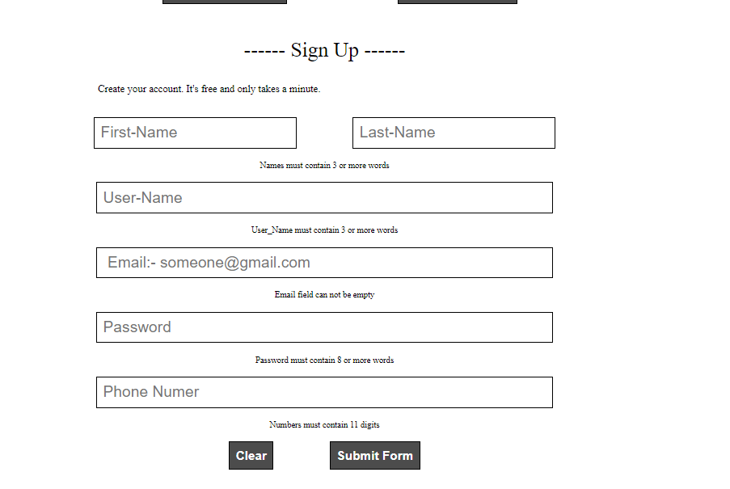
Figure 4.1:-Signup front end testing

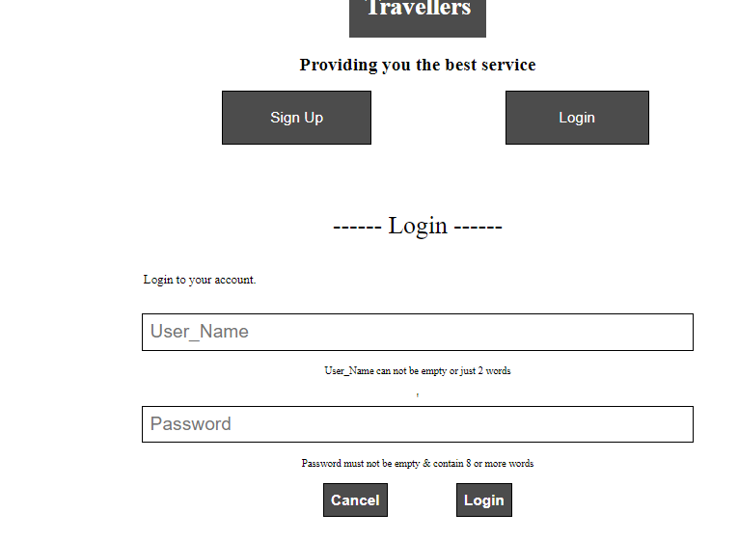
Figure 5:-login front end testing

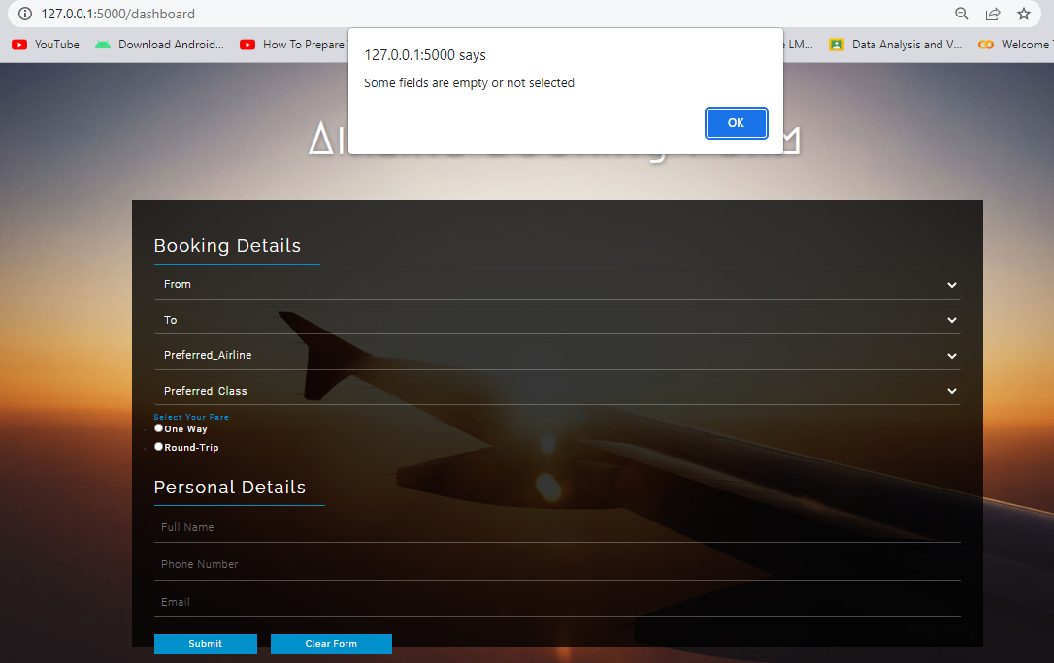
Figure 6:- Booking Page Front End Validation

5.2:- Backend:-

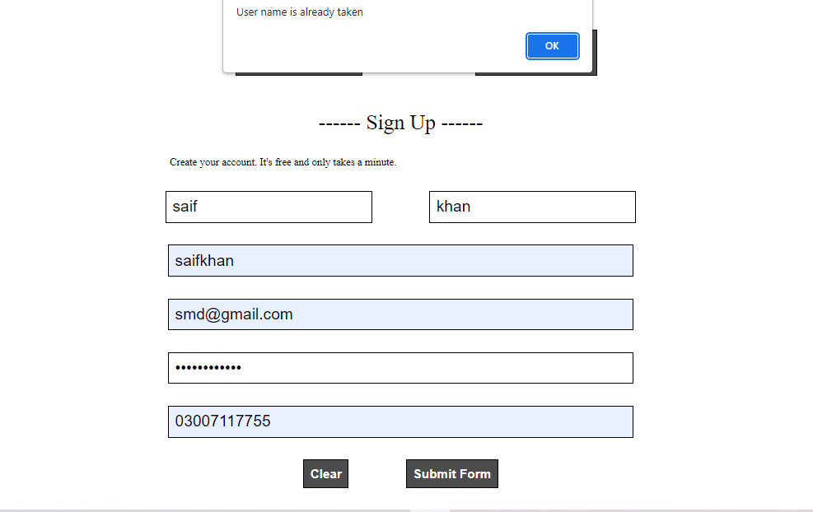

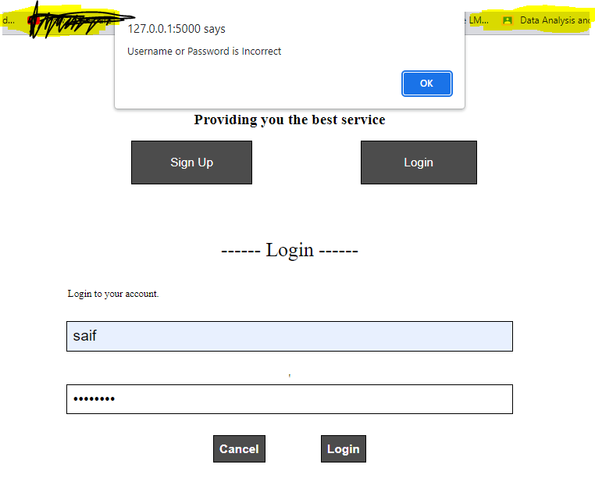

6:- Remaining Work:-
1:- One last view that contain a ticket template
2:- Database tables with name countries that provide information about the fair on the basis of the distance between the Countries.
3:- In the booking page the input field for credit card pin is not present if user want to buy the ticket online.

