TK3223 Network Programming

Lab 2: UDP

Lab Requirement
1. The following files are required:
UDPClient.class, UDPServer.class, UDPClient1.java, UDPServer1.java, in.txt
2. Task 1 is to understand the UDPClient and UDPServer programs.
3. The goal of Task 2.1 until Task 2.4 is to develop a client program (UDPClient1) which resembles the behavior of the UDPClient program. Use UDPServer program to test your client program.
4. The goal of Task 3.1 until Task 3.5 is to develop a server program which resembles the behavior of the UDPServer program. To test your server program, use either the UDPClient program or the client program you have developed in Task 2.

Task 1
i. First, execute the server program as follows:
java UDPServer
ii. Then, execute the client program as follows:
java UDPClient
iii. Based on the generated output of both programs,
- Identify the data contained in the packet sent by the server to the client?
- What is the server response towards the packet received from the client?

Task 2.1
You will develop a client program which resembles the UDPClient program. Use the UDPClient1.java file to start your work. Compile and execute it.

Task 2.2
Modify the program to read data from a file and packaged the data into DatagramPacket to be sent to the server. Follow the following directions:
i. Create an input stream to read data from file using a BufferedReader object and connect it to a FileReader object. Use the in.txt as input file. Use the readLine() method to read data one line at a time (String). Test your program by printing it to the screen.
ii. Create a ByteArrayOutputStream object, then create a PrintStream object and connect it to the ByteArrayOutputStream object.
Use the println() method to write the data read from input file to PrintStream stream.
iii. To test the output stream, use the following codes to display the buffer contents in ByteArrayOutputStream stream:
System.out.println(baos.toString());
baos is a variable which contain reference to the stream. Method toString() returns a string which contain the buffer contents.
Compile and execute your program.
iv. Create a DatagramPacket object. Use toByteArray() method to get the byte array from the above ByteArrayOutputStream stream. Set IP address and port destination for the DatagramPacket object.
v. To test the packet built, use the following codes to display the packet contents:
BufferedReader rd;
rd = new BufferedReader
(new InputStreamReader
(new ByteArrayInputStream
(packetOut.getData())));
System.out.println("Packet info:");
System.out.print("Destination IP: ");
InetAddress addr = packetOut.getAddress();
System.out.println(addr.getHostAddress());
System.out.print("Destination Port :");
System.out.println(packetOut.getPort());
System.out.println("Contents:");
while (true) {
String str = rd.readLine();
if (str == null)
break;
System.out.println(str);
}

Task 2.3
Modify the program to create DatagramSocket object to send the packet.
i. Create object DatagramSocket.
ii. using the method send()send the packet to the server via this socket.
iii. Compile and test your program using the UDPServer program.

Task 2.4
Modify the program to wait for respond packet from server to confirm that the packet sent is received. Client program needs to display the packet contents.
i. Create a packet to receive data from server using DatagramPacket class.
ii. call method receive() via socket.
iii. Display the packet contents which consists of:
a. First line: Sequence number
b. Second line: Date and time of data receipt
Create input stream using BufferedReader, connecting it to InputStreamReader which is connected to ByteArrayInputStream. Link the ByteArrayInputStream to the buffer of DatagramPacket. Object. Use getData() method to read data from the packet.
Use readLine() method to read line by line from the DatagramPacket object via the BufferedReader stream.

Tasks 3.1
Develop program which resembles the UDPServer. Starts your work with the UDPServer1.java file.

Task 3.2
Modify the program UDPServer1 to create DatagramSocket object and DatagramPacket object for receiving packet from client.
i. Create object DatagramSocket. Use the SERVICE_PORT value for server port.
ii. Create a packet (DatagramPacket object) to save data received from client.
iii. Call method receive() using socket created. Use the DatagramPacket object created in step ii.
iv. Test your program as follows:
a. Compile and execute your program.
b. Execute the client program (either the UDPClient or UDPClient1 you have created before).

Task 3.3
Modify the program to read data in the packet received from client. Your program should generate submission/sequence no and a timestamp (using class Date). Display the data received from client to the screen.
i. Create input stream using BufferedReader, connecting it to InputStreamReader which is connected to ByteArrayInputStream. Link the ByteArrayInputStream to the buffer of DatagramPacket. Object. Use getData() method to read data from the packet.
Refer to step (iii) in Task 2.4.
ii. Display the data received.
iii. Test your program. Refer to step (iv) in Task 3.2.

Task 3.4
Modify the program to send packet to client to confirm packet has been received.
i. Create the appropriate streams. Refer to step (i) in Task 2.2.
ii. Write the following data to stream PrintStream (refer step (ii) in Task 2.2):
a. First line: Sequence number
b. Second line: Date and time of data receipt
(You may use java.util.Date or java.sql.Timestamp or Calendar)

iii. reuse object DatagramPacket created in task 3.2 to send packet back to client. Destination IP address and port no. need not be set because the DatagramPacket has already contain the information from client. Use method setData() to set the buffer contents for the DatagramPacket object. (Use method toByteArray() to get the byte array from ByteArrayOutputStream stream.
iv. Send the packet to client.
v. Test your program. Refer to step (iv) in Task 3.2.

Task 3.5
Modify your server program so that it is able to receive packets from client by increasing the submission no. every time packet is received from client.

UDPServer1
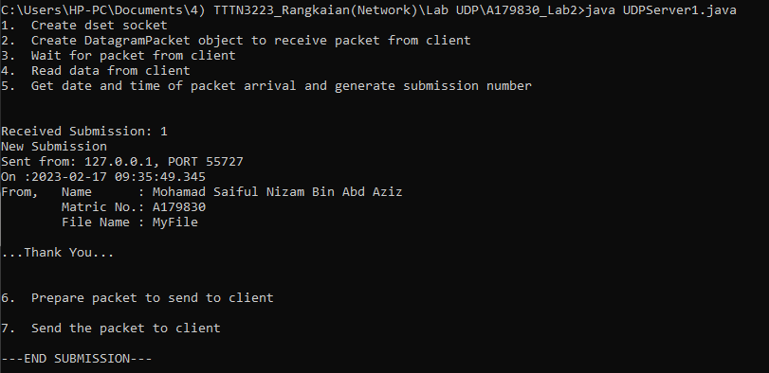
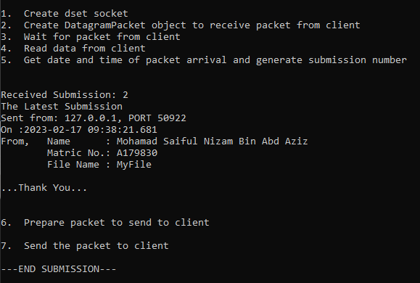

UDPClient1
