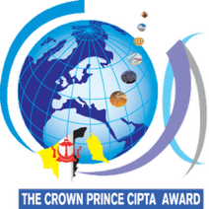
THE CROWN PRINCE CIPTA AWARD 2027
Proposal Form
Title:

Preliminary description of the innovation/product:
Please give a clear description of the creative or innovative product either in Malay or English language, using a maximum of 250 words. This must be typed using word-processing software and may include a maximum of three annotated figures.
The description should offer justifications for the originality of the innovation/product and the concepts behind it and justifications for either some or all of the following:
- The possible impacts of the innovation/product on the economy, environment and society;
- The value/benefits of the innovation/product in terms of consumer needs;
- Its relation to the theme “Bridge. Innovate. Beyond.”

