Introduction

Overview

Instruction pioneers are always searching for the most ideal ways and intends to create instructive organizations keeping in mind the end goal to give an intuitive learning condition that pulls to understudies' advantage and urges them to trade sees. The Internet is a standout amongst other approaches to give an instructive domain.

Understudies utilize the Internet every now and again, get to valuable data, and encourage the making of an instructive stage where every understudy needs clarifications and data about his or her investigation, use however much data as could be expected, and help different understudies.

In our chance, there has been enormous advance in different fields, including training, where ICT has opened another and compelling wellspring of instructing and learning for all people and segments. Instruction through this innovation has turned out to be a standout amongst the most essential mainstays of the age. To the degree that numerous ideas, phrasing, connections and ways of life have changed, is not any more an alternative that can be neglected as much as is important to keep pace with worldwide patterns towards a learning economy, which thusly looks for logical and logical research.

Problem definition

Goals

The overall goal is to help students develop relationships with other students and help them facilitate communication between students and exchange ideas and allow students to recover what they are studying at any time.

Objectives:

1. Facilitating students' access to threatening forms of questions and tests

2. Help students to exchange ideas, which help to think creatively.

3. Accessibility of educational materials.

4. Encourages students to participate.

5. Enhancing student interaction.

6. Acquiring students skills or competencies crisis to use communication and information technologies.

Critical success factors

1. Increase interaction between students and help each other understand the content of the material they are studying

2. Share appropriate educational content for students

3. Provide various forms of questions, exams and tests to be a bank of questions

4. A community that combines all disciplines at all levels

5. Allows all students at all levels to take advantage of the content of the learning platform

Edmodo

Edmodo is a global education network that helps connect all learners with the people and resources needed to reach their full potential. It is a free educational social networking application. It is being used as an alternative to LMSs by universities and Ministries of Educations and schools all over the world because of its Cost is free, it is designed for teachers and students and online learning. It does not have or promote commercial content, It supports low-bandwidth communications so students and instructors can carry on synchronous (real-time or live) and asynchronous (delayed) conversations without the need for a lot of bandwidth. Additionally, students or instructors with smart phones can access the Edmodo app and/or access the course via their phones, versus a computer, it makes for an excellent course site, allowing for readings to be housed in a library, the formation of small groups, discussions to be archived, third-party apps, and posting of photos and videos. And Edmodo mimics Facebook in use and structure and should thus require very little training to use. It mimics an application with which, many instructors and students are familiar. Shown in figure.

Chapter 2: System Analysis

E-learning system is a Web-based system for training programs and information sharing between individuals giving them the flexibility to access it from their workplace or home. Authorized individuals have 24/7 access to this unique system through URL or through a unique User ID and Password.

The E-learning system goes far beyond conventional training by sharing every idea, managing individual training requirements and reporting training progress. Most E-learning platform s are Web-based and facilitate “anytime, anyplace, any pace” access to learning content and administration.

E-learning platforms enable an organization to effectively train a large group of students spread across the organization. With a Learning Platform, training and e-Learning are managed by software that allows users and administrators alike to easily access tests and assignments reports.

Our E-learning platform is being extensively used in placement training and college.

Description of Data Flow Diagram(DFD)

Context diagram

E-learning platform Data flow diagram is often used as a preliminary step to create a summery of the E-learning without going into great detail, which can later be elaborated.it normally, consists of overall application dataflow and processes of the E-learning process. It contains all of the user flow and their entities such all the flow of Student, Activity Log, Assignment, Tests, Subject, levels, specialties. All of the below diagrams has been used for the visualization of data processing and structured design of the E-learning process and working stream.

Overview diagram(level 0)

This is the Zero Level DFD of E-learning Platform, where we have elaborated the high level process of E-learning. It’s a basic overview of the full E-learning platform or process being analyzed or modeled. It is really designed to be an at-a-glance view of specialties and Student showing the system as a single high-level process, with its relationship to external entities of Student, Activity Log and Assignment, Test, levels. That should be easily realized by a wide audience, including Student, Assignment and specialties In zero level DFD of E-learning Platform, we now have a description of the high level flow of the E-learning system. High Level Entities and process stream of E-learning Platform:

▪ Managing all the Student

▪ Managing all the Activity Log

▪ Managing all the Assignment

▪ Managing all the Specialties

▪ Managing all the Tests

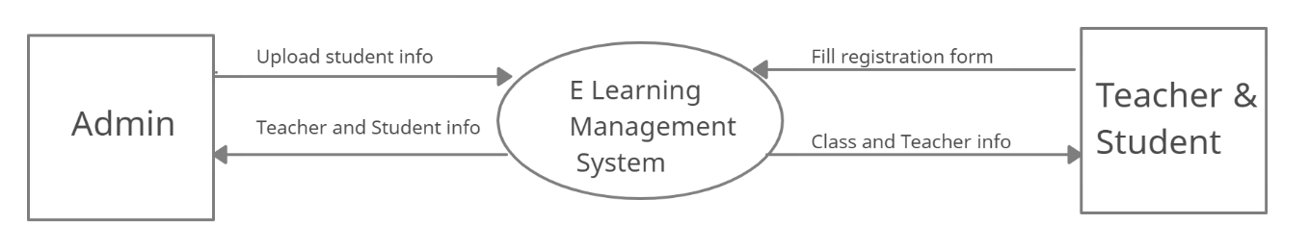

Figure (2.1) Zero Level DFD E-learning platform

Detailed data flows

First level data flow diagram(1st level DFD)

First of all levels DFD (1st level) of e-learning platform shows how the system is consisted sub- systems (processes), each of which works with one or more of the data flows to or from another agent, and which together provide all of the features of the e-learning system as an entire. It also identifies inside data stores of college student, subject, test, specialties, task that must be present in order for the e-learning platform to do its job, and shows the flow of information between the various parts of student, assignment, check, specialty of the system. DFD level 1 provides a more detailed large of pieces of the 1st level DFD. You will highlight the primary features of e-learning.

Main entities and output of |first of all level DFD (1st level DFD):

* processing student data and generate report of most students.
* processing assignment records and generate report of all assignment processing files data and generate report of all tests.
* processing specialties records and generate survey of all specialties.

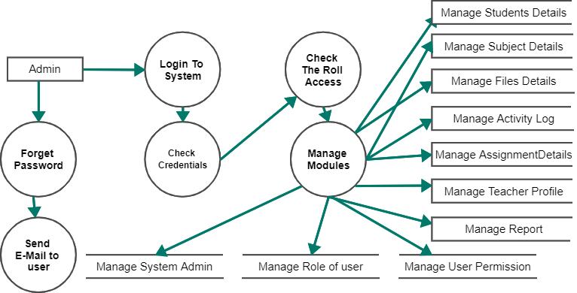

E learning platform ER diagram

This kind of ER (entity relationship) diagram shows the model of e-learning platform entity. The entity-relationship diagram of e-learning platform represents all the visual instrument of database tables and the relations between students, tests, specialties and assignment. It used structure data also to define the relationships between structured data sets of e-learning platform functionalities. The main entities of the e-learning platform are students, courses, tests, specialties, assignment.

E learning platform entities and their attributes:

Student entity: attributes of students are student_id,student_college_id, student_name,student_mobile,student_email,student_password,student_username, student_password, student_address,student_level.

Course entity: attributes of courses are course_id, course_name, course_description.

Specialties entity: attributes of specialty are specialty_id, specialty_name, specialty_description.

Test entity: attributes of test are test_id, test_name, test_file, test_description, course_id.

Assignment entity: attributes of assignments are assignment_id, assignment_name, assignment_file, assignment_description, course_id, student_id.

Description of e-learning platform database:

1. The details of courses is store into the course tables respective with all tables

2. The details of students is store into the students tables respective with all tables

3. The details of specialties is store into the specialties tables respective with all tables

4. Each entity (courses, students, assignments, tests, specialties) contains primary key.

5. The entity tests, assignment has related with course, students entities with foreign key

6. There are one-to-one and one-to-many relationships available between courses, students, assignments, tests, and specialties

7. All the entities courses, students, assignments, tests, specialties are normalized and reduce duplicity of records

8. I have implemented indexing on each table of e-learning platform tables for fast query execution.

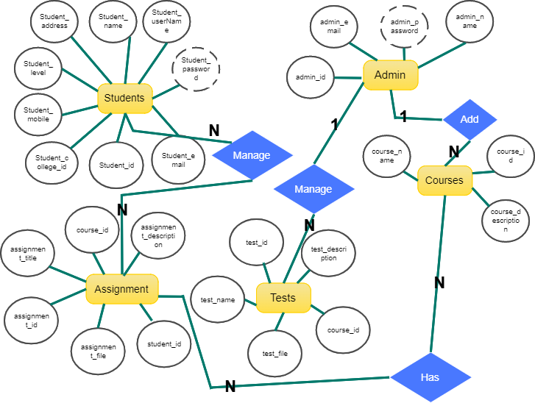

Figure (2.4) ER diagram for E-learning platform

Class Diagram:

As shown in figure (2.8) E-learning platform Class Diagram describes the structure of a E-learning platform classes, their attributes, operations (or methods), and the relationships among objects.

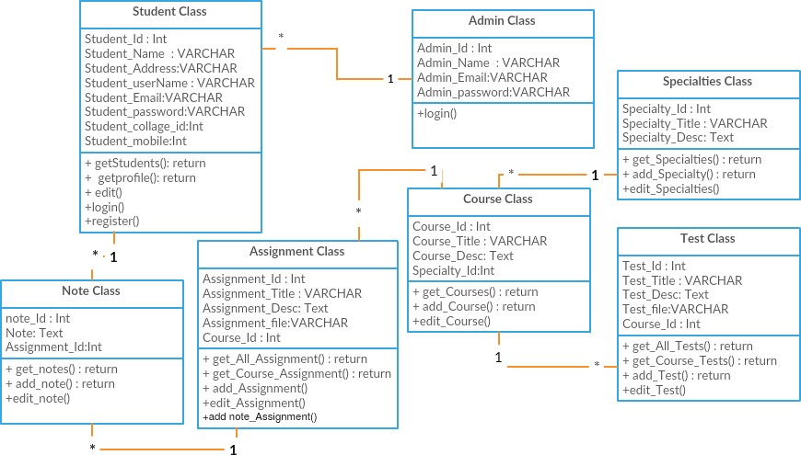

Figure (2.8) Class diagram for E-learning platform

Chapter 3: System Design

Overview

Development of software systems requires analysing of the process to be digitized in order to enable a correct system, a system that functions as required and also to assist the potential users of the system understand the general functionality of the system. The target specifies the system's objectives and constraints to which designers have to confirm. The objective of doing analysis is to remodel the anatomy’s major inputs into organized specification.

Functional Requirements

In this section we will discuss different functional requirement of different user.

Admin

FR1: Create usernames and passwords.

FR2: Manage students account.

FR3: Ability to login and update proﬁle.

FR4: Ability to logout after the completion of process.

FR5: Ability to create, edit or delete courses.

FR6: Ability to create, edit or delete test.

FR7: Ability to create, edit or delete assignments.

FR8: Ability to create, edit or delete specialties.

Students

FR1: ability to download tests

FR2: Ability to view assignments.

FR3: Ability to share solutions of assignments.

FR4: Register data.

FR5: Ability to login and update proﬁle.

FR6: Ability to logout after the completion of the process.

Non-Functional Requirements

Consistency.

Convenience.

Availability.

Usability.

Security.

Reliability.

Database Design

This section describes the six tables that are linked to our project. These six tables is described in the following point:-

Admin.

Students.

Specialties.

Courses

Assignments.

Tests.

Admin

The Admin table stores the information about Admin profile. All the Admins who will manage the system will be saved in this table.

**Table 3.1 Admin**

|  |  |  |  |  |  |
| --- | --- | --- | --- | --- | --- |
| Field Name | Data Type | Length | Key | A_T | Default value |
| Admin_id | Int | 11 | Primary key | √ | None |
| Admin_email | VARCHAR | 150 |  |  | None |
| Admin_password | VARCHAR | 100 |  |  |  |
| Admin_name | VARCHAR | 50 |  |  |  |

Specialties:

The table specialty stores all specialties requested through the platform will issue. All of these specialties data will be in this table.

**Table 3.3 Specialties**

|  |  |  |  |  |  |
| --- | --- | --- | --- | --- | --- |
| Field Name | Data Type | Length | Key | A_T | Default Value |
| Specialty_ id | INT | 11 | Primary Key | √ | None |
| Specialty_ title | VARCHAR | 20 |  |  | None |

Student

The table Student stores the information about Student profile. The entire Student who signs up the system will be saved in this table.

|  |  |  |  |  |  |
| --- | --- | --- | --- | --- | --- |
| Field Name | Data Type | Length | Key | A_T | Default value |
| Student_ id | Int | 11 | Primary Key | √ | None |
| student_username | VARCHAR | 20 |  |  | None |
| student_ password | VARCHAR | 20 |  |  | None |
| Student_email | VARCHAR | 50 |  |  | None |
| Student_name | VARCHAR | 50 |  |  | None |
| Student_collage_id | Int | 10 |  |  | None |
| Student_ address | VARCHAR | 50 |  |  | None |
| Student_ level | VARCHAR | 11 |  |  | None |
| Student_ mobile | VARCHAR | 11 |  |  | None |

Courses

The table course stores all courses belong to specialty through the platform. All of these courses data will be in this table.

|  |  |  |  |  |  |
| --- | --- | --- | --- | --- | --- |
| Field Name | Data Type | Length | Key | A_T | Default Value |
| Course_ id | INT | 11 | Primary Key | √ | None |
| Course_ title | VARCHAR | 20 |  |  | None |
| Course_ description | TEXT |  |  |  | None |

Assignment

The table Assignment stores all Assignments which added by students through the platform .All of these Assignments data will be in this table.

**Table 3.5 Assignments**

|  |  |  |  |  |  |
| --- | --- | --- | --- | --- | --- |
| Field Name | Data Type | Length | Key | A_T | Default Value |
| Assignment_ id | INT | 11 | Primary Key | √ | None |
| Assignment _ title | VARCHAR | 50 |  |  | None |
| Assignment _ description | TEXT |  |  |  | None |
| Assignment_file | VARCHAR | 50 |  |  | None |
| Course_id | Int | 11 | Foreign key |  | None |