

Bug Report for E-Shop

Lab Report



**Team Members:**

Md. Saifur Rahman

Roll: ASH1825031M

Akash Chandra Debnath

Roll: ASH1825037M

**Institute of Information Technology**

**Noakhali Science and Technology University**

19-02-2022

**Software Testing Life Cycle for E-Shop**

**Phrase 01: Requirement Analysis**

|  |  |
| --- | --- |
| Functional Requirements | Non-Functional Requirements |
| Keeping the records of products. | Security |
| Keeping records of admission of customers and access control. | Performance |
| Keeping the daily sell. | Reliability |
| Keeping details about the product it is delivered or not. | Scalability |
| Storing the items selected by the customer in the temporary storage. | Maintainability |
| Storing the feedback given by the customer. | Portability |
| Registration to the system | Extensibility |
| Minimum steps to make a purchase | Reusability |
| Product Attributes |  |
| Mobile-friendliness |  |
| Unique, recognizable design |  |
| Relevant, useful content |  |
| Email newsletter tools |  |
| Shipping & payment systems integration |  |

**Phrase 02: Test planning & Strategies**

**A] Unit testing -:**

Definition -: Test individual unit of E-Shop

Tested by -: Developer

Methodology -: Test individual unit of E-Shop

**B] Integration and System Testing -:**

Definition -: Integration testing test two or more than two integrated models System testing test functional and non-functional user requirement.

Tester by -: Tester

Methodology -: It is used for integrated model, functional and non-functional user requirement.

**C] Performance Testing -:**

Definition -: It measure performance / response under critical, load and stress condition

Tested by -: Tester

Methodology -: Measure performance under critical, stress and load system

**D] Regression Testing -:**

Definition -: Used to uncover new errors in existing functionality after changes have been made.

Tested by -: Tester

Methodology -: Test system response after functional enhancements in existing system.

**Testing tool:**

1. QTP
2. Selenium

**Phrase 03: Test Case Development**

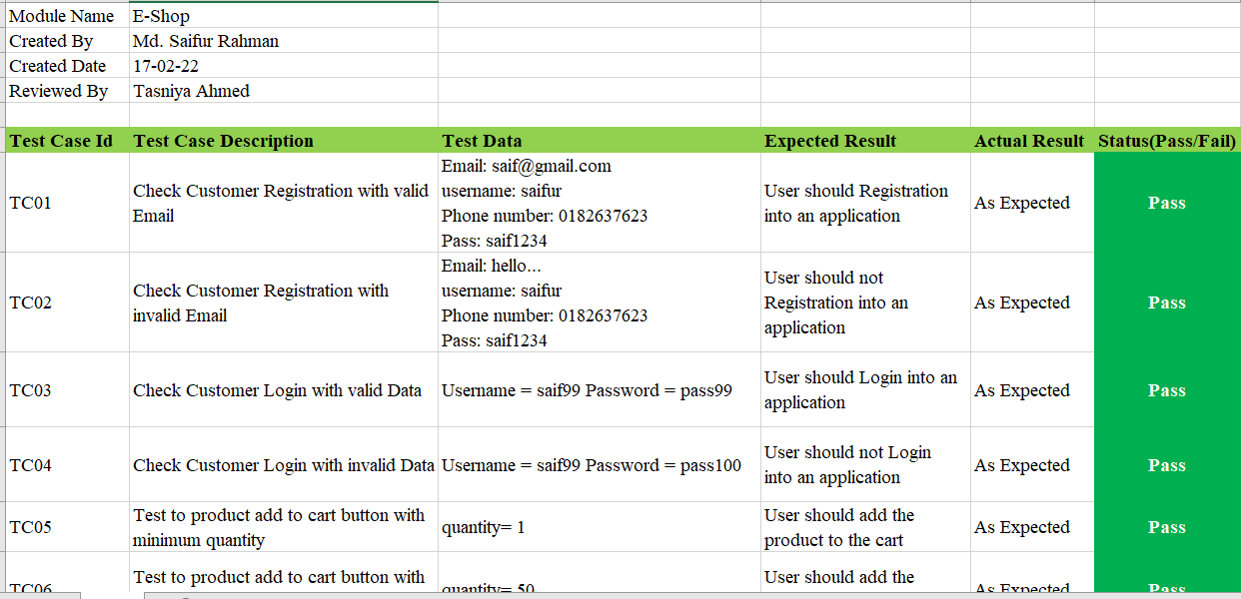

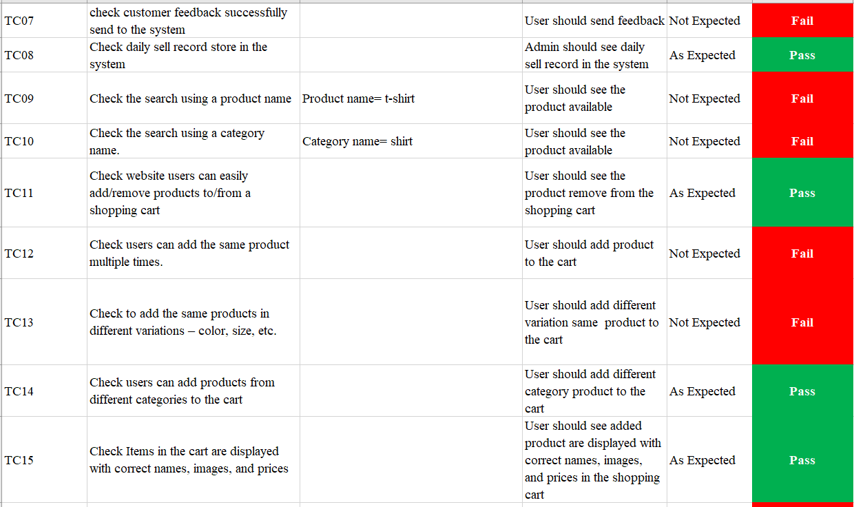

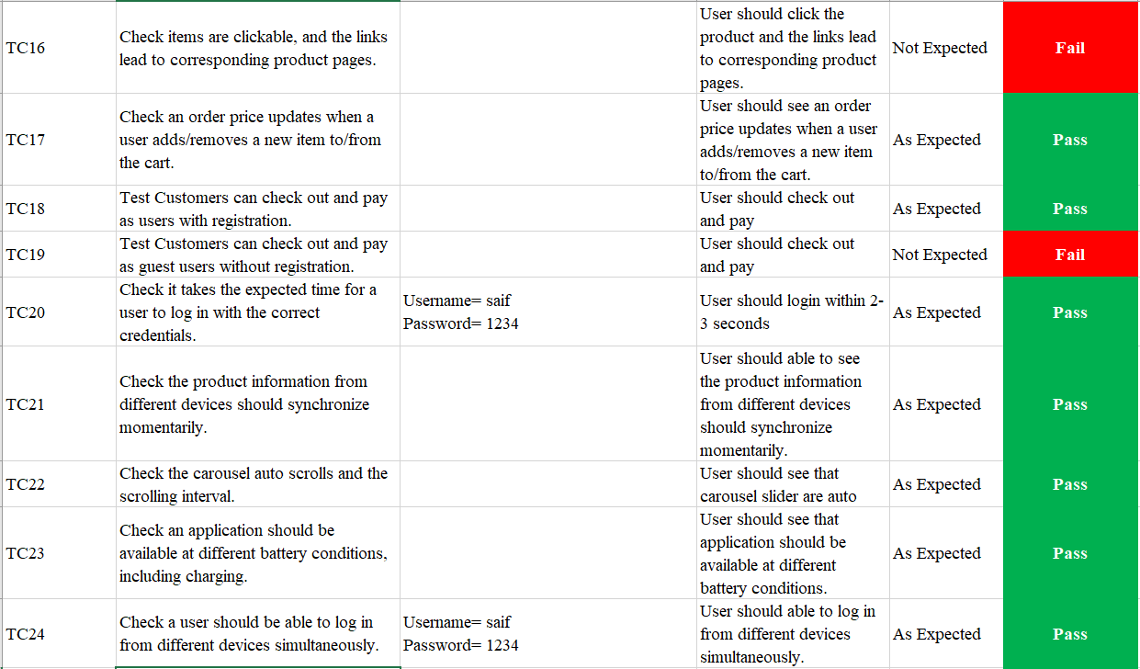

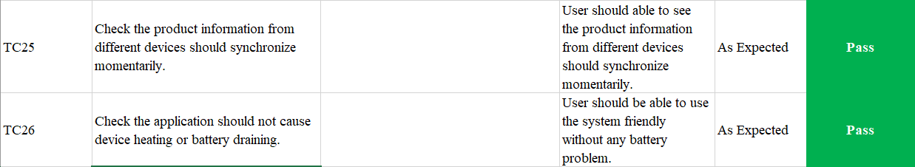

**Phrase 04: Environment Setup**

* Hardware: Dual Core or above machines
* Software: Microsoft Windows 10 installed

**Phrase 05: Test Execution & Bug reporting**

**Test Execution Report:**

|  |  |  |  |  |  |  |  |
| --- | --- | --- | --- | --- | --- | --- | --- |
| Scenarios | Complexity | Responsible  Tester | Date of  Execution | Status  (Pass/Fail) | BugID | Severity | Status |
| Verify if a user will be able to register with a valid information. | Medium | Saifur | 18-02-2022 | Fail | 101 | High | Regist-  ration  Error |
| Verify if a user will be able to login with a valid email and password. | Complex | Saifur | 18-02-2022 | Pass |  |  |  |
| Verify if a user will be able to login with a valid email and password. | Complex | Saifur | 18-02-2022 | Pass |  |  |  |
| Check if user will be able to add product to shopping cart | Complex | Akash | 18-02-2022 | Pass |  |  |  |
| Check if admin will be able to change his password | Complex | Saifur | 18-02-2022 | Fail | 102 | High | Update Fail |
| Check if user will be able to input product quantity | Medium | Saifur | 18-02-2022 | Pass |  |  |  |
| Verify if user will be able to remove from cart | Medium | Akash | 18-02-2022 | Pass |  |  |  |
| Verify if user will be able to checkout product and order confirm | Complex | Saifur | 18-02-2022 | Pass |  |  |  |
| Verify that user will be able to input correct payment information | Complex | Saifur | 18-02-2022 | Fail | 103 | High | Trans-  action  ID  Valid-  ation |
|  |  |  |  |  |  |  |  |

**Bug Report:**

Bug Name: Verify if a user will be able to register with a valid information.

Bug Id: 101

Expect Result: Registration Successfully

Build Version: 1.0

OS: Windows 10

Severity: High

Priority: High

Bug Name: Check if admin will be able to change his password

Bug Id: 102

Expect Result: Updating Successfully

Build Version: 1.0

OS: Windows 10

Severity: High

Priority: High

**Phrase 06: Test Cycle Closure**

|  |  |  |  |  |  |
| --- | --- | --- | --- | --- | --- |
| Test Cycle | Number of test cases | Test case execute | Test case not execute | Test Case pass | Test case fail |
| Cycle 01 | **19** | **19** | **0** | **12** | **7** |
| Cycle 02 | **7** | **7** | **0** | **7** | **0** |
| Total | **26** | **26** | **0** | **19** | **7** |