**Group members: Ali Raza khan Saifullah khan**

Sidra Ayesha Noman Shehzad

Becoming Scientists..

(to be Continued)

Artificial intelligence

**Acknowledgment**

We are highly grateful to our respected teacher Dr. Junaid Akhtar, who provided us the opportunity to learn the scientific method, and using scientific method to to solve computational problems. And we are on our way to become “scientists”. :)

**Problem statement**

We have to find out a sample image from a big image not by programming and engineering techniques but a scientific approach for solving computational problems. This technique is referred to a different domain of algorithms called **Evolutionary** or **Genetic Algorithms.**

Our goal was just like to find a specific car in traffic. Possible inputs are a picture of a group of many cars and a picture of target car to be searched.

**Natural Phenomenon+Theory:**

The idea was inspired from a famous biological theory Theory of Evolution by Charles Darwin. He stated that “Every specie is evolved from its ancestor specie”. He explained his theory by writing a complete book named “Origin of Species”. The first thing which gained Darwin’s interest was the beaks of Finches. He noticed that same specie, Finches, were having long beaks that was best suitable for eating grain and in another region, Finches had short beaks, good for nut cracking. He studied it in his laboratory and came up with the idea that if grains are endangered than the finch with the long beaks would have low chances of surviving. But the nature won’t allow too quick change or evolution, but it would a specie to whether evolve or disappear slowly and gradually. Based on this he stated that specie is evolved from a single cell or origin, so are humans.

The key idea was that one specie turn into another specie with a very small change as time passes by, depending on the requirements of environment. If the specie can survive in that environment it is referred as “Best Fit”, also these two words are base of his “Theory of Evolution”.

Hence our algorithm uses the same idea of Darwin’s theory of evolution, that our initial population can evolve into another with a very small change, but deriving from its parent. Hence we select a patch of the large image and compare it with targeted search which will give us a constant matched value. And based on this value we add small changes to each member of population. By juncture of two members having highest matching values we determine two new children which may take us closer to the our desired output. Below is a picture of natural phenomena and the representation of what Darwin purposed in his books embedded in the document:

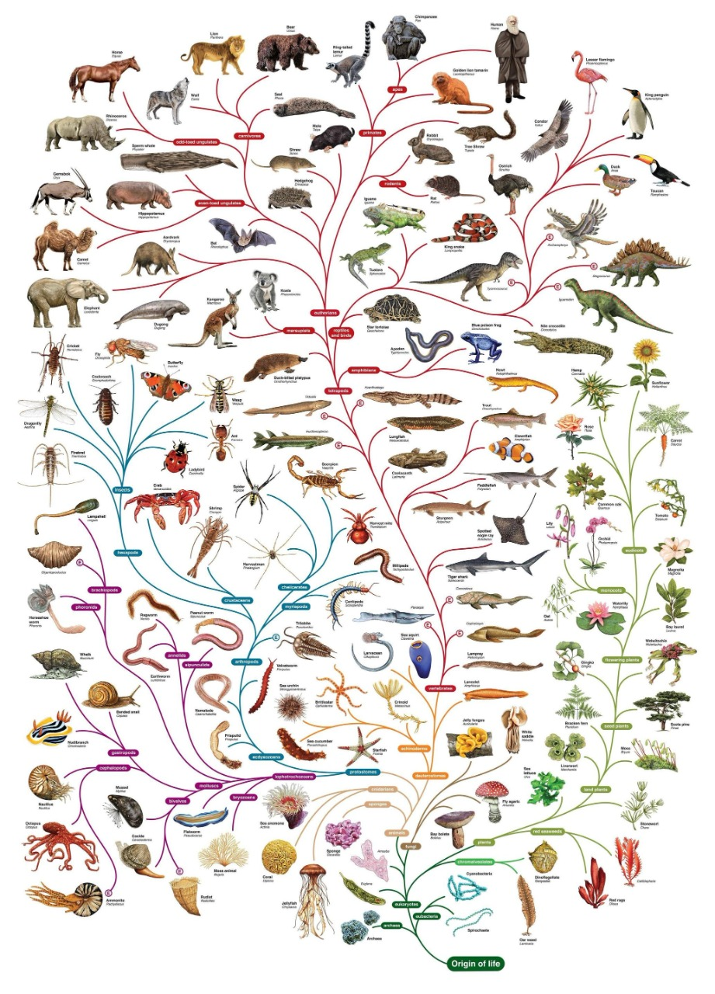

**Computational Model:**

Below is a graphical representation of the actual computational model we followed in solving the problem.

|  |
| --- |
|  |

**Application:**

Following are the steps that we have used in our algorithm:   
InitializePopulation  
Fitness  
selection  
crossover  
mutation  
stopping criteria

**Population(initialization)**

The first step of our algorithm is to initialize the population. Means that, first we have to select some random points of the larger image to compare with the small image. Firstly we find the length & width of the image so that the points should not from out of the image. We initialized an array of size 100 to generate 100 points from the image. Then we generated 100 different points from the image & stored in array.

**Fitness**

In this step we compared the small image with the all points of the initial population. We found the co-relation between small image & initial points. By this we found that how much small image matches with these points. And stored co-relation of all the points in dictionary. Then we sorted the list according to the co-relation.

**Selection:**  
 Then we see that whether the best fitness matches with our defined threshold or not. If not then we have to crossover the points according to the best fit. I.e. we have to do crossover between first & second, third & fourth & so on.

**Crossover:**  
 In this step we have to do crossover between two points. So first we converted both the points into binary. Then we have generated a random number less than the length of binary number. On this number we have to make a cut. We made a cut on both the numbers & then swapped LSBs of both the numbers. So two new numbers are generated. We have to do this on all the population. So finally we got a new list of population.

**Mutation**

In some of the cases crossover doesn’t work. For example if selected LSB bits of both the points are same then again same number is generated & we have duplication in population. So to avoid this problem we used mutation in our code. In this step we generate a random number less than the length of binary representation of number & flip the bit of number at that position.

**For example:**

If bit is 0 then it will become 1 & if it is already one then it will become 0.

Stopping Criteria:   
 To stop our algorithm we should must have a stopping criteria. So we defined it that if threshold become 0.9 then the algorithm will start & if after 1000 iterations threshold does not match to 0.9 then it will stop & will give maximum match.

**The Experiments...**

1.

2.