**Name: Saif Ullah Awan**

**Intern ID:** **TN/IN01/PY/015**

**Email ID : saifullahawan865@gmail.com**

**Internship Domain : Python Development**

**Task Week : 1,2,3**

**Instructor Name : Hassan Ali**

**Task 1 :**

Setup Your Python Envirenment i.e IDE , Externsions , package manager etc

**Solution :**

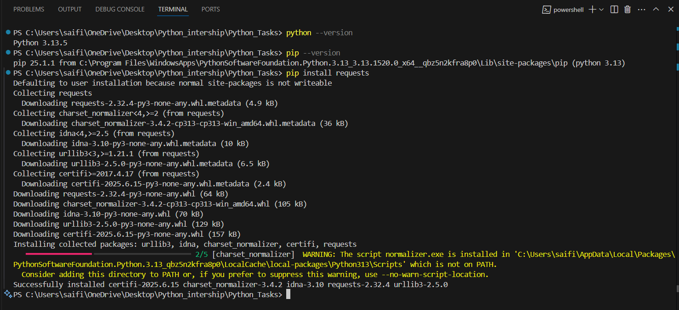

**Task 2**

**Write a Python script that prints:**

**Your name , Your Hobby , Age & Why you want to learnPython.**

**Solution :**

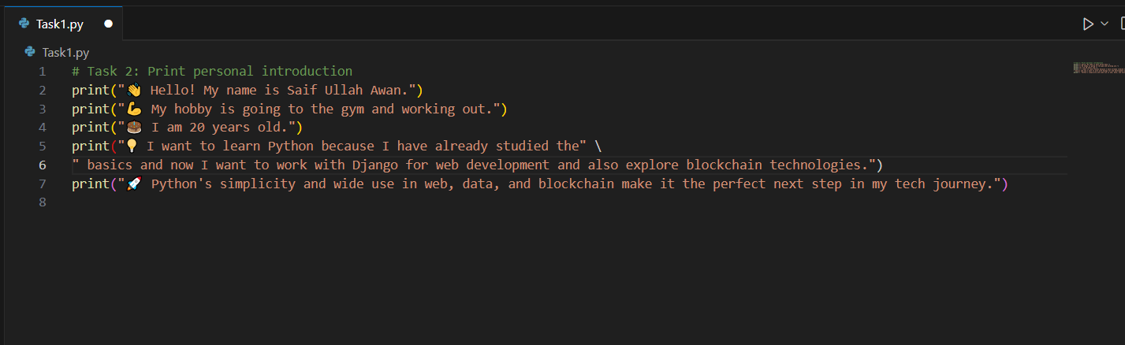

**Output:**

**Task 3**

**Write a Python script that prints:**

**Ask the user to input two numbers, Print the result of their addition.**

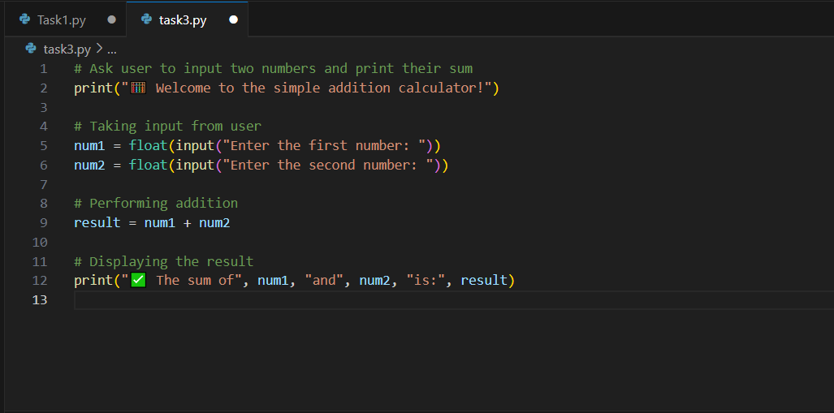

**Solution :**

**WEEK 2 TASKS:**

**Task 1:**

**Create a mini profile for a fictional user using variables. Store the following information:**

**Full name, Age , Current year, Country, Hobby, Expected graduation year (calculate it from current year + 4)**

**Print all details in a proper sentence format.**

**Also print how many years are left till graduation.**

**SOLUTION:**

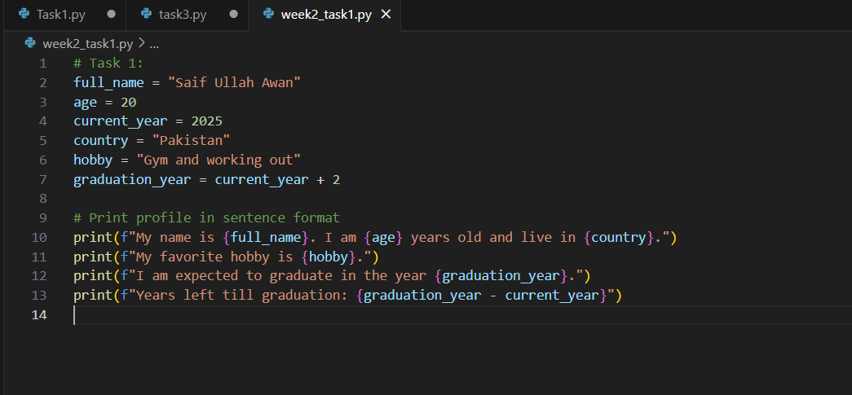

**OUTPUT:**

**Task 2:**

**Create 3 different user profiles (using variables). For each profile, include:**

**Name, profession, country, is employed (Boolean)**

**Print their data in a tabular format using print () (not with external libraries).**

**CODE:**

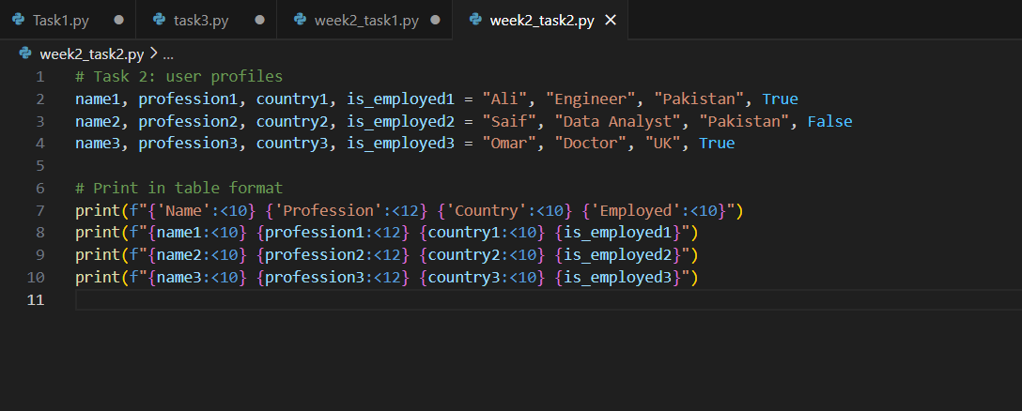

**Output:**

**Task 3:**

Write a program that:

Declares five different variables , Stores a different data type in each (e.g., string, integer, float, boolean, complex)

Prints their values and data types

Then, converts each variable to a different type (where possible) and prints the new types

Note: You may not be able to convert all types — handle errors or comment why.

**OUTPUT:**

**Task 4:**

Create a data type tester:

Ask the user to input any value. , Detect and print what Python guesses its type as (use type()).

Add conditions to identify if it's likely an integer, float, or string, and print a message like:

"You entered a float!"

**SOLUTION:**

**OUTPUT:**

**Task 5:**

Design a command-line survey that:

Asks the user 5 different questions (e.g., name, favorite food, birth year, favorite number, favorite language)

Then prints a summary of all responses in sentence format.

Use formatting to make the output look professional (e.g., f-strings).

**SOLUTION:**

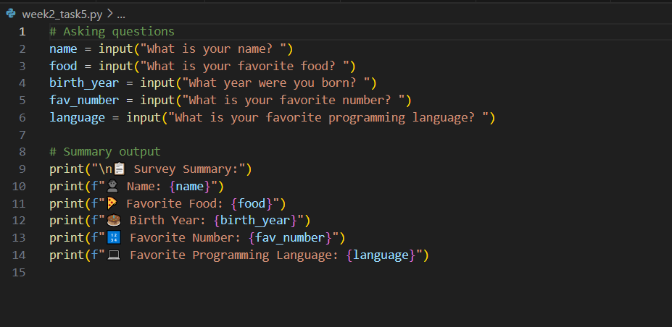

**OUTPUT:**

**Task 6:**

Ask the user to:

Enter their year of birth, Calculate their age (based on current year) ,Check if the user is eligible to vote (18+ years)

Display a message:

"You are eligible to vote." or "You are not eligible to vote yet."

**SOLUTION:**

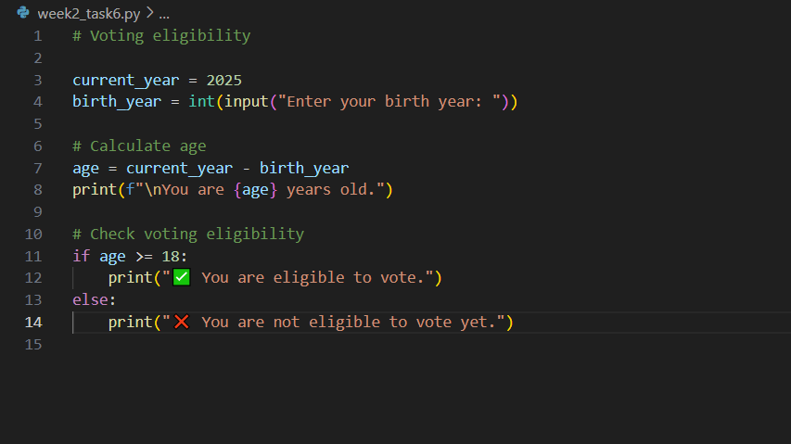

**OUTPUT:**

**Task 7:**

Create a marks percentage calculator:

Ask user to input marks for 5 subjects (input as strings) , Convert them to integers

Calculate the total and percentage

Print percentage along with a grade: A (90+), B (80-89), C (70-79), Fail (<70)

**SOLUTION:**

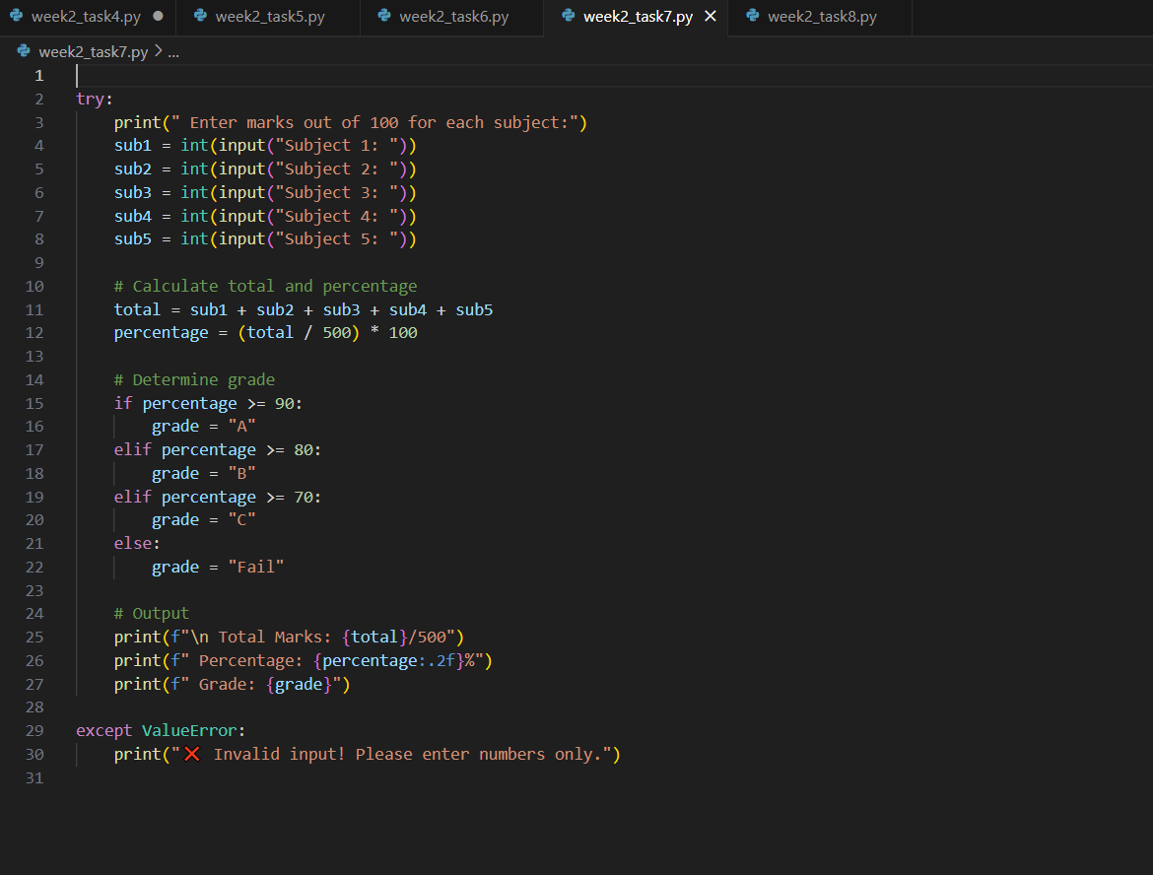

**OUTPUT:**

**Task 8:**

Create a temperature converter:

Ask the user to input temperature in Celsius.

Convert it to Fahrenheit using: F = (C * 9/5) + 32 , Then reverse: Ask for Fahrenheit, convert it to Celsius.

Handle wrong input types using try-except.

**SOLUTION:**

**OUTPUT:**

**WEEK 4:**

**Task 1: Calculator with Operator Input**  
Description:  
Create a calculator that:

* Accepts two numbers and an operator (+, -, *, /, %, //, **)
* Performs the corresponding operation
* Handles division by zero safely

**SOLUTION:**

**OUTPUT:**

**Task 2: Grading System  
Description:**  
Take marks of 3 subjects and:

* Calculate total marks
* Calculate percentage
* Assign grade:
  + A (>=85)
  + B (>=70)
  + C (>=50)
  + Fail (<50)

**SOLUTION:**

**OUTPUT:**

**Task 3: Income and Savings Analyzer  
Description:**  
Ask the user for:

* Monthly income
* Monthly expenses

Calculate savings and classify:

* Greater than 10000: Saving Well
* Between 5000 and 9999: Average
* Less than 5000: Try to Save

**SOLUTION:**

**OUTPUT:**

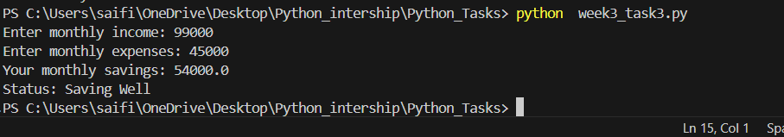

**Task 4: Simple Login System  
Description:**  
Prompt user for:

* Username
* Password

Validation:

* If username is 'admin' and password is '1234': Access Granted
* Otherwise: Access Denied

**SOLUTION:**

**OUTPUT:**

**Task 5: Promotion Eligibility  
Description:**  
Ask for:

* Attendance percentage
* Final exam marks

Decision:

* If attendance is greater than or equal to 75 and marks are greater than or equal to 50: Promoted
* Otherwise: Not Promoted

**SOLUTION:**

**OUTPUT:**

**Task 6: Billing System with Discount  
Description:**  
Input:

* Number of products
* Total price

Apply Discounts:

* If total price is greater than 1000 and number of products is greater than 3: 15% discount
* If total price is greater than 500: 10% discount
* Otherwise: No discount

Show the final bill after applying the appropriate discount.

**SOLUTION:**

**OUTPUT:**

