**Name: Saif Ullah Awan**

**Intern ID:** **TN/IN01/PY/015**

**Email ID : saifullahawan865@gmail.com**

**Internship Domain : Python Development**

**Task Week : 5**

**Instructor Name : Hassan Ali**

**WEEK 4:**

**Task 1: Calculator with Operator Input**  
Description:  
Create a function `square_numbers` that takes a list of numbers and returns a list of their squares.

**SOLUTION:** 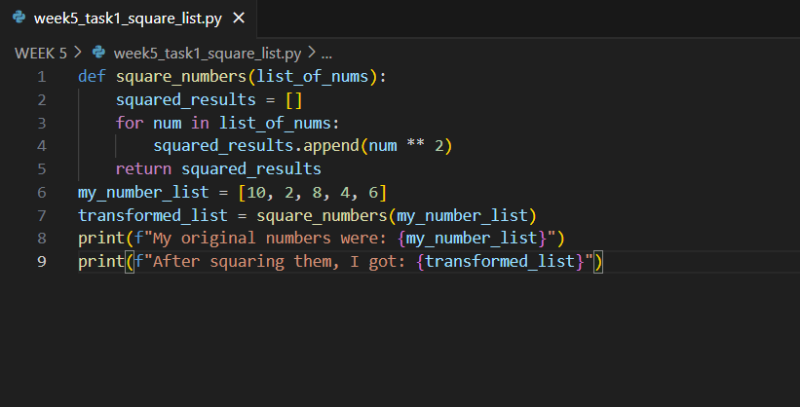

**OUTPUT:**



**Task 2:   
Description:**  
Create a function `is_even_or_odd` that takes a number and returns whether it is even or odd.

**SOLUTION:**

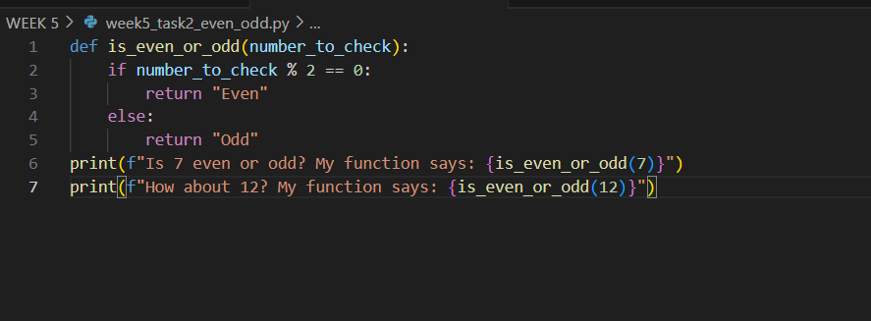

**OUTPUT:**

**Task 3:   
Description:**  
Write a function `calculate_area` that takes radius and returns area of a circle.

**SOLUTION:**

**OUTPUT:**



**Task 4:**

**Description:**

Write a function `greet_user(name, age)` that returns a greeting like: 'Hello Ali, you are 20 years old.'

**

**OUTPUT:** 

**Task 5:   
Description:**  
Create a function `change_counter()` that modifies a global counter variable.

**OUTPUT:** 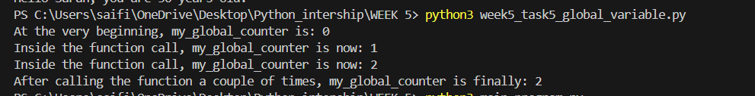

**Task 6:   
Description:**  
Create a module named `math_tools.py` with a function `multiply(x, y)` and use it in another script.

**SOLUTION:**

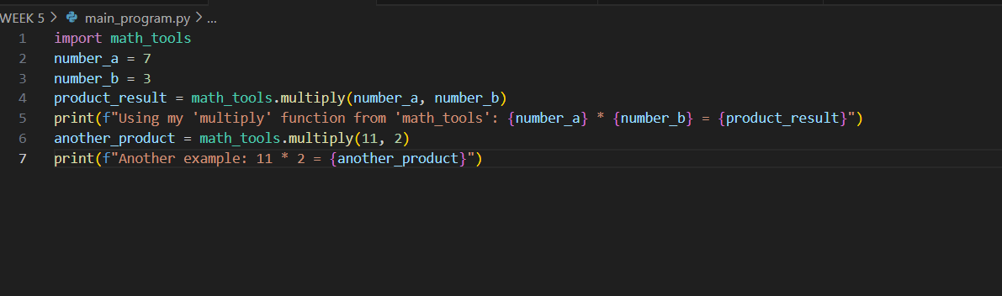

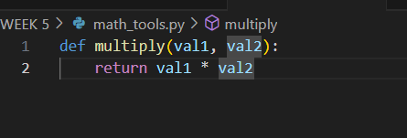

**OUTPUT:** 