**Name: Saif Ullah Awan**

**Intern ID:** **TN/IN01/PY/015**

**Email ID : saifullahawan865@gmail.com**

**Internship Domain : Python Development**

**Task Week : 6**

**Instructor Name : Hassan Ali**

**WEEK 6:**

**📊 Task 1**

**Description:**

Use math and statistics libraries to calculate the square root of a list of marks and find the average.

**Solution:**

***import math  
import statistics  
  
marks = [65, 78, 90, 88]  
sqrt_marks = [math.sqrt(m) for m in marks]  
avg = statistics.mean(marks)  
  
print("Square Roots:", sqrt_marks)  
print("Average:", avg)***

**Output:**

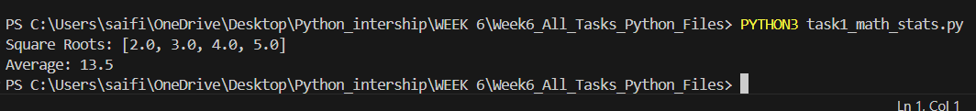---

**📁 Task 2**

**Description:**

Create a custom Python module and import it in another script to display a greeting.

**Solution:**

***import custom_package.module as mod  
  
mod.greet("Saif Ullah Awan")***

**Custom Module (module.py):**

***def greet(name):  
 print(f"Hello, {name}! Welcome to Python scripting.")***

**Output:**



**📃 Task 3**

**Description:**

Create a Python script to print the versions of the 'requests' and 'numpy' libraries.

**Solution:**

***import requests  
import numpy  
  
print("Requests version:", requests.__version__)  
print("NumPy version:", numpy.__version__)***

**Output:**

---****

**🔢 Task 4**

**Description:**

List all the currently installed pip packages using Python.

**Solution:**

***import pkg_resources  
  
for dist in pkg_resources.working_set:  
 print(dist.project_name, dist.version)***

**Output:**



