# Overview:

I've been told that the travel review rating dataset includes a survey of both males and females in a range of contexts. As a result, I looked into the specific issues with the data set and have presented my results below. I covered in depth this particular data set using data visualization tools. By analyzing and changing the data, the issues with the set of data were discovered (https://archive.ics.uci.edu/ml/datasets/tarvel+review+ratings#). When all of the data has been arranged according to each response derived from the data set, after evaluation with visual analysis of the type of data presented in each analysis, and lastly, when each question has been resolved, a result has been made in order to address each.

# Descriptive Stats of Data:

The travel review rating dataset have 25 columns and 5457 rows. Each column shows the rating.

* The first column’s name is User which shows all the users in this data set (user1, user2, user3, etc.).
* The second column’s name is category.1 which shows the rating which is on numeric type of data between 0 to 5
* The third column’s name is category.2 which shows the rating which is on numeric type of data between 0 to 5.
* The fourth column’s name is category.2 which shows the rating which is on numeric type of data between 0 to 5.
* The fifth column’s name is category.3 which shows the rating which is on numeric type of data between 0.83 to 5.
* The second column’s name is category.4 which shows the rating which is on numeric type of data between 1.12 to 5.
* The sixth column’s name is category.5 which shows the rating which is on numeric type of data between 1.11 to 5.
* The seventh column’s name is category.6 which shows the rating which is on numeric type of data between 1.12 to 5.
* The eighth column’s name is category.7 which shows the rating which is on numeric type of data between 0.86 to 5.
* The ninth column’s name is category.8 which shows the rating which is on numeric type of data between 0.84 to 5.
* The tenth column’s name is category.9 which shows the rating which is on numeric type of data between 0.81 to 5.
* The eleven column’s name is category.10which shows the rating which is on numeric type of data between 0.78 to 5.
* The twelve column’s name is category.11which shows the rating which is on numeric type of data between 0.78 to 5.
* The Thirteen column’s name is category.12 which shows the rating which is on numeric type of data between 0.77 to 5.
* The fourteen column’s name is category.13 which shows the rating which is on numeric type of data between 0.76 to 5.
* The fifteen column’s name is category.14 which shows the rating which is on numeric type of data between 0 to 5.
* The sixteen column’s name is category.15 which shows the rating which is on numeric type of data between 0 to 5.
* The seventeen column’s name is category.16 which shows the rating which is on numeric type of data between 0 to 5.
* The eighteen column’s name is category.17 which shows the rating which is on numeric type of data between 0 to 5.
* The nineteen column’s name is category.18 which shows the rating which is on numeric type of data between 0 to 5.
* The twenty column’s name is category.19 which shows the rating which is on numeric type of data between 0 to 5.
* The twenty first column’s name is category.20 which shows the rating which is on numeric type of data between 0 to 5.
* The twenty second column’s name is category.21which shows the rating which is on numeric type of data between 0 to 5.
* The twenty third column’s name is category.22 which shows the rating which is on numeric type of data between 0 to 5.
* The twenty fourth column’s name is category.23 which shows the rating which is on numeric type of data between 0 to 5.

# Data Type:

# Data Importation:

This is how we imported a data collection into compiler and this data have 5457 rows and 25 columns. .



# Data Presentation:

In this method after importing the data set I can print the data to check the data which I loaded.

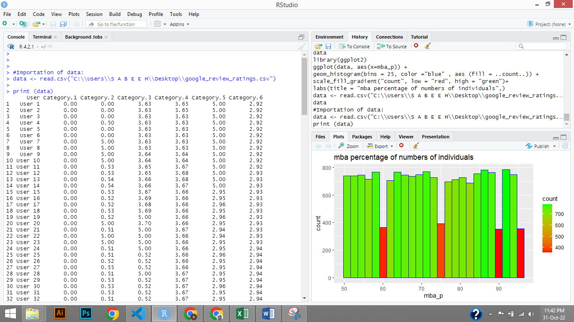

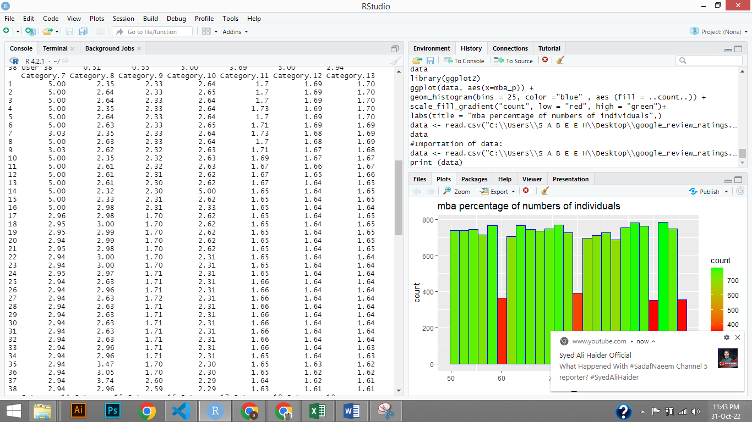

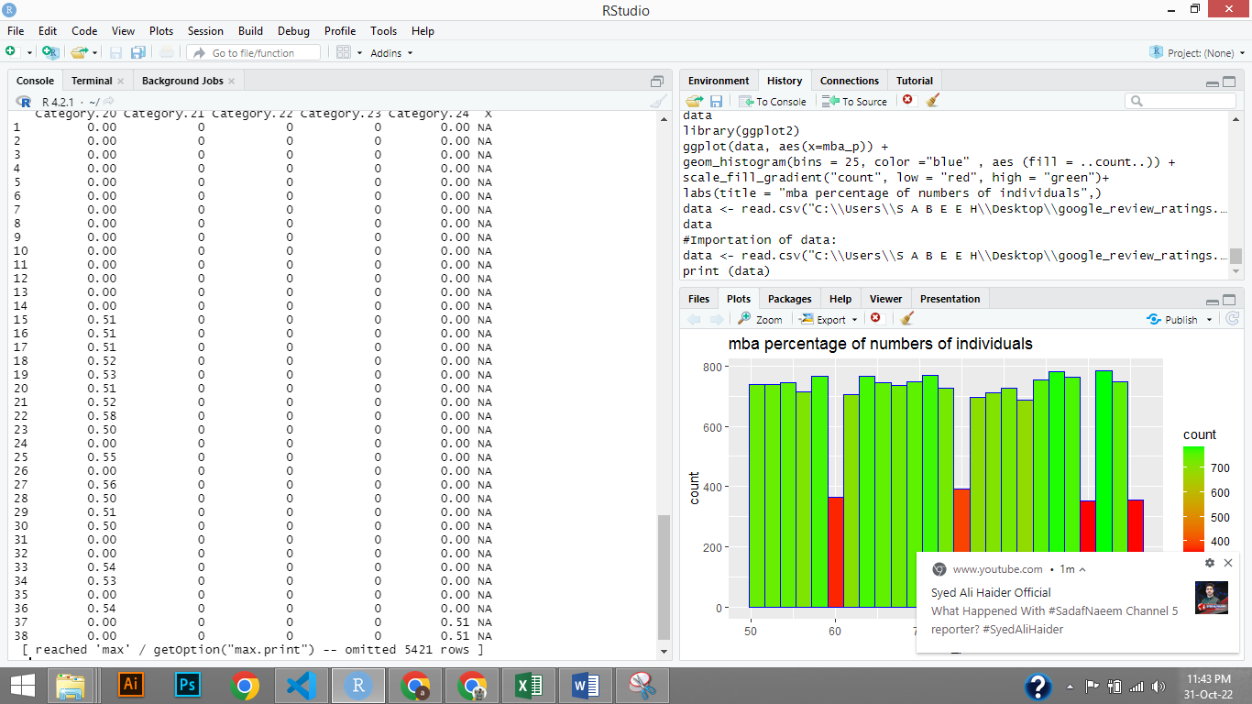

# Structure of data:

Through this method I can check the structure of the data before the analyzation.

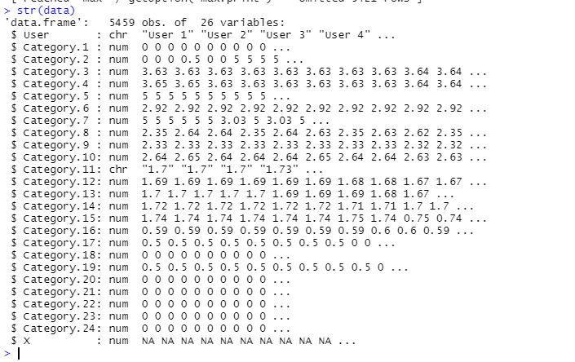

# Data Cleaning:

First we need to install the library (tidyr) for cleaning the data. The method shown in the figure which is given below.

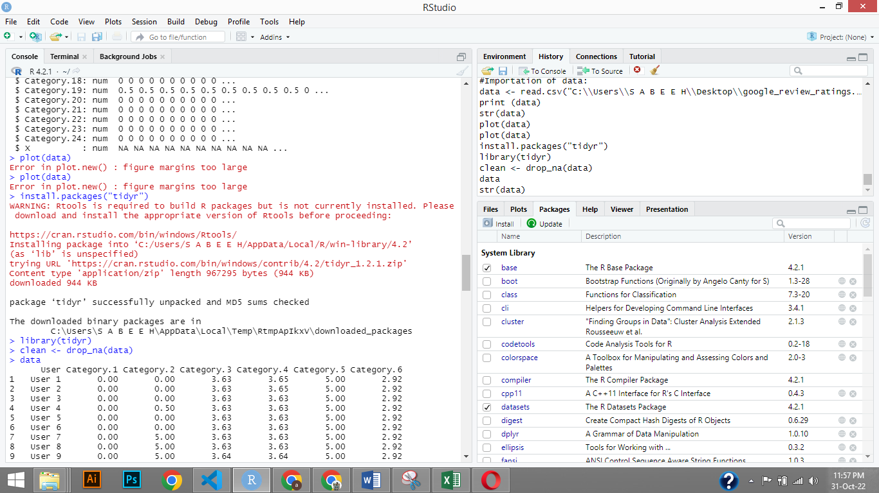

# Analysis 1:

# Graph

# Explanation

# Analysis 2:

# Graph

# Explanation

# Analysis 3:

# Graph

# Explanation

# Analysis 4:

# Graph

# Explanation

# Analysis 5:

# Graph

# Explanation

# Conclusion:

# Reference: