- Print your name in green.
- Print the numbers 1 - 10, each number being a different color.
- Prints your name in a Tahoma font. Print a paragraph with 4 - 5 sentences. Each sentence should be a different font.
- Print a paragraph that is a description of a book, include the title of the book as well as its author. Names and titles should be underlined, adjectives should be italicized and bolded
- Print your name to the screen with every letter being a different heading size.
- Print a definition list with 5 items.
- Print two addresses in the same format used on the front of envelopes (senders address in top left corner, receivers address in the center).using Address tag.
- Print ten acronyms and abbreviations of your choosing, each separated by two lines. Specify the data that the abbreviations and acronyms represent.
- Create a page with a link at the top of it that when clicked will jump all the way to the bottom of the page.
- Create a page with a link at the top of it that when clicked will jump all the way to the bottom of the page. At the bottom of the page there should be a link to jump back to the top of the page.
- Display five different images. Skip two lines between each image. Each image should have a title.
- Display an image that has a border of size 2, a width of 200, and a height of 200.
- Display an image that when clicked will link to a search engine of your choice (should be opened in a new window).
- Write a program to create HTML table with the following output :
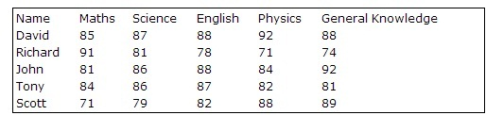
- Write a program to create HTML table having border and alternate columns background colors using CSS. Final output should be like this:
