ASSIGNMENT-3
from selenium import webdriver
from selenium.webdriver.common.by import By
from selenium.webdriver.common.keys import Keys
from selenium.webdriver.support.ui import WebDriverWait
from selenium.webdriver.support import expected_conditions as EC
import time

driver = webdriver.Chrome()
wait = WebDriverWait(driver, 30)

driver.get("https://www.amazon.in")
driver.maximize_window()

print("Amazon opened")

signin = wait.until(
EC.element_to_be_clickable(
(By.ID, "nav-link-accountList")
)
)
signin.click()

email = "saiganeshdepuru24@gmail.com"

email_box = wait.until(
EC.presence_of_element_located(
(By.ID, "ap_email_login")
)
)

email_box.send_keys(email)
email_box.send_keys(Keys.ENTER)

print("Email entered")
print("Complete password / OTP manually in browser")

input("After login is completed, press Enter...")

driver.switch_to.new_window("tab")
driver.get("https://www.amazon.in")

print("Search tab opened")

search = wait.until(
EC.presence_of_element_located(
(By.ID, "twotabsearchtextbox")
)
)

product = "Samsung Galaxy S23 Ultra"

search.send_keys(product)
search.send_keys(Keys.ENTER)

print("Samsung Galaxy S23 Ultra searched")

time.sleep(7)

print("Finding first search result...")

first_product = wait.until(
EC.presence_of_element_located(
(
By.XPATH,
"(//h2[@aria-label])[1]"
)
)
)

product_name = first_product.get_attribute("aria-label")

print("First product found:")
print(product_name)

print("Finding Add to Cart button...")

add_cart = driver.execute_script("""
var title = arguments[0];
var parent = title;

for (var i = 0; i < 12; i++) {
if (!parent) {
break;
}

var elements = parent.querySelectorAll("button, input, a");

for (var j = 0; j < elements.length; j++) {
var el = elements[j];

var text = (
el.innerText ||
el.value ||
el.getAttribute("aria-label") ||
""
).toLowerCase();

if (text.includes("add to cart")) {
return el;
}
}

parent = parent.parentElement;
}

return null;
""", first_product)

if add_cart:
print("Add to Cart button found")

driver.execute_script(
"arguments[0].scrollIntoView({block:'center'});",
add_cart
)

time.sleep(1)

driver.execute_script(
"arguments[0].click();",
add_cart
)

print("SEARCHED PRODUCT ADDED TO CART")
else:
print("Add to Cart button not found")
input("Press Enter to close browser...")
driver.quit()
exit()

time.sleep(5)

print("Cart updated")

driver.switch_to.new_window("tab")
driver.get("https://www.amazon.in/gp/cart/view.html")

print("Cart tab opened")

time.sleep(5)

print("Cart opened successfully")

input("Press Enter to close browser...")

driver.quit()

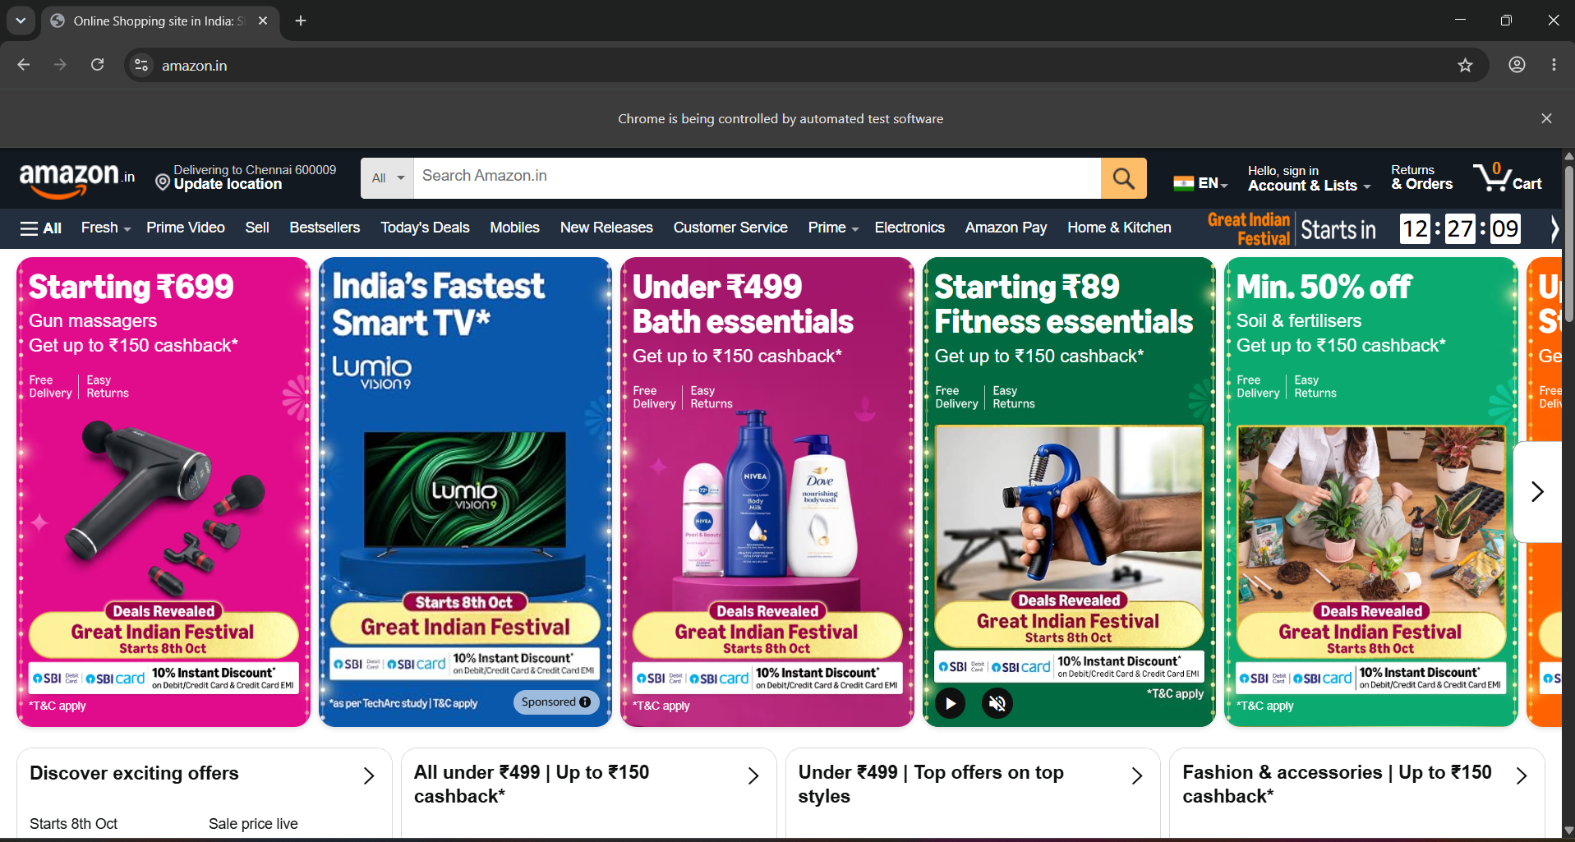

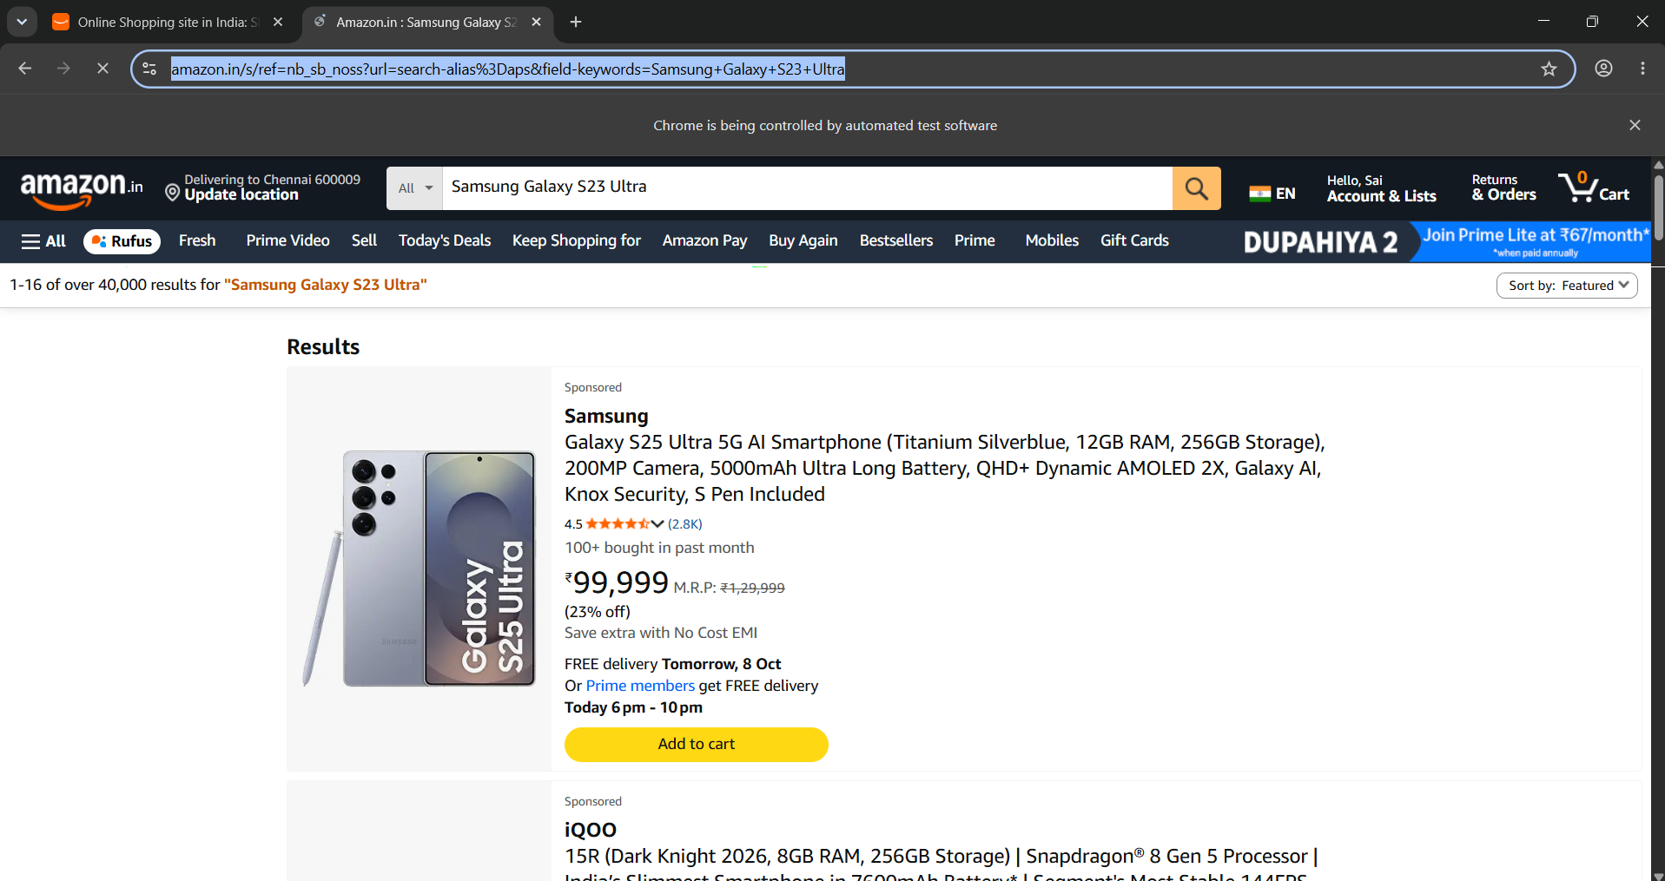
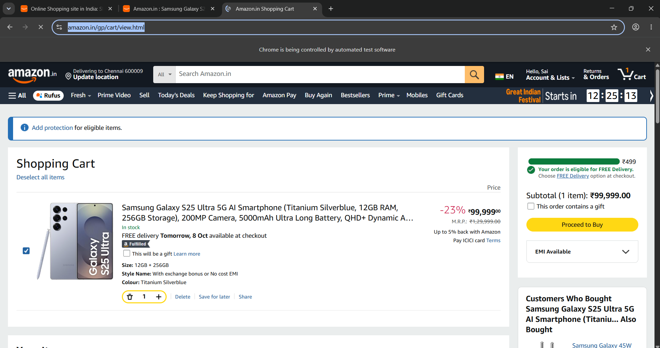

Github Link: https://github.com/saiganesh2006/MANUAL-TEST-CASES-HCL

