1. DISPLAY THE FACULTY NAMES WHOSE SALARY IS NULL?

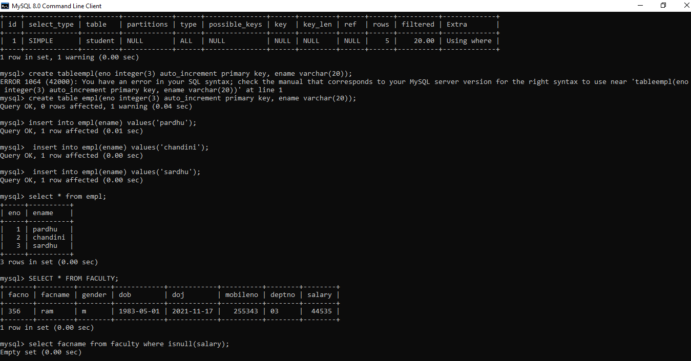

1. DISPLAY THE SAALRY OF LL THE FAULTY.IF NULL AALARY IT SHOULD BE DISPLAYED AS 0?

