1. Find the courses which have taken by students

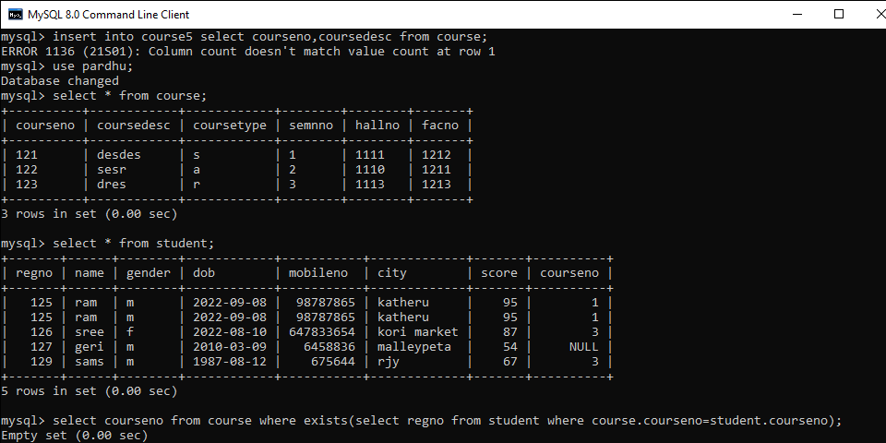

1. Find the faculties to whom course are assigned.

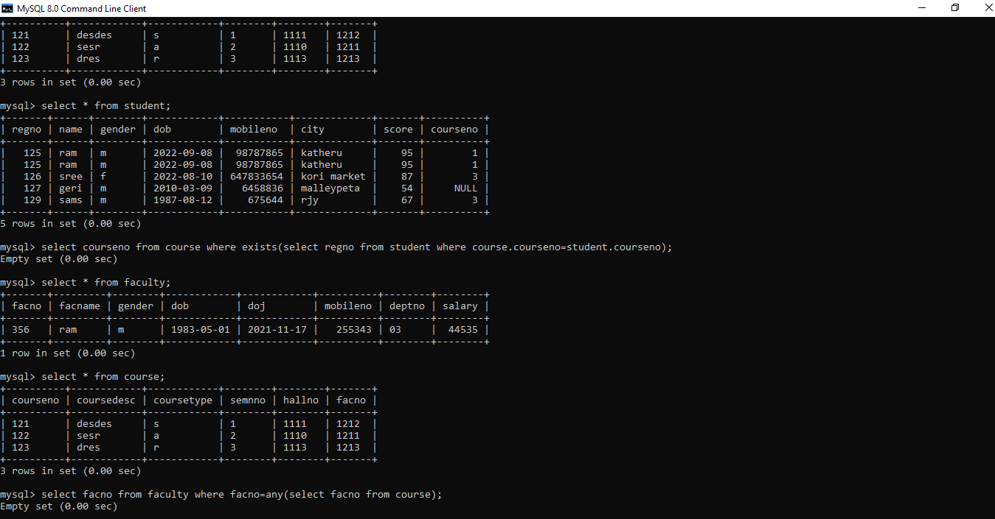

1. Find the d1 dept employess whose salary is greater than all the d2 dept employees slaries.

