**TITLE Interconnected Microgrids**

**AUTHORS**

***ABSTRACT***

Owing to several operational drawbacks in the existing power management schemes for interlinked AC-DC micro grids which are either concerned about only on sharing power or regulation of voltage but not on both, so as to overcome these issues this paper is proposed. This proposed autonomous power management scheme will consider the specific loading condition of the DC micro grid before importing power from the interlinked AC microgrid. This strategy not only enables voltage regulation in the DC microgrid but also reduces the number of converters in operation which will in turn reduces the power transfer losses. Theproposed scheme is fully self governed as it holds on the plug-nplay features for generators and tie-converters. The performance of the proposed control scheme has been validated under different operating scenarios. The results reveal the usefulness of the proposed scheme in managing the shortcoming of power in the DC microgrid efficiently and autonomously, on the other hand maintaining the better voltage regulation in the DC micro grid. In this project a DG interfacing network and its control also to be simulated to analyze the system stability The results are verified through MATLAB/SIMULINK environment.

1. **INTRODUCTION**

THE technical advancement in power electronics is playing an important role in the deployment of renewables and alternative energy technologies [1]–[3] which have so far been widely realized in different forms of network topologies and configurations [4], [5]. Similarly, they have been controlled and supervised using various control strategies and architectures [6], [7].In order to maximize the benefits while meeting the load requirements,their network topologies and control strategies are mainly resolved.Now a days,renewable and alternative energy technologies are extensively installed in microgrids. The distribution of these new technologies in the form of a micro grid is

preferred as it has several advantages, such as optimal utilization of resources, improved power quality and enhanced supply reliability [8]–[10]. Now a days the features of advanced grid have merged with the zone based grid features.These are interlinked AC-DC micro grids, interlinked AC -AC micro grid and finally multi micro grids[18]–[22].It was the main aim to utilize the maximum benefits of renewable and alternative energy sources.For example,interconnection of two or more micro grids will enable reserve sharing, support voltage and frequency, and ultimately intensify the overall reliability and resilience of interlinked micro grids.Depending upon the overall objectives,control and management strategies the interlinking between two or more micro grids have been made. The micro grids can be interlinked directly or through harmonizing tie converter.When two or more micro grids having different operating voltages and frequencies, the harmonised tie converters are mainly used. If the microgrids to be interlinked have different control strategies and the power flow among them needs to be regulated, then the tie converters are necessary. [16].

Similarly, the tie converters also required for interlinking of the DC micro grid with utility grid or another AC grid, as well as to regulate the power flow among other functionalies and that has been investigated under various scenarios in the published literature for the interlinking of tie-converters of the AC-DC microgrids, the demand droop control has been proposed. The power flow action is determined on the basis of normalized terminal voltage and frequency of the droop controlled interlinked AC-DC micro grids. This scheme allows autonomous power transfer between two interlinked micro grids on the basis of relative loading condition. The interlinking converter will operate continuously if the power flow decision is made on the basis of relative loading and thus it may result in unavoidable operational losses. The same power sharing scheme has been extended to interlinked microgrids by providing a storage system.

This scheme is further improved with the progressive auto-tuning to minimize the energy flow through interlinking converters. The proposed scheme of auto-tuning enables the power transfer only when one micro grid is heavily-loaded, and another micro grid is lightly-loaded. For different operating conditions of the interlinked AC and DC micro grids, this droop based power sharing has been investigated in. In ,this power management strategy is presented for a three port system which comprises of AC, DC and a storage network. The decision about the power sharing is on the basis of loading condition -So far the published decentralized power sharing schemes for interlinked AC-DC microgrids are either entirely based on droop principle or voltage regulation. The droop based power sharing schemes will transfer power by taking an account of relative loading of all converters regardless of the overall power transfer requirement. This will result in unnecessary converter operational losses. Contrarily, the voltage regulation schemes regulate only the voltage of the DC microgrid by ignoring the specific loading conditions of the generators, and also lacks the plug-n-play feature for tie-converters. These shortcomings and drawbacks can be specifically addressed by using the proposed control scheme in this project.

The proposed autonomous power management scheme for the interlinked AC-DC micro grids transfer power from AC to DC micro grid during its peak load demand by considering the specific loading condition of the generators and also regulates the voltage of the DC micro grid. The proposed scheme enables the plug-n-play feature for tie converters and it also reduces the number of converters in operation in order to avoid superfluous losses. In the contemplated scenario, because of the high variability of the loads and high and low renewable energy generation, the DC grid has inadequate generation capacity. The AC micro grid is considered to be adequate which have regulated voltage and frequency and also have the surplus power to transfer to the DC micro grid during its peak demand or contingency condition. In order to achieve the features discussed above, a hybrid droop and voltage regulation mode control has been proposed for the tie-converters in interlinked AC-DC microgrids.

The proposed control scheme depends on the terminal voltage information of tie converter so as to determine the overall loading condition of the droop-controlled DC microgrid. The tie-converter starts automatically and transfers power to the DC microgrid during the peak-load demand or contingency condition in the DC microgrid on the basis of the threshold of set load. The voltage of the DC microgrid is regulated at a defined nominal level with the proposed hybrid control mode. More than that, the proposed scheme allows to interface more than one tie-converters, but it was opposed to the existing scheme where all tie-converters operate simultaneously regardless of the power transfer demand. The subsequent tie-converter only activates once when the first converter power capacity has been saturated. The proposed scheme is fully autonomous with intensified features.

1. **CONTROL STRATEGIES**

The regarded DC microgrid includes both non-dispatchable generator (solar-PV) and dispatchable generators (microturbine, fuel-cell) and loads, as shown in Fig. 1. But the non dispatchable-solar PV system extracts maximum power at all the times as it is set to operate in current control mode. The dispatchable generators are either controlled through a centralized or decentralized control scheme and it is normally used for stabilizing the renewable capacity. Because of its simplicity and reliability, the decentralized droop scheme is the most widely used and preferred scheme. Therefore, the traditional droop (P-V)scheme has been used for the dispatchable generators of theDC microgrid (see Fig. 1), which is given by

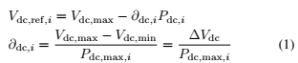

where, *i* is the DC generator number (*i* = 1, 2, 3. . . ); *V*dc*,*ref*,I*is the reference voltage of *i*th generator; *P*dc *,* is the output power of *i*th generator; *V*dc*,*max and (*V* dc*,*min= *V*dc*,*nom*,*TC1) are the defined maximum and minimum voltage; *P*dc*,*max*, is the* maximum or rated power of *i*th generator; and *∂*dc*,i* is the droop gain of *i*th generator. Based on (1), the voltage reference for the droop controlled generators 1 and 2 can be calculated by (2) and (3).As generators 1 and 2 share common DC bus voltage (i.e.,*V*dc*,*ref*,*1 = *V*dc*,*ref*,*2), (2) and (3) can be equated and rewritten by (4), which demonstrates that the power sharing of droop controlled generator will be proportional, according to their rated capacity.

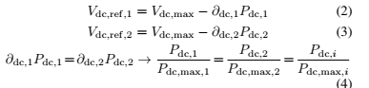

the generator terminals is the same. Practically, all the generators are connected through feeders and cables of different lengths and hence the voltage at all the generator terminals is not equal. This voltage mismatch at the generator terminals needs to be compensated by using any of the appropriate compensation methods as it affects the power sharing. The droop equation with compensation of the feeder voltagedrop can be rewritten by



With the change of load, the voltage of the droop controlled DC micro grid will change but within the defined permissible range. For the considered DC microgrid, the voltage range  
with increased aggregated loading is shown in Fig. 1 (bottomleft). For the droop controlled generators, the voltage range i

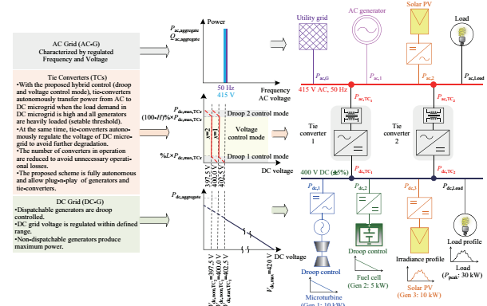

Fig. 2.1. Interlinked AC-DC microgrids and their control strategy.

set between 395 V and 420 V, indicating that the generators will deliver no-power at 420 V and 100% power at 395 V. As soon as the DC generators are heavily loaded (e.g., *≤* 402.5 V at80% generators loading), the tie-converters will start to import power from the AC microgrid to meet the peak load demand on the DC system. Hence, by using tie converters we can also regulate the voltage of the DC microgrid. For example interlinked microgrids shown in in Fig. 1, the voltage and frequency of the AC microgrid is considered stiff. The AC microgrid can be droop controlled with secondary voltage and frequency regulation, or operating in grid-connected mode.The characteristics of the AC microgrid for constant voltage and frequency at nominal value are shown in Fig. 1(e.g., 50 Hz and 415 V).

In addition, the AC microgrid has adequate generation capacity so as to meet its local demand and also able to export surplus power to the DC microgrid which has been revealed through the proposed autonomous control of the tie-converters. The details of the tie-converters control are given in Section

**III. PROPOSED HYBRID CONTROL OF TIE-CONVERTERS**

The variability of the renewable source and loads in the micro grid will decide the power rating of the dispatchable generators or storage system so as to stabilize the renewable capacity. The high power rating dispatchable generators or storage systems are required for highly variable renewables and loads, which may or may not be a viable solution. Alternatively, the microgrid with inadequate generation capacity can be interconnected with another microgrid or utility grid, directly or through harmonizing converters. The tie converter is the only way possible to interconnect the DC micro grid to AC micro grid as shown in Fig. 1. In the proposed interlinked system, the AC microgrid is specified as a regulated voltage and frequency system with adequate generation capacity, whereas the DC microgrid is specified as a droop controlled system with inadequate generation generation because of high variability of the renewable and loads. On the occurrence of peak demand or at the low renewable power output, the power deficit in the DC microgrid is managed by importing power from the AC microgrid. Ideally, with the proposed control of the tie-converters, it can be achieved.In summary, the control scheme of the tie-converters is developed based on the following objectives:

1) To transfer power from the AC to DC microgrid as there any contingency in the DC microgrid or requirement of peak demand occurred ;

2) To minimize the power transfer losses, by reducing the number of tie converters in operation which is based on the power transfer demand, for example only during the peak load demand a tie converter should operates.

3) To regulate the voltage of the droop controlled DC microgrid;

4) To achieve fully autonomous control which is independent of the communication network

5) To allow the plug-n-play feature for tie converters and generators .

Instead of the existing schemes for the interlinked AC-DCmicrogrids [18]–[22], a hybrid droop and voltage regulationmode control is proposed for the tie-converters and the mathematical form of the proposed control scheme is given by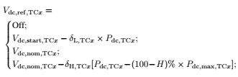

where TC*x*represents the tie-converter number (*x* = 1, 2, 3..);*V*dc is the DC microgrid voltage; *V*dc*,*ref*,*TC*x*is the reference voltage of *x*th tie-converter; *V*dc*,*start*,*TC*x* is the threshold voltage to start of *x*th tie-converter; *V*dc*,*nom*,*TC*x*is the nominal voltage to be regulated by *x*th tie-converter; *P*dc*,*TC*x.* is the DC power output of *x*th tie-converter; *P*dc*,*max*,*TC*x* is the maximum power limit of *x*th tie-converter; *L*% and*H*% are the percentage of tie-converer rated power allocated for droop1 and 2 mode, respectively; Vdc,nom,TCx+1 is the DC microgrid voltage when xth tie-converter transfers maximum power; δL,TCx= (Vdc,start,TCx - Vdc,nom,TCx)/(L% ×Pdc,max,TCx) is the droop 1 gain (at low power) of xthtieconverter; δH,TCx= (Vdc,nom,TCx - Vdc,nom,TCx+1)/(H% ×Pdc,max,TCx) is the droop 2 gain (at high power) of xthtieconverter.As shown in Fig. 1, tie-converter 1 starts in droop 1 control mode when the voltage in the DC microgrid drops to the set threshold of Vdc,start,TCx. When all the generators in the DC microgrid are heavily-loaded (e.g. over 80% loaded), the voltage drops to the threshold set point. The start of the tie-converter in the droop control mode through a smooth transition to the voltage regulation mode at the set condition i.e., Pdc,TCx> L% × Pdc,max,TCx. The tie converter imports power from AC micro grid to DC micro grid so as to meet the peak load demand and also to regulate its voltage to be set to the nominal value of Vdc,nom,TCx and hence this is called voltage regulation mode. Furthermore, the converters operation has been prioritized unlike the parallel operation of tie converters in the existing schemes. The first tie-converter only starts whenall the generators in the DC microgrid are heavily-loaded. As the first tie-converter power capacity approaches to saturation at Pdc,TCx= (100 - H)% × Pdc,max,TCx, its control mode is changed to droop 2 control mode from voltage regulation mode and it allows minor voltage drop. The next tie converter will start its operation by utilizing the minor voltage drop caused by droop 2 control. If the first tie-converter is failed to operate, then the second tie-converter will automatically starts its operation followed by the voltage drop due to high load demand. Therefore, without any concession of the inherited flexibility of the droop based scheme, the proposed control strategy ensures efficient and reliable operation during all the operating conditions. The allocation of the tie-converter’s power for droop1 and droop 2 control mode depends on the chosen value of L% and H% that are user definable, and should be tuned that should be able to smooth transition between different modes while considering the voltage and power measurement tolerance or errors in the considered microgrid. The overallvoltage regulation performance of the DC microgrid can be improved, by deploying the proposed voltage regulation mode. In particular during the peak load demand, the

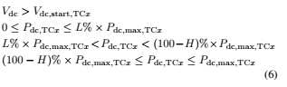

voltage of the DC micro grid is controlled at the nominal value, which is not done with the existing power management schemes for interlinked micro grids. The performance of the proposed scheme has been corroborated for different load operating scenarios, as described.

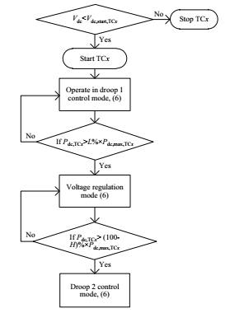

Fig.3. 3 Logic flow diagram showing mode transitions of tie-converter

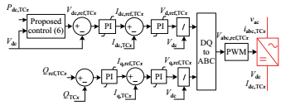

Fig. 3.4. Control block diagram of tie-converter.

**IV DG interfacing System description:**

The recommended test system for islanding detection study consisting of an inverter-based DG, a parallel RLC load and the grid represented by a source behind impedance is shown in Fig 4.1. The operation mode of the DG depends on the circuit breaker position whether it is closed or not. The Inverter based DG such as photovoltaic generation and windpower generation is usually configured with the maximum power point tracking controller.Because of the very short islanding detection time, the output power can be considered to be constant during the detection. As ,the DG is designed as a constant power source, a constant dc source is employed behind a three phase inverter. Fig 5.6 represents the block diagram of the DG interface control.The three essential parts are Phase Locked Loop(PLL), the outer powercontrol loop and the inner current control loop.According to the instantaneous power theory and the Park transformation,the DG can control the active and reactive power output independently based on the dual close loop control structure in the d-q synchronous reference frame.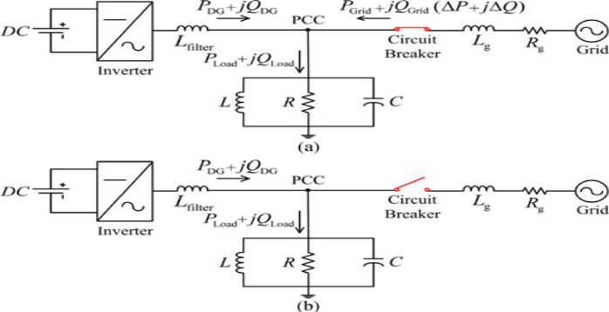

Fig. 4.1 Test system for islanding detection study

(a) Grid-connected operation mode

(b) Islanding operation mode.

Asshown,whentheDGisconnectedtotheutilitygrid,thefollowingequationsdescribethepowerflowsandtheactiveandreactivepowerconsumedbytheload:

Pload = PDG+PGrid = (1)

Qload = QDG +QGrid =3V_PCC^2 (1/2πfL-2πfC) (2)

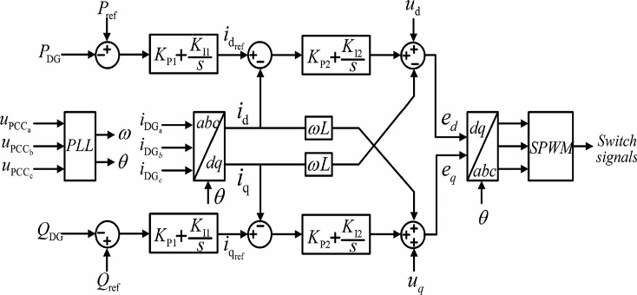Fig.4.2. DG interface control for constant power operation.

**V.MATLAB DESIGN AND RESULTS**

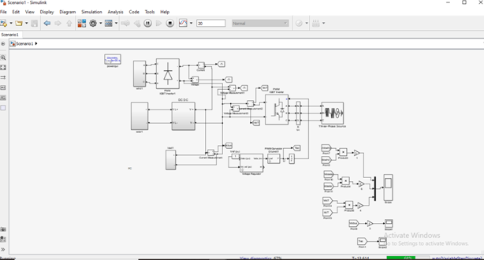

Fig.5.1: DC microgrid with microturbine, fuel cell and load.

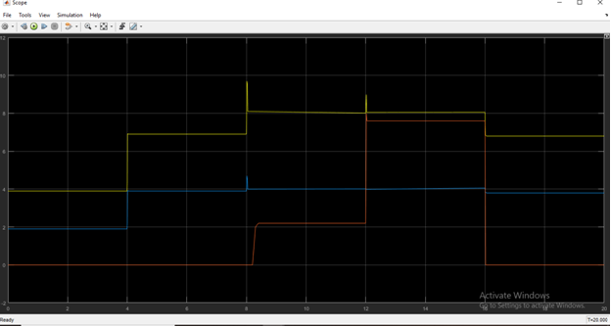

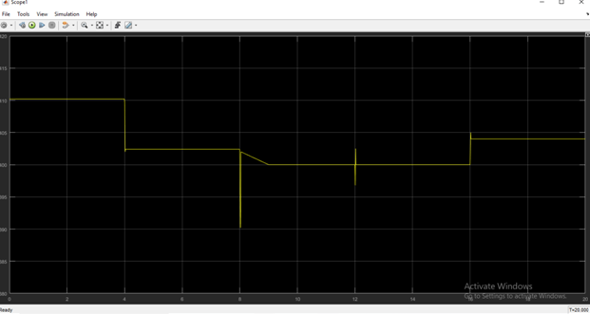

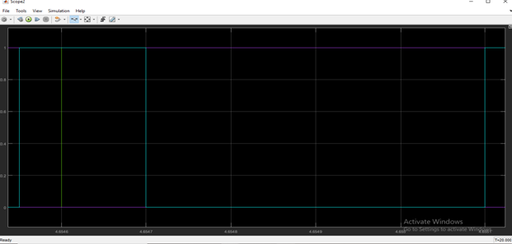

Fig. 5.2: Results showing (a) generators and tie-converter power, (b) DC microgrid voltage and (c) tie-converter control signals for four different load operating conditions.

**DG INTERFACE SYSTEM:**

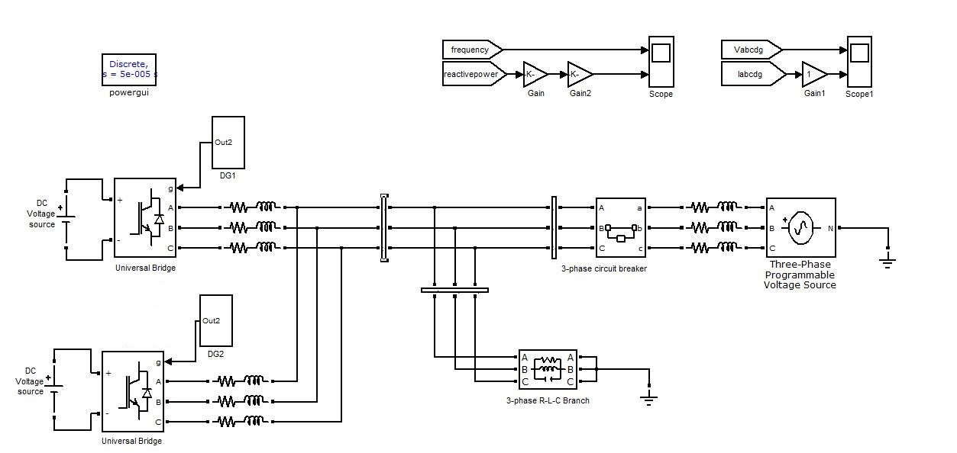

Fig. 5.3 Overall Configuration of the Islanding Detection Method

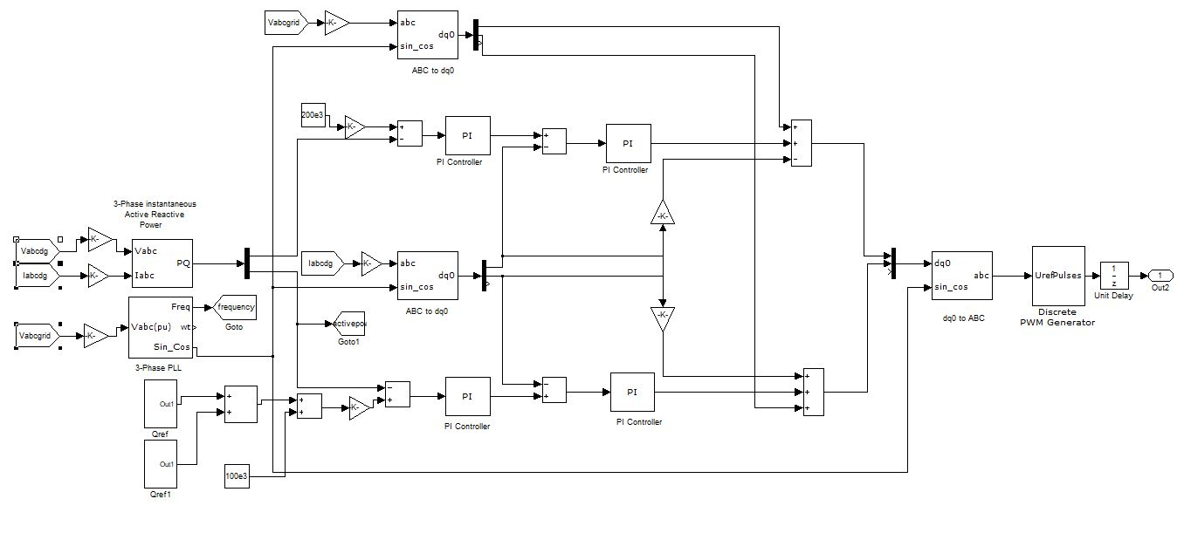

Fig 5.4 The block diagram of the DG interface control

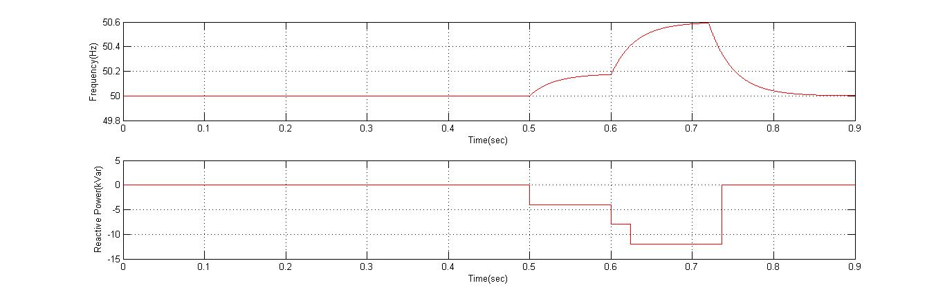

Fig 5.5 shows Reactive power and frequency vs time In sec

**CONCLUSION**

An autonomous power management scheme has been presented for interlinked AC-DC micro grids having different configurations. The proposed scheme manages the power deficit in the DC micro grid efficiently and autonomously. The number of tie-converters in operation has been reduced with the proposed prioritization to avoid unnecessary operational losses. A DG interfacing network and its control also to be simulated to analyzed the system stability .The scheme has demonstrated better voltage regulation in the DC micro grid. The performance and robustness of the proposed scheme have been validated for two different scenarios of the DC micro grid at variable load conditions.

**REFERENCES**

[1] J. Rocabert, A. Luna, F. Blaabjerg, and P. Rodr´ıguez, “Control of power converters in AC microgrids,” *IEEE Transactions on Power Electronics*, vol. 27, no. 11, nov-2011

[2] M. Liserre, T. Sauter, and J. Y. Hung, "Future energy frameworks: incorporating environmentally friendly power sources into the keen force network through mechanical hardware," IEEE Industrial Electronics Magazine, vol.4. no. 1, pp. 18–37, Mar. 2010.

[3] M. Tsili and S. Papathanassiou, "A survey of network code specialized prerequisites for wind ranches," IET Renewable Power Generation, vol. 3, no. 3, pp. 308–332, Sep. 2009.

[4] T. Strasser, F. Andren, J. Kathan, C. Cecati, C. Buccella, P. Siano, P. ' Leitao, G. Zhabelova, V. Vyatkin, P. Vrba, and V. Mama ˜ ˇ r'ık, "An audit of structures and ideas for knowledge in future electric energy frameworks," IEEE Transactions on Industrial Electronics, vol. 62, no. 4, pp. 2424–2438, Apr. 2015.

[5] A. Kwasinski, "Quantitative assessment of dc microgrids accessibility: Effects of framework engineering and converter geography plan decisions," IEEE Transactions on Power Electronics, vol. 26, no. 3, pp. 835–851, Mar. 2011.

[6] P. Basak, S. Chowdhury, S. H. N. Dey, S. P. Chowdhury, "A writing audit on incorporation of conveyed energy assets in the point of view of control, security and steadiness of microgrid," Renewable and Sustainable Energy Reviews, vol. 16, no. 8, pp. 5545–5556, Oct. 2012.

[7] D. E. Olivares, A. Mehrizi-Sani, A. H. Etemadi, C. A. Canizares, R. Iravani, M. Kazerani, A. H. Hajimiragha, O. Gomis-Bellmunt, M. Saeedifard, R. alma-Behnke, G. A. Jimenez-Estevez, and N. D. Hatziargyriou, "Patterns in microgrid control," IEEE Transactions on Smart Grid, vol. 5, no. 4, pp. 1905–1919, Jul. 2014.

[8] N. Hatziargyriou, H. Asano, R. Iravani, and C. Marnay, "Microgrids," IEEE Power and Energy Magazine, vol. 5, no. 4, pp. 78–94, Jul. /Aug. 2007.

[9] L. E. Zubieta, "Are microgrids the fate of energy?: DC microgrids from idea to showing to sending," IEEE Electrification Magazine, vol. 4, no. 2, pp. 37–44, Jun. 2016.

[10] G. Venkataramanan and C. Marnay, "A bigger part for microgrids," IEEE Power and Energy Magazine, vol. 6, no. 3, pp. 78–82, May-Jun. 2008.

[11] W. Yuan, J. H. Wang, F. Qiu, C. Chen, C. Q. Kang, and B. Zeng, "Powerful advancement based versatile conveyance network arranging against cataclysmic events," IEEE Transactions on Smart Grid, vol. 7, no. 6, pp. 2817–2826, Nov. 2016.

[12] N. Nikmehr, S. N. Ravadanegh, "Ideal force dispatch of multimicrogrids at future keen conveyance matrices," IEEE Transactions on Smart Grid, vol. 6, no. 4, pp. 1648–1657, Jul. 2015.

[13] H. Farzin, M. Fotuhi-Firuzabad, M. Moeini-Aghtaie, "Improving force framework versatility through progressive blackout the board in multimicrogrids," IEEE Transactions on Smart Grid, vol. 7, no. 6, pp. 2869–2879, Nov. 2016.

[14] J. Wu, X. H. Guan, "Facilitated multi-microgrids ideal control calculation for savvy dispersion the board framework," IEEE Transactions on Smart Grid, vol. 4, no. 4, pp. 2174–2181, Dec. 2013.

[15] N. Hatziargyriou, "Activity of multi-microgrids," in Microgrids: Architectures and Control, Wiley-IEEE Press, 2014.

[16] I. U. Nutkani, P. C. Loh, and F. Blaabjerg, "Disseminated activity of interlinked AC microgrids with dynamic and responsive force tuning," IEEE Transactions on Industry Applications, vol. 49, no. 5, pp. 2188–2196, Sep. /Oct. 2013.