31-07-2026 CO-2-AT-1 P.Sai Ganesh Reddy
192525111
Debugging
1.
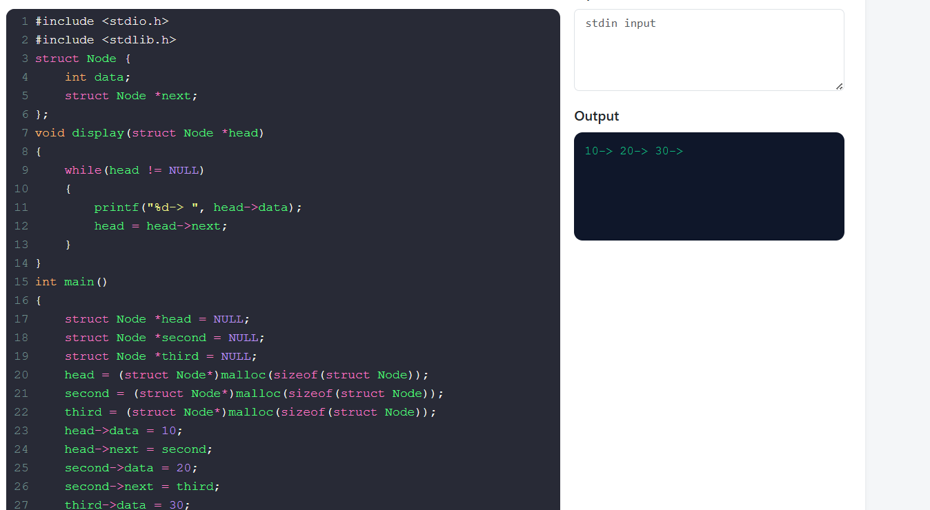

2.
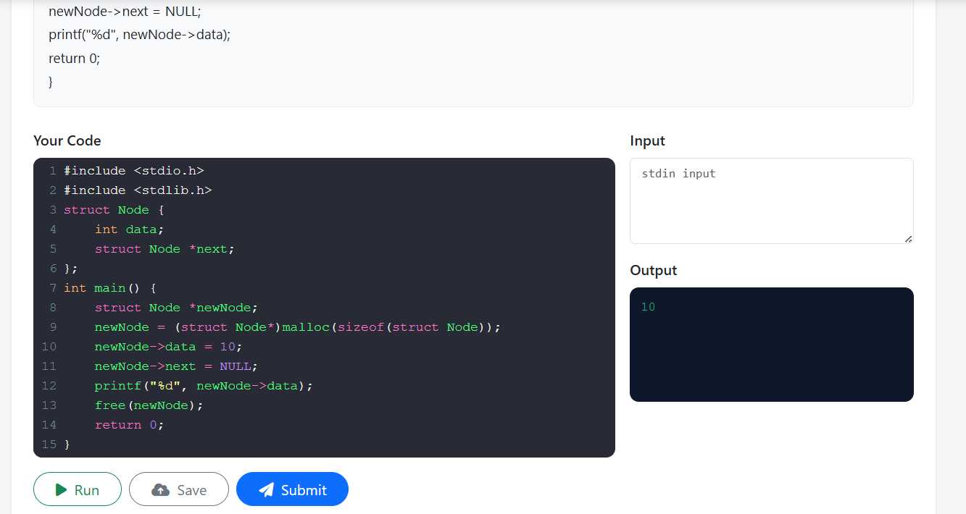
3.
