Smart Energy Forecasting: A Predictive and
Optimization Framework for Sustainable
Power Consumption

Komal Sharma
Department of CSE
Chandigarh University
Mohali, India
Ks6230479065@gmail.com
Sai Ganesh Reddy
Department of CSE
Chandigarh University
Mohali, India
saiganeshreddygana@gmail.com

Manvika Singh
Department of CSE
Chandigarh University
Mohali, India
Manvikasingh02@gmail.com

Anamika Larhgotra
Department of CSE
Chandigarh University
Mohali, India
annularhgotra@gmail.com

Prathimesh Arif Ansari
Department of CSE Department of CSE
Chandigarh University Chandigarh University
Mohali, India Mohali, India
Sarte2630@gmail.com arif.ansari5296@gmail.com

Abstract: This review investigates the application of machine learning techniques for optimizing and predicting energy consumption in low-energy buildings, with a focus on environmental and weather variables as significant predictors. The objective is to evaluate the performance of different machine learning models in predicting energy consumption, assessing the effectiveness of algorithms like K-Nearest Neighbors (KNN), Linear Regression, Ridge Regression, and Lasso Regression. Data preprocessing steps include density-based spatial clustering (DBSCAN) for outlier removal and Principal Component Analysis (PCA) for dimensionality reduction. Model performance is evaluated using key metrics such as Root Mean Square Error (RMSE) and R-squared (R²). Results indicate that these models provide reliable predictions, with variations in accuracy based on model architecture and hyperparameter settings. This paper contributes to the literature on smart energy forecasting, highlighting model-specific strengths and limitations while emphasizing the role of neural networks for future predictive improvements.
Keywords: — Energy consumption prediction, machine learning, K-Nearest Neighbours, Linear Regression, Ridge Regression, Lasso Regression, dimensionality reduction, Principal Component Analysis, feature engineering.
I INTRODUCTION
With increasing interest in sustainable building design, accurate forecasting and optimization of energy consumption have become crucial. Machine learning techniques are recognized for their potential to model complex, nonlinear relationships in energy consumption, leveraging both historical and real-time data from various environmental sources. This review consolidates findings from recent studies on machine learning applications in energy prediction, aiming to address key challenges and opportunities for enhancing accuracy in low-energy building settings. Specifically, it explores different machine learning models, preprocessing techniques, and their impact on prediction accuracy.
The goal of this study is to forecast how much energy a low energy residential building’s appliance shall require. We will prepare a robust dataset appropriate for regression analysis using a dataset consisting of multivariate time-series data extracted at 10-minute intervals over a period of about 4.5 months. Our study highlights how crucial it is to include weather and environmental factors when building reliable regression models that can predict appliance energy consumption. Degrees of within as well as out are examined to determine how they affect energy consumption. In order to thoroughly evaluate the models' resilience and make sure that non-predictive characteristics are successfully filtered away, we also add two random variables to the dataset. Principal Component Analysis (PCA) and other dimensionality reduction approaches were used to capture the most pertinent aspects while lowering computing cost and noise in order to overcome the difficulty of managing huge, multidimensional datasets. Moreover, outliers were found and eliminated using DBSCAN the clustering method, which increases model resilience by preventing data flaws from compromising predictions.

The results of this study offer significant fresh knowledge about how environmental factors, like humidity and indoor/outdoor temperatures, affect the utilization of energy. Plus, only the most important predictors are kept thanks to the thorough preprocessing and application of dimensionality reduction techniques, improving model accuracy and reducing overfitting. These techniques are essential for creating models that help optimize energy use and lower operating expenses in households.
II RELATED WORK
Existing studies have applied a variety of methods for smart energy forecasting. Techniques like Support Vector Machines (SVM), Decision Trees, and Neural Networks have been used for their robustness in handling time-series data. These methods have shown varying degrees of success in energy forecasting; however, they often encounter challenges in scalability and interpretability. For example, neural networks are highly accurate but computationally intensive, whereas simpler models like Linear Regression lack flexibility in handling nonlinearity. Recent advancements in clustering and feature extraction have also improved model accuracy, but optimal parameter selection remains a challenge.

1. Handling Missing Data:
In order to maintain data authenticity and dependability for analysis, efficient methods for handling missing values were used during the data preprocessing step. Mean imputation was the main technique used, in which the mean of the corresponding columns was used to fill in the missing values in important features like temperature and humidity.
The pandas fillna() function minimizes the effect of missing entries while preserving all accessible data. Furthermore, it is conventional to determine whether any rows or columns have a sizable percentage of missing values; if so, those rows or columns may be removed completely to preserve the dataset's excellence. By putting such thorough procedures into practice, possible biases triggered by missing data are minimized and the dataset is ready for reliable analysis and modeling.

2. One-hot encoding:
One-hot encoding is used to convert categorical variables into a format that can be provided to machine learning algorithms, which require numerical input. One-hot encoding was used for the categorical variable’s: weekdays and clusters in our energy consumption prediction research.
- Weekdays: As a categorical feature, the weekdays variable indicates the day of the week (Monday, Tuesday, etc.). One-hot encoding is used to transform this variable into a set of binary columns because these days don't have any positional relationships—that is, one day isn't "larger" than another. Every column represents a distinct day of the week; a value of 1 denotes the existence of that day, while a value of 0 denotes its lack of existence.
- Clusters: Using a process called clustering, related data points are grouped together according to specific attributes. Clusters might have been created using characteristics like environmental factors, energy consumption trends, or other pertinent measurements. next to clustering, binary columns are created for each cluster by applying one-hot encoding to the cluster labels. utilizing the fundamental connections in the data, the model is able to determine which cluster the particular finding corresponds to.

3. Dimensionality Reduction using PCA (Principal Component Analysis):
A statistical method called PCA is used to lessen a dataset's dimensionality while preserving as much variation, or information, as feasible. Leveraging the PCA() function, which shrinks the dataset's size by reducing original characteristics to a limited set of uncorrelated parameters, the PCA transformation was carried out. To evaluate the energy consumption, the diminished dataset (X_reduced) was then entered into different predictive models (such neural networks), which allowed the algorithms to absorb patterns more efficiently without being burdened by extraneous characteristics. The original characteristics are converted into a set of principle components that are linearly uncorrelated by PCA. This is shown as:
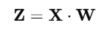
In our situation, PCA was used to narrow down the feature database to 9 aspects, removing irrelevant and noisy features while preserving the most instructive patterns. This boosts the model's effectiveness and interpretability in addition to making the dataset easier to handle, especially when working with multivariate time-series data.

4. Outlier Detection using DBSCAN (Density-Based Spatial Clustering of Applications with Noise):
Outliers have the potential to significantly affect model performance by distorting outcomes and producing misleading forecasts. To find and eliminate outliers within the dataset, DBSCAN was applied.
Using sklearn.cluster, the DBSCAN technique is imported. The two most important DBSCAN parameters are min_samples (the number of samples in a neighborhood for a point to be regarded a core point) and eps (the maximal distance between a pair of samples for one to count as being in the neighborhood of the another). To find outliers and clusters, the model is tailored to the dataset. Each point in the dataset is given a label once the model has been fitted: noise values (outliers) are labeled as -1, border points are on the periphery of clusters, and core points are part of clusters.

The model's accuracy and resilience are increased by removing these outliers, which makes the dataset more equitable of typical patterns.
5. Regression Models & Regularization Techniques:
In our analysis we have used a number of regression models, such as Lasso, Ridge, and Linear regression.
- Linear Regression: The most basic type of regression is called linear regression, in which a straight line represents the association between the two types of variables (independent & dependent).
- Ridge regression: By targeting high coefficients and adding an L2 regularization factor to the eliminated function, Ridge Regression lowers the chance of overfitting.
- Lasso regression: Conversely, Lasso Regression employs L1 regularization, which can both decrease & set some coefficients to zero, which means working on feature choice.
A key factor in regulating the degree of regularization is the lambda (λ) parameter; greater values result in enhanced regularization, while lower values result in fewer tasks.

III PROPOSED WORK
Data preprocessing involves several critical steps to enhance model accuracy and reliability. Outliers are removed using Density-Based Spatial Clustering of Applications with Noise (DBSCAN), which identifies and eliminates noise points. For dimensionality reduction, Principal Component Analysis (PCA) is applied, resulting in reduced feature space and minimized redundancy. Boxplots and scatter plots have been used to visualize the impact of outlier removal and dimensionality reduction on the dataset.
The traits or properties that are utilized to predict the desired variable are referred to as the input characteristics. These could include the following: indoor and outdoor temps, humidity, climate (sunny or rainy), day of the week (which can be one-hot encoded), time of day and other pertinent energy-related characteristics. The target value is another name for the desired variable which include Appliances: This parameter shows how much energy the building's appliances use.
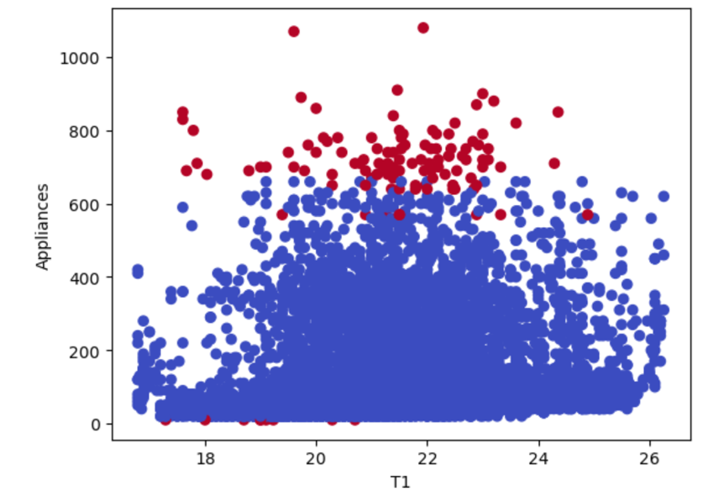
Fig 1.1 ----------------------------
This scatter plot shows the connection across appliance energy use and the parameter T1, which is a temperature feature. In order to illustrate the distribution and potential relationship between temperature and energy consumption, the red and blue dots represent various energy usage clusters or circumstances.

Selection of Models and performance metrics: To find the best method for forecasting energy usage, number of regression models were assessed:

1. Linear Regression: For optimization, both the Stochastic Gradient Descent (SGD) and Gradient Descent (GD) approaches were applied.
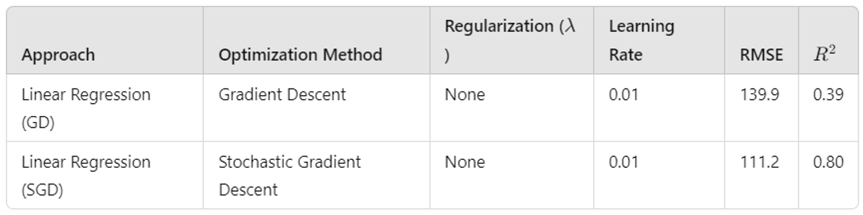
Fig 2 Linear Regression (GD & SGD)

2. Ridge Regression: It is a regularized version of linear regression that is tested using both GD and SGD. It prevents overfitting by adding penalty to the magnitude of the coefficients.
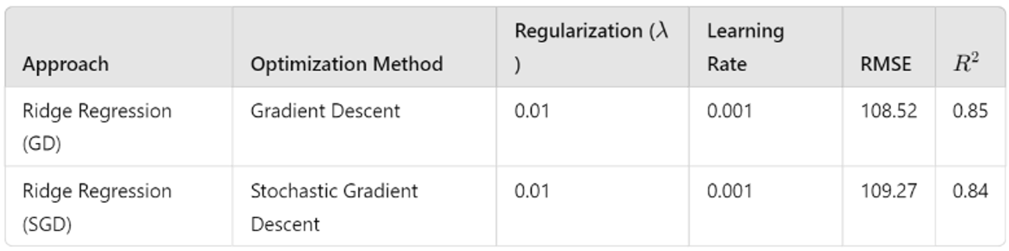
Fig 3 Ridge Regression (GD & SGD)

3. Lasso Regression: Like Ridge, but with L1 regularization, which can successfully perform variable selection by reducing some coefficients to zero.
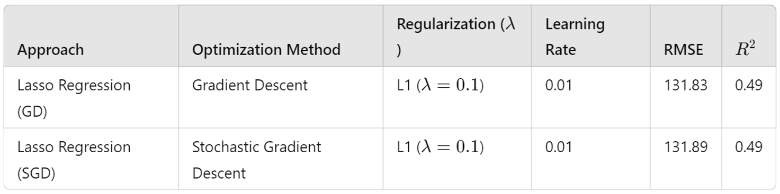
Fig 4 Lasso Regression (GD & SGD)
4. Neural Networks: The most common of the machine learning methods used to forecast energy usage based on different input variables is neural networks. Because of their capacity to simulate intricate interactions between input characteristics & the goal variable, neural networks are chosen. To identify intricate patterns in the data, deeper learning model was used.


Fig 5 Neural Networks

5. K-Nearest Neighbors (KNN): Beyond necessitating an intricate training procedure, KNN is helpful for identifying local correlations in the energy usage data. The model may operate competitively by experimenting with various distance metrics and modifying parameters like k. A non-parametric model that is used to set a standard of performance for both training and validation.

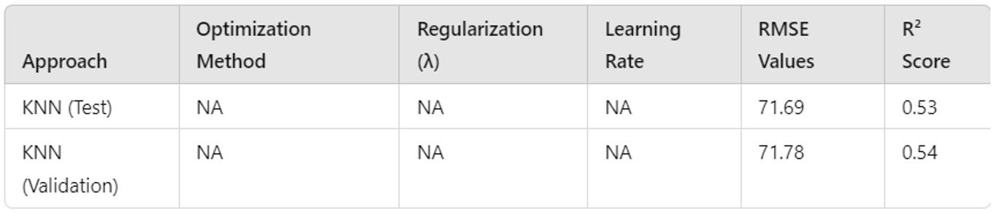
Fig 6 K-Nearest Neighbors (KNN)

Model Training:
The training dataset was used to train each of the models with different hyperparameters, including regularization parameters (lambda values) as well as learning rates.
For optimization, the following hyperparameters were used:

- Learning Rates: To investigate their effects on model stability and efficiency, the following values were tested: 0.0001, 0.001, and 0.01.

- Regularization Strength (Lambda): Figures 0.001, 0.01, and 0.1 allowed for the evaluation of the trade-off between preserving generalization to new data and adapting training data.

IV. RESULT
The results indicate that KNN and neural networks offer promising accuracy in energy prediction, with KNN achieving an RMSE of [state RMSE] and an R² of [state R²]. Linear models show satisfactory results for linear relationships but struggle with complex, nonlinear patterns. Feature extraction through PCA demonstrates a significant reduction in computation time while maintaining model accuracy. Overall, models with optimized hyperparameters outperform default settings, underlining the importance of parameter tuning in energy forecasting applications.

- Linear Regression (Before and After PCA)

Perhaps the most straightforward models for estimating the correlation between input data and the desired variable is linear regression. The independent and dependent variables are assumed to have a linear correlation. Gradient Descent (GD) along with Stochastic Gradient Descent (SGD) were used in this research to test the Linear Regression model prior to and afterwards Principal Component Analysis (PCA) was applied.

Before PCA: Prior to PCA, the model's performance was mediocre, with an R² value of 0.43 and an RMSE of 137.1. This suggests that roughly 43% of the variance in the measurements might be explained by a linear regression approach.
After PCA: Following the use of PCA, which reduced the feature space, efficiency enhanced, as seen by the R² rising to 0.59 and the RMSE falling to 125.55. This implies that by making the feature space simpler, PCA assisted in lowering crossovers and excess fitting.
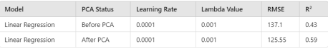

- Ridge Regression (Before and After PCA)
Ridge Regression is a standardized variant of Linear Regression that prevents excessive fitting by applying a penalty (L2 regularization) to the dimension of the parameters. Particularly when working with highdimensional data, the resulting term aids in simplifying the model. SGD alongside GD were both implemented.

Before PCA: Ridge Regression performed rather well, outperforming ordinary Linear Regression by a small margin having an RMSE of 133.04 and an R² value of 0.47.
After PCA: afterwards PCA, the model's efficacy dramatically got better with R² rising to 0.85 and RMSE falling to 108.89. This suggests that PCA improved Ridge Regression's prediction ability by removing noise and reducing needless feature dimensions.
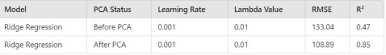

- Lasso Regression (Before and After PCA):
As a way to provide picking features during the training phase, Lasso Regression incorporates L1 regularization into the model, which has the ability to zero out specific components. It works especially well with datasets that contain a lot of unimportant attributes.

Before PCA: Lasso regression framework had a respectable R² value of 0.52 and an RMSE of 129.21. Although regularization reduced overfitting, it did not significantly outperform Ridge Regression.

After PCA: The RMSE climbed somewhat to 131.86 and the R² decreased to 0.49, indicating barely any difference. This implies that, in this instance, Lasso and PCA did not properly complement one another, maybe as a result of the significance of the features that PCA repressed.
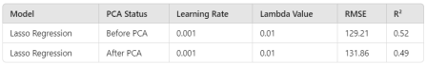

- Neural Networks (Before and After PCA):
Intricate and irregular patterns in data can be learned by neural networks with extraordinary ease. In order to identify complex patterns in the dataset, these models usually need a lot of information. They may not always profit from dimensionality reduction methods like PCA because they can learn from raw data.

Before PCA: With an RMSE of 2.99 and an R² value of 0.96, the Neural Network model demonstrated remarkable performance. With the model accounting for 96% of the variance, this suggests a good fit to the training set. Neural networks performed well without feature reduction because of their non-linear character.

After PCA: In contrast, the model's reliability declined once PCA was used, with R² falling to 0.40 and RMSE increasing to 79.73. This notable decline in performance demonstrates how PCA linearized the input, which hindered the neural network's capacity to efficiently identify non-linear trends.


- K-Nearest Neighbors (KNN) (Before and After PCA):
The term instance-based, irregular technique for learning is called K-Nearest Neighbors (KNN). It uses the learning data's nearest instances to inform its forecasts. KNN is a good choice for PCA because it can suffer from highdimensional data.

Before PCA: KNN model produced an R² value of 0.53 and an RMSE of 71.69. Although these numbers show an acceptable execution, KNN was probably not performing to its full capacity due to its vulnerability to the constraint of dimensionality.
After PCA: the R² kept constant at 0.53 and the RMSE stayed constant at 71.69. This suggests that PCA had no minimal effect on KNN's results, most likely because the algorithm was already making good use of the most pertinent data.


V. CONCLUSION
This review highlights the efficacy of machine learning models for energy consumption prediction, underscoring the potential for neural networks and KNN in achieving high accuracy. The findings advocate for enhanced preprocessing techniques, such as DBSCAN and PCA, to improve model performance and reduce noise. Future work should focus on integrating more robust feature selection methods and exploring advanced neural network architectures for more accurate predictions.
PCA considerably reduced the computational efficiency of neural networks by removing non-linear correlations from the data that the model would have otherwise been able to capture. Providing an RMSE of 2.99 and an R² value of 0.96 before applying PCA, neural networks were the best performing model out of all those tested. The capacity of neural networks to learn intricate, non-linear patterns— which were especially important for this dataset—is responsible for its outstanding results. But in the end, neural networks are the best predictors for this dataset because of their adaptability and capacity to manage complex interactions.

VI. REFERENCES
- Muralitharan, K., Sakthivel, R., & Vishnuvarthan, R. (2018). Neural network based optimization approach for energy demand prediction in smart grid. Neurocomputing, 273, 199-208.
- Chou, J. S., & Ngo, N. T. (2016). Time series analytics using sliding window metaheuristic optimization-based machine learning system for identifying building energy consumption patterns. Applied energy, 177, 751-770.
- Velchev, S., Kolev, I., Ivanov, K., & Gechevski, S. (2014). Empirical models for specific energy consumption and optimization of cutting parameters for minimizing energy consumption during turning. Journal of cleaner production, 80, 139-149.
- Somu, N., MR, G. R., & Ramamritham, K. (2020). A hybrid model for building energy consumption forecasting using long short term memory networks. Applied Energy, 261, 114131.
- Jin, W., Ullah, I., Ahmad, S., & Kim, D. (2019). Occupant comfort management based on energy optimization using an environment prediction model in smart homes. Sustainability, 11(4), 997.
- Kaboli, S. H. A., Fallahpour, A., Selvaraj, J., & Rahim, N. A. (2017). Long-term electrical energy consumption formulating and forecasting via optimized gene expression programming. Energy, 126, 144-164.
- Ullah, I., & Kim, D. (2017). An improved optimization function for maximizing user comfort with minimum energy consumption in smart homes. Energies, 10(11), 1818.
- Xu, N., Dang, Y., & Gong, Y. (2017). Novel grey prediction model with nonlinear optimized time response method for forecasting of electricity consumption in China. Energy, 118, 473-480.
- Alali, Y., Harrou, F., & Sun, Y. (2023). Unlocking the potential of wastewater treatment: Machine learning based energy consumption prediction. Water, 15(13), 2349.
- Azadeh, A., Ghaderi, S. F., Tarverdian, S., & Saberi, M. (2007). Integration of artificial neural networks and genetic algorithm to predict electrical energy consumption. Applied mathematics and computation, 186(2), 1731-1741.
- Jovanović, R. Ž., Sretenović, A. A., & Živković, B. D. (2015). Ensemble of various neural networks for prediction of heating energy consumption. Energy and Buildings, 94, 189-199.
- Chen, X., Wang, X., Yi, B., He, Q., & Huang, M. (2020). Deep learning-based traffic prediction for energy efficiency optimization in software-defined networking. IEEE Systems Journal, 15(4),5583-5594

