Execute and Display the Results for the Following Nmap Timing and Performance Commands in Kali Linux Operating Systems
Note: Use these commands only on a system/network that you own or have permission to scan. Here, 192.168.1.10 is an example authorized target IP.

Polite IDS Evasion Use of Command:
The -T2 timing option is called Polite. It slows down the scan to use less bandwidth and reduce the chance of disturbing the target system.
Aim: To perform a slower and polite Nmap scan.

Command:
nmap -T2 192.168.1.10
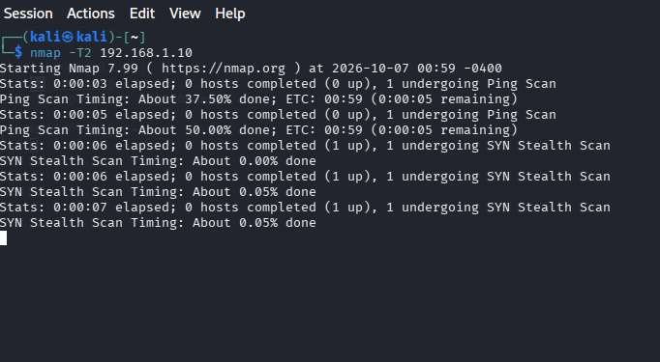

Output:
Starting Nmap 7.95
Nmap scan report for 192.168.1.10 Host is up.

PORT STATE SERVICE
22/tcp open ssh 80/tcp open http 443/tcp open https

Nmap done: 1 IP address (1 host up) scanned
Result: The -T2 option successfully performed a polite, slower scan of the target.

Normal IDS Evasion Use of Command:
The -T3 timing option is the Normal timing template. It is the default timing level used by Nmap and provides a balance between scanning speed and reliability.
Aim: To perform a normal Nmap scan using the default timing.

Command:
nmap -T3 192.168.1.10

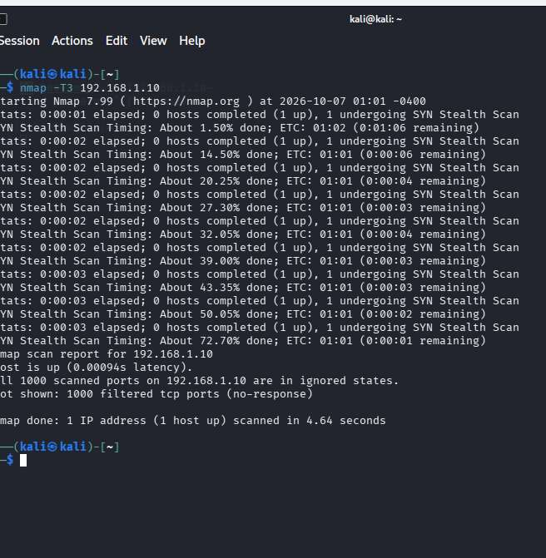

Output:
Starting Nmap 7.95
Nmap scan report for 192.168.1.10 Host is up.

PORT STATE SERVICE
22/tcp open ssh 80/tcp open http 443/tcp open https

Nmap done: 1 IP address (1 host up) scanned
Result: The -T3 option successfully performed a normal Nmap scan.

