What is DPDK?
---- The Data Plane Development Kit (DPDK) is a set of data plane libraries and network interface controller drivers for fast packet processing. The DPDK framework creates a set of libraries for specific hardware/software environments through the creation of an Environment Abstraction Layer (EAL).
(or)
The Data Plane Development Kit (DPDK) is a set of data plane libraries and network interface controller drivers for fast packet processing. DPDK provides a programming framework for Intel x86 processors and enables faster development of high speed data packet networking applications.

Why DPDK?
---- DPDK enables us to build applications, that we can use to process packets faster! It does so by enabling packets to follow "fastpath" instead of normal route of Network layers and Context switching. DPDK accelerated hardware enables the packets to bypass the Kernel entirely!

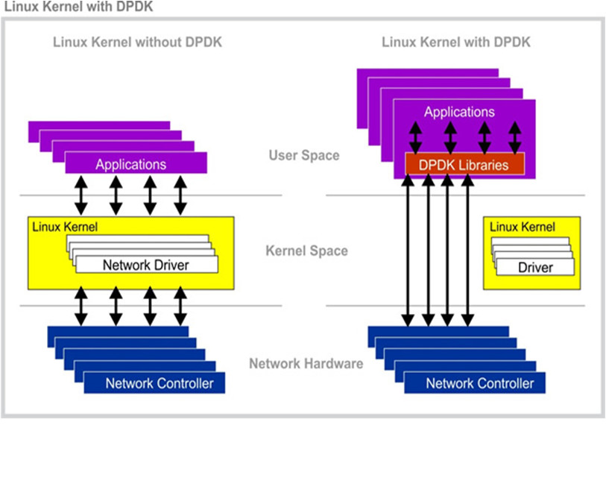
What are Active Queue Management Algorithms(AQM)?
---- In routers and switches, active queue management (AQM) is the policy of dropping packets inside a buffer associated with a network interface controller (NIC) before that buffer becomes full, often with the goal of reducing network congestion or improving end-to-end latency. This task is performed by the network scheduler, which for this purpose uses various algorithms such as random early detection (RED), Explicit Congestion Notification (ECN), or controlled delay (CoDel). Active queue disciplines drop or mark packets before the queue is full. Typically, they operate by maintaining one or more drop/mark probabilities, and probabilistically dropping or marking packets even when the queue is short.

Why AQM?
---- Drop-tail queues have a tendency to penalise bursty flows, and to cause global synchronisation between flows. By dropping packets probabilistically, AQM disciplines typically avoid both of these issues.
By providing endpoints with congestion indication before the queue is full, AQM disciplines are able to maintain a shorter queue length than drop-tail queues, which combats bufferbloat and reduces network latency.

What is RED?
---- Random Early Detection, or RED, is an active queue management algorithm for routers suited for congestion avoidance. In contrast to traditional queue management algorithms, which drop packets only when the buffer is full, the RED algorithm drops arriving packets probabilistically. The probability of drop increases as the estimated average queue size grows. RED responds to a time-averaged queue length, not an instantaneous one.
The RED router calculates the average queue size, using a low-pass filter with an exponential weighted moving average. The average queue size is compared to two thresholds, a minimum threshold and a maximum threshold. When the average queue size is less than the minimum threshold, no packets are *marked. When the average queue size is greater than the maximum threshold, every arriving packet is *marked. This ensures that the average queue size does not significantly exceed the maximum threshold.
When the average queue size is between the minimum and the maximum threshold, each arriving packet is *marked with probability p a , where p a is a function of the average queue size avg. Each time that a packet is *marked, the probability that a packet is *marked from a particular connection is roughly proportional to that connections share of the bandwidth at the router.

Why RED?
---- Random early detection (RED), also known as random early discard or random early drop is a queuing discipline for a network scheduler suited for congestion avoidance. In the conventional tail drop algorithm, a router or other network component buffers as many packets as it can, and simply drops the ones it cannot buffer. If buffers are constantly full, the network is congested. Tail drop distributes buffer space unfairly among traffic flows. Tail drop can also lead to TCP global synchronization as all TCP connections "hold back" simultaneously, and then step forward simultaneously. Networks become under-utilized and flooded—alternately, in waves. RED addresses these issues by pre-emptively dropping packets before the buffer becomes completely full. It uses predictive models to decide which packets to drop. RED monitors the average queue size and drops (or marks when used in conjunction with ECN) packets based on statistical probabilities. If the buffer is almost empty, then all incoming packets are accepted. As the queue grows, the probability for dropping an incoming packet grows too. When the buffer is full, the probability has reached 1 and all incoming packets are dropped.

What is GRED?
---- GRED(Gentle Random Early Detection) was proposed as an AQM method that controls congestion at router buffers preliminary. GRED aims to solve some of RED’s problems. GRED was proposed as a variant of RED, in which GRED enhances the way of tuning some of RED’s parameters such as maxthreshold and Dmax(the maximum value of the initial packet dropping probability).

Why GRED?
---- GRED maintains the aql(average queue length) value at a level on a router buffer which is between the minthreshold and maxthreshold positions,this level is named Taql(Target level for the aql). Maintaining aql value at Taql level avoids increasing the router buffer size to be above the maxthreshold position, and therefore smaller number of packets is dropped.

