**MicroMapReport**

**United States Cancer Statistics, 1999-2015 Mortality Data for Lung and Bronchus Cancer sites:**Cancer is the second largest cause of death in the United States, exceeded only by heart diseases. One of every four died due to cancer in the United States. Lung and Bronchus can is top cancer by rates of cancer deaths.

**Dot Micromap for United States Lung and Bronchus Cancer Statistics, 2015 Mortality rate**

From the below micromap we can visualize that West Virginia is with highest death rate followed by Kentucky, Maine, Arkansas. States with the lowest death rate in 2015 are Utah, Colorado, D.C. We can observe a spatial pattern here that middle states have the highest death rate than the west side.

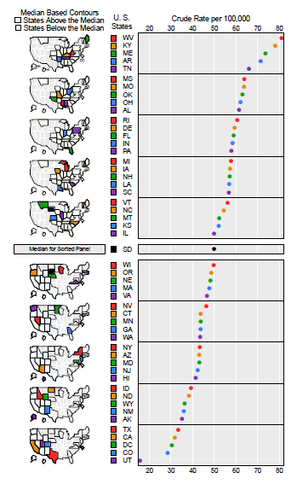

Figure: United States Lung and Bronchus Cancer Statistics, 2015 Mortality Trend