**EXTENDED KALMAN FILTER APPLICATION IN THE UNDERWATER VEHICLE POSITIONING TASK**

**ABSTRACT**

В данной статье предложена схема комплексирования информации для использования расширенного фильтра Калмана в задаче позиционирования ведущего подводного аппарата с помощью коммуникационных устройств (буев), дающих информацию о положении при помощи механизма наклонных дальностей, инерциальных датчиков, допплеровского лага и глубинометра. Описаны методики расчета параметров всех компонент комплексной навигационной модели. Приведены результаты имитационного моделирования с соответствующими метриками качества.

**INTRODUCTION**

Автономные подводные аппараты (AUVs) – роботы, которые способны перемещаться под водой самостоятельно без вмешательства оператора. До относительно недавнего времени, AUV использовались лишь в ограниченных областях применения. С развитием технологий обработки данных и высокоэффективных источников питания, AUV стали развиваться и использоваться чаще. Как правило, AUV обладают высокой степенью автономности, гибкости и возможностями удаленной навигации при исследовании морских ресурсов, подводной разведке, сборе данных и других аспектах [1]. С развитием технологий воздушной и наземной навигации, технологии подводной навигации также стали существенно эволюционировать [2,3,4]. Однако, из-за специфики подводной среды, все еще существует разрыв между точностью навигации и позиционирования подводных аппаратов по сравнению с воздушными и наземными, и на данный момент подводная навигация стала главным камнем преткновения в области морских исследований [5].

Подводя итог, можно сказать, что даже при наличии большего количества датчиков, все еще существует множество ограничений и недостатков в независимой работе AUV под водой. Однако AUV способны использовать свои навигационные датчики для получения соответствующей измерительной информации для последующего комплексирования с технологиями подводной акустической связи. Простота и гибкость использования подобных систем привели к повышенному вниманию исследователей к подводному позиционированию AUV [6,7].

Основной проблемой навигации и позиционирования является оценка состояния, и точный сбор информации о наблюдениях, в особенности для ведущего аппарата в группе. Большинство существующих методов позиционирования AUV включают улучшенные алгоритмы навигации на основе фильтра Калмана (KF) в сочетании с данными измерений от подводных навигационных датчиков. Модель совместной системы локализации AUV часто является нелинейной. Поэтому для оценки состояния обычно используется расширенный фильтр Калмана (EKF) [8,9,10].

В настоящее время использование гидроакустических устройств связи для получения относительных наблюдений является наиболее эффективным и надежным методом измерения. Однако AUV используются в сложных морских средах, где на измерительные датчики могут повлиять неблагоприятные условия, приводя к неизвестным ошибкам измерительной системы. Это неизбежно приводит к снижению точности и стабильности процедуры фильтрации.

Среди существующих решений по задаче позиционирования выделяется работа [11], где рассматривалась система комплексирования информации с датчиков, среди которых данные наклонных дальностей от трех гидроакустических буев, расположенных на поверхности. Аналогичная задача представлена в [12], но задействованы уже четыре буя. В представленных источниках можно выделить существенные недостатки: отсутствие параметров для настройки фильтра и методологии комплексирования информации с датчиков. Более того, не приведены метрики качества по ошибкам работы фильтра, от чего трудно определить степень точности работы алгоритмов восстановления состояния.

Для решения вышеуказанных проблем необходима разработка алгоритма фильтрации при помощи EKF с учетом шумовых параметров датчиков. В настоящей работе будет принято использование двух буев с ультракороткой базой для обеспечения позиционирования подводного аппарата при комплексировании информации с датчиками инерциальной навигации, допплеровским лагом и глубинометром.

**MATERIALS AND METHODS**

**AUV NAVIGATION SYSTEMS**

In contrast to airborne or ground-based drones, AUVs are dealing with a uniquely difficult navigational problem due to the lack of high-precision satellite navigation underwater. Of course, for remotely piloted vehicles, additional navigation information (position, speed) may be sent to the vehicle via fiber optic cable. However, for unmanned submersibles without cable communication, this is almost impossible to be implemented in practice [13,14].

There are three main methods of AUV navigation in the literature: dead reckoning and inertial navigation, acoustic navigation and geophysical navigation methods [15].

The first method is based primarily on the inertial navigation equipment, which has become financially affordable, especially after the creation of microelectromechanical systems (MEMS).

Since measurement errors of inertial navigation equipment are monotonically increasing and unlimited, other aids (e.g., differential global positioning system for position estimation, Doppler velocity log or correlated speed log for velocity estimation; pressure sensors for depth estimation, etc.) must be integrated to improve positioning system accuracy [16].

Acoustic navigation is based on using the AUV transponder's acoustic signals to determine its position. The most common methods are the long baseline, which uses at least two widely separated transponders mounted usually on the seafloor; and the ultra-short baseline, which uses GPS-calibrated transponders on an accompanying surface vessel. Both methods have limited range (about 10 km for individual LBLs, about 4 km in deep water, while less than 0.5 km in shallow water for USBL networks). Because LBL requires the installation of beacons, its applicability is limited to missions performed in stationary locations (e.g., harbor defense). In addition, beacon installation and maintenance are complicated and expensive operations. USBL may not be applicable in some military applications because of tactical limitations, as it requires an accompanying vessel [17].

As can be seen in Fig. 1, it is necessary to provide measurements fusion of different sensors in order to estimate AUV position together with errors.

**GYROSCOPE**

**ACCELEROMETER**

**PRESSURE SENSOR**

**DOPPLER VELOCITY LOG**

**GPS**

**EXTENDED KALMAN FILTER**

,

,

Figure 1 – Fusion and filtering scheme for sensor readings

The most commonly used method of obtaining absolute position information underwater is through the buoys. These buoys are in known locations and the AUV receives the range and/or azimuth to several of them and then calculates its position through trilateration or triangulation. Based on the location of the transceivers, three different basic systems can be distinguished: Long Baseline System (LBL), Short Baseline System (SBL) and Ultra Short Baseline System (USBL) [18,19].

A typical configuration for a standard long baseline is shown in Figure 2(a). Two or more buoys are deployed around the perimeter of the area in which the AUV will operate. These buoys are anchored and float on the surface or, especially in deeper waters, several meters above the seafloor. Each unit receives acoustic requested pings from a common receiving channel. После получения запросного пинга от AUV, каждый блок ждет уникальное специфическое время ответа TAT, а затем посылает в ответ пинг на своем отдельном канале передачи. AUV затем получает ответный пинг. Канал передачи, а также ТАТ различны для каждого блока. Уникальный ТАТ гарантирует, что два буя не будут смешиваться при передаче в одно время, и с использованием различных частот передачи буи обеспечивают способ определения для AUV, из какого блока был отправлен ответный пинг.

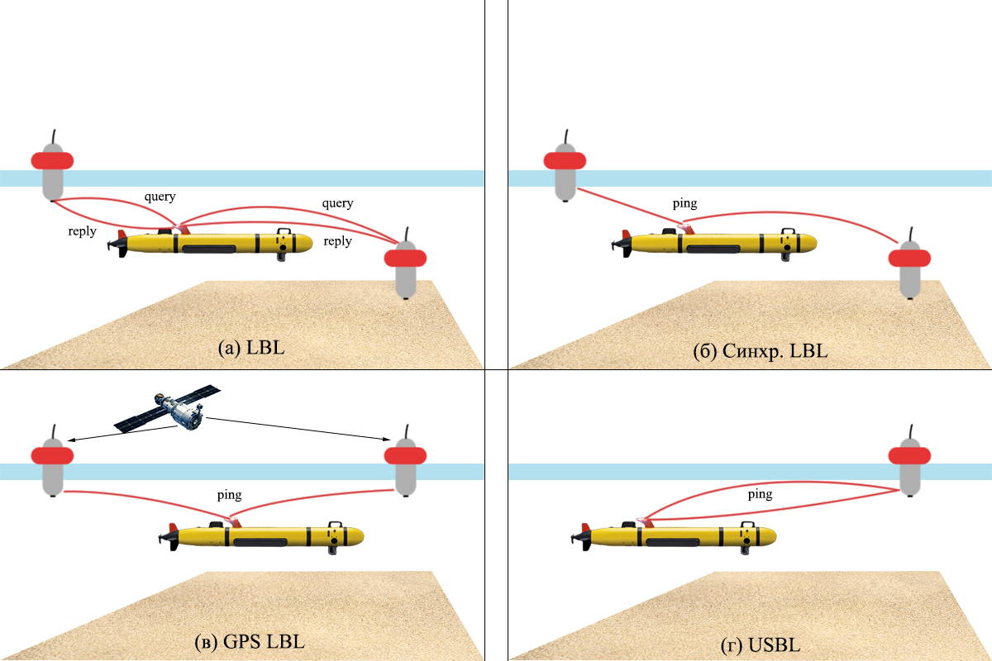

Figure 2 – Buoy-based underwater positioning methods

The standard LBL systems mentioned earlier are not well suited for large groups, as only one AUV can access the buoy network at a time and receive position updates. Therefore, the position update interval increases with the number of vehicles.

New LBL systems like the one shown in Fig. 3(b), synchronized the clocks of the buoys and the AUV transceiver units. The buoys broadcast a ping containing a unique identifier at certain intervals. When the AUV receives this ping, the known beacon broadcast schedule and the timing of the synchronized clocks ensure that the vehicle knows when the ping was sent and can directly calculate the OWTT (one-way travel-time).

Another improvement over conventional LBLs is the system shown in Fig. 3(c). Relying on the setup in Fig. 3(b), the buoys now transmit their GPS positions along with a unique identifier. As with the system described earlier, the AUV does not need to send queries to the buoys. With the buoy positions embedded in the ping, the buoys are free to swim, and there is no need to save their coordinates to the AUV before deployment.

**Slant Ranges Usage**

If there are two or more buoys, it is possible to reconstruct information about the location of the modem-object using the slant range mechanism to recalculate the position in the global coordinate system by GPS or GLONASS.

Two buoys are considered in the task. Their locations at longitudinal, lateral and vertical displacements are determined by the and vectors. Assuming that the depth is constant (without considering wave perturbations), it is possible to neglect the and values, obtaining the positions in the plane and .

The possibility to obtain slant range to the underwater vehicle will allow to calculate its position, but preliminary requires knowledge of its depth (assuming that the pressure sensor is always working) to determine the projection of the range on the XY plane. Denoting the slanted ranges as and , expressions for their plane projections are obtained

Further, the positioning problem is reduced to the geometric problem of finding intersection points between two circles whose centers are the buoy positions, and whose radii are the projections found earlier ( and ).

The distance between the circles allows to use the cosine theorem

The possible positions of the submersible are now defined by the expression

where – unit vector between the first and the second center,

– perpendicular to the unit vector.

The duality of solving the equation is resolved if the previous underwater vehicle position is known. In this case, it is necessary to choose the point closest to the last vehicle position (Fig. 3).

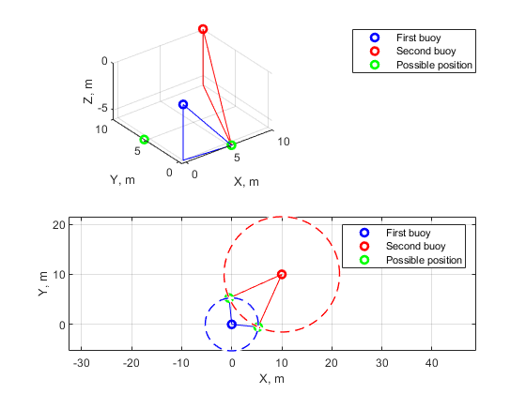

Figure 3 – Slant ranges geometry

**UNDERWATER VEHICLE MODEL DESCRIPTION**

General coordinates of an autonomous underwater vehicle (AUV) are determined in a geocentric coordinate system using SNAME notation [20,21]:

where determines the longitudinal, lateral, and vertical positions, respectively, and the vector determines the Euler angles: roll, pitch, and yaw, respectively.

The velocity vector is expressed in the coordinate system associated with the body. The velocities according to the notation announced above should be written as

Under the influence of hydrodynamic effects caused by the aquatic environment, it is possible to write down the expression for the underwater vehicle dynamics in the following form

where – the solid body inertia matrix ( is the DoF number),

– added mass matrix,

– solid body Coriolis matrix,

– added mass Coriolis matrix,

– dissipative coefficients matrix,

– gravitational forces and moments vector,

– vector (of forces and moments) of the controls applied to the body,

– vector (of forces and moments) of external disturbances applied to the body.

In real systems, is calculated with the thruster’s models using the thruster’s distribution matrix () as

where – is a vector that describes the thrusters' load ( is the number of thrusters), and the matrix relates the thrusters' load and the forces/moments vector

The kinematics equation linking (1) and (2) is written in the form

where – the rotation matrix obtained from the Euler angles,

– the Jacobian linking the angular velocities of the world reference system and the body system.

The rotation matrix is defined by the following expression

Given , it is possible to write the state vector

The latter equation can be represented in the State-Dependent Coefficients (SDC) form [13]

,

, .

where – dynamics matrix,

– control matrix,

– output matrix ( – number of system outputs),

– input-output coupling matrix,

– control vector, including the vector of external perturbations .

**DESCRIPTION OF THE KALMAN FILTER MODEL**

Consider the problem of constructing a filter for a nonlinear system, known as an extended Kalman filter. It allows to estimate the controlled object state, even if the dimensionality of the state vector of the system under study exceeds the number of measured parameters. To calculate the current state of an a priori known dynamic system, it is necessary to know its current measured state, as well as the state of the filter at the time of the previous measurement. The purpose of the filter is to minimize the sum of squared errors of the state vector estimation [8,9,10].

Taking into account the white noise of the system and the white noise of measurements , the system in SDC-form has the following view:

The state vector estimation of the Kalman filter is defined as

where – is the state covariance estimation, – is the initial value of the state covariance estimation, – is the Kalman filter gain matrix, and are the cost matrices in the Riccati equation.

Noises and must satisfy the conditions:

**NAVIGATION SYSTEM COMPONENTS**

**DESCRIPTION OF THE CONTROLLED OBJECT MMT-300**

The MMT-300 AUV is designed to perform bottom and aquatic surveys at depths of up to 300 m. Search programs (missions) can be described as AUV tacking through the surveyed area with activation of on-board search devices (one or several) at specified intervals and then returning the vehicle to the supplying vessel.

The location of the main AUV elements is shown in Fig. 4: 1 – sustainer propulsion system, 2 – stabilizers, 3 – aft compartment, 4 – charge connector, 5 – aft cover, 6 – navigation and communication compartment, 7 – side-scan sonar, 8 – hermetic payload compartment, 9 – bow cover, 10 – outboard payload compartment, 11 – horizontal thruster, 12 – compartment cover, 13 – radio module, 14, 16 – cargo arm, 15 – autopilot compartment, 17 – vertical thruster, 18, 22 – payload compartment cover, 19 – towing arm, 20 – emergency ballast mechanism, 21 – Doppler velocity logger, 23 – ELS antennas, 24 – hermetic communication connector.

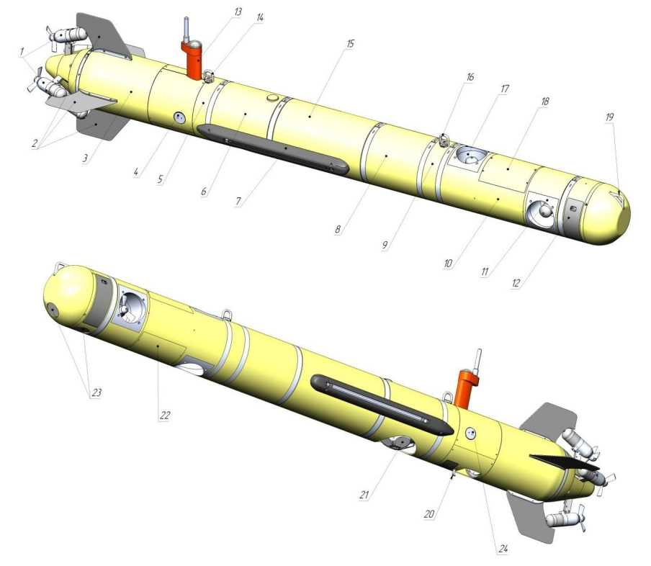

Figure 4 – Location of the AUV’s main components

**Software control and on-board navigation system**

The Onboard Control and Navigation System (OCNS) is designed to control all systems of the vehicle in all operating modes of the AUV.

The OCNS provides:

− выполнение заранее заложенной оператором программы-задания (миссии) АНПА с учетом имеющейся внешней обстановки;

− детектирование возникающих аварийных ситуаций и их адекватную их отработку;

− управление траекторным перемещением различных типов (движение заданным курсом/в точку в режимах стабилизации глубины/высоты над грунтом и т.п.);

− управление поисковыми средствами и иным оборудованием полезной нагрузки (вкл/выкл фотосистемы или гидролокатора бокового обзора, перевод их в различные режимы функционирования);

− комплексирование информации от магнитного компаса, датчиков ориентации, доплеровского лага, датчика глубины, а также GPS (на поверхности);

− определение результирующего местоположения АНПА в географических координатах.

Система бортового управления и навигации включает в свой состав:

− аварийные датчики и исполнительные устройства;

− магнитный компас и датчики ориентации (датчик крена, датчик дифферента, датчики угловых скоростей курса и дифферента, магнитный компас);

− радиомодуль (бортовые элементы системы радиосвязи, приемник спутниковой навигации (GPS/ГJIOHACC) и проблесковый светомаяк);

− датчик глубины;

− доплеровский лаг, имеющий следующие характеристики:

− частота – 700 кГц;

− максимальное отстояние от грунта – 60 м;

− диапазон измеряемых скоростей – 0 …2 м/с;

Магнитный компас и датчики ориентации предназначены для определения магнитного курса, крена и дифферента АНПА и используются для обеспечения траекторного движения АНПА.

Доплеровский лаг предназначен для определения вектора абсолютной скорости АНПА.

Система радиосвязи предназначена для обеспечения связи АНПА-судно со скоростью не менее 10 МБит на дистанции до 400 м (при нахождении АНПА на поверхности).

Приемник спутниковой навигации (GPS/TJIOHACC) предназначен для определения географических координат АНПА при нахождении его на поверхности.

**Propulsion-steering complex**

The propulsion-steering complex (PSC) is a program-controlled executive device. The AUV uses a propulsion system consisting of four aft reversible thrusters and two thrusters of horizontal and vertical channels. Stern thrusters are located in pairs in the horizontal and vertical planes at an angle of 22° to the longitudinal axis. This propulsion scheme makes it possible to create arbitrary forces and moments to control the AUV, as well as to implement various movement modes.

The AUV motion is controlled by five degrees of freedom. The range of possible values for a given longitudinal velocity is 0–2.0 m/s.

**Hydroacoustic navigation and communication system (option)**

The HNCS provides vehicle tracking, as well as periodic correction in determining the onboard coordinates of the AUV. The error in determining the distance depends significantly on hydrological conditions of the working area, as well as on the error in the set sound velocity. In the absence of GANS, the AUV uses calculus (using magnetic compass (MC), depth sensor (DS) and Doppler velocity logger (DVL) readings) and GNSS (on the surface) to determine its own coordinates.

The main HNCS features are summarized in Table 1.

Table 1 – HNCS features

|  |  |
| --- | --- |
| Parameter | Value |
| Operating depth, m | up to 300 |
| Operating range (slant), km | up to 3.5 |
| Slant range measurement error, m | no more than 0.01 |
| Operating frequency, kHz | 18 … 34 |
| Bearing measurement error, deg | 0.1 |
| Data transfer rate, kbit/s | up to 13.9 |

**MMT-300 MATHEMATICAL MODEL**

The main MMT-300 vehicle parameters are summarized in Table 2.

Table 2 – AUV parameters

|  |  |  |  |  |  |
| --- | --- | --- | --- | --- | --- |
| Mass, | Length, | Radius, | Center-of-mass vector, | Buoyancy center vector, | Buoyancy, |
| 150 kg | 3.081 m | 0,147 m |  |  | , N |

**Thrusters allocation matrix**

Given the geometric and physical parameters of the thrusters, it is possible to determine the thrusters allocation matrix (4) by the following expression

where – is the force created by the -th thruster,

– is the geometric position of the force application point of the -th thruster relative to the vehicle's center of mass.

It is worth noting that the forces generated by the MMT-300 thrusters depend on the software control, which leads expression (9) to the parametric form

where – is the software control code.

From Fig. 5 it is possible to determine the values , which are presented in Table 3.

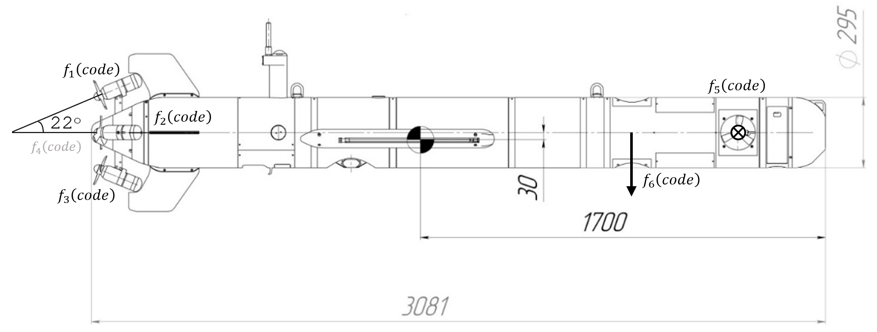

Figure 5 – MMT-300 geometric parameters

Table 3 – Thrusters moment of arms of the ММТ-300

|  |  |  |  |
| --- | --- | --- | --- |
| Thruster № | , (mm) | | |
| , (mm) | , (mm) | , (mm) |
| 1 | -1330 | 0 | 189 |
| 2 | -1330 | 159 | 30 |
| 3 | -1330 | 0 | -129 |
| 4 | -1330 | -159 | 30 |
| 5 | 1330 | 0 | 30 |
| 6 | 882 | 0 | 30 |

Since all thrusters are the same in design, they create a single force that depends on the software control code . In this case is defined taking into account the geometry of the control object as

, ,

, ,

, .

From the thruster’s static characteristic (Fig. 6) it is possible to write down the functional dependence between the control code and the generated force, for example by means of a sixth-order polynomial



Figure 6 – Static characteristics of the MMT-300 thrusters

With the dependencies defined above, it is possible to determine which makes it possible to define the expression for forces and moments (4) already in parametric form . In this case, determines the thruster’s load percentage. At full performance .

**Inertia and added masses matrices**

The matrix в уравнении (6) is constant, symmetric and positively determined (). The values filling it largely depend on the geometric configuration and, in the most general case, have the following form [20,21]

where – is rigid body mass,

– is identity matrix,

– is the inertia tensor in the reference frame of the body,

– is the vector from the origin to the gravity center of the body,

– is an operator of vector transformation into a skewed matrix:

as expanded:

The inertia tensor for a solid cylinder is defined as

The matrix consists of the external forces and moments elements, and is written in composite form as [21]

,

where , , etc.

Given the symmetric form approximation of the underwater vehicle, the matrix notation will be greatly simplified and will take a diagonal form:

There is no unique correct way to calculate the matrix elements, so, as a rule, a variety of estimation methods are used. For a solid cylinder of mass , length , radius the added masses (15) are defined as [20]

**Coriolis matrix**

According to Fossen [21], the matrix is generally defined from the blocks of the inertia matrix . In this case , then

**Gravitational and buoyancy vector**

In [21], to calculate , the author uses the expression

where – is the vessel's mass including water in space,

– is the acceleration of gravity,

– is the buoyancy force,

where – is the liquid density,

– is the liquid volume displaced by the vessel,

, , – are the components of the vector from the origin to the center of buoyancy.

**Damping forces**

Figure 7 – Damping force distribution diagram

The drag force/lifting force is calculated with

where – is the drag coefficient,

– is the lift coefficient,

– is the environmental density,

– is the body velocity in the fluid,

– is the surface area, relative to the flow,

– is the surface area perpendicular to the flow,

The coefficients for the cylindrical approximation form AUV are given in [22]. For a given ratio of length and radius, the corresponding coefficient is .

The coefficient is determined relative to the bow cover’s geometry. In this case, the closest shape is a hemispherical bowl. In [23] the corresponding value of .

The frontal and side areas are determined solely from the basic geometric parameters of the submersible by the following expressions:

(m2).

(m2).

The forces induced by the cylindrical body motion , are approximately defined as

The moments created by the cylindrical body motion are approximately defined as

The damping forces, taking into account the calculated parameters are defined as

**MATHEMATICAL MODEL OF THE BUOY**

The scheme of the buoys involved in the system is shown in Fig. 8. Their parameters are summarized in Table 4.

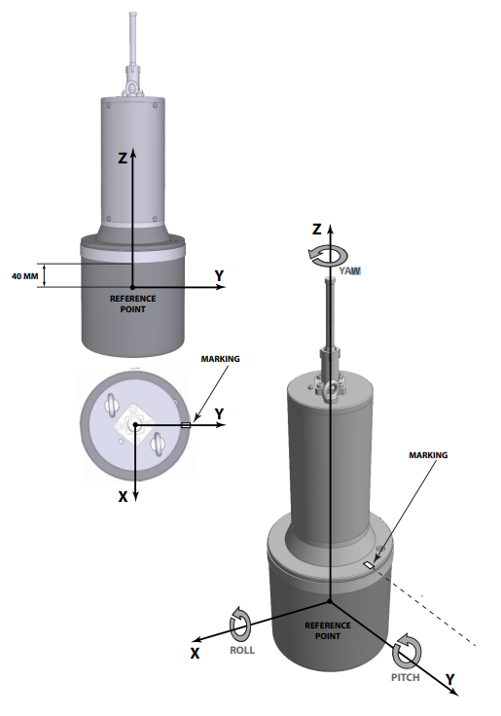

Figure 8 – The schematic representation of the buoy in its reference frame

Table 4 – Buoy parameters

|  |  |  |  |  |  |
| --- | --- | --- | --- | --- | --- |
| Mass, | Length, | Radius, | Center-of-mass vector, | Buoyancy center vector, | Buoyancy, |
| 12 kg | 0.36 m | 0.08 m |  |  | 171, N |

Given that the buoy has a cylindrical shape, it is possible to describe its dynamics similar to MMT-300, except that the inertia tensor is rotated and defined as

**DESCRIPTION OF ON-BOARD SENSORS**

No one sensor can measure perfectly, i.e., without errors. An error is the difference between the true value and the actual measured value. Sensor errors are divided into random and systematic components. Random components are also called random measurement errors. Their specific realization at a particular time cannot be predicted; it is only possible to describe a general pattern of their behavior. The mathematical model of random components is defined as a sequence of the white noise counts sum with Markov process counts or flicker noise [24]. Determining the characteristics of the random processes allows us to correctly describe their dynamics when integrating the IMU with other sensors, improving the filtering quality.

**Inertial sensors**

When combining the IMU with other sensors, the zeropoint bias of accelerometers and gyroscopes are included in the vector of estimated parameters: this allows to take into account their random component, which is the main source of positioning errors after compensating for other systematic errors. Temperature has the greatest effect on the zero-offset of MEMS-sensors; at the same time, its influence on the axis unorthogonality and scale coefficient errors is limited.

The output vector of velocity measurements from the 3-axis accelerometer unit is modeled as

,

where , – RMS error of the accelerometer, – is acceleration bias, which is modeled as a 1st-order Markov process.

Similarly, the real output of the gyroscope is defined as

,

where , – RMS error of the accelerometer, – is gyroscope bias, which is modeled as a 1st-order Markov process.

**Depthmeter (pressure sensor)**

Depth and underwater pressure have a direct correlation. As the unit goes deeper into the water, the pressure readings increase linearly.

The actual depth sensor output is simulated by adding noise to the actual depth

,

where , – RMS error in depth.

Depth RMS for the used sensor is approximately defined as m, then the variance is m.

**Doppler velocity logger**

The Doppler logger measures the change in acoustic frequency to determine the vehicle's speed relative to the seafloor. The actual Doppler logger output is modeled by adding noise to the actual vehicle speed

,

where , , – RMS of the velocity error.

It is necessary to determine the variance for the speed estimation. Мы знаем, что максимально измеряемая скорость передвижения — . Но начальное значение скорости нам неизвестно. Поэтому, мы выберем изначальное значение переменной — 0 м/с, а среднеквадратичное отклонение, по правилу «трёх сигм» . Соответственно, дисперсия определяется как

м/с.

Для допплеровского лага MMT-300 параметр м/c.

**GPS**

При моделировании показаний приемника СНС положим, что точность разрешения горизонтальных координат выше, чем вертикального канала. На практике данный эффект известен как VDOP (Vertical Dillusion Of Precision – снижение точности по вертикали). Также учтем эффект запаздывания решения относительно данных ИНС – . Данное запаздывание может быть вызвано буферизацией данных в приемнике и задержками при обработке сигналов, которые часто возникают при использовании в качестве источника данных недорогих приемников СНС или смартфона на базе операционной системы Android. По причине вариативности такой задержки её целесообразно включать в вектор состояния фильтра и динамически оценивать в процессе работы алгоритма. Тогда модель показаний приемника СНС примет вид:

,

где , , , а , – СКО ошибок по горизонтали и вертикали.

**SENSORS FUSION**

According to Fig. 1, it is required to combine information from the sensors to form a measurements vector for subsequent filtering. There are numerous methods of combining sensor readings.

In telecommunications, maximum ratio combining (MRC) is a data fusion method in which: the signals of each channel are summed, the gain of each channel is set proportional to the RMS signal level and inversely proportional to the RMS noise level in that channel:

Maximum ratio combining is the optimal fusion tool for independent channels with additive white Gaussian noise.

Вектор измерений в настоящей работе имеет следующий вид

,

где , , , , , , .

**NAVIGATION SYSTEM MODELING**

The filtering software simulation considers the following situation: the MMT-300 moves to a predetermined point, and two hydroacoustic buoys are located on the water surface. The influence of surface current is taken into account by influencing the displacement of buoys. If the measurement error is larger than the state uncertainty estimate, the filter will "trust" the simulation data more. That is why it is important to correctly select the values of covariance matrices, the main tool for tuning the filter. With the given measurement devices noise parameters, the EKF parameters are as follows:

, ,

,

.

It is assumed that a Doppler logger is used when fusing sensor information due to the small distance from the seafloor. It should also be noted that zero-order extrapolators with update frequencies, presented in the table below, are used to simulate the discrete nature of the measurement devices.

Table 5 – Update rates of the sensors

|  |  |
| --- | --- |
| Sensor | Update rate |
| IMU | 50 Hz |
| GPS | 1 Hz |
| DVL | 25 Hz |
| PS | 50 Hz |

The block diagram of the system model is shown in Fig. 9 and reflects its main components: hydroacoustic buoys to obtain slant ranges to AUV, controller to send control signals, dynamics/kinematics block of the underwater vehicle and sensors fusion block.

*Extended Kalman filter*

*Dynamics and kinematics of the ММТ-300*

Figure 9 – Positioning system block diagram

The simulation results are presented below. The initial state of the underwater vehicle in this case is defined as zero. Fig. 10 shows the trajectories of the submersible and the hydroacoustic buoys.



Figure 10 – XY position of buoys and AUV

Графики выхода системы приведены на рис. 11. Здесь очевидны погрешности измерительных датчиков: заметны шумы и высокие частоты обновления. Результаты работы фильтра Калмана для восстановления состояния приедены на рис. 12 и показывают более приемлемые результаты относительно действительных данных.



Figure 11 – Measurements

Более корректную оценку работы фильтра возможно произвести по ошибке относительно действительных данных (рис. 13). Количественная оценка уже определяется метриками качества. MSE, MAE и RMSE метрики сведены в таблицу 6.



Figure 12 – EKF estimation



Figure 13 – EKF estimation error

Table 6 – Quality metrics

|  |  |
| --- | --- |
| Metric | Value |
| MSE () |  |
| MSE () |  |
| MAE () |  |
| MAE () |  |
| RMSE () |  |
| RMSE () |  |

**CONCLUSION**

Основная цель настоящего исследования заключалась в разработке подходов и решений, позволяющих обеспечить качественную навигацию в автономном режиме с использованием ИНС на базе MEMS-датчиков грубого класса точности. В ходе выполнения исследования была разработана имитационная модель движения подводного робота. Все предложенные алгоритмы и подходы были протестированы с помощью средств имитационного моделирования и с использованием натурных данных.

Поставленная цель была достигнута: показана практическая возможность достижения приемлемого качества навигации в автономном режиме с использованием ИНС грубого класса точности. Ошибка позиционирования оказывается ограниченной на длительном временном интервале даже при условии начала движения из большой области начальной неопределенности.

Дальнейшие исследования будут направлены на формирование управляющих законов для роя подводных аппаратов относительно ведущего, т.к. основной проблемой кооперативной навигации и позиционирования до сих пор остается оценка состояния, и точный сбор информации о наблюдениях, в особенности для ведущего элемента.

**REFERENCES**

1. Miller A., Miller B., Miller G. Navigation of Underwater Drones and Integration of Acoustic Sensing with Onboard Inertial Navigation System // Drones. 2021. Т. 5. № 3. С. 83.
2. Li J. и др. Research on Error Correction Technology in Underwater SINS/DVL Integrated Positioning and Navigation // Sensors. 2023. Т. 23. № 10. С. 4700.
3. Otero P. и др. Underwater Positioning System Based on Drifting Buoys and Acoustic Modems // JMSE. 2023. Т. 11. № 4. С. 682.
4. Li P. и др. A Robust INS/USBL/DVL Integrated Navigation Algorithm Using Graph Optimization // Sensors. 2023. Т. 23. № 2. С. 916.
5. González-García J. и др. Autonomous Underwater Vehicles: Localization, Navigation, and Communication for Collaborative Missions // Applied Sciences. 2020. Т. 10. № 4. С. 1256.
6. Kebkal K. G., Mashoshin A. I. AUV acoustic positioning methods // Gyroscopy Navig. 2017. Т. 8. № 1. С. 80–89.
7. Pacini F. и др. Integrated comunication network for underwater applications: the SWARMs approach // 2018 Fourth Underwater Communications and Networking Conference (UComms). Lerici: IEEE, 2018. С. 1–5.
8. Zhao L. и др. An Adaptive Filtering Method for Cooperative Localization in Leader–Follower AUVs // Sensors. 2022. Т. 22. № 13. С. 5016.
9. Zhang F., Wu X., Ma P. Consistent Extended Kalman Filter-Based Cooperative Localization of Multiple Autonomous Underwater Vehicles // Sensors. 2022. Т. 22. № 12. С. 4563.
10. Sheng G. и др. Cooperative Navigation Algorithm of Extended Kalman Filter Based on Combined Observation for AUVs // Remote Sensing. 2023. Т. 15. № 2. С. 533.
11. Almeida J. и др. Underwater Localization System Combining iUSBL with Dynamic SBL in ¡VAMOS! Trials // Sensors. 2020. Т. 20. № 17. С. 4710.
12. Huang J. An Underwater Target Tracking Algorithm Based on Extended Kalman Filter // Mobile Information Systems. 2023. Т. 2023. С. 1–12.
13. Kabanov A. и др. Cooperative Control of Underwater Vehicle–Manipulator Systems Based on the SDC Method // Sensors. 2022. Т. 22. № 13. С. 5038.
14. Kabanov A., Kramar V. Marine Internet of Things Platforms for Interoperability of Marine Robotic Agents: An Overview of Concepts and Architectures // JMSE. 2022. Т. 10. № 9. С. 1279.
15. Luo Q. и др. A SINS/DVL/USBL Integrated Navigation and Positioning IoT System with Multiple Sources Fusion and Federated Kalman Filter. : In Review, 2021.
16. Miller A., Miller B., Miller G. Navigation of Underwater Drones and Integration of Acoustic Sensing with Onboard Inertial Navigation System // Drones. 2021. Т. 5. № 3. С. 83.
17. Morvan P.-Y., Bagot G. Innovative software solutions for subsea positionings. : pico, 2021.
18. Caiti A. и др. Experimental results with a mixed USBL/LBL system for AUV navigation // 2014 Underwater Communications and Networking (UComms). Sestri Levante, Italy: IEEE, 2014. С. 1–4.
19. Kebkal K. G. и др. Experimental Performance of a Hydro-Acoustic USBL-Aided LBL Positioning and Communication System // IFAC Proceedings Volumes. 2012. Т. 45. № 5. С. 249–254.
20. Antonelli G. Underwater Robots. Cham: Springer International Publishing, 2014.
21. Fossen T. I. Handbook of marine craft hydrodynamics and motion control =: Vademecum de navium motu contra aquas et de motu gubernando. Hoboken, NJ: Wiley, 2021. Вып. Second edition.
22. Blevins R. D. Applied fluid dynamics handbook. Malabar, Fla: Krieger Pub, 2003. Вып. Reprint ed. with corrections. 558 с.
23. <https://ntrs.nasa.gov/citations/19930091586>
24. Quinchia A. и др. A Comparison between Different Error Modeling of MEMS Applied to GPS/INS Integrated Systems // Sensors. 2013. Т. 13. № 8. С. 9549–9588.