**Gaivi:**

**ImportError: /lib64/libstdc++.so.6: version `CXXABI_1.3.9' not found**

**Reproduce:**

ImportError: /lib64/libstdc++.so.6: version `CXXABI_1.3.9' not found (required by /home/l/longdang/miniconda3/envs/torch171/lib/python3.8/site-packages/scipy/sparse/_sparsetools.cpython-38-x86_64-linux-gnu.so)

Run: strings /lib64/libstdc++.so.6 | grep '^CXXABI_'. Can’t find CXXABI_1.3.9'

**Solutions:**

Source: https://superuser.com/questions/1432321/importerror-lib64-libstdc-so-6-version-cxxabi-1-3-8-not-found

Run this:

>> cd /home/l/longdang/miniconda3/envs/torch171

>> strings lib/libstdc++.so.6 | grep '^CXXABI_' //Did you see CXXABI_1.3.9'

>> export LD_LIBRARY_PATH="/home/l/longdang/miniconda3/envs/torch171/lib/:$LD_LIBRARY_PATH"

**Models**

<https://gdrive-wget.glitch.me/>

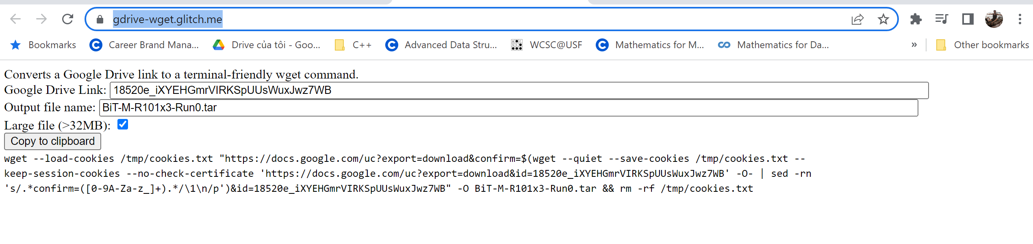

* BiT-M-R101x3

wget --load-cookies /tmp/cookies.txt "https://docs.google.com/uc?export=download&confirm=$(wget --quiet --save-cookies /tmp/cookies.txt --keep-session-cookies --no-check-certificate 'https://docs.google.com/uc?export=download&id=18520e_iXYEHGmrVIRKSpUUsWuxJwz7WB' -O- | sed -rn 's/.*confirm=([0-9A-Za-z_]+).*/\1\n/p')&id=18520e_iXYEHGmrVIRKSpUUsWuxJwz7WB" -O BiT-M-R101x3-Run0.tar && rm -rf /tmp/cookies.txt

* ViT-L_16,cifar10,run0_15K_checkpoint.bin

wget --load-cookies /tmp/cookies.txt "https://docs.google.com/uc?export=download&confirm=$(wget --quiet --save-cookies /tmp/cookies.txt --keep-session-cookies --no-check-certificate 'https://docs.google.com/uc?export=download&id=1J-HUoxJKDuiLu9HiNJEW2YefC3pSw6Wo' -O- | sed -rn 's/.*confirm=([0-9A-Za-z_]+).*/\1\n/p')&id=1J-HUoxJKDuiLu9HiNJEW2YefC3pSw6Wo" -O ViT-L_16,cifar10,run0_15K_checkpoint.bin && rm -rf /tmp/cookies.txt

* imagenet21k_ViT-B_32.npz

wget --load-cookies /tmp/cookies.txt "https://docs.google.com/uc?export=download&confirm=$(wget --quiet --save-cookies /tmp/cookies.txt --keep-session-cookies --no-check-certificate 'https://docs.google.com/uc?export=download&id=1wDk3P7YdBUFxiQLRHIGu1AIsRLwuBp_o' -O- | sed -rn 's/.*confirm=([0-9A-Za-z_]+).*/\1\n/p')&id=1wDk3P7YdBUFxiQLRHIGu1AIsRLwuBp_o" -O imagenet21k_ViT-B_32.npz && rm -rf /tmp/cookies.txt

srun -D /work_bgfs/l/longdang/ViTRobust/VisionTransformersRobustness/VisionTransformersRobustness --nodes=1 --mem=128G --partition=simmons_itn18 --qos=preempt_short --gpus=3 --time=01:00:00 --pty /bin/bash

How to load existing data