Exploring Healthcare Prescription Patterns Using Data Visualization

Sai Goud Koyyala
MSDS670 – Data Visualization
Regis University

Introduction
Data visualization plays an important role in identifying trends and patterns within healthcare datasets. By converting raw prescription data into visual representations, analysts can better understand medication demand, pharmacy workload, and prescription duration patterns. Visual analytics allows complex healthcare information to be interpreted quickly and supports better decision-making.
This project explores prescription data using data visualization techniques to identify patterns in medication usage, pharmacy activity, and prescription supply duration.

Research Question
How do prescription patterns across medications and pharmacies reveal trends in healthcare dispensing activity?

Data
The dataset used in this project contains prescription records including drug names, pharmacy names, dispense dates, and medication supply duration. These variables allow analysis of prescription trends, pharmacy activity, and medication usage patterns.
Key variables used in this analysis include:
• Drug Name – identifies the medication prescribed
• Pharmacy Name – identifies the pharmacy dispensing the medication
• Dispense Date – date when the prescription was filled
• Days of Supply – duration the medication is intended to last
This dataset provides insights into how prescriptions are distributed across medications and pharmacies over time.

Methodology
The analysis was conducted using Python and Matplotlib. The stateless interface of Matplotlib was used to generate professional visualizations that follow best practices for reproducible analysis.
Four visualizations were created to explore the dataset:
• Horizontal bar charts to examine medication demand
• A heatmap to analyze prescription distribution across pharmacies
• A time series line plot to observe prescription trends over time
• A histogram to understand medication supply duration patterns
These visualizations help reveal patterns that may not be easily visible in raw data.

Visualizations
5.1 Visualization 1: Prescription Distribution – Pharmacy vs Drug
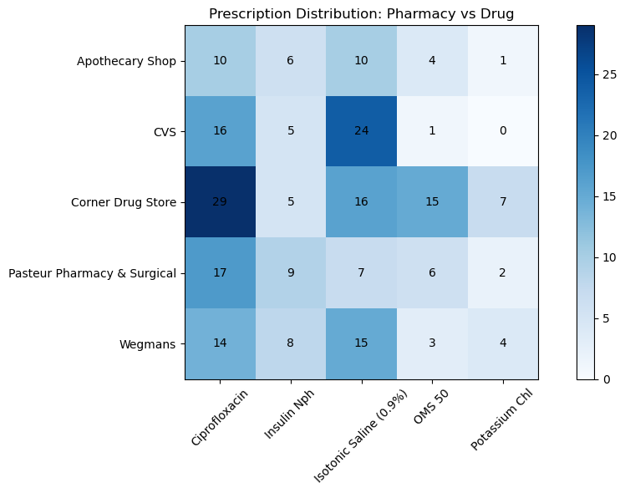
• Corner Drug Store appears to handle the highest number of prescriptions for several drugs.
• CVS and Wegmans also show strong prescription activity for certain medications.
• This visualization highlights how medication distribution varies across pharmacies.
5.2 Visualization 2: Top Medications by Prescription Count. 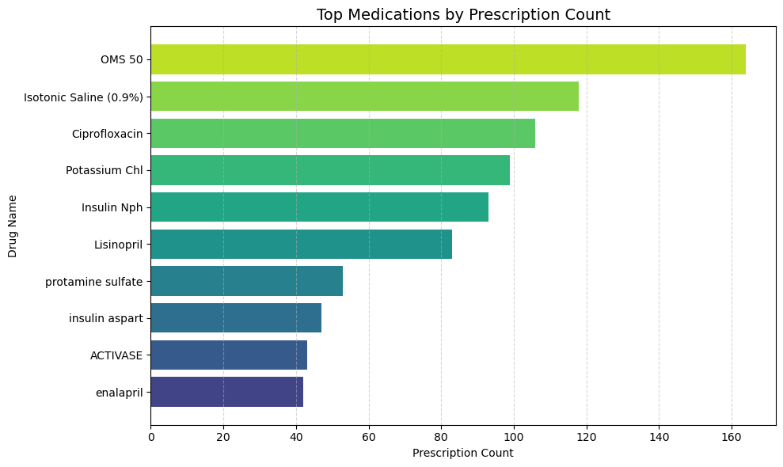
• OMS 50 is the most frequently prescribed medication in the dataset.
• Other commonly prescribed drugs include Isotonic Saline and Ciprofloxacin.
• The chart shows that a small number of medications account for a large portion of prescriptions.

5.3 Visualization 3: Monthly Prescription Trend – identifies patterns in prescription activity over time.
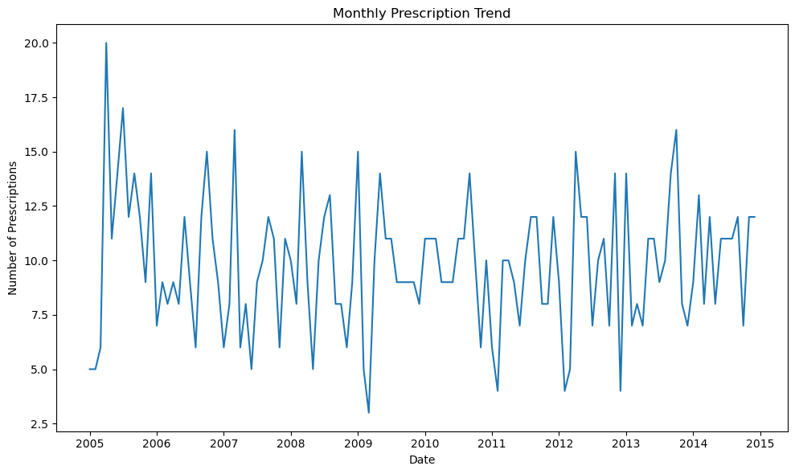
The time series chart shows how prescription activity changes over time.
• Prescription counts fluctuate slightly from month to month.
• Most months show between 5 and 15 prescriptions.
• Overall, the trend appears relatively stable over the observed time period.

5.4 Visualization 4: Distribution of Medication Supply Duration – examines prescription supply patterns.
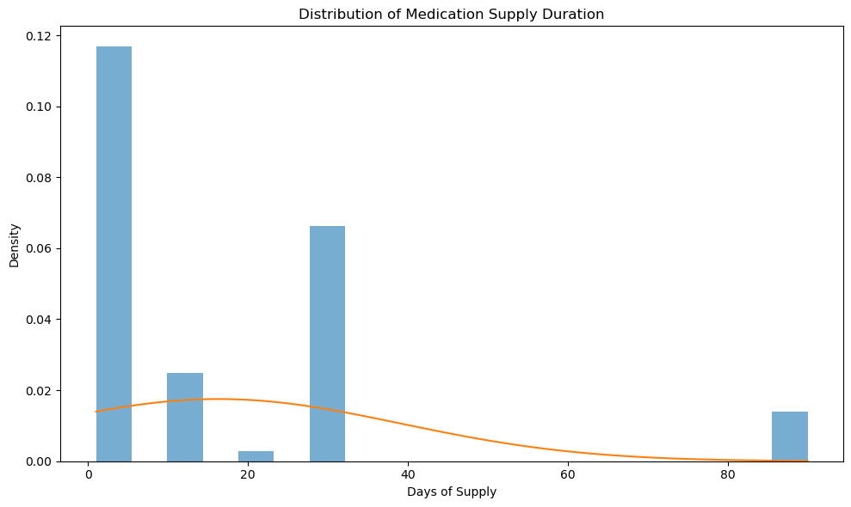
• Most prescriptions last between 1 and 10 days, indicating short-term treatments.
• Some prescriptions last around 30 days, which is common for routine refills.
• A smaller number of prescriptions extend to 90 days for long-term medications.

6. Conclusion
The visualizations reveal several important insights about prescription patterns in the dataset. Certain medications account for a large portion of prescriptions, indicating concentrated demand for specific treatments. Pharmacy activity varies across locations, with some pharmacies dispensing significantly more prescriptions than others.
Additionally, the distribution of medication supply duration shows that most prescriptions are short-term, while a smaller portion represents longer-term treatments. Overall, data visualization provides a powerful way to understand healthcare data and uncover patterns that support better analysis and decision-making.

