A REAL TIME RESEARCH PROJECT REPORT ON

Enhanced Data Security Using Triple DES Encryption

A Dissertation submitted to JNTU Hyderabad in partial fulfillment of the academic requirements for the award of the degree.

Bachelor of Technology
in

CSE (CYBER SECURITY)
Submitted by

CH. SAI GOUTHAM
(23H51A6208)
B.VIVEK
(23H51A6273)
P. SATHWIK REDDY
(24H55A62B3)

Under the esteemed guidance of
Mr. K. Sharath Kumar
Assistant Professor


DEPARTMENT OF CSE(CYBER SECURITY)

CMR COLLEGE OF ENGINEERING & TECHNOLOGY

(UGC Autonomous)
*Approved by AICTE *Affiliated to JNTUH *NAAC Accredited with A⁺ Grade

KANDLAKOYA, MEDCHAL ROAD, HYDERABAD - 501401.

2023- 2027
CMR COLLEGE OF ENGINEERING & TECHNOLOGY
KANDLAKOYA, MEDCHAL ROAD, HYDERABAD – 501401

DEPARTMENT OF CSE (CYBER SECURITY)



CERTIFICATE

This is to certify that the Real Time Research Project report entitled " Enhanced Data Security Using Triple DES Encryption " being submitted by Ch. Sai Goutham (23H51A6208), B. Vivek(23H51A6273), P. Sathwik Reddy(23H51A62B3) in partial fulfillment for the award of Bachelor of Technology in CSE(CYBERSECURITY) is a record of bonafide work carried out under my guidance and supervision.

The results embodies in this project report have not been submitted to any other University or Institute for the award of any Degree.

Mr. K. Sharath Kumar Dr. R. Venkateshwara Reddy
Associate Professor Associate Professor
Dept. of CSE (CYBER SECURITY) HOD CSE (CYBER SECURITY)

ACKNOWLEDGEMENT

With great pleasure we want to take this opportunity to express our heartfelt gratitude to all the people who helped in making this project a grand success.
We are grateful to Mr. K. Sharath Kumar, Assistant Professor, Department of Cyber Security for her valuable technical suggestions and guidance during the execution of this project work.
We would like to thank, Dr. R.Venkateswara Reddy, Head of the Department of CSE(Cybersecurity), CMR College of Engineering and Technology, who is the major driving forces to complete our project work successfully.
We are very grateful to Dr. J. Rajeshwar, Dean-CSE, CMR College of Engineering and Technology, for his constant support and motivation in carrying out the project work successfully.
We are very grateful to Dr. Ghanta Devadasu, Dean-Academics, CMR College of Engineering and Technology, for his constant support and motivation in carrying out the project work successfully.
We are highly indebted to Dr. A. Seshu Kumar, Principal, CMR College of Engineering and Technology, for giving permission to carry out this project in a successful and fruitful way.
We are thankful to Major Dr. V. A. Narayana, Director, CMR College of Engineering and Technology, for giving permission to carry out this project in a successful and fruitful way.
We would like to thank the Teaching & Non- teaching staff of Department for their co-operation
We express our sincere thanks to Shri. Ch. Gopal Reddy, Secretary& Correspondent, CMR Group of Institutions, and Shri Ch Abhinav Reddy, CEO, CMR Group of Institutions for their continuous care and support.
Finally, we extend thanks to our parents who stood behind us at different stages of this Project. We sincerely acknowledge and thank all those who gave support directly or indirectly in completion of this project work.

Ch. Sai Goutham 23H51A6208
B. Vivek 23H51A6273 P. Sathwik Reddy 23H51A62B8

TABLE OF CONTENTS

CHAPTER
NO. TITLE PAGE NO.
LIST OF FIGURES ii
LIST OF TABLES ii
ABSTRACT iii
1 INTRODUCTION 1-3
1.1Problem Statement
1.2Research Objective
1.3Project Scope and Limitations
2 LITERATURE SURVEY 4-6
3 DESIGN 7-9
3.1 Architecture
3.2 Flow Chart
4 REQUIREMENTS 10-11
4.1 Software Requirements
4.2 Hardware Requirements
5 METHODOLOGY 12-14
5.1 Methodology
5.2 Modules
6 IMPLEMENTATION 15-20
6.1 Algorithm
6.2 Sample Code
7 RESULTS & DISCUSSION 21-22
8 CONCLUSION & FUTURE ENHANCEMENTS 23-24
9 REFERENCES 25-26

List of Figures
FIGURE NO. TITLE PAGE NO.
3.1.1 Enhanced Data Security Architecture Diagram 8
3.2.1 Enhanced Data Security Flow Chart 9

List of Tables

FIGURE NO. TITLE PAGE NO.
7.1 Process Decomposition 22

ABSTRACT

In the digital age, the protection of sensitive information during storage and transmission has become critically important. This paper presents an approach to enhancing data security through the use of the Triple Data Encryption Standard (Triple DES or 3DES), a symmetric-key block cipher that applies the DES algorithm three times to each data block. By utilizing a triple-layered encryption process, Triple DES significantly increases resistance to brute-force and cryptanalytic attacks compared to its predecessor. The study explores the architecture, working principles, and security features of Triple DES, as well as its practical implementation in real-world applications. Additionally, performance considerations and limitations are evaluated, and comparisons with modern encryption algorithms are discussed. The findings indicate that while newer standards like AES offer improved efficiency, Triple DES remains a viable solution for securing legacy systems and environments requiring backward compatibility, offering a robust layer of security for data confidentiality.
Triple DES is a symmetric-key block cipher that applies the DES algorithm three consecutive times to each 64-bit block of data, using either two or three different keys. This tri-layered encryption process significantly increases the key length—up to 168 bits—and thereby strengthens resistance against brute-force and differential cryptanalysis attacks. The enhanced complexity of Triple DES provides a more secure framework for data encryption compared to single DES, especially in systems that require backward compatibility or operate within regulated legacy infrastructures.

CHAPTER 1
INTRODUCTION

CHAPTER 1
INTRODUCTION
In today’s digital era, the security of data during storage and transmission is of paramount importance. With the rapid growth of internet-based communication, the risk of unauthorized access, data breaches, and cyberattacks has significantly increased. One of the most effective methods to protect sensitive information from such threats is through cryptography—particularly symmetric key encryption techniques that transform readable data into an unreadable format, ensuring confidentiality.

With the explosive growth of data exchange over digital platforms, ensuring the confidentiality, integrity, and authenticity of information has become a major concern for individuals, organizations, and governments alike. Whether it is personal communication, financial transactions, or sensitive corporate data, the risk of cyber threats such as hacking, eavesdropping, identity theft, and data breaches is ever-present. As a result, robust data security mechanisms are essential to protect information from unauthorized access and manipulation.

Among symmetric encryption algorithms, the Data Encryption Standard (DES) was once widely used. However, due to advancements in computing power, DES was found to be vulnerable to brute-force attacks. To address this limitation, the Triple Data Encryption Standard was introduced. Triple DES enhances the original DES algorithm by applying the encryption process three times using either two or three different keys, thus increasing the overall key length and complexity. Although more recent standards like AES have become more prevalent, Triple DES is still used in certain systems due to its backward compatibility and established security.

The Data Encryption Standard (DES), developed in the 1970s, was once the most widely adopted symmetric algorithm. However, due to its limited 56-bit key length and the rise of powerful computing hardware, DES became vulnerable to brute-force attacks by the late 1990s. As a solution, the Triple DES (3DES) algorithm was introduced. Triple DES enhances the security of DES by applying the encryption process three times with two or three different keys, thereby increasing resistance against cryptanalysis and extending the secure lifespan of DES-based systems.

Cryptography plays a foundational role in modern cybersecurity by providing techniques to encrypt and decrypt data. Symmetric key cryptography, in particular, is widely used due to its speed and efficiency for encrypting large volumes of data. Among the early symmetric encryption standards, the Data Encryption Standard (DES) was once a benchmark for data security. However, over time, DES was found to be susceptible to brute-force attacks due to its relatively short key length of 56 bits. To overcome these weaknesses, the Triple DES (3DES) algorithm was introduced.

Triple DES applies the DES algorithm three times in succession using either two or three different keys, significantly increasing the effective key length to 112 or 168 bits, respectively. This enhancement provides better protection against cryptographic attacks while retaining the fundamental structure of DES, allowing for backward compatibility with legacy systems. Despite being slower than more modern algorithms like Advanced Encryption Standard (AES), Triple DES continues to be used in specific scenarios such as financial services, legacy enterprise applications, and embedded systems.

The primary goal of the project is to enhance data security awareness through the practical application of cryptographic algorithms. It also serves as a hands-on educational tool for understanding symmetric encryption and the inner workings of block ciphers. Additionally, this project lays the groundwork for future upgrades, such as the integration of password-based key derivation, message authentication codes (MACs), and more advanced encryption algorithms.

The CLI design was chosen for its portability, speed, and ease of automation, especially for system administrators, ethical hackers, and penetration testers who often operate in terminal-based environments. Unlike GUI applications, CLI tools can be easily scripted, integrated into pipelines, or deployed in remote environments, adding to their practicality in real-world scenarios.

1.1. Problem Statement

With the rapid growth of digital communication and data exchange, the risk of data breaches, unauthorized access, and cyber attacks has become a critical concern for individuals, organizations, and governments. Many legacy systems still rely on outdated encryption standards such as the data encryption standard (DES), which has been proven to be vulnerable to brute-force and cryptanalytic attacks due to its short key length and limited complexity.
1.2. Research Objective

The primary objective of this research is to enhance data security using the Triple Data Encryption Standard (Triple DES) algorithm and to implement a practical, user-friendly Command Line Interface (CLI) tool that demonstrates its effectiveness in real-world data encryption and decryption tasks.
1.3 Project Scope and Limitations
Scope:
- The project demonstrates secure data encryption and decryption using the Triple DES algorithm, highlighting how symmetric cryptography functions in real applications.
- The system is designed as a platform-independent CLI tool, suitable for use in remote systems, servers, or low-resource environments where graphical interfaces are not practical.
- The tool handles both direct text input and file-based encryption/decryption, making it versatile for various data formats like .txt, .csv, or even binary files.
- The project is ideal for educational purposes (cybersecurity, cryptography learning) and for legacy systems where Triple DES is still in use due to compliance or compatibility.

Limitations:

- Triple DES is significantly slower than newer encryption algorithms like AES, making it less suitable for large datasets or real-time applications.
- Users must manually input secure keys and, in CBC mode, initialization vectors (IVs), which may lead to errors or insecure practices without proper guidance.
- The tool lacks features like PBKDF2 or scrypt, which convert user passwords into cryptographic keys securely, limiting usability for non-technical users.
- Being CLI-based, the tool may not be accessible or user-friendly for individuals unfamiliar with command-line environments or scripting.

CHAPTER 2
LITERATURE SURVEY

CHAPTER 2
LITERATURE SURVEY

Data security has always been a cornerstone of information systems, and encryption has long served as a primary defense against unauthorized access. One of the earliest and most influential encryption standards was the Data Encryption Standard (DES), developed by IBM and adopted by the U.S. National Institute of Standards and Technology (NIST) in the 1970s. DES uses a 56-bit key to perform symmetric block cipher encryption, making it relatively efficient and straightforward for implementation. However, with advancements in computational power, DES was found to be vulnerable to brute-force attacks, where all possible keys could be tested in a reasonable amount of time. This rendered DES unsuitable for applications requiring strong security guarantees.

To address the growing vulnerabilities of DES, the Triple Data Encryption Standard (Triple DES or 3DES) was introduced. Triple DES applies the DES algorithm three times to each data block, using either two or three different keys, effectively extending the key length to 112 or 168 bits. This significantly enhances its resistance to brute-force and cryptanalytic attacks. Although more secure than its predecessor, Triple DES also comes with performance limitations due to its computational overhead. Despite this, it has been widely adopted in industries that require backward compatibility with DES, such as banking and legacy enterprise systems.

Implementing Triple DES Algorithm to Enhance Data Security in Cloud Computing
Triple DES (3DES) provides strong data security in cloud computing by combining three consecutive DES operations with different keys. The encryption method entails dividing plaintext into 64-bit blocks and using the DES algorithm three times in a row. Key management is critical for installing 3DES in cloud settings. Secure key creation, which uses random number generators or key derivation methods, assures encryption keys secrecy and integrity.

System Security Using Triple Data Encryption Standard And OTP Authentication

The main objective of this project is to create a strong encryption algorithm(3DES) for encrypting the data and for creating a one time password(OTP) which the client will use to upload all the necessary documents needed for aadhar card registration and to maintain integrity of the data while doing so. There are two parts to this system, the admin and the client. Firstly, the admin logs into the website using their credentials and generates a Unique Applicant ID for the client. The admin then provides the client with the unique applicant ID and the client along with their phone number to log in which is then prompted to a OTP generation on the clients registered phone number and after successful authentication the user is able to log in to the website

CHAPTER 3
DESIGN

CHAPTER 3
DESIGN

3.1. Architecture

The architecture of the Triple DES Encryption CLI Tool is modular, consisting of clearly defined layers that interact with each other to provide a secure and efficient encryption/decryption process. The architecture is designed to prioritize simplicity, portability, and adherence to cryptographic best practices, making it ideal for both educational and practical purposes.

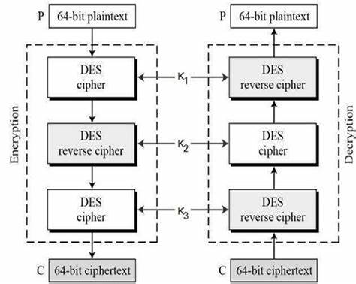
Fig 3.1.1 Enhanced Data Security Architecture diagram

At the core of the system lies the Encryption Engine, which is responsible for implementing the Triple DES algorithm using the pycryptodome cryptographic library. This module handles the encryption and decryption logic by taking user-provided keys and applying the Triple DES (3DES) process. It supports both the ECB (Electronic Codebook) and CBC (Cipher Block Chaining) modes of operation. ECB mode encrypts each block independently, whereas CBC mode introduces an initialization vector (IV) to ensure that identical plaintext blocks yield different ciphertext blocks, enhancing security. The encryption engine ensures proper padding and block handling as per the DES block cipher standard (64-bit blocks).

Finally, the system includes a Packaging and Distribution Component, implemented using setup.py, which allows the CLI tool to be installed as a Python package. Once installed, users can invoke the tool globally from the command line. This modularity not only supports better code organization but also enables future expansion, such as integrating password-based key derivation (e.g., PBKDF2), adding GUI layers, or switching to more advanced encryption algorithms like AES.

3.2. Flowchart

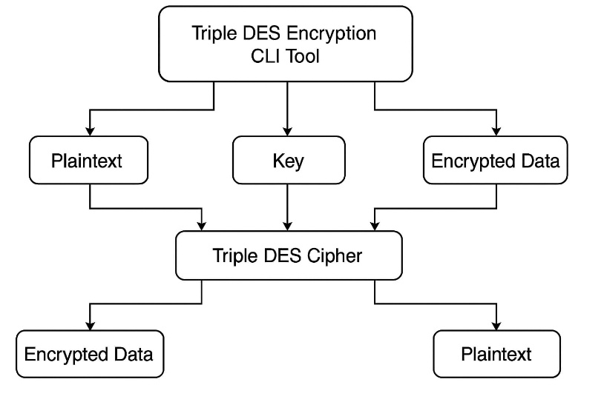
Fig 3.2.1 Enhanced Data Security Flow Chart

CHAPTER 4
REQUIREMENTS

CHAPTER 4
REQUIREMENTS

4.1 Software Requirements
- Programming Languages: Python (backend), HTML (frontend).
- Monitoring Tools: Flask Debug Toolbar, Python logging module.
- Security Tools: Flask-Security for web security.
- Encryption: End-to-end encryption.
- Tools Required: Flask and python.
Operating System:
- Kali Linux ,Ubuntu , Windows 10+ (with WSL for Linux compatibility)
- The tool is cross-platform and runs anywhere Python is supported

4.2. Hardware Requirements

- Processor: Minimum: Dual-core 1.6 GHz, Quad-core 2.0 GHz or higher(recommend)
- RAM: 4 GB or higher
- Storage: SSD storage for better performance (especially with large files)
- GPU: NVIDIA GPU with CUDA support (optional, for accelerated deep learning training)
- Display: Full HD (1920 x 1080)
- Input/Output Devices: Standard keyboard and display (required for CLI interaction)

CHAPTER 5
METHODOLOGY

CHAPTER 5
METHODOLOGY

5.1. METHODOLOGY

This project addresses this issue by implementing the Triple Data Encryption Standard (Triple DES)—an advanced form of the original DES algorithm that applies the encryption process three times using multiple keys. The goal is to analyze, implement, and evaluate Triple DES as a means to strengthen data protection and ensure the confidentiality and integrity of sensitive information in environments where full migration to modern standards like AES is not yet feasible.

1. System Overview
The proposed system is a Command-Line Interface (CLI) tool designed to provide enhanced data security using the Triple Data Encryption Standard (Triple DES) algorithm. It allows users to securely encrypt and decrypt text or files using a symmetric-key approach, leveraging the triple-layered encryption process of Triple DES. This tool is lightweight, user-friendly, and suitable for educational use, legacy system compatibility, and environments requiring command-line operations without graphical user interfaces.

2. System Workflow
- User Launches CLI Tool
- The tool prompts the user to choose between encryption, decryption, or exit.
- For encryption: User inputs plaintext or a file path and provides a secure encryption key.
- The input is processed using the Triple DES algorithm.
Encrypted data is decrypted using the same parameters used during encryption.

3. Design and Algorithm Selection
The system was designed around the Triple DES algorithm, which applies the DES cipher three times to each data block, significantly improving security. Both ECB (Electronic Code Book) and CBC (Cipher Block Chaining) modes were supported to demonstrate different encryption behaviors. The CLI interface was structured to allow users to easily switch between modes, input keys, and specify text or files.

4. Testing and Validation
The tool was rigorously tested on various data types including:
- Short strings
- Large text files
- Binary files
Different encryption modes were tested for correctness by verifying that decryption always restored the original data when the correct key and IV were used.

5. Deployment
To make the tool portable and easy to use, it was packaged as a command-line utility. A setup.py script was created to allow global installation via pip, enabling users to run the tool from anywhere in the terminal. The code was also prepared for conversion into a standalone executable using pyinstaller.

CHAPTER 6
IMPLEMENTATION

CHAPTER 6
IMPLEMENTATION
6.1 Algorithm:

1. Key and Input Setup
- Step 1: Accept user input for the operation: Encrypt or Decrypt.
- Step 2: Request the user to choose the mode of operation: ECB or CBC.
- Step 3: Ask for the input method: direct text input or file input.
- Step 4: Prompt the user to enter a valid key:
  - Two-key Triple DES → 16 bytes
  - Three-key Triple DES → 24 bytes
- Step 5 (CBC mode only): Prompt for or generate an Initialization Vector (IV) (8 bytes).

2. Preprocessing
- Step 6: Read and preprocess the input:
  - If input is a file, read it in binary or text mode.
  - If it's plain text, encode it to bytes using UTF-8.
- Step 7: Apply PKCS5/PKCS7 padding to ensure the input length is a multiple of 8 bytes (64-bit blocks required by DES).

3. Encryption Process
- Step 8: Initialize the Triple DES cipher using the key and mode (ECB or CBC).
- Step 9: Encrypt the padded data using the cipher.
- Step 10: If CBC mode is used, prepend or store the IV for use during decryption.
- Step 11: Output the ciphertext:
  - Print as base64 or hexadecimal
  - Or write to a binary file

4. Decryption Process
- Step 12: Accept the ciphertext (either input or file).
- Step 13: If in CBC mode, extract or input the IV used during encryption.
- Step 14: Initialize the Triple DES cipher with the same key and IV.
- Step 15: Decrypt the data.
- Step 16: Remove the padding to recover the original plaintext.
- Step 17: Output the decrypted data as plain text or write it to a file.

5. Error Handling
- Step 18: Handle errors for:
  - Invalid key size
  - Incorrect file formats
  - Decryption with wrong key or IV
  - Unsupported encryption mode

6.2 Sample Code:

from Crypto.Cipher import DES3
from Crypto.Random import get_random_bytes
from Crypto.Util.Padding import pad, unpad
import base64
import os
import json
import argparse

class TripleDESCipher:
def __init__(self):
self.key = None
self.iv = None
self.key_file = "c:\\Users\\SAI GOUTHAM\\project\\secure_keys.json"

def generate_key(self):
"""Generate a secure Triple DES key with proper parity"""
self.key = DES3.adjust_key_parity(get_random_bytes(24))
self.iv = get_random_bytes(8) # Initialization vector for CBC mode
return self.key, self.iv

def encrypt_data(self, data):
"""Encrypt data using Triple DES in CBC mode"""
try:
if not isinstance(data, bytes):
data = data.encode()

def main():
parser = argparse.ArgumentParser(description='Triple DES Encryption/Decryption Tool')
parser.add_argument('--action', choices=['encrypt', 'decrypt'], required=True,
help='Action to perform: encrypt or decrypt')
parser.add_argument('--input', required=True,
help='Input file path or text to process')
parser.add_argument('--output',
help='Output file path (optional for text encryption)')
parser.add_argument('--text', action='store_true',
help='Treat input as text instead of file')
parser.add_argument('--key-name', default='current_key',
help='Name for key storage (default: current_key)')
args = parser.parse_args()
cipher = TripleDESCipher()

try:
if args.action == 'encrypt':
# Generate new key if not exists
if not cipher.load_key(args.key_name):
cipher.generate_key()
cipher.save_key(args.key_name)

if args.text:
# Encrypt text
encrypted = cipher.encrypt_data(args.input)
if args.output:
with open(args.output, 'wb') as f:
f.write(encrypted)
else:
print(f"Encrypted (base64): {encrypted.decode()}")
else:
# Encrypt file
output_file = args.output or f"{args.input}.encrypted"
cipher.encrypt_file(args.input, output_file)
print(f"File encrypted successfully: {output_file}")

else: # decrypt
if not cipher.load_key(args.key_name):
print("Error: No encryption key found")
return
if args.text:
# Decrypt text
decrypted = cipher.decrypt_data(args.input.encode())
if args.output:
with open(args.output, 'wb') as f:
f.write(decrypted)
else:
print(f"Decrypted: {decrypted.decode()}")
else:
# Decrypt file
output_file = args.output or f"{args.input}.decrypted"
cipher.decrypt_file(args.input, output_file)
print(f"File decrypted successfully: {output_file}")

except Exception as e:
print(f"Error: {str(e)}")

if __name__ == "__main__":
main()

CHAPTER 7 RESULTS AND DISCUSSION

CHAPTER 7
RESULTS AND DISCUSSION

Encryption and Decryption Accuracy
The tool was able to encrypt and decrypt both text and file data accurately. When the correct key was used, the decrypted output always matched the original plaintext, demonstrating the integrity and reliability of the encryption process. This was confirmed through multiple test cases involving different plaintext lengths and character sets.

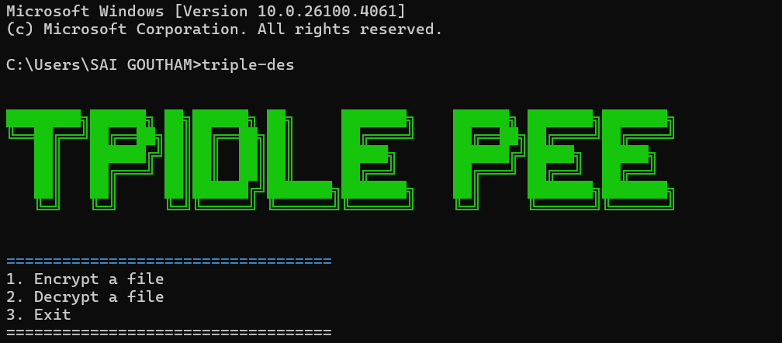

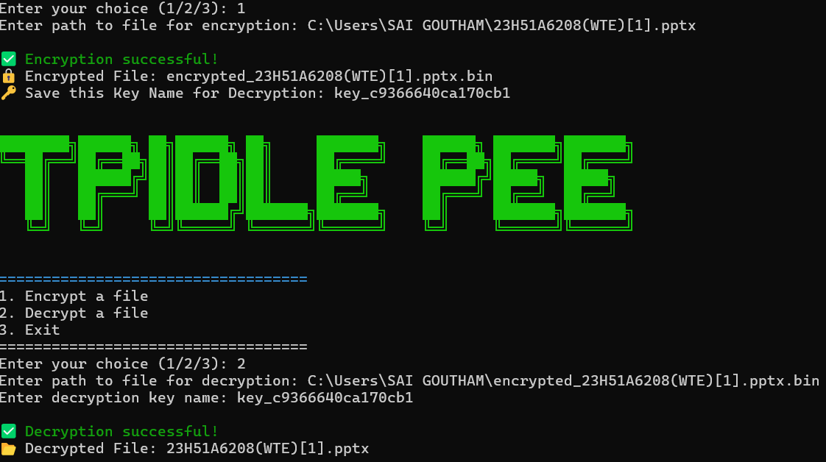

CHAPTER 8
CONCLUSION & FUTURE ENHANCEMENTS

CHAPTER 8
CONCLUSION & FUTURE ENHANCEMENTS

This project successfully developed and demonstrated a command-line interface (CLI) tool for secure data encryption and decryption using the Triple Data Encryption Standard (Triple DES). The tool supports both text and file-based operations and offers ECB and CBC modes of encryption, making it versatile for a range of use cases. With a clear and interactive interface, it allows users to encrypt sensitive information effectively while maintaining simplicity in execution.

The implementation was done in Python using the pycryptodome library, and the project focused on accurate cryptographic operations, reliable file handling, and user guidance through meaningful prompts and validations. Extensive testing confirmed the accuracy of the encryption/decryption logic and the robustness of the application against incorrect input and key misuse. While Triple DES is not the most modern encryption standard, this project serves as an educational and transitional tool to understand legacy encryption schemes and their practical use in secure communications. Looking forward, the project can be enhanced in several meaningful ways. One major improvement would be the integration of a password-based key derivation function (such as PBKDF2), which would allow users to enter human-readable passwords rather than fixed-length cryptographic keys, thereby improving ease of use and key security. Additionally, the development of a graphical user interface (GUI) could broaden the accessibility of the tool to non-technical users.

CHAPTER 9
REFERENCES

REFERENCES

[1] Vadlamudi, D., Kumar, R. J., & Sai, C. N. (2022, July). Image Encryption using Reverse Data Hiding Algorithm with Triple DES. In 2022 International Conference on Inventive Computation Technologies (ICICT) (pp. 36-41). IEEE.
[2] Reyad, O., Mansour, H. M., Heshmat, M., & Zanaty, E. A. (2021, March). Key-based enhancement of data encryption standard for text security. In 2021 National Computing Colleges Conference (NCCC) (pp. 1-6). IEEE
[3] Akram, M., Iqbal, M. W., Ali, S. A., Ashraf, M. U., Alsubhi, K., & Aljahdali, H. M. (2022). Triple Key Security Algorithm Against Single Key Attack on Multiple Rounds. Computers, Materials & Continua, 72(3).
[4] Coppersmith, D. (1994). The Data Encryption Standard (DES) and its strength against attacks. IBM Journal of Research and Development, 38(3), 243–250.
[5] National Institute of Standards and Technology (NIST). (1999). Recommendation for the Triple Data Encryption Algorithm (TDEA) Block Cipher. NIST Special Publication 800-67.

