WEEK 2
PROJECT REPORT
Data Visualization and
Insight Communication using R
Dataset: Titanic Passenger Dataset
Prepared by: SONTYANA SAI GOWTHAM
Submission date: 21 October 2026

1. Introduction
Data visualization converts data into visual forms that make patterns, comparisons, relationships, and unusual observations easier to understand. This project uses the Titanic passenger dataset to demonstrate an exploratory data analysis workflow and communicate observations through charts. The accompanying R script is designed to use R and ggplot2 for reproducible visualization.
The analysis focuses on passenger survival, age, ticket fare, passenger class, and sex. Different chart types are used according to the question being examined, rather than relying on a single chart type.

2. Objectives
- Explore the Titanic dataset and understand its important variables.
- Prepare selected fields for visualization and document missing-value checks.
- Create varied visualizations using R and ggplot2.
- Compare survival outcomes across passenger groups.
- Explore distributions and relationships between numerical variables.
- Communicate analytical observations clearly and responsibly.

3. Dataset Description
The Titanic training dataset contains passenger-level information such as survival status, passenger class, sex, age, ticket fare, family-related counts, cabin, ticket, and embarkation port. The supplied R script is written to load the titanic_train dataset from the R package named titanic.
The analysis workflow includes checking missing values and preparing selected fields for plotting. The script describes median imputation for missing age and fare values and mode-based replacement for missing embarkation values. A CabinKnown indicator distinguishes records with a recorded cabin from records without one. Interpretations should account for these preparation choices.

4. Tools and Method
- R and RStudio: intended environment for running the analysis script.
- ggplot2: chart creation and styling.
- dplyr and tidyr: data preparation and summary operations.
- titanic R package: dataset source referenced by the script.
- CSV summaries: supporting tables for dataset overview, missingness, correlations, and group comparisons.
The chart images included in this report are visual previews created from the available cleaned Titanic data package; the R script itself has not been executed in this environment. They are included to make the report readable, but they should not be described as verified R-generated output. For an assessment that requires proof of R execution, run data_visualization_week2.R in R/RStudio and replace these images with the corresponding outputs produced by that run.

5. Visualizations and Interpretation

5.1 Survival Counts — Bar Chart
Figure: survival_counts.png
Compares the number of passengers in the two survival categories. The chart provides an overview of the outcome counts in this dataset.
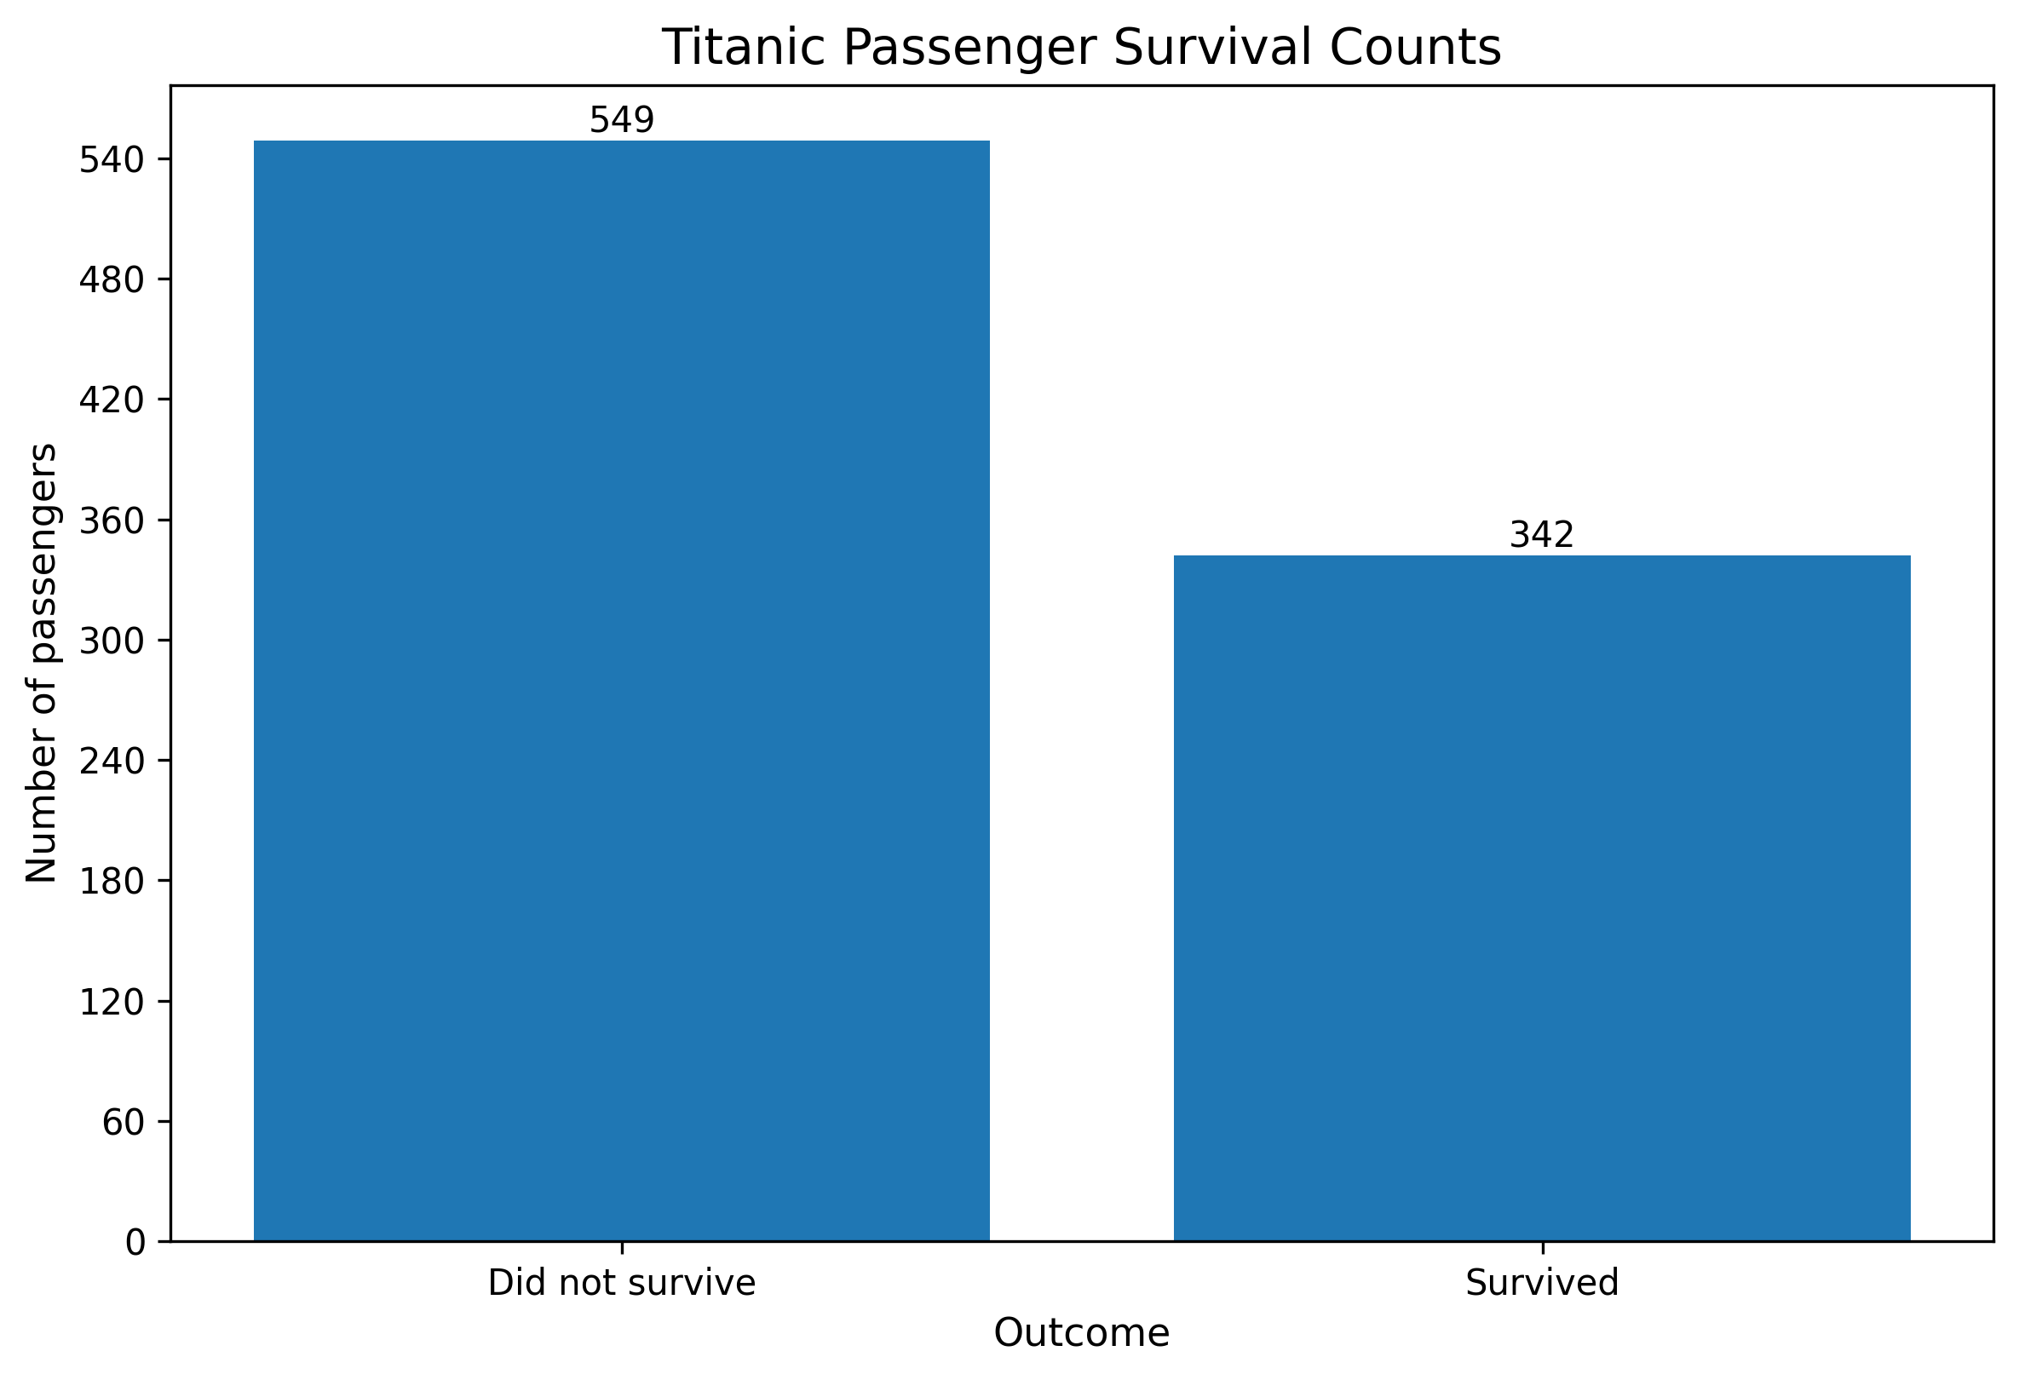
Figure — Survival Counts — Bar Chart

5.2 Age Distribution — Histogram
Figure: age_distribution.png
Shows the distribution of passenger ages. Examine where observations are concentrated and whether the distribution is skewed. Missing age values were prepared by imputation in the analysis workflow.
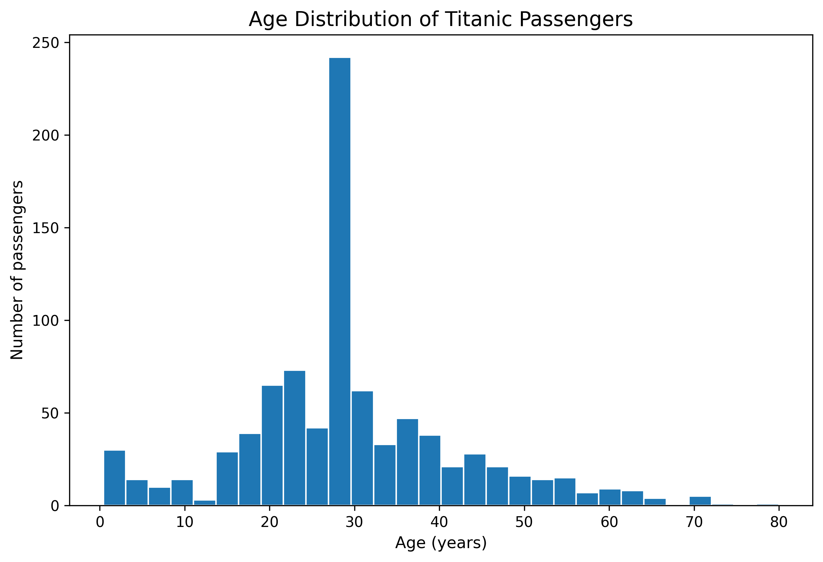
Figure — Age Distribution — Histogram

5.3 Fare Distribution — Histogram
Figure: fare_distribution.png
Shows how passenger fares are distributed. A concentration at lower fares and a smaller number of high fares can produce a right-skewed distribution; the plotted scale should be considered when interpreting the chart.
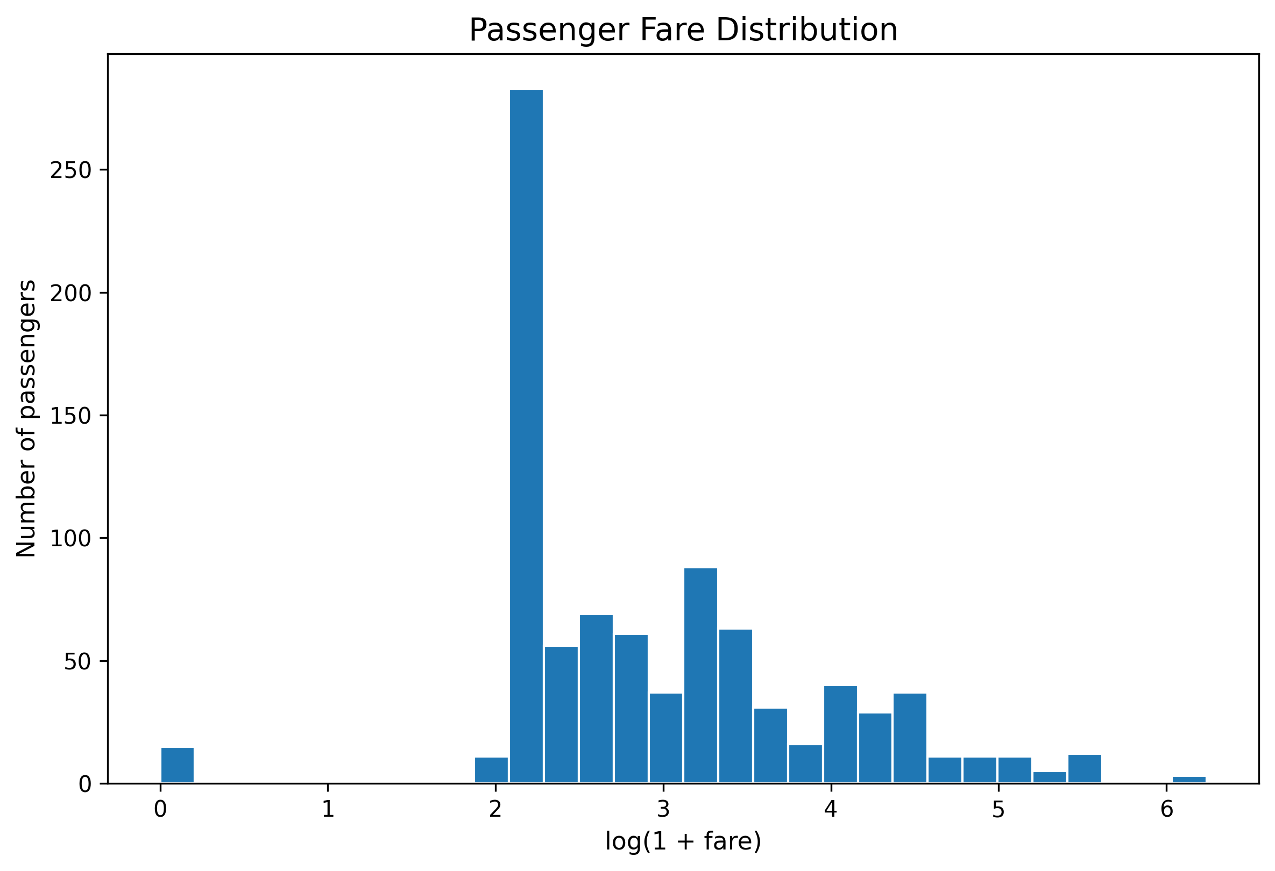
Figure — Fare Distribution — Histogram

5.4 Age versus Fare — Scatter Plot
Figure: age_vs_fare_scatter.png
Displays age and fare together, with points representing passengers. Use it to inspect clusters and possible relationships. Overlapping points can obscure individual records.
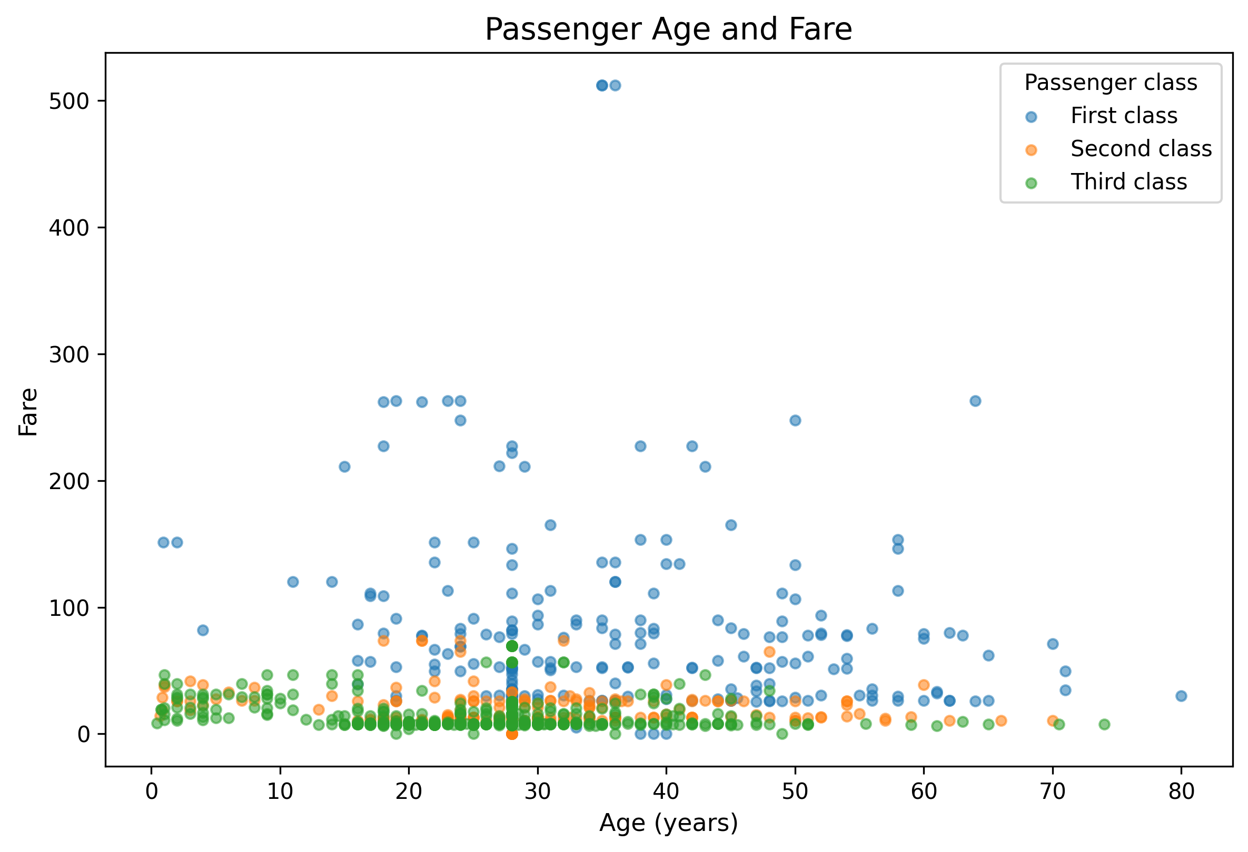
Figure — Age versus Fare — Scatter Plot

5.5 Survival by Passenger Class — Stacked Bar Chart
Figure: survival_by_class.png
Compares survival outcomes across passenger classes. If bars are normalized to percentages, compare proportions rather than raw counts; group sizes can differ.
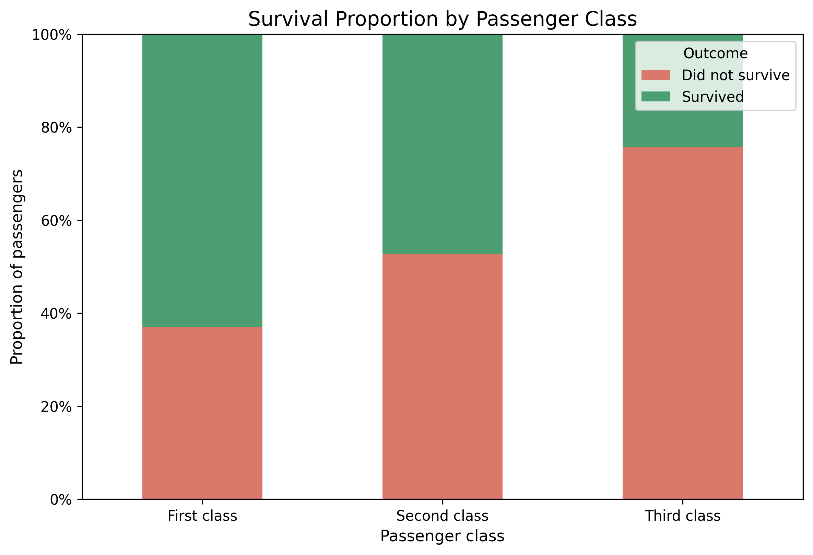
Figure — Survival by Passenger Class — Stacked Bar Chart

5.6 Survival by Sex — Stacked Bar Chart
Figure: survival_by_sex.png
Compares survival outcomes across recorded sex categories. Distinguish percentages from counts and consult the corresponding summary table for exact values.
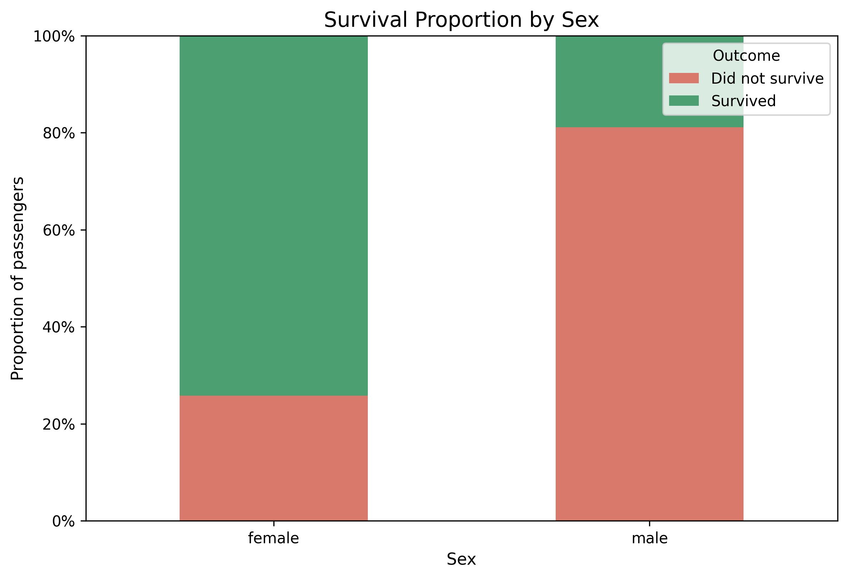
Figure — Survival by Sex — Stacked Bar Chart

5.7 Fare by Passenger Class — Box Plot
Figure: fare_boxplot.png
Summarizes fare medians, spread, and potential outliers across passenger classes. Points beyond whiskers are potential outliers under the plotting rule, not automatically errors.
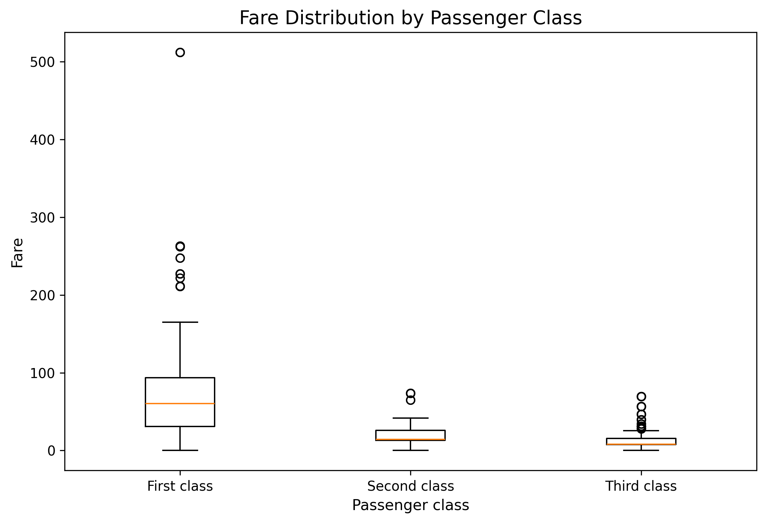
Figure — Fare by Passenger Class — Box Plot

5.8 Survival by Age Group — Line Chart
Figure: survival_by_age_group.png
Shows the survival-rate pattern across age groups. Age bands simplify a continuous variable, so differences should be interpreted in the context of the group boundaries and sample sizes.
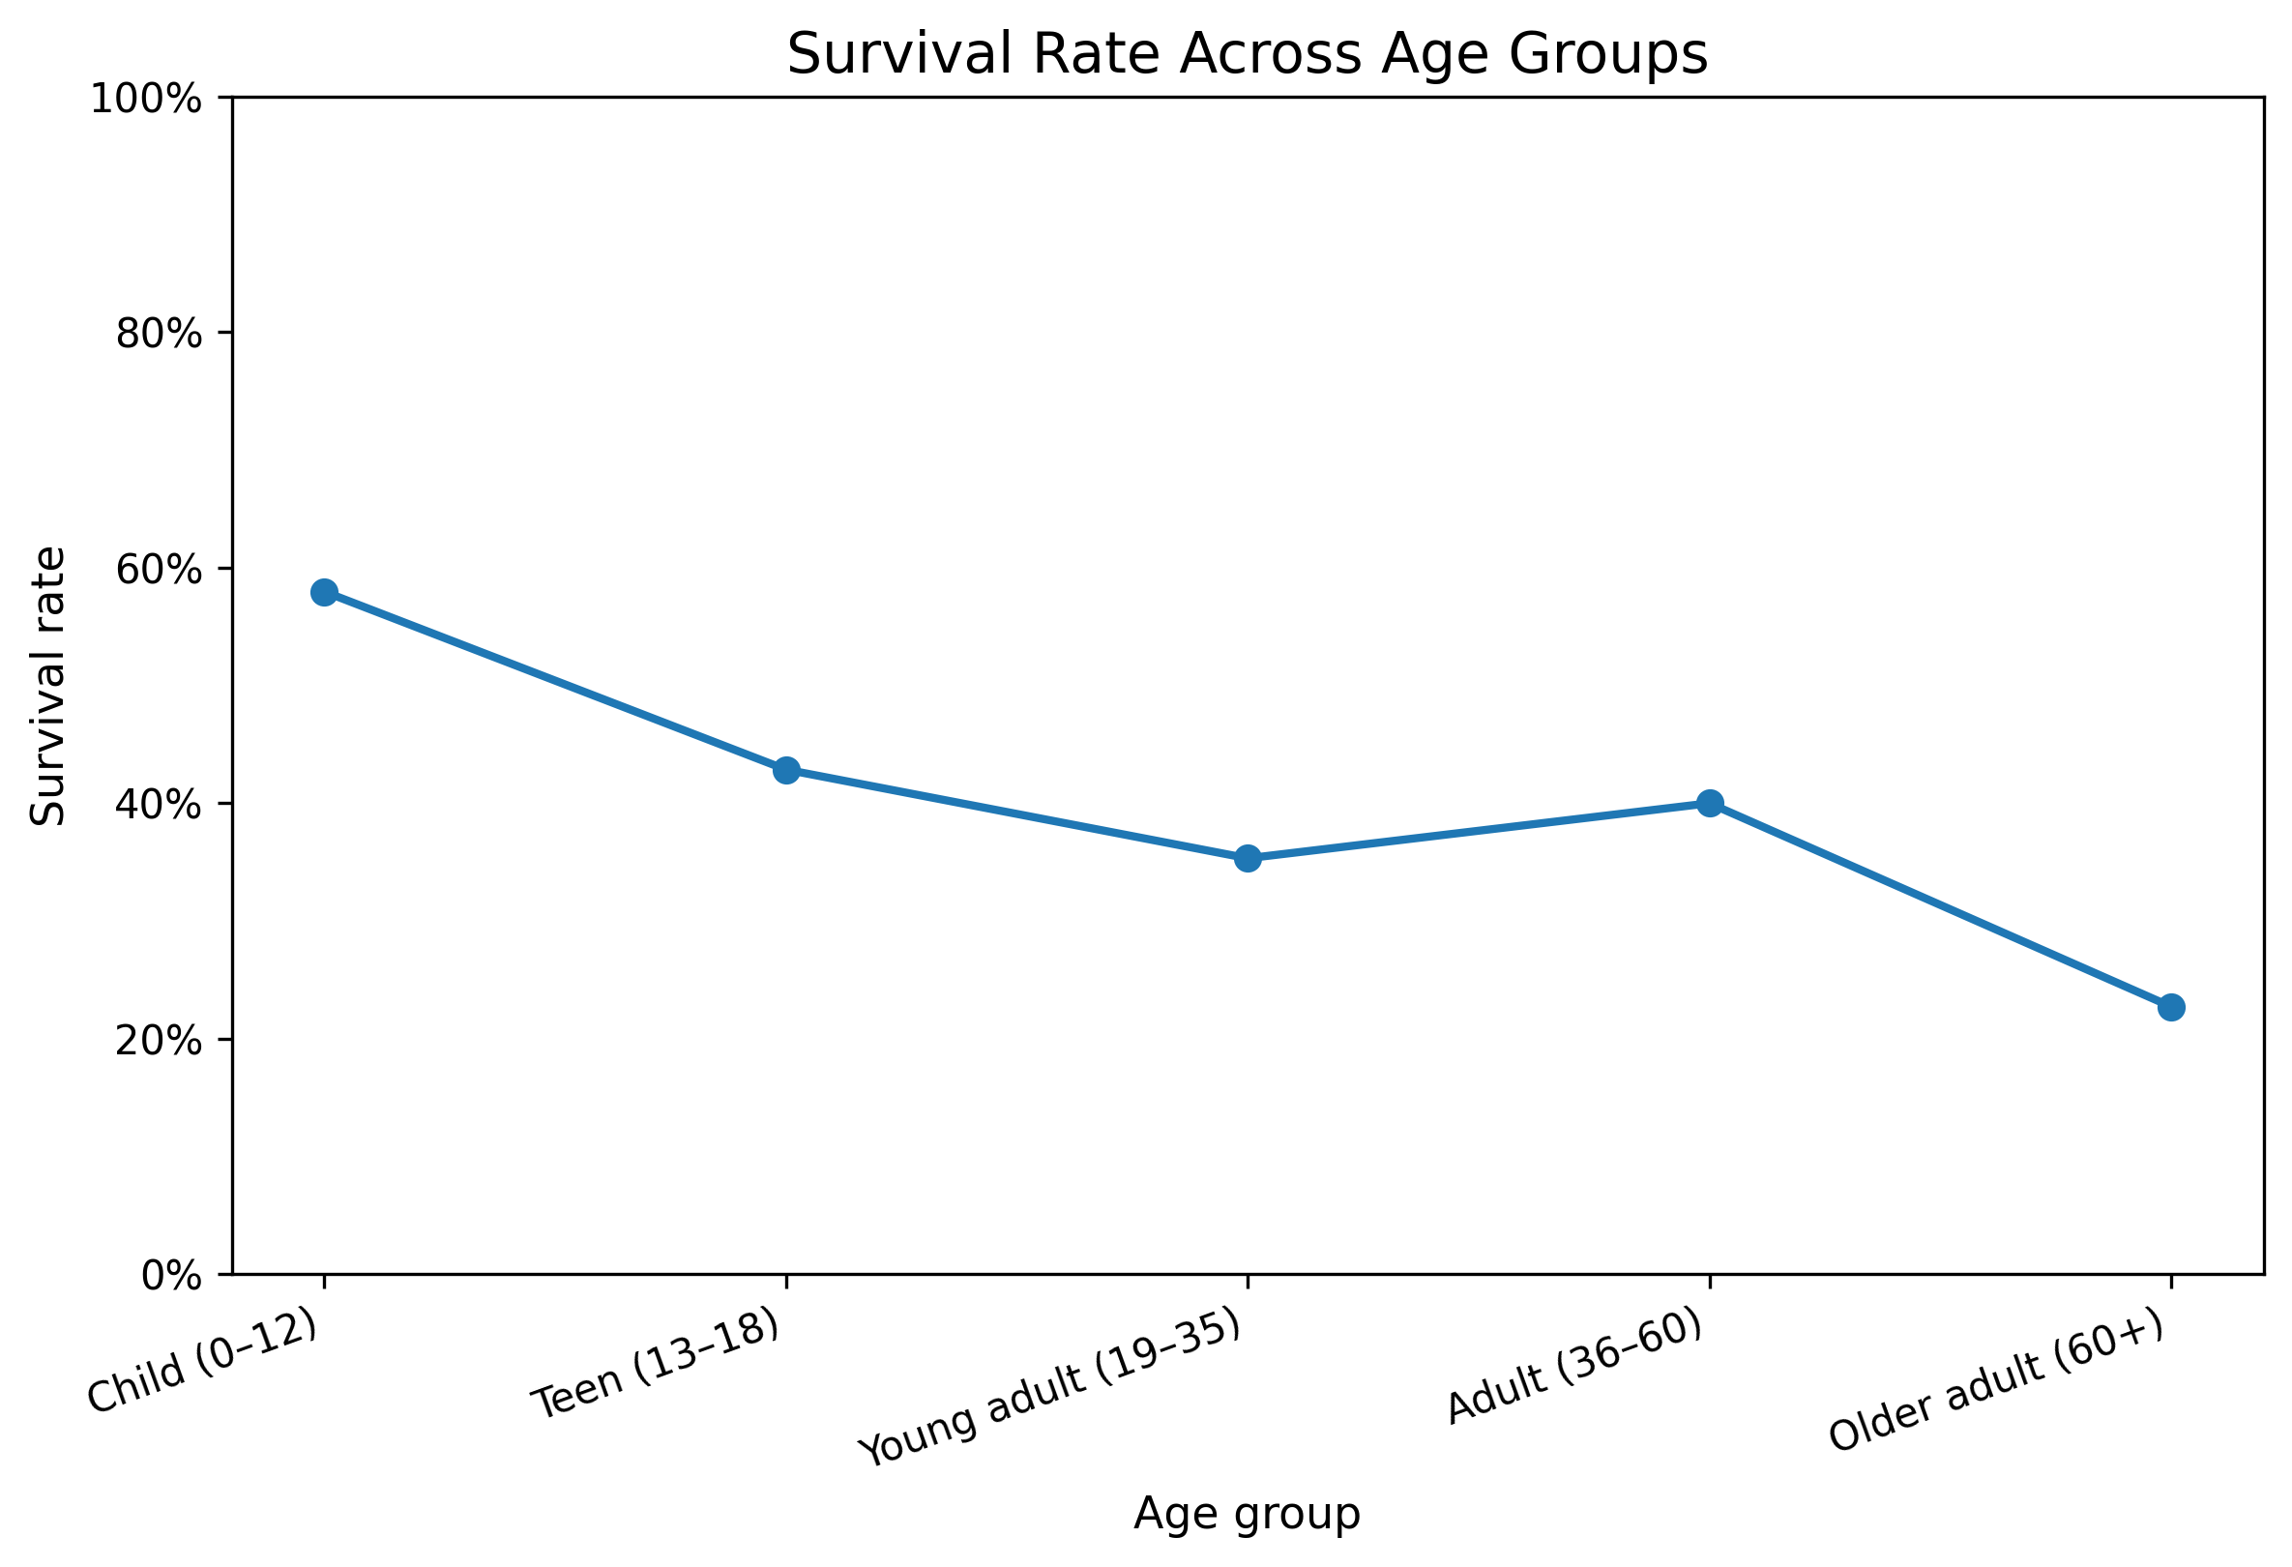
Figure — Survival by Age Group — Line Chart

5.9 Correlation Heatmap — Correlation Matrix
Figure: correlation_heatmap.png
Summarizes pairwise linear correlations among numeric variables. Values near +1 indicate positive association, values near −1 indicate negative association, and values near zero indicate weaker linear association. Correlation does not establish causation.
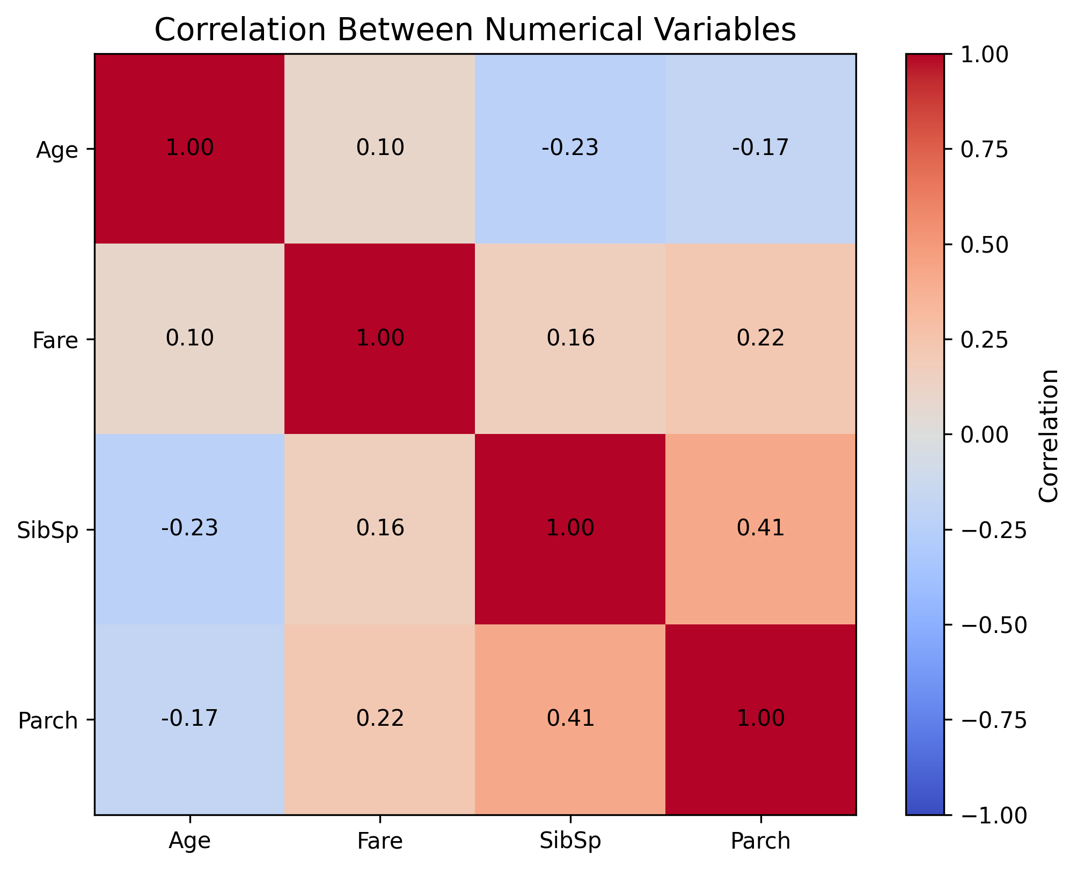
Figure — Correlation Heatmap — Correlation Matrix

6. Data Quality and Supporting Outputs
The project output package includes CSV summaries for dataset overview, missing-value checks, a correlation matrix, survival summaries by sex and passenger class, and visualization metadata. These files are intended to support chart interpretation with values and counts. Before final assessment, confirm that these outputs match a successful run of the accompanying R script.

7. Key Findings
- The survival-count visualization shows that the two survival outcomes are not equally frequent in the available Titanic data.
- The passenger-class comparison indicates that survival outcomes differ across class groups; exact rates should be read from the corresponding summary output.
- The sex-based comparison shows different survival patterns between the recorded sex categories; the summary table should be used for precise proportions.
- The fare distribution is concentrated toward lower values, with a tail toward higher fares; the log-transformed display scale helps show the distribution more clearly.
- The correlation heatmap and age-versus-fare scatter plot support exploration of numerical associations, but correlation alone cannot establish cause and effect.
Note: These are qualitative observations from the included preview charts and should be cross-checked against the CSV summaries and the output of a successful R script run before submission.

8. Limitations
- The Titanic dataset describes one historical event and is not representative of all passengers or modern travel.
- Imputing missing values makes selected plots easier to produce but introduces assumptions and may affect distributions.
- Passenger-level observations can overlap, especially in scatter plots.
- A correlation heatmap shows linear association, not cause and effect.
- Counts and rates answer different questions; group sizes should be considered when comparing outcomes.

9. Conclusion
This project demonstrates how different visualizations can help explore a single dataset from multiple angles. Bar charts support category comparisons, histograms describe distributions, scatter plots display relationships between numerical variables, box plots compare spread and potential outliers, and heatmaps summarize correlations. Together, these views provide a structured way to explore passenger characteristics and survival patterns. The conclusions should be confirmed against the actual outputs from the R script before the report is treated as a fully reproducible R analysis.

10. Project Repository
GitHub repository: https://github.com/saigowtham-24/Week_2_Data_Visualization_R
The repository should include the R script, README, plots folder, and outputs folder. Confirm that all files are committed and accessible before entering the URL in the internship submission form.

