WEEK 3
PROJECT REPORT
Statistical Analysis and
Predictive Modeling using R
Dataset: Titanic Passenger Dataset
Prepared by: SONTYANA SAI GOWTHAM
Week 3 Internship Project

1. Abstract
This project demonstrates an end-to-end statistical analysis and predictive modeling workflow using the Titanic passenger dataset. It investigates whether survival outcomes are associated with passenger sex and passenger class, compares age distributions between survival groups, examines numerical distributions and correlations, and builds classification models. Logistic Regression provides an interpretable statistical baseline, while Random Forest can capture nonlinear patterns and interactions. The workflow uses an 80/20 stratified train/test split and repeated five-fold cross-validation on the training data. Model evaluation includes accuracy, precision, recall, specificity, F1-score, ROC-AUC, and a confusion matrix. The accompanying R script is designed to generate the statistical tests, models, charts, and CSV outputs reproducibly.

2. Introduction and Objectives
Predictive modeling uses known examples to estimate outcomes for new observations. The Titanic dataset is a useful educational dataset because it contains a binary outcome (Survived) and passenger characteristics such as class, sex, age, family counts, fare, and embarkation port. The project combines inferential statistics with supervised classification so that conclusions are supported by both hypothesis tests and held-out predictive evaluation.
- Describe the dataset and inspect missingness and distributions.
- Formulate and test hypotheses about survival and passenger characteristics.
- Use normality tests and correlation analysis where appropriate.
- Build Logistic Regression and Random Forest classifiers.
- Use stratified splitting and cross-validation to reduce evaluation bias.
- Compare models using multiple metrics and interpret diagnostic plots.
- Discuss limitations and practical improvements.

3. Dataset Selection and Rationale
The analysis uses the public Titanic training dataset, containing 891 passenger records. The response variable is Survived (0 = did not survive, 1 = survived). Predictors include Pclass, Sex, Age, SibSp, Parch, Fare, and Embarked. The dataset is widely used for classification exercises, has a clear binary target, and contains both numeric and categorical variables, allowing multiple statistical methods to be demonstrated.
The R script downloads the CSV from a public GitHub-hosted dataset if it is not already present in data/titanic_train.csv. The dataset URL and preprocessing choices are documented in the script and README.

4. Data Preparation and Exploratory Analysis
The script records missing-value counts before and after imputation. Missing Age and Fare values are replaced with their medians, and missing Embarked values are replaced with the most frequent category. These simple imputation choices retain records for the educational model, but they can affect distributions and relationships. The script also calculates descriptive statistics (mean, median, standard deviation, minimum, and maximum) for Age, Fare, SibSp, and Parch.
The figures illustrate the data exploration goals: survival counts, age distribution, fare by class, survival rate by sex and class, and correlations.

Figure: Survival distribution
Compares counts for survived and did-not-survive outcomes; it provides the baseline class balance.
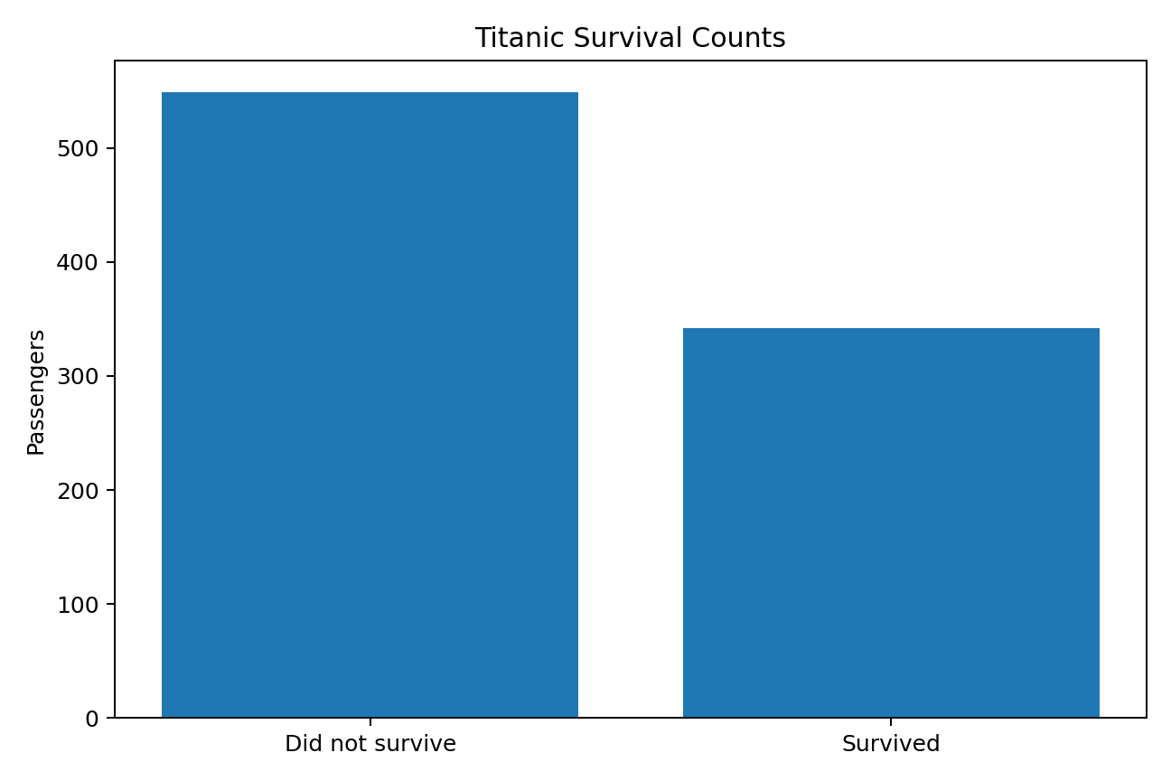
Survival distribution

Figure: Age distribution by survival
Shows the age distribution split by survival status. Missing ages are imputed in the R workflow, which should be acknowledged when interpreting the plot.
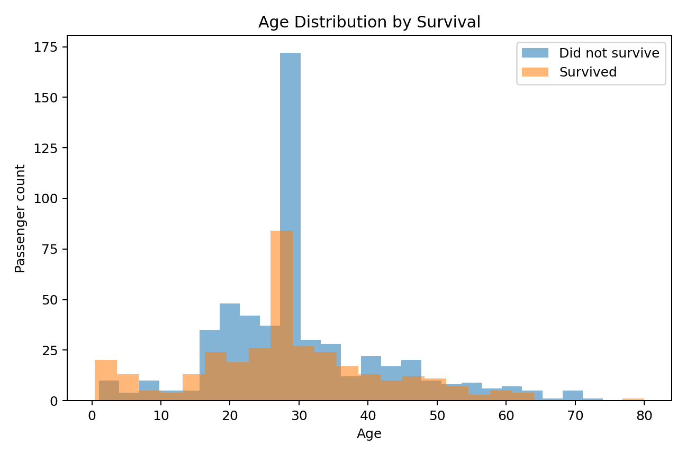
Age distribution by survival

Figure: Fare by passenger class
Compares medians, spread, and potential outliers in fares across passenger classes.
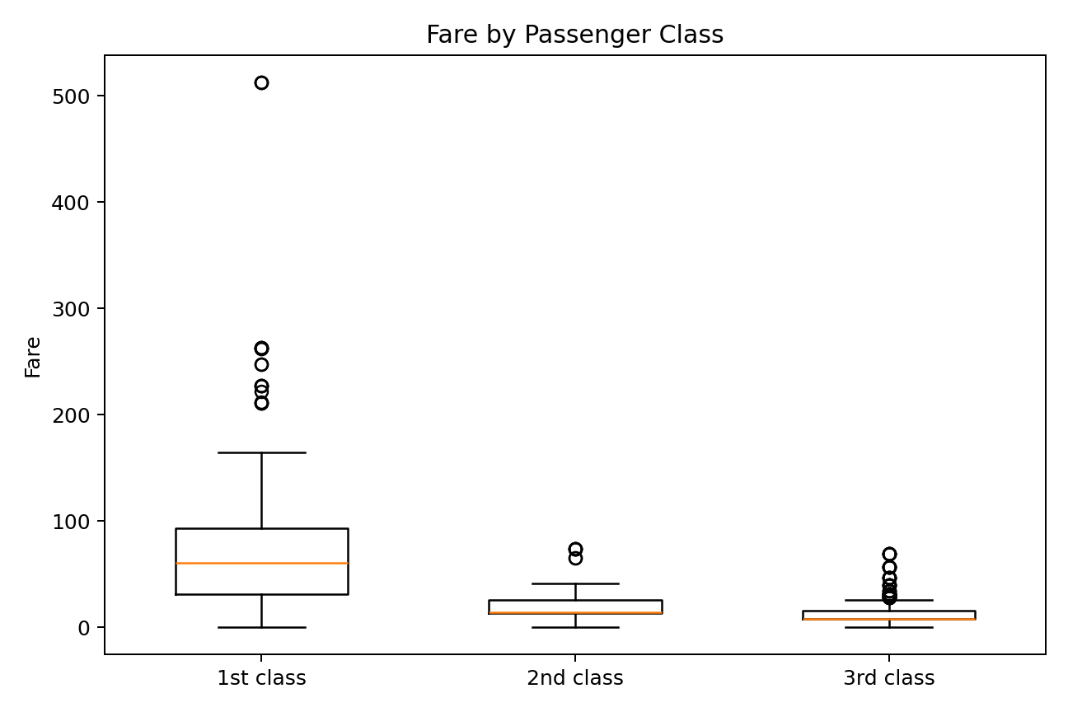
Fare by passenger class

Figure: Survival rate by sex and class
Shows how survival proportions vary by sex within passenger class; rates are more comparable than counts when group sizes differ.
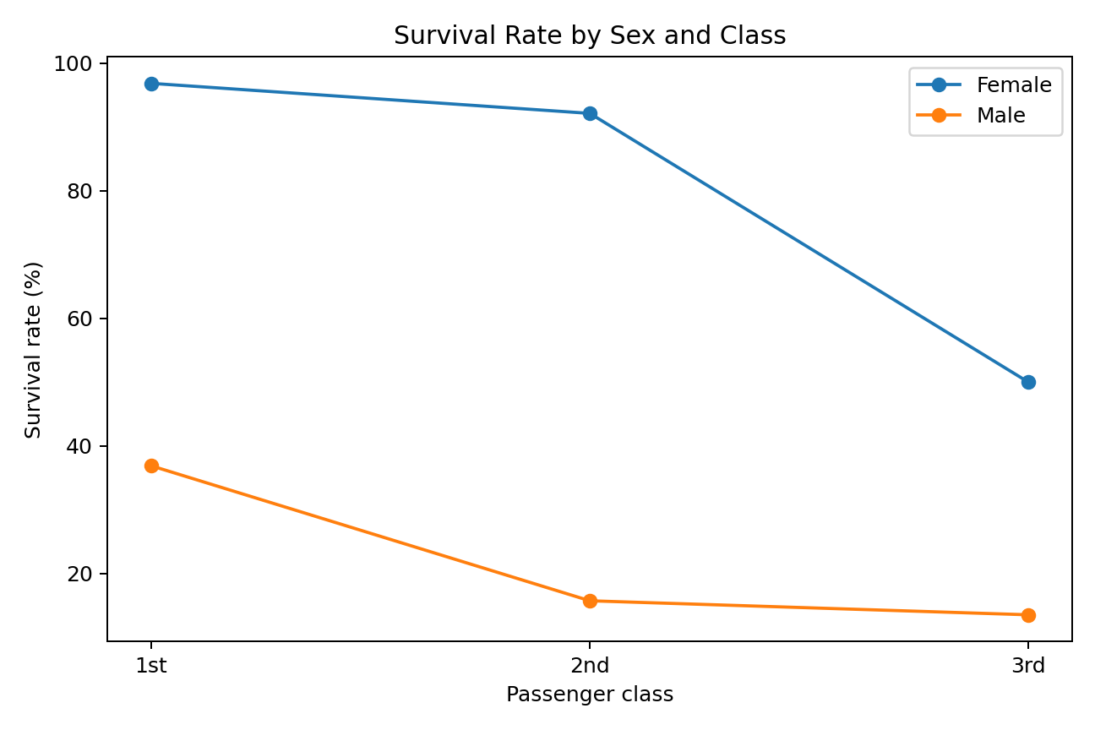
Survival rate by sex and class

Figure: Correlation heatmap
Summarizes linear associations among numeric fields. Correlation is not evidence of causation.
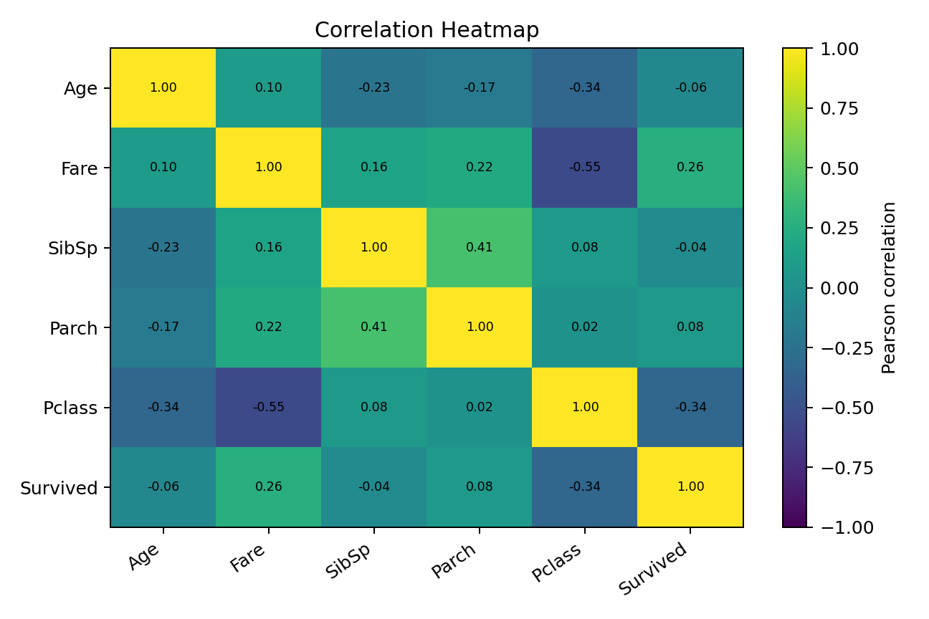
Correlation heatmap

5. Hypothesis Formulation and Testing

5.1 Sex and survival: Chi-square test
H0: Sex and survival are independent. H1: Sex and survival are associated. A chi-square test of independence is suitable because both variables are categorical. The R script builds a contingency table and uses chisq.test(). If p < 0.05, reject H0 and conclude that the data provide evidence of an association; this does not establish causation.

5.2 Passenger class and survival: Chi-square test
H0: Passenger class and survival are independent. H1: Passenger class and survival are associated. Passenger class has three categories and survival has two, so a chi-square test compares the observed counts with expected counts under independence. The script records the test statistic, degrees of freedom, p-value, and decision at alpha = 0.05.

5.3 Age by survival: Wilcoxon rank-sum test
H0: Age distributions are the same for survivors and non-survivors. H1: The distributions differ. The Wilcoxon rank-sum test is used as a nonparametric comparison because age may not be normally distributed. The test is run after the documented imputation, so the result depends partly on that preprocessing choice.

5.4 Normality and correlation
The Shapiro–Wilk test is applied to random samples of Age and Fare. H0 states that the sampled values come from a normal distribution. A small p-value indicates evidence against normality; with large datasets, even small departures may be statistically significant. Pearson correlation is calculated for numeric variables and is interpreted as a measure of linear association, not causality.

6. Predictive Modeling

6.1 Target and predictors
Target: Survived (No/Yes). Predictors: Pclass, Sex, Age, SibSp, Parch, Fare, and Embarked. The R workflow uses an 80% training subset and a 20% held-out test subset, with stratification to preserve the survival-class proportion.

6.2 Logistic Regression
Logistic Regression estimates the probability that a passenger survived. It is a useful baseline because coefficients can be interpreted in terms of direction of association and, after exponentiation, odds ratios. The model is trained using caret with a binomial generalized linear model. Predictors are not interpreted as causal effects.

6.3 Random Forest
Random Forest combines predictions from many decision trees and can capture nonlinear patterns and interactions. The script trains a Random Forest with repeated cross-validation and a small tuning grid. Variable importance is exported to a CSV and plotted. Importance indicates predictive usefulness within this model, not a causal effect.

6.4 Cross-validation and evaluation
The training set uses repeated five-fold cross-validation (five folds repeated three times) for model selection. The test set is kept separate for final evaluation. The models are compared using accuracy, precision, recall/sensitivity, specificity, F1-score, and ROC-AUC. Accuracy measures overall correctness; precision measures how many predicted survivors actually survived; recall measures how many actual survivors were identified; F1 balances precision and recall; ROC-AUC measures ranking discrimination across thresholds.

7. Model Diagnostics and Interpretation
The script creates a ROC curve for both classifiers, a confusion matrix for the model with the higher held-out ROC-AUC, a Random Forest variable-importance plot, and standard diagnostic plots for the logistic model. The confusion matrix helps identify false positives and false negatives. ROC-AUC should be interpreted alongside recall and precision, particularly when the outcome classes are imbalanced.
The R workflow writes the held-out test metrics to outputs/model_comparison.csv. ROC curves, a confusion matrix, Random Forest variable importance, and logistic-regression diagnostic plots support interpretation of model performance.

8. Limitations and Potential Improvements
- The Titanic data describe one historical event; results should not be generalized to modern populations.
- Median/mode imputation can distort distributions and correlations. Multiple imputation or models that handle missingness could be explored.
- The train/test result depends on the random split; repeated cross-validation provides a more stable estimate.
- Class imbalance and threshold choice affect precision and recall. Threshold tuning may improve the metric most relevant to the task.
- Random Forest importance can be biased toward certain predictor types; permutation importance and SHAP-style explanations could add insight.
- Additional models such as regularized logistic regression, gradient boosting, or calibrated classifiers could be compared.
- Fairness and ethical implications should be discussed when using sensitive variables such as sex for prediction.

9. Conclusion
This project combines hypothesis testing, descriptive statistics, and supervised classification in one reproducible workflow. Chi-square tests assess associations between survival and categorical passenger characteristics, the Wilcoxon test compares age distributions, Shapiro–Wilk tests assess normality, and correlation analysis summarizes linear relationships. Logistic Regression and Random Forest are evaluated using cross-validation and a held-out test set. The final interpretation should rely on the metrics, diagnostics, and screenshots produced by a successful R execution.

10. Reproducibility and Deliverables
Run statistical_analysis_week3.R from the project root in RStudio. The script installs required packages if missing, downloads the public CSV if necessary, and writes plots and outputs. Capture screenshots from your actual RStudio session and add them to screenshots/. The README documents the workflow and data source.
GitHub repository: Week_3_Statistical_Analysis_R

