WEEK 4 FINAL REPORT
Comprehensive Data Analysis
Reporting and Presentation
Integrated Data Cleaning, Visualization,
Statistical Analysis and Predictive Modeling

Dataset: Titanic Passenger Training Dataset
Programming Language: R
Prepared by: Sai Gowtham
Project Period: Weeks 1–4
Report date: 28 October 2026

Executive Summary
This report consolidates the four-week data analysis project built around the Titanic passenger training dataset. Week 1 established the data-cleaning workflow; Week 2 focused on visualization and insight communication; Week 3 specified statistical tests and predictive classification; and Week 4 integrates those activities into a coherent analytical narrative. The project uses R and packages such as dplyr, ggplot2, tidyr, caret, randomForest, and pROC to support preprocessing, visualization, inference, and classification.
The available Week 2 summary describes 891 passenger records, of which 342 survived (38.4%) and 549 did not survive (61.6%). The reported survival rate was 63.0% in first class, 47.3% in second class, and 24.2% in third class. The reported rate was 74.2% among female passengers and 18.9% among male passengers. These are descriptive associations within this dataset and do not establish causation.
The Week 3 workflow defines chi-square tests, a Wilcoxon rank-sum test, Shapiro–Wilk tests, Pearson correlation, Logistic Regression, Random Forest, repeated five-fold cross-validation, and held-out evaluation. The earlier report did not contain verified R execution output for exact test statistics or model metrics. For that reason, this integrated report does not invent p-values or claim that model-performance numbers were generated by R. The methods and descriptive findings are documented, and inferential/model conclusions should be finalized from the actual R outputs.

Report Roadmap
Section | Focus
1. Introduction | Project context, objectives, and analytical questions
2. Dataset and workflow | Dataset structure, tools, and four-week progression
3. Data preparation | Missingness, imputation, duplicates, outliers, and encoding
4. Visualization and findings | Charts, numerical patterns, and interpretation
5. Statistical analysis | Hypotheses, test choices, assumptions, and interpretation
6. Predictive modeling | Logistic Regression, Random Forest, validation, and metrics
7. Discussion and impact | What the findings mean, risks, and limitations
8. Conclusion and future work | Lessons learned, recommendations, and next steps

1. Introduction
Data analysis is most useful when data quality, statistical reasoning, model evaluation, and communication are treated as connected activities rather than separate deliverables. This project follows that principle by using the Titanic passenger dataset to practice an end-to-end workflow: inspect the source data, document cleaning decisions, explore distributions and group differences, test selected hypotheses, develop classifiers, and communicate findings through figures and narrative.

1.1 Objectives
- Inspect the dataset's structure, data types, missingness, and duplicate records.
- Apply documented preprocessing decisions while preserving plausible observations.
- Use descriptive statistics and visualizations to understand passenger attributes and survival outcomes.
- Investigate selected associations using appropriate statistical tests.
- Build and compare Logistic Regression and Random Forest classifiers.
- Use a held-out test set and cross-validation to evaluate predictive performance.
- Explain the practical meaning, assumptions, and limitations of the results.

1.2 Analytical Questions
- How are survival outcomes distributed across the dataset?
- How do reported survival rates differ by passenger class, sex, and age group?
- What missing-data and distribution issues must be considered before modeling?
- Are categorical passenger characteristics associated with survival in statistical tests?
- How well do Logistic Regression and Random Forest classify survival on unseen data?

2. Dataset and Project Workflow
The project uses the public Titanic training dataset commonly distributed in a CSV with 891 records and 12 original columns. Variables include Survived, Pclass, Sex, Age, SibSp, Parch, Ticket, Fare, Cabin, and Embarked. The target variable Survived is binary: 0 represents non-survival and 1 represents survival.
The source used in the Week 3 workflow is the DataScienceDojo Titanic CSV hosted on GitHub. Dataset copies and derived tables should be treated as versions of the same teaching dataset only after checking their row counts, column definitions, and preprocessing.
Data source: https://raw.githubusercontent.com/datasciencedojo/datasets/master/titanic.csv
Week | Main work | Integrated contribution
Week 1 | Data cleaning and preliminary analysis | Inspection, missingness checks, imputation, outlier screening, encoding, scaling examples, descriptive summaries, and initial plots.
Week 2 | Data visualization and insight communication | Nine visualizations and quantified descriptive findings on survival, age, fare, class, sex, and correlations.
Week 3 | Statistical analysis and predictive modeling | Hypothesis-test design, distribution checks, correlation analysis, Logistic Regression, Random Forest, cross-validation, and evaluation metrics.
Week 4 | Comprehensive reporting | Integration of methods and findings into a single report with limitations, impact, and recommendations.

2.1 Tools and Packages
Tool/package | Role in the project
R / RStudio | Script execution, statistical computing, and reproducibility.
dplyr / tidyr | Data filtering, transformation, reshaping, and summaries.
ggplot2 | Distribution, comparison, relationship, and diagnostic charts.
caret | Training/test partitioning, cross-validation, and model training.
randomForest | Random Forest classification.
pROC | ROC curves and ROC-AUC evaluation.
base R statistics | Summary statistics, chi-square, Wilcoxon, Shapiro–Wilk, and correlation.

3. Data Preparation and Quality

3.1 Initial inspection
The first stage checks dimensions, variable names, types, summaries, missing values, and exact duplicate rows. A Week 2 summary reports 891 rows and 12 columns, with no duplicate rows reported. Repeated values such as ticket fares or family counts should not be treated as duplicate records by themselves.
Annotated R excerpt — data inspection
# Inspect the source table before modifying it
dim(df_raw)
names(df_raw)
str(df_raw)
summary(df_raw)
# Count missing values by variable
missing_count <- colSums(is.na(df_raw))
missing_pct <- round(100 * missing_count / nrow(df_raw), 2)
# Check exact duplicate rows
sum(duplicated(df_raw))

The original object should be kept unchanged so that every cleaning operation can be traced back to the source.

3.2 Missing-value profile
Variable | Missing count | Share of 891 records | Interpretation
Age | 177 | 19.87% | A material share of age values is missing; imputation can affect the distribution.
Cabin | 687 | 77.1% | Cabin is highly incomplete; a CabinKnown indicator can preserve the fact of whether it was recorded.
Embarked | 2 | 0.22% | Only a small number of embarkation values are missing in the reported summary.

These missingness figures are taken from the prior Week 2 report's summary. They should be confirmed against the exact CSV version used in the final run, because counts can differ if the source file or preprocessing version changes.

3.3 Imputation strategy
The documented cleaning approach fills missing Age and Fare values with their respective medians and fills missing Embarked values with the mode. The median is less sensitive to extreme values than the mean and is a practical baseline for skewed data. Mode imputation retains records for categorical analysis. Neither method proves that values are missing at random, and both can change distributions or relationships.
Annotated R excerpt — missing-value treatment
# Median imputation for numeric variables
age_median <- median(df$Age, na.rm = TRUE)
fare_median <- median(df$Fare, na.rm = TRUE)
df$Age[is.na(df$Age)] <- age_median
df$Fare[is.na(df$Fare)] <- fare_median
# Mode imputation for a categorical variable
get_mode <- function(x) {
values <- x[!is.na(x)]
names(which.max(table(values)))
}
embarked_mode <- get_mode(df$Embarked)
df$Embarked[is.na(df$Embarked)] <- embarked_mode

3.4 Outliers, encoding, and scaling
The Week 1 workflow uses the interquartile-range rule to flag unusual Age and Fare values. An IQR flag is a screening result, not proof of an error; a high fare may be a valid observation. The workflow also demonstrates factor conversion and dummy-variable construction for categorical predictors. Scaling or normalization is useful for methods sensitive to feature scale, but categorical labels should not be normalized as if they were continuous measurements.
The Cabin field is highly incomplete in the teaching dataset. The documented approach creates a CabinKnown indicator and avoids inventing cabin values. This preserves some information without pretending the missing cabin identifiers are known.

3.5 Data preparation risks
- Imputed values are estimates, not recovered original observations.
- Potential outliers should be reviewed in context rather than deleted automatically.
- Data preparation must be fitted on training data only in a predictive pipeline to avoid information leakage; imputation performed before splitting can bias evaluation.
- The dataset represents a historical event and is not a representative sample of contemporary passengers or populations.

4. Visualization and Descriptive Findings
The Week 2 work used charts to answer different questions: counts show the overall balance, group proportions enable fairer comparisons between differently sized groups, histograms show distribution shape, box plots compare spread and potential outliers, and correlation heatmaps summarize linear relationships. The figures below are carried forward from the previous visualization report. They are visual assets from that report, not screenshots of RStudio execution.

4.1 Overall survival distribution
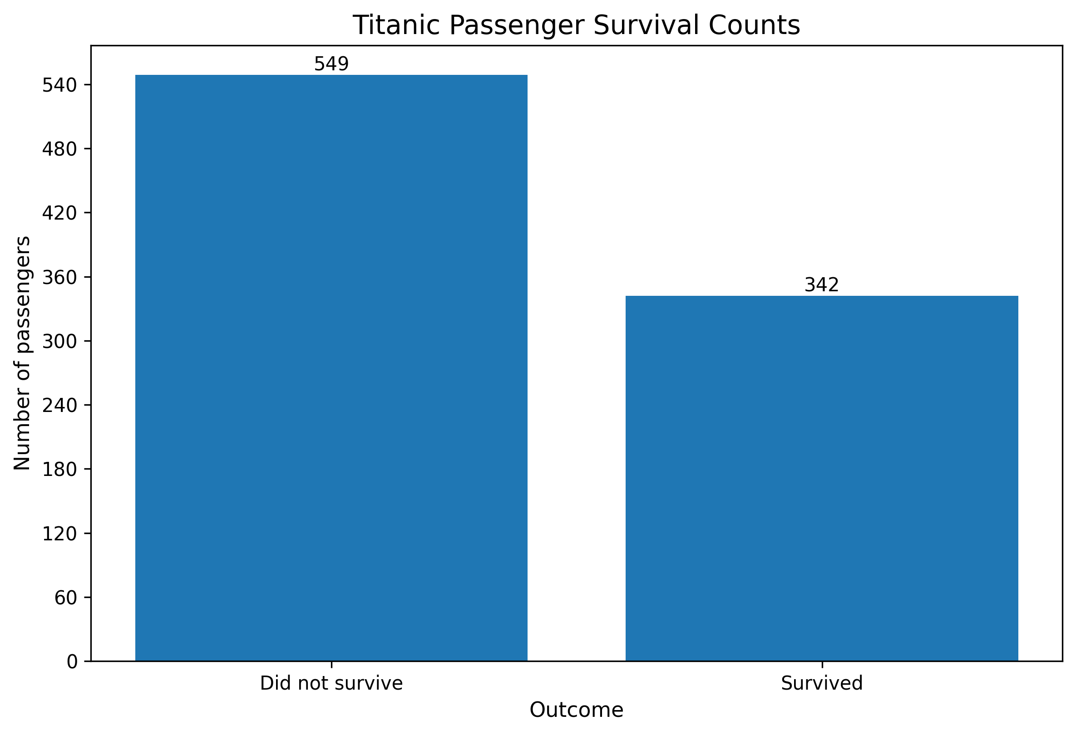
Figure 1. Reported counts of survivors and non-survivors.
The prior summary reports 342 survivors and 549 non-survivors. The survival proportion is 342 / 891 = 38.4%, while 61.6% of records are non-survivors. This class balance matters for interpreting classification results: a model's accuracy should be compared with simple baselines and accompanied by recall, precision, and ROC-AUC.

4.2 Age distribution
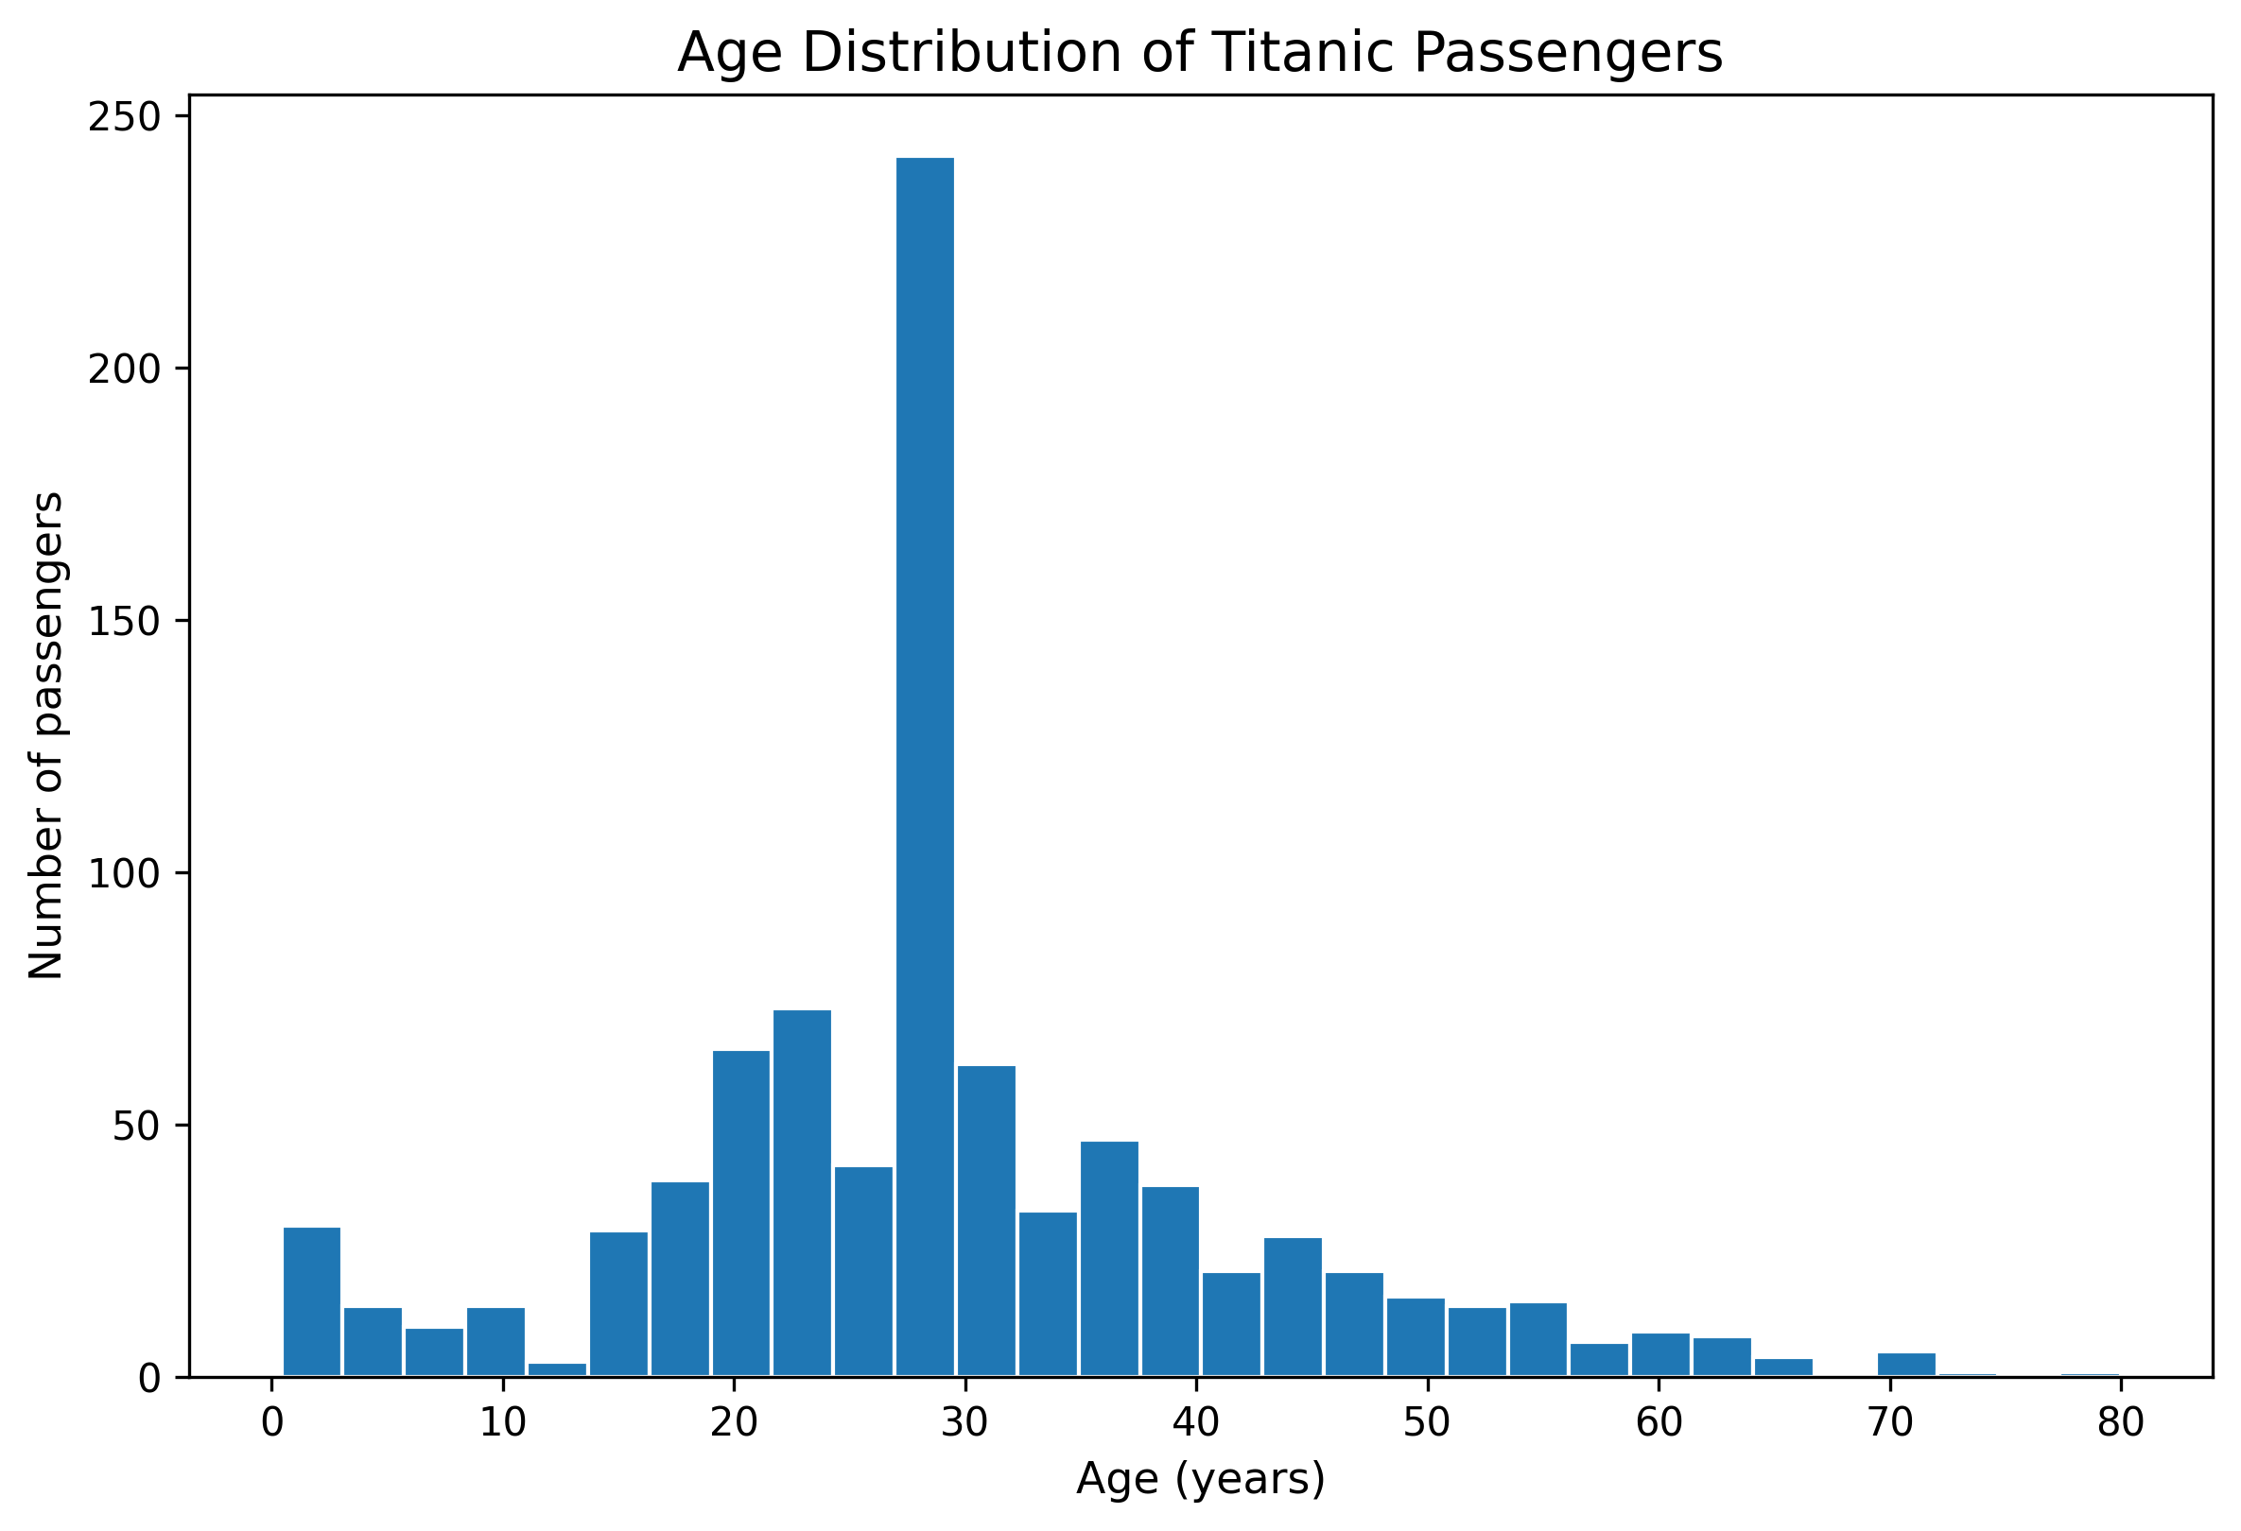
Figure 2. Passenger age distribution from the previous visualization report.
The age histogram shows where recorded and prepared ages concentrate. The earlier missingness summary identifies 177 missing Age values (19.87%). If median imputation is used, repeated values at the median can create an artificial concentration in the histogram; the plot should therefore be interpreted alongside the original missingness count.

4.3 Fare distribution
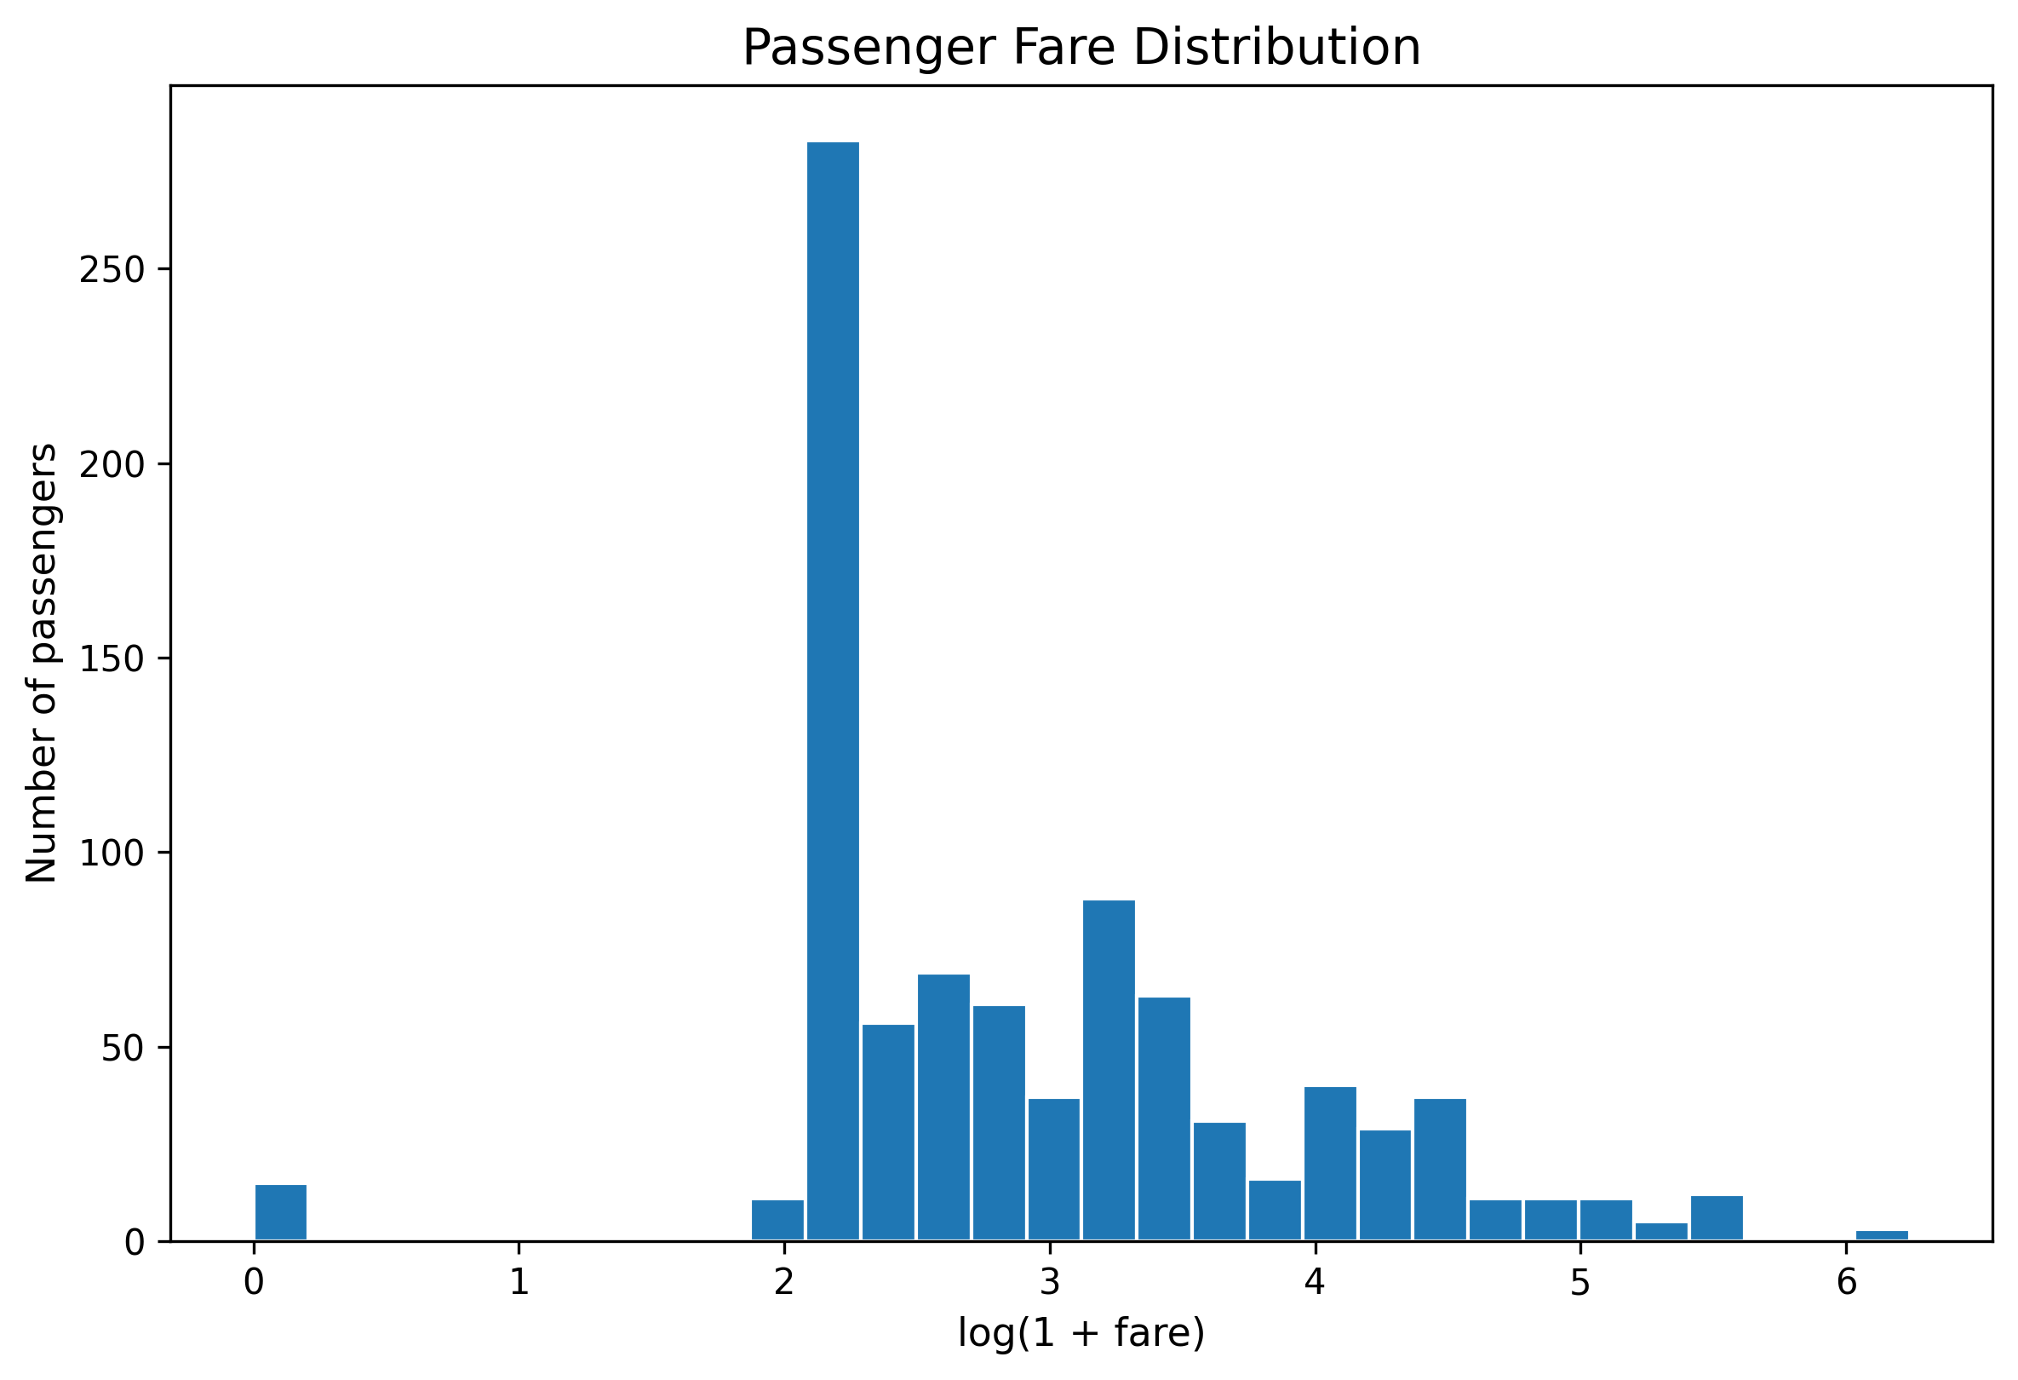
Figure 3. Fare distribution displayed using log(1 + fare) in the previous report.
Fare values are concentrated at lower levels with a long right tail. A log(1 + fare) scale helps show variation among lower fares while compressing high values. This transformed axis is useful for visualization but should not be mistaken for raw fare increments.

4.4 Age and fare relationship
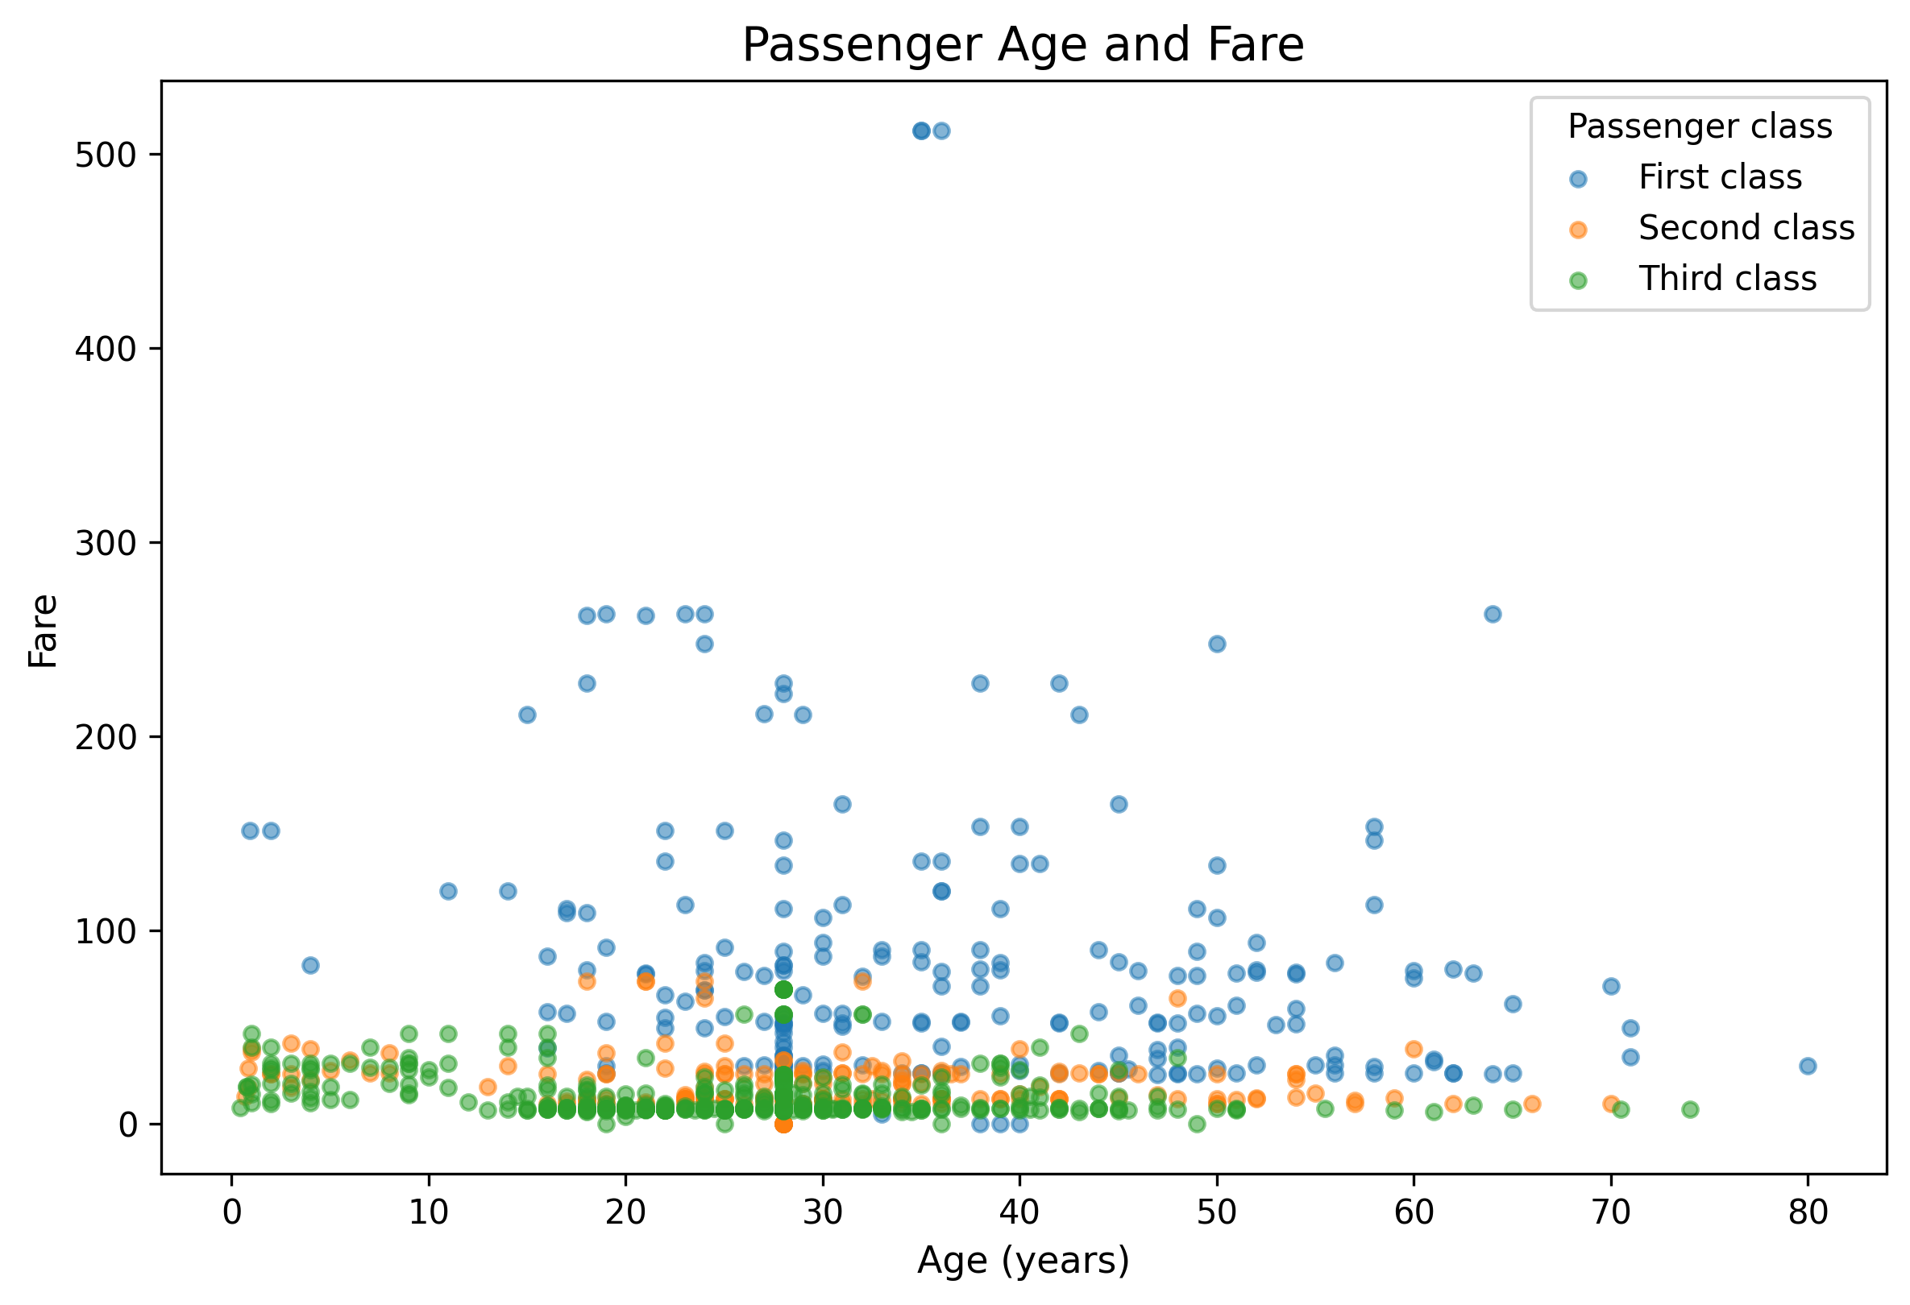
Figure 4. Passenger age versus fare, coloured by passenger class.
The prior correlation summary reports an Age–Fare Pearson correlation of approximately 0.097, a weak positive linear association. This does not rule out group-specific or nonlinear patterns. Overlapping points can also conceal individual observations.

4.5 Survival by passenger class
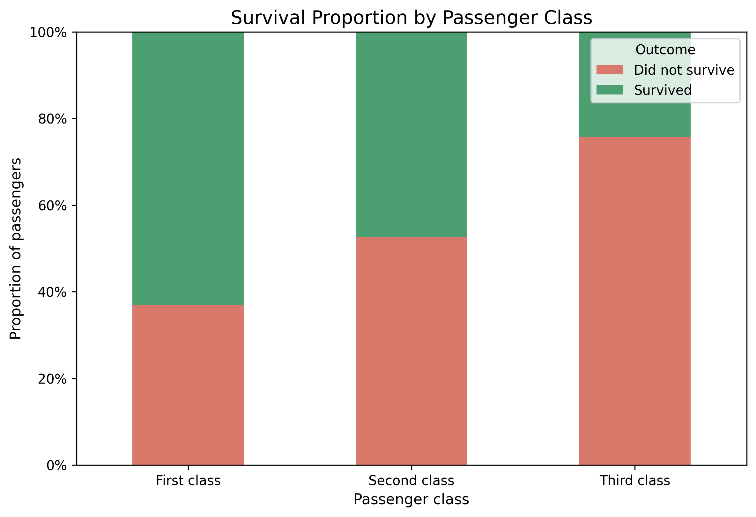
Figure 5. Survival proportions by passenger class.
The prior report gives 136 survivors among 216 first-class passengers (63.0%), 87 among 184 second-class passengers (47.3%), and 119 among 491 third-class passengers (24.2%). The difference between first- and third-class survival rates is approximately 38.7 percentage points. Because class groups have different sizes, proportions are more informative than survivor counts alone.

4.6 Survival by sex
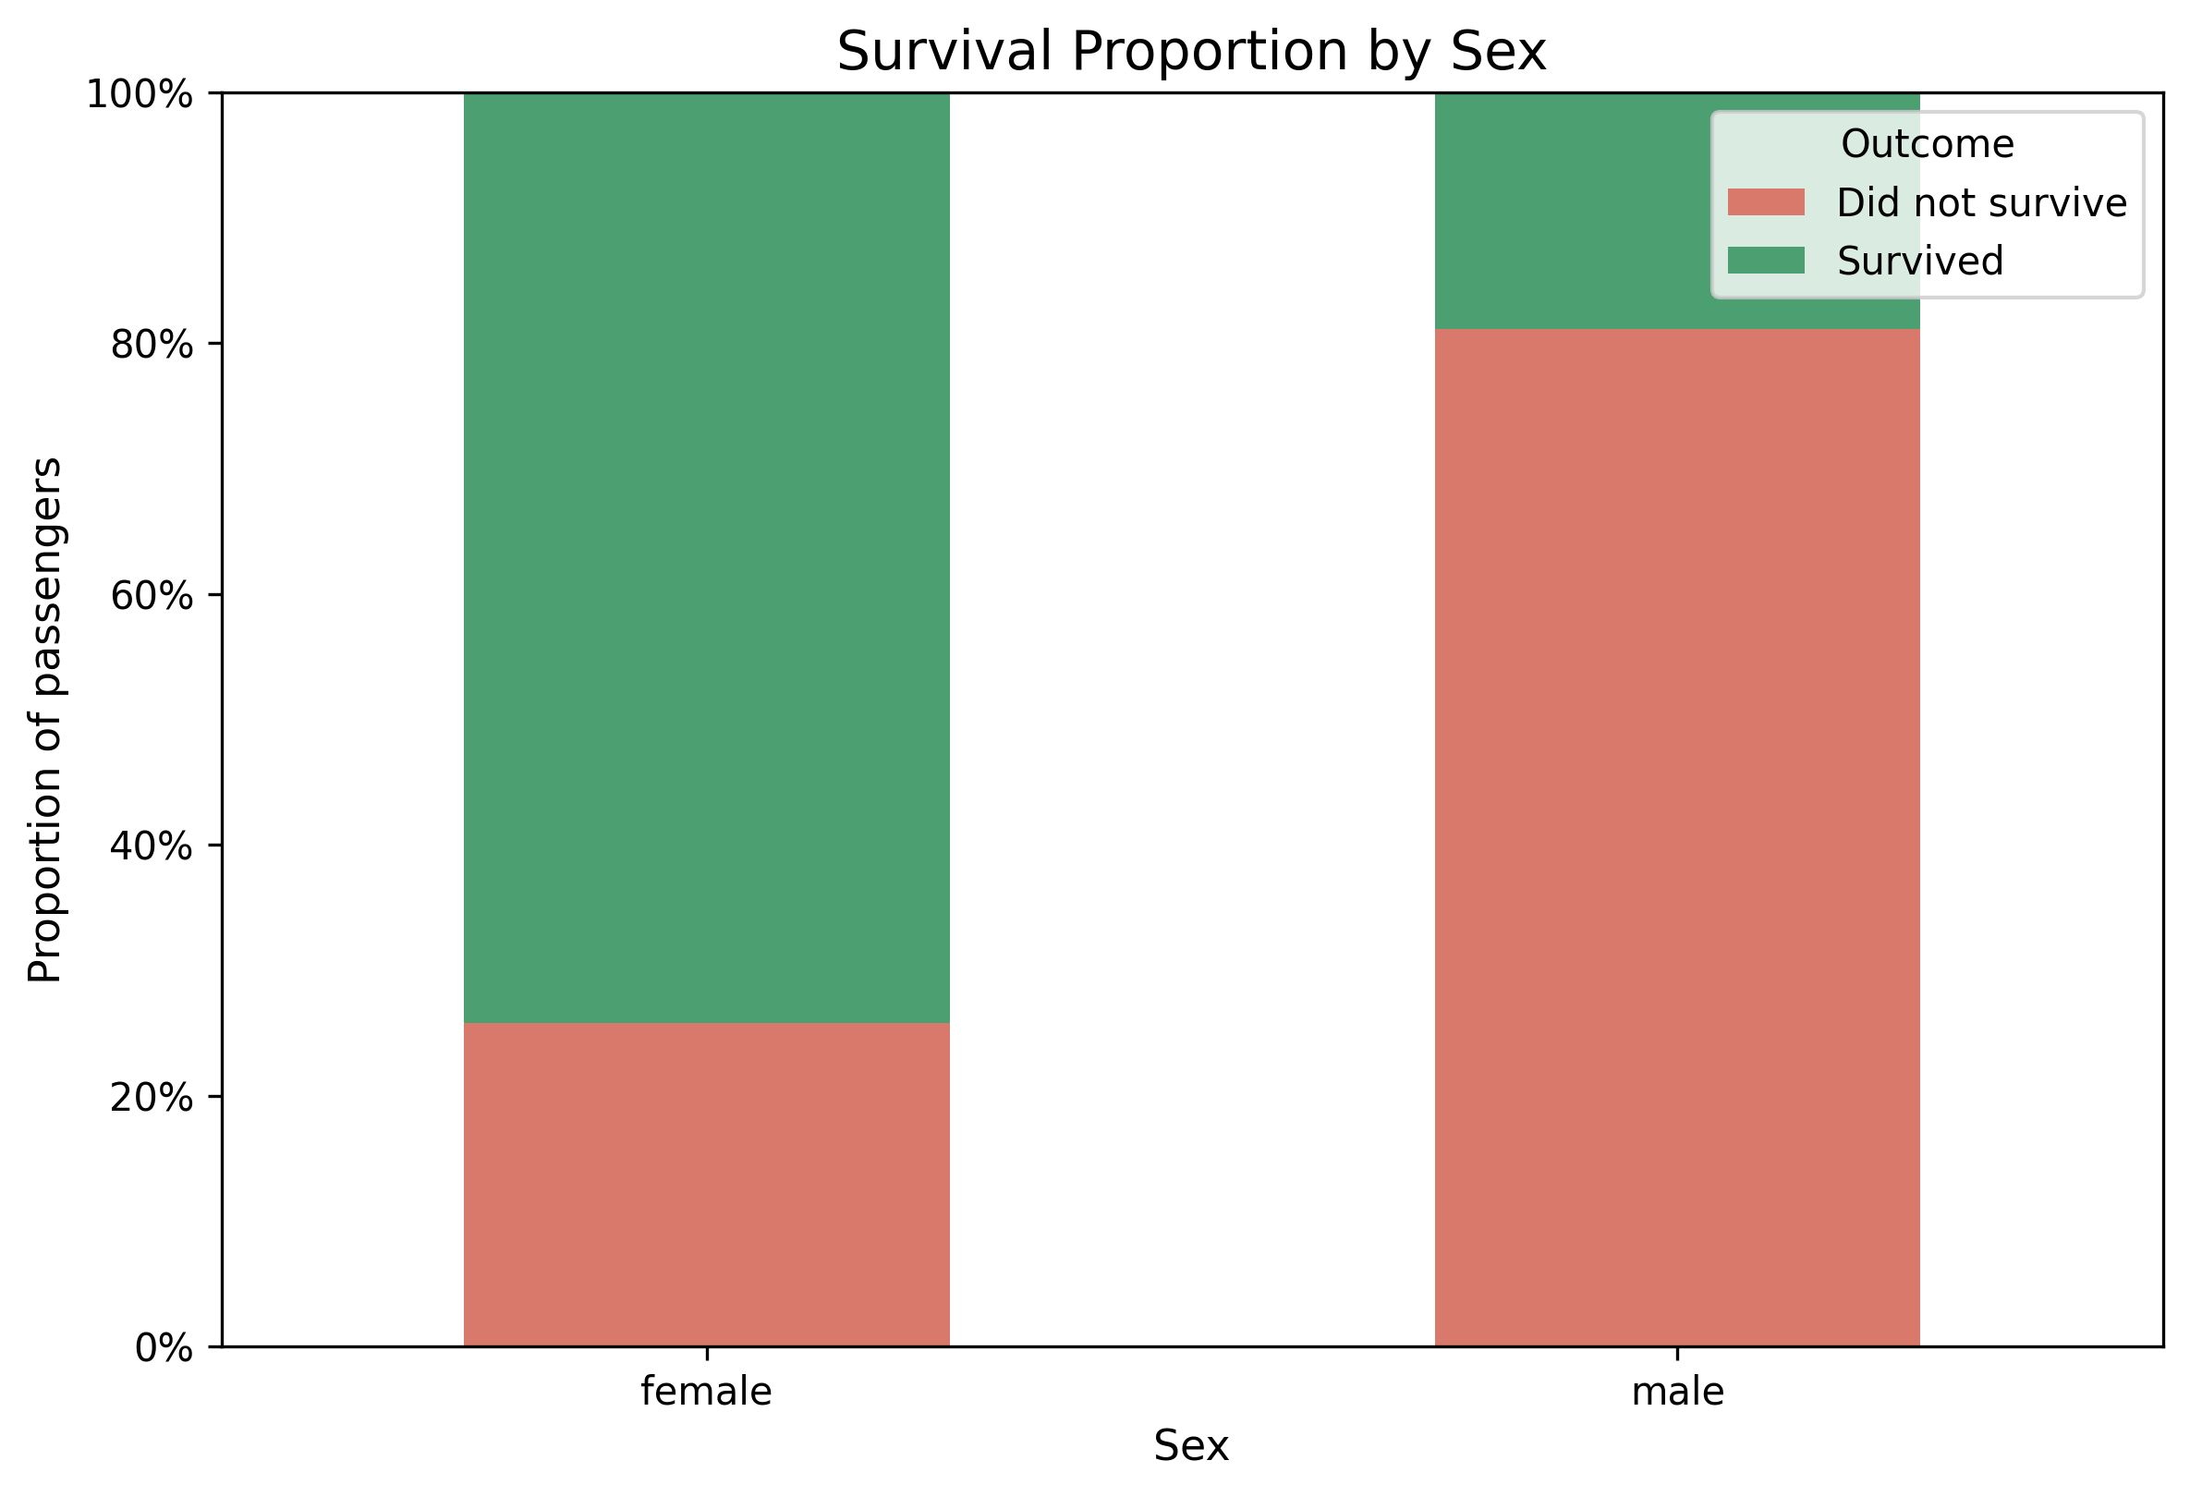
Figure 6. Survival proportions by sex.
The prior report gives 233 survivors among 314 female passengers (74.2%) and 109 among 577 male passengers (18.9%), a difference of approximately 55.3 percentage points. This is a descriptive association, not evidence that sex alone caused survival. Passenger class, age, evacuation procedures, and other factors may be relevant.

4.7 Fare by passenger class
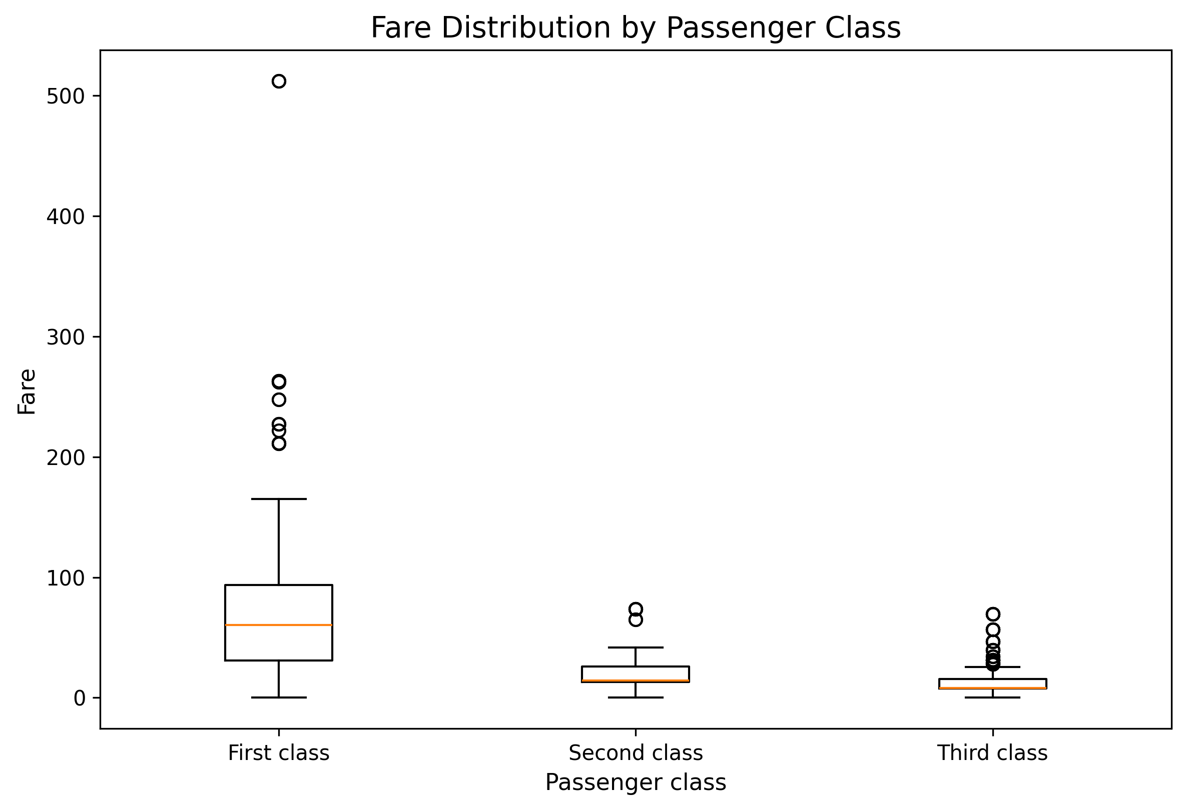
Figure 7. Fare distribution across passenger classes.
The box plot compares medians, interquartile ranges, and potential outliers across classes. The chart suggests differences in fare levels between classes, while high values remain candidates for contextual review rather than automatic deletion.

4.8 Survival by age group
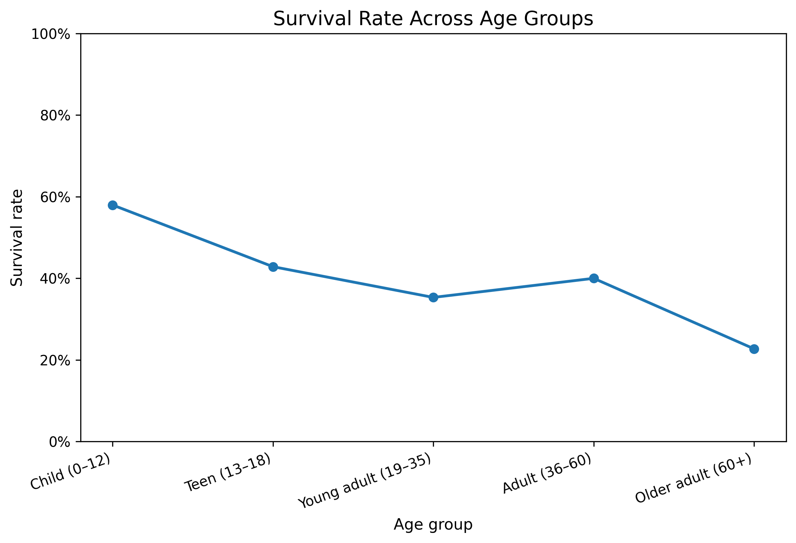
Figure 8. Reported survival rate across age groups.
The prior summary reports 58.0% survival for children aged 0–12 (40 of 69), 42.9% for ages 13–18 (30 of 70), 35.3% for ages 19–35 (189 of 535), 40.0% for ages 36–60 (78 of 195), and 22.7% for ages 60+ (5 of 22). The oldest group is small, so its percentage is less stable. The line connects ordered age bands and should not be read as a continuous age-by-age trend.

4.9 Correlation heatmap
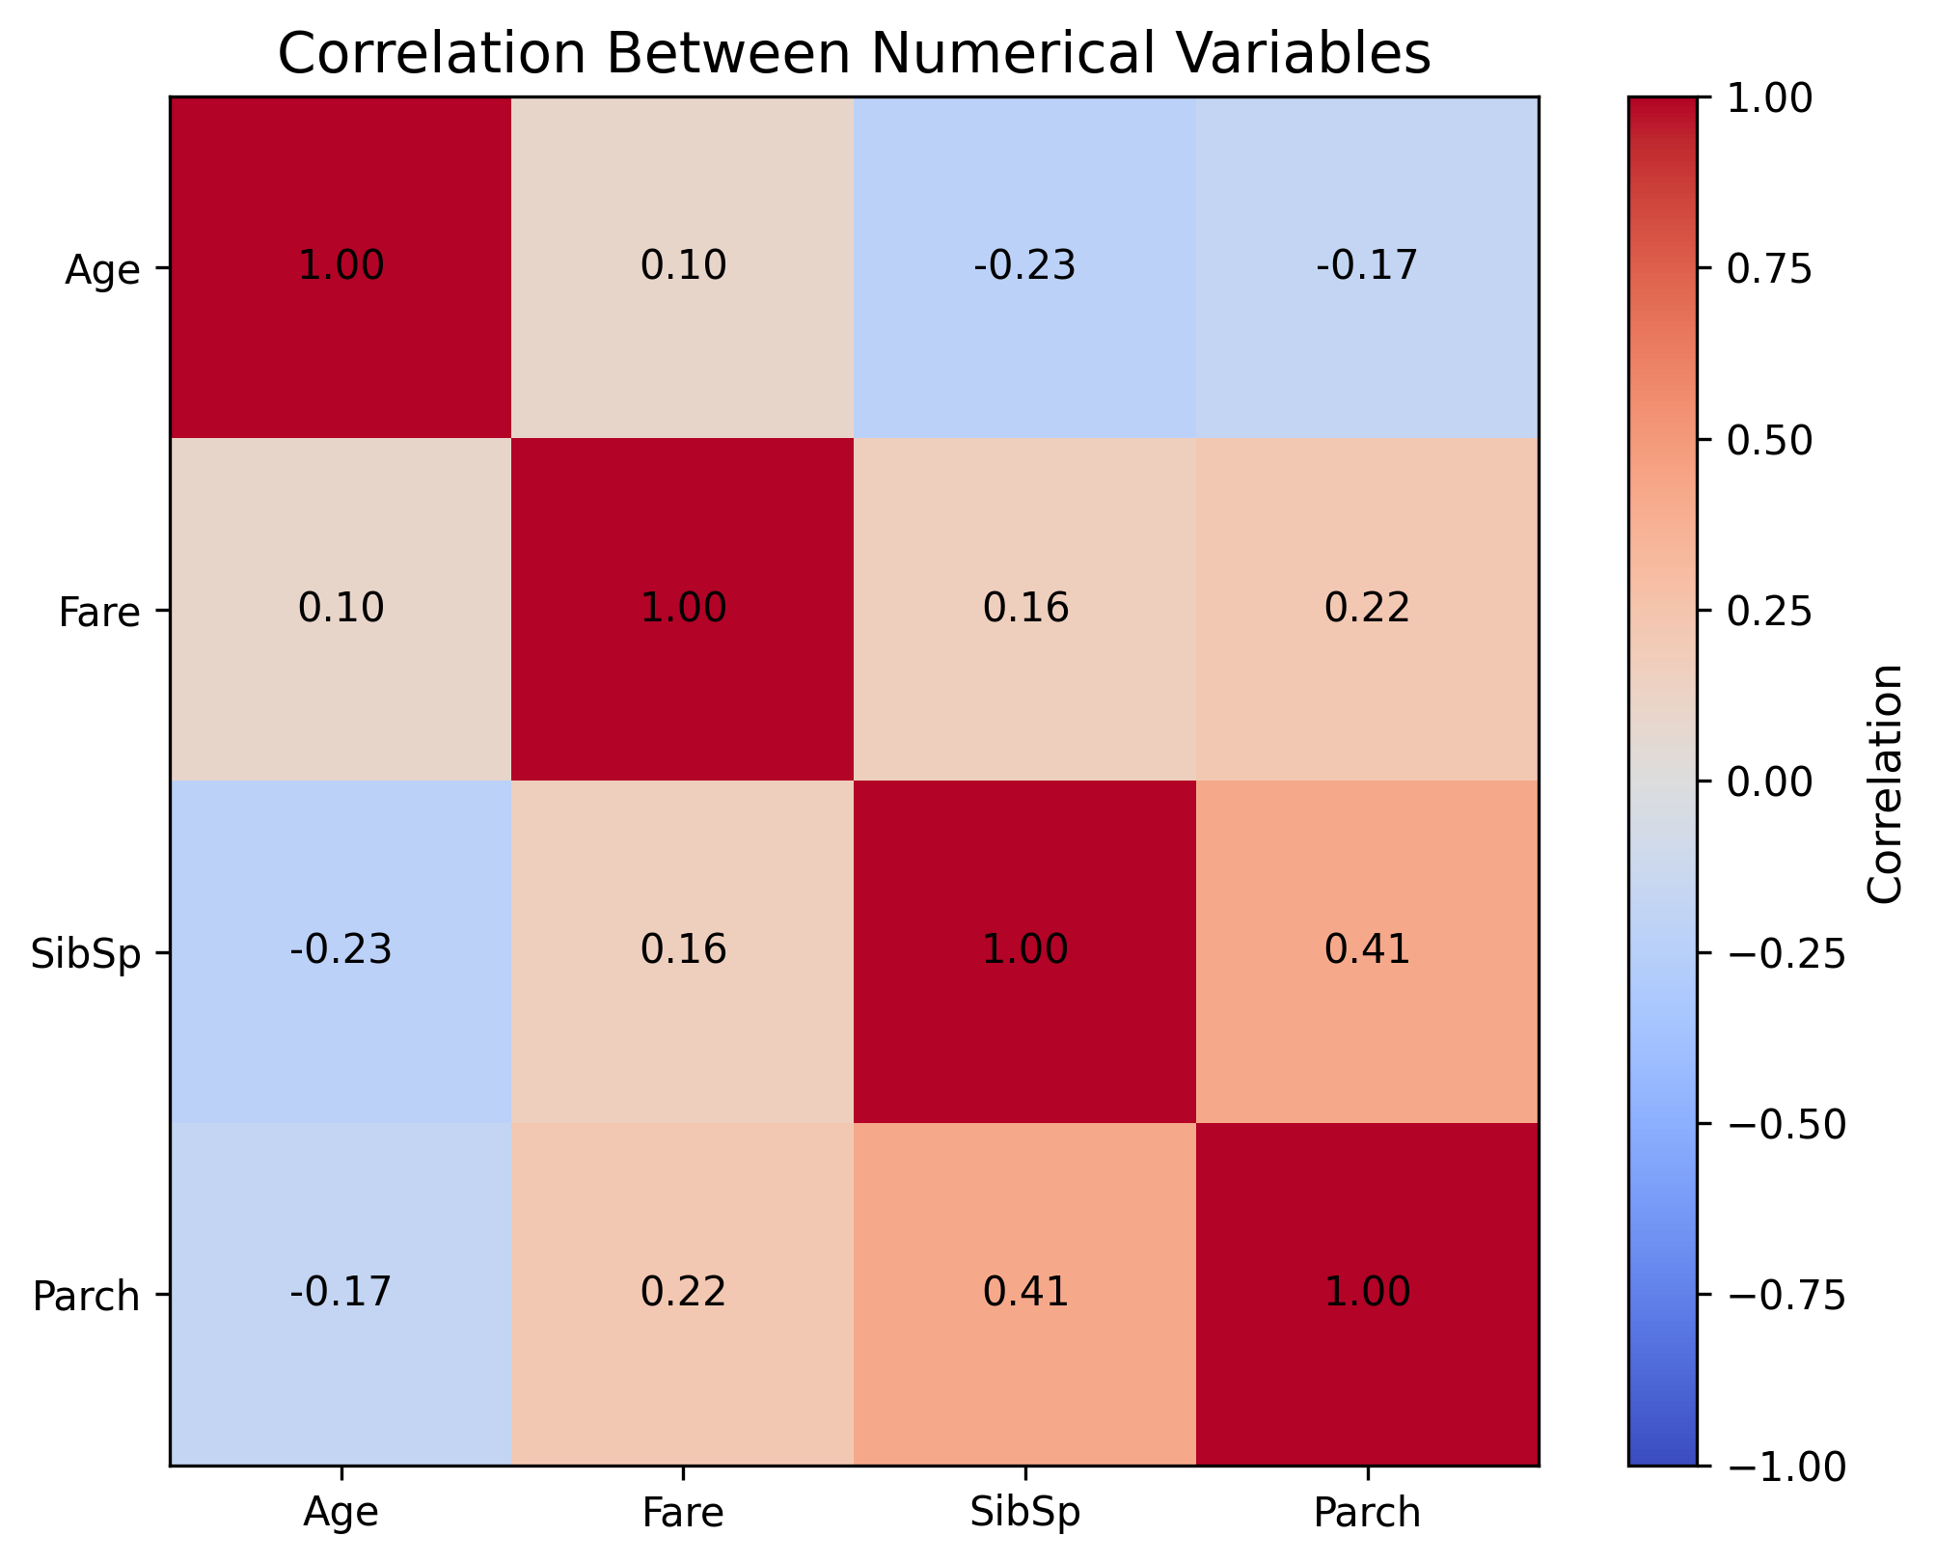
Figure 9. Pearson correlation heatmap for selected numerical variables.
The prior report gives a SibSp–Parch correlation of approximately 0.415, a moderate positive association; Age–SibSp of −0.233; Age–Parch of −0.172; and Age–Fare of 0.097. Correlation measures linear association and does not establish causation. It may also miss nonlinear relationships.

4.10 Consolidated descriptive insights
Finding | Reported value | Careful interpretation
Overall survival | 342 / 891 = 38.4% | Most records are non-survivors; model accuracy needs context.
First-class survival | 63.0% | Highest of the three class-specific rates in the report.
Second-class survival | 47.3% | Between first- and third-class rates.
Third-class survival | 24.2% | Lowest of the three class-specific rates in the report.
Female survival | 74.2% | Higher than the reported male rate in this dataset.
Male survival | 18.9% | Lower than the reported female rate in this dataset.
Age–Fare correlation | r ≈ 0.097 | Weak positive linear association.
SibSp–Parch correlation | r ≈ 0.415 | Moderate positive linear association.

5. Statistical Analysis
Week 3 extends exploratory analysis by formalizing questions as hypotheses and selecting tests based on variable types and assumptions. The prior Week 3 report describes the tests to run, but it does not provide verified R-generated test statistics or p-values. This section therefore explains the analytical design without claiming statistical significance that has not been confirmed.

5.1 Sex and survival: chi-square test
Null hypothesis (H₀): sex and survival are independent. Alternative hypothesis (H₁): sex and survival are associated. Both variables are categorical, so a chi-square test of independence is an appropriate starting point if expected cell counts are adequate. The p-value must be taken from the actual R output. Even a statistically significant association would not demonstrate causation.
Annotated R excerpt — categorical association
# Contingency table and chi-square test
sex_survival <- table(df$Sex, df$Survived)
chisq.test(sex_survival)

5.2 Passenger class and survival: chi-square test
H₀ states that passenger class and survival are independent; H₁ states that they are associated. Passenger class has three categories and survival has two. The test output should be reviewed for the chi-square statistic, degrees of freedom, p-value, and expected cell counts.

5.3 Age by survival: Wilcoxon rank-sum test
H₀ states that age distributions are the same between survivors and non-survivors; H₁ states that the distributions differ. The Wilcoxon rank-sum test is a nonparametric comparison suitable when a normal-distribution assumption is questionable. If imputed ages are used, the result partly reflects the imputation choice.
Annotated R excerpt — two-group comparison
# Compare age distributions between outcome groups
wilcox.test(Age ~ Survived, data = df)

5.4 Normality and correlation
The Shapiro–Wilk test evaluates evidence against a normal-distribution assumption for selected numerical variables. With large samples, small departures can be significant, so the test should be interpreted with histograms or Q–Q plots. Pearson correlation summarizes linear association among numeric variables; its magnitude and context matter in addition to the p-value.
Annotated R excerpt — distribution and correlation
# Inspect distributions and numeric relationships
shapiro.test(sample(df$Age, min(5000, sum(!is.na(df$Age)))))
cor(df[c("Age", "Fare", "SibSp", "Parch")],
use = "pairwise.complete.obs",
method = "pearson")

5.5 Statistical interpretation protocol
- State the null and alternative hypotheses before interpreting the result.
- Use a significance threshold selected in advance (the Week 3 plan uses alpha = 0.05).
- Report the test statistic, degrees of freedom where applicable, p-value, and sample size.
- Check assumptions and expected cell counts; choose alternatives if assumptions are not met.
- Distinguish statistical significance from practical importance and do not infer causation from association.

6. Predictive Modeling

6.1 Target, predictors, and split
The target is Survived, with No/Yes or 0/1 outcome labels. The planned predictors are Pclass, Sex, Age, SibSp, Parch, Fare, and Embarked. The Week 3 design uses a stratified 80/20 training/test split and repeated five-fold cross-validation (five folds repeated three times) for training/model selection. The test set should remain separate from tuning.

6.2 Logistic Regression
Logistic Regression is the interpretable baseline for binary classification. It estimates survival probability from the predictors. Coefficients describe conditional associations; exponentiated coefficients can be interpreted as odds ratios under the fitted model, but should not be presented as causal effects.

6.3 Random Forest
Random Forest combines many decision trees and can capture nonlinear patterns and interactions. Its variable-importance output can help identify predictors useful for prediction, but importance is model-dependent and does not establish that a variable causes survival.

6.4 Evaluation metrics
Metric | Meaning | Interpretation note
Accuracy | Correct predictions divided by all predictions | Can be misleading if classes are imbalanced.
Precision | Correct predicted survivors divided by all predicted survivors | High precision means fewer false-positive survivor predictions.
Recall / sensitivity | Actual survivors correctly identified | Low recall means many survivors are missed.
Specificity | Actual non-survivors correctly identified | Measures performance on the negative class.
F1-score | Harmonic mean of precision and recall | Balances these two measures.
ROC-AUC | Discrimination across classification thresholds | Compare with other metrics and the confusion matrix.

6.5 Model comparison and diagnostics
The Week 3 plan exports a model-comparison table, test predictions, confusion matrix, ROC curve, and Random Forest variable-importance results. Those outputs should be generated by the R script and inspected before model conclusions are finalized. No numerical accuracy, F1-score, or ROC-AUC value is asserted here because the available prior report explicitly identified its numeric model preview as Python-generated rather than verified R execution output.
The preferred model should not be chosen by accuracy alone. Compare cross-validation estimates with held-out performance, review recall and precision, inspect false positives and false negatives, and consider whether a model is well calibrated for its intended use.

6.6 Avoiding leakage and improving evaluation
- Split the data before fitting preprocessing parameters, and estimate imputation/scaling from training data only.
- Use cross-validation inside the training data for model selection.
- Evaluate the selected model once on the held-out test set.
- Keep the random seed, package versions, and model settings recorded.
- Consider repeated seeds or nested cross-validation if a more robust estimate is needed.

7. Discussion, Impact, and Recommendations

7.1 What the integrated analysis shows
The descriptive summaries indicate that survival varied substantially across the passenger groups in the dataset. The class-specific rates decrease from first class to third class, and the reported female survival rate is higher than the reported male rate. The age-band summary also varies, although the oldest age group contains relatively few records. These patterns provide useful exploratory signals for formal testing and predictive modeling.
The project demonstrates how cleaning decisions affect downstream conclusions. Median imputation makes more records usable but may concentrate values around the median. Cabin's high missingness makes direct use of that variable difficult without a more deliberate strategy. Outlier flags identify observations for review rather than automatic deletion.

7.2 Practical impact
The main practical value is methodological: the project demonstrates a repeatable way to move from raw data to defensible findings. Counts and proportions communicate group differences, hypothesis tests formalize questions, and held-out model evaluation tests predictive performance beyond the training data. In a real organization, the same workflow could support quality monitoring, risk analysis, customer segmentation, or operational forecasting, provided the dataset and model are suitable for the decision.

7.3 Limitations
- The Titanic dataset is a historical teaching dataset and findings should not be generalized to modern populations.
- Imputation can affect distributions, correlations, test statistics, and model performance.
- Passenger class, sex, age, and other attributes are associated with social and historical conditions; association is not causation.
- Small subgroups, including the 60+ age band, can yield unstable percentages.
- Model metrics depend on the split, seed, preprocessing, predictors, and tuning settings.
- Inferential findings and predictive performance should be interpreted using the statistical test results and held-out evaluation metrics produced by the analysis workflow. The descriptive patterns presented here are exploratory and do not, by themselves, establish statistical significance or predictive accuracy.

7.4 Recommendations
- Use a reproducible R workflow to generate the statistical summaries, model comparisons, and visualizations reported in the final analysis.
- Include clear figures and compact result tables that allow readers to follow the analytical workflow and interpret the findings.
- Report chi-square statistics, degrees of freedom, p-values, and expected counts; report the Wilcoxon and Shapiro–Wilk results with context.
- Compare complete-case analysis with imputation or a more robust missing-data method.
- Use a consistent preprocessing pipeline so that train/test evaluation is free from leakage.
- Compare Logistic Regression and Random Forest using ROC-AUC, F1, precision, recall, specificity, and confusion matrices.
- Consider threshold tuning, calibration checks, and interpretable effect summaries if model performance is adequate.

8. Lessons Learned and Future Directions

8.1 Lessons learned
- Data quality checks should precede visualizations and modeling.
- Counts and rates answer different questions; rates are essential when group sizes differ.
- Imputation and outlier treatment must be documented because they affect results.
- A statistical association is not a causal explanation.
- Cross-validation and held-out evaluation serve different purposes and should not be conflated.
- A polished report should connect each conclusion to the relevant data summary, statistical result, visualization, or model-evaluation measure.

8.2 Future directions
- Improve reproducibility by documenting the execution environment, package versions, random seed, and analytical outputs.
- Test whether conclusions are robust to alternative imputation strategies and random splits.
- Add confidence intervals for key group survival rates and effect-size measures for hypothesis tests.
- Compare regularized Logistic Regression, Random Forest, and gradient-boosting approaches.
- Evaluate model calibration and use permutation importance to complement built-in importance.
- Document the data version, package versions, seed, and exact execution date.

9. Conclusion
This four-week project connects data cleaning, visualization, statistical analysis, and predictive modeling into one workflow. The reported descriptive findings show meaningful differences in survival rates by passenger class, sex, and age group, while the correlation summaries illustrate that numerical relationships vary in strength. The planned inferential tests and classification models provide a structured next step beyond visual inspection.
The central lesson is that credible data-driven communication depends on both analytical technique and transparent evidence. Data preprocessing decisions, assumptions, sample sizes, validation design, and model diagnostics all influence the conclusions. Once the R workflow has been executed and its actual test and model outputs verified, those results can support a stronger final interpretation. The methods and reporting structure documented here provide the foundation for that reproducible final analysis.

Appendix A. Code-to-analysis map
Workflow stage | Representative R operation | Output/use
Inspection | dim(), str(), summary(), duplicated() | Dataset dimensions, types, and duplicate check
Missingness | colSums(is.na()), median(), mode helper | Missing-value report and prepared data
Visualization | ggplot() + geom_histogram()/geom_bar()/geom_boxplot() | Distribution and comparison charts
Correlation | cor(..., method = 'pearson') | Correlation matrix and heatmap
Hypothesis testing | chisq.test(), wilcox.test(), shapiro.test() | Test statistics and p-values
Modeling | caret::train() with logistic regression / Random Forest | Cross-validated model fits
Evaluation | confusion matrix, precision, recall, F1, ROC-AUC | Held-out model comparison

Appendix B. Evidence and provenance
The figures in this report integrate the exploratory visualizations developed during Week 2. They illustrate descriptive patterns in the Titanic passenger dataset. The statistical methods and predictive models described in the Week 3 section extend this exploratory work by specifying appropriate tests and classification approaches. Numerical inferential results and model-performance values should be interpreted alongside the corresponding result tables generated by those analyses.
The report emphasizes descriptive findings, analytical methodology, and responsible interpretation. Statistical significance and predictive performance are data-dependent results and should be reported with their test statistics, p-values, evaluation metrics, and relevant sample sizes when those results are available.

