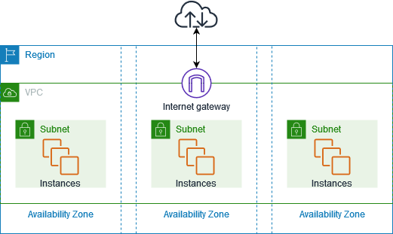

Practical’s with AWS Virtual Private Cloud (VPC) involve configuring and managing networking resources within AWS. Here are some common practical exercises to help you get hands-on experience with AWS VPC:

**1. Creating a VPC**

* **Objective:** Create a new VPC with a custom CIDR block.
* **Steps:**
  1. Go to the AWS Management Console and navigate to the VPC Dashboard.
  2. Click on "Create VPC."
  3. Choose "VPC only" and enter a name for your VPC.
  4. Specify the IPv4 CIDR block (e.g., 10.0.0.0/16).
  5. (Optional) Set an IPv6 CIDR block if needed.
  6. Choose the default tenancy or dedicated tenancy.
  7. Click "Create VPC."

**2. Creating Subnets**

* **Objective:** Create public and private subnets within the VPC.
* **Steps:**
  1. Navigate to the VPC Dashboard and select "Subnets."
  2. Click on "Create subnet."
  3. Enter a name for your subnet and select the VPC you created.
  4. Define the Availability Zone and CIDR block for the subnet (e.g., 10.0.1.0/24 for a public subnet).
  5. Repeat the process to create additional subnets with different CIDR blocks (e.g., 10.0.2.0/24 for a private subnet).

**3. Creating and Configuring an Internet Gateway**

* **Objective:** Allow internet access for the public subnet.
* **Steps:**
  1. Go to the VPC Dashboard and select "Internet Gateways."
  2. Click on "Create internet gateway."
  3. Enter a name and click "Create."
  4. Select the newly created Internet Gateway and click "Attach to VPC."
  5. Choose the VPC you created and click "Attach."

**4. Setting Up Route Tables**

* **Objective:** Configure routing for public and private subnets.
* **Steps:**
  1. Navigate to "Route Tables" in the VPC Dashboard.
  2. Click "Create route table."
  3. Enter a name and select the VPC.
  4. Click "Create."
  5. Select the route table and go to the "Routes" tab.
  6. Click "Edit routes" and add a route with destination 0.0.0.0/0 and target as the Internet Gateway.
  7. Go to the "Subnet Associations" tab and associate the route table with your public subnet.
  8. Repeat the process to create another route table for the private subnet without the Internet Gateway route.

**5. Creating and Configuring Security Groups**

* **Objective:** Set up security groups to control inbound and outbound traffic.
* **Steps:**
  1. Navigate to "Security Groups" in the VPC Dashboard.
  2. Click "Create security group."
  3. Enter a name and description, and select the VPC.
  4. Configure inbound and outbound rules (e.g., allow HTTP and SSH access).
  5. Click "Create."
  6. Attach the security group to instances as needed.

**6. Creating and Configuring Network ACLs**

* **Objective:** Configure Network ACLs (NACLs) for additional layer of security.
* **Steps:**
  1. Go to "Network ACLs" in the VPC Dashboard.
  2. Click "Create network ACL."
  3. Enter a name and select the VPC.
  4. Click "Create."
  5. Configure inbound and outbound rules similar to security groups.
  6. Associate the NACL with subnets as needed.

**7. Launching EC2 Instances in Public and Private Subnets**

* **Objective:** Test connectivity and functionality of instances in different subnets.
* **Steps:**
  1. Navigate to the EC2 Dashboard.
  2. Click "Launch Instance."
  3. Choose an Amazon Machine Image (AMI) and instance type.
  4. Configure instance details, including selecting the appropriate VPC and subnet.
  5. Configure storage, tags, and security groups.
  6. Launch the instance.
  7. Repeat the process for both public and private subnets.

**8. Testing Connectivity**

* **Objective:** Verify that instances in the public subnet can access the internet and those in the private subnet can access the public subnet.
* **Steps:**
  1. Connect to the EC2 instance in the public subnet using SSH.
  2. Test internet connectivity (e.g., ping google.com).
  3. Connect to the EC2 instance in the private subnet using SSH through a bastion host (if configured).
  4. Test connectivity to the public subnet instance.

--------------------------------------------------------------------------------------------------------------------------------------

Here's a streamlined explanation with simple, practical examples to help clarify when to use public and private subnets:

**Public Subnet**

**Characteristics:**

* **Internet Access:** Instances in a public subnet can communicate directly with the internet.
* **Route Table:** Includes a route to the Internet Gateway.

**When to Use:**

1. **Web Servers:** If you have a server that hosts a website or application and needs to be accessed by users from the internet, place it in a public subnet.
   * **Example:** An EC2 instance running a public-facing website.
2. **Load Balancers:** To distribute incoming traffic to your application servers, use a public subnet.
   * **Example:** An Elastic Load Balancer (ELB) that directs traffic to your application.
3. **Bastion Hosts/Jump Box:** For securely accessing other instances within your VPC, use a bastion host in a public subnet.
   * **Example:** A jump box that you use to SSH into private instances.

**Private Subnet**

**Characteristics:**

* **No Direct Internet Access:** Instances in a private subnet cannot directly reach the internet.
* **Route Table:** No route to the Internet Gateway, but may have a route to a NAT Gateway for outbound traffic.

**When to Use:**

1. **Databases:** Store your databases in private subnets to keep them protected from direct internet access.
   * **Example:** An RDS instance or an EC2 instance running a database.
2. **Application Servers:** Place backend application servers in a private subnet where they can interact with databases and other services without being exposed to the internet.
   * **Example:** An EC2 instance running an application that processes data but doesn’t need to be accessed directly from the internet.
3. **Internal Processing:** Use private subnets for services that perform internal tasks and need to communicate with other internal resources.
   * **Example:** A microservice that interacts with other internal services but doesn’t need to be reached from the outside.

**Summary**

* **Public Subnet:** Use for resources that need to be accessible from the internet, like web servers, load balancers, and bastion hosts.
* **Private Subnet:** Use for resources that should remain internal and are not exposed directly to the internet, such as databases and application servers.

This organization helps keep your infrastructure secure and functional by controlling access to your resources based on their roles and requirements.

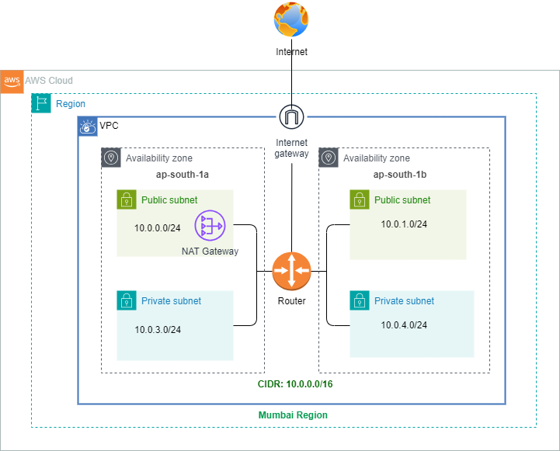

**AWS VPC Connections: A Comprehensive Guide**

**1. Internet Gateway (IGW)**

**Purpose:**

Provides a path for instances in a public subnet to access the internet.

**Practical Steps:**

1. **Create an Internet Gateway:**
   * Navigate to the **VPC Dashboard** in the AWS Management Console.
   * Click on **Internet Gateways** and then **Create Internet Gateway**.
   * Name it and click **Create Internet Gateway**.
2. **Attach the Internet Gateway to Your VPC:**
   * Select the newly created Internet Gateway.
   * Click **Actions** > **Attach to VPC**.
   * Choose your VPC and click **Attach**.
3. **Update Route Table for Public Subnet:**
   * Go to **Route Tables**.
   * Select the route table associated with your public subnet.
   * Click on **Routes** > **Edit Routes**.
   * Add a route with 0.0.0.0/0 as the destination and the Internet Gateway as the target.
   * Save the route.

**Real-Time Example:**

Hosting a public website. Create an EC2 instance in a public subnet, and it will be accessible via the internet.

**2. NAT Gateway**

**Purpose:**

Allows instances in private subnets to access the internet for outbound traffic while preventing inbound traffic.

**Real-Time Example:**

Allowing a private database to download updates or access external services without exposing it directly to the internet.

Let's walk through a hands-on practical example to set up a NAT Gateway to enable a private instance to download updates or access external services without being directly exposed to the internet.

**Hands-On Practical Example**

**Objective**

Set up a NAT Gateway to allow a private EC2 instance to access the internet to download updates, while keeping it secure.

**Prerequisites**

* An AWS account.
* Basic understanding of VPC, subnets, and route tables.
* A VPC with at least one public subnet and one private subnet.

**Steps**

1. **Create a VPC**

If you don't have a VPC, create one:

* + Go to the **VPC Dashboard**.
  + Click **Create VPC**.
  + Enter a name, CIDR block (e.g., 10.0.0.0/16), and select other options as needed.
  + Click **Create VPC**.

1. **Create Subnets**

**Public Subnet**:

* + Go to **Subnets** in the VPC Dashboard.
  + Click **Create subnet**.
  + Choose the VPC you created.
  + Enter a name, CIDR block (e.g., 10.0.1.0/24), and select an Availability Zone.
  + Click **Create subnet**.

**Private Subnet**:

* + Repeat the steps to create another subnet.
  + Use a different CIDR block (e.g., 10.0.2.0/24).
  + Ensure this subnet is different from the public one.

1. **Create and Attach an Internet Gateway**
   * Go to **Internet Gateways** in the VPC Dashboard.
   * Click **Create internet gateway**.
   * Enter a name and click **Create internet gateway**.
   * Select the new Internet Gateway and click **Actions** > **Attach to VPC**.
   * Choose your VPC and click **Attach**.
2. **Create a NAT Gateway**
   * Go to **NAT Gateways** in the VPC Dashboard.
   * Click **Create NAT Gateway**.
   * Select the public subnet you created.
   * Allocate a new Elastic IP by clicking **Allocate Elastic IP**.
   * Choose the allocated Elastic IP and click **Create NAT Gateway**.
3. **Update Route Table for Public Subnet**
   * Go to **Route Tables** in the VPC Dashboard.
   * Select the route table associated with your public subnet.
   * Click **Routes** > **Edit routes**.
   * Add a route with destination 0.0.0.0/0 and target as the Internet Gateway you created.
   * Click **Save changes**.
4. **Update Route Table for Private Subnet**
   * Select the route table associated with your private subnet.
   * Click **Routes** > **Edit routes**.
   * Add a route with destination 0.0.0.0/0 and target as the NAT Gateway you created.
   * Click **Save changes**.
5. **Launch EC2 Instances**

**Public Instance**:

* Go to **Instances** in the EC2 Dashboard.
* Click **Launch Instance**.
* Choose an Amazon Linux 2 AMI.
* Choose an instance type.
* Select the public subnet.
* Configure security group to allow SSH (port 22) from your IP.
* Launch the instance.

**Private Instance**:

* Repeat the steps to launch another instance.
* Select the private subnet.
* Configure the security group to allow only necessary inbound traffic.

1. **Test Internet Access from Private Instance**

* Connect to your public EC2 instance via SSH.
* Use it as a jump box to connect to the private EC2 instance

**8.1 Using a Public EC2 Instance as a Bastion Host**

**1. Set Up Your Bastion Host**

1. **Launch the Bastion Host (Public EC2 Instance)**:
   * Ensure it's in a public subnet with an Elastic IP assigned.
   * Configure its security group to allow inbound SSH access (port 22) from your IP address.
2. **Connect to the Bastion Host**:
   * From your local machine, connect to the bastion host using SSH:

bash

Copy code

ssh -i /path/to/your-local-key.pem ec2-user@<Bastion-Host-Public-IP>

**2. Upload Your PEM File to the Bastion Host**

1. **Create a Nano File for the PEM Key**:
   * On your local machine, use nano to create a file with your PEM key content:

bash

Copy code

nano my-key.pem

* + Paste the PEM key content into the file and save it (Ctrl + X, then Y to confirm, and enter to save). Relace my-key.pem with your actual pem file that you created for your private ec2.

1. **Set Permissions for the PEM File on the Bastion Host**:
   * Connect to the bastion host if not already connected and set the correct permissions:

bash

Copy code

chmod 400 /home/ec2-user/my-key.pem

**3. Configure Security Groups**

1. **For the Private EC2 Instance**:
   * Ensure the private EC2 instance’s security group allows inbound SSH connections from the bastion host’s security group.
2. **For the Bastion Host**:
   * Ensure that the security group of the bastion host allows inbound SSH connections from your IP address.

**4. Connect from the Bastion Host to the Private EC2 Instance**

1. **SSH into the Private EC2 Instance from the Bastion Host**:
   * Use the PEM file you uploaded to connect to the private EC2 instance:

bash

Copy code

ssh -i /home/ec2-user/my-key.pem ec2-user@<Private-EC2-Instance-Private-IP>

On the private instance, run:

bash

Copy code

sudo yum update -y

sudo yum install git -y

This command should successfully download updates from the internet, indicating that the NAT Gateway is correctly configured.

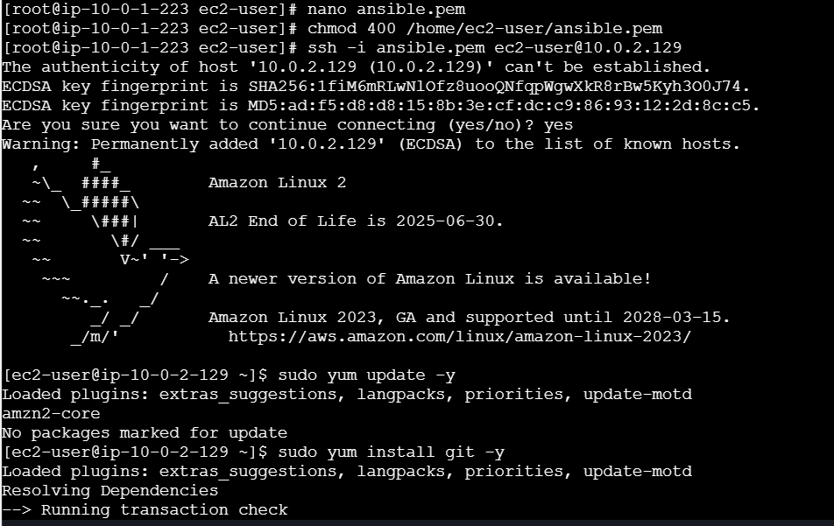

--------------------------------------------------------------------------------------------------------------------------------------

**NAT Gateways** and **NAT Instances** both serve the purpose of allowing instances in private subnets to access the internet for outbound traffic while preventing inbound traffic. However, they differ significantly in terms of ease of use, scalability, and management. Here’s a comparison:

**NAT Gateway**

**Overview**

* **Managed Service**: AWS manages the NAT Gateway, handling scaling, high availability, and maintenance.
* **Ease of Use**: Simple to set up and configure.
* **Performance**: Provides better performance and scalability than NAT Instances.
* **Cost**: Charged based on the number of NAT Gateways and the amount of data processed.

**Key Features**

1. **Scalability**: Automatically scales to accommodate high traffic volumes without requiring manual intervention.
2. **High Availability**: Built to be highly available within an Availability Zone. For multi-AZ setups, you would need to create multiple NAT Gateways in different Availability Zones.
3. **Maintenance**: No need to patch or manage the underlying infrastructure. AWS handles these aspects.
4. **Security**: Offers integrated security features, but you need to ensure that security groups and network ACLs are configured properly.

**Use Case**

* Ideal for production environments requiring high availability, performance, and minimal management overhead.

**NAT Instance**

**Overview**

* **Self-Managed**: You must set up, configure, and maintain the NAT instance yourself.
* **Flexibility**: Provides more control over the configuration and customization.
* **Performance**: May require additional configuration and scaling for high traffic volumes.

**Key Features**

1. **Customizable**: You can choose the instance type based on your performance requirements and configure it as needed.
2. **Scalability**: You need to manually handle scaling and failover. For high availability, you would need to set up multiple NAT Instances and configure a failover mechanism, such as using Elastic Load Balancing.
3. **Maintenance**: Requires you to manage updates, patches, and other maintenance tasks.
4. **Cost**: You pay for the EC2 instances, EBS volumes, and data transfer. For some use cases, this might be more cost-effective, especially at low traffic levels.

**Use Case**

* Useful for scenarios where you need specific configurations or have cost constraints and can manage the additional operational overhead.

**Summary**

* **NAT Gateway**: Preferable for most use cases due to ease of management, automatic scaling, and high availability. Best suited for production environments where performance and reliability are critical.
* **NAT Instance**: Offers more control and customization at the cost of additional management and potential performance limitations. Suitable for development or specific use cases where fine-tuned control is necessary.

------------------------------------------------------------------------------------------------------------------------------------

Setting up a NAT Instance involves several steps to ensure it is correctly configured to provide internet access to instances in a private subnet. Here's a step-by-step guide:

**Setting Up a NAT Instance**

**1. Launch a NAT Instance**

1. **Go to the EC2 Dashboard**:
   * Open the [AWS Management Console](https://aws.amazon.com/console/).
   * Navigate to **Services** and select **EC2**.
2. **Launch Instance**:
   * Click **Launch Instance**.
   * Choose an Amazon Linux AMI (or another supported Linux AMI with NAT capabilities).
3. **Select Instance Type**:
   * Choose an instance type suitable for your expected traffic (e.g., t3.medium).
4. **Configure Instance**:
   * **Network**: Select the VPC where your subnets are located.
   * **Subnet**: Select a public subnet where the NAT instance will be placed.
   * **Auto-assign Public IP**: Ensure this option is enabled so the NAT instance gets a public IP address.
5. **Add Storage**:
   * Adjust storage settings if needed. The default settings are typically sufficient.
6. **Configure Security Group**:
   * Create a new security group or select an existing one.
   * **Inbound Rules**: Add a rule to allow SSH (port 22) from your IP address for management.
   * **Outbound Rules**: Allow all outbound traffic (or specify rules based on your requirements).
7. **Launch Instance**:
   * Review your settings and click **Launch**.
   * Select or create a key pair to access the instance and click **Launch Instances**.

**2. Configure the NAT Instance**

1. **Connect to the NAT Instance**:
   * Use SSH to connect to the NAT instance.

bash

Copy code

ssh -i "your-key-pair.pem" ec2-user@your-nat-instance-public-ip

1. **Enable IP Forwarding**:
   * Edit the sysctl configuration file.

bash

Copy code

sudo nano /etc/sysctl.conf

* + Add or modify the following line:

bash

Copy code

net.ipv4.ip_forward = 1

* + Apply the changes:

bash

Copy code

sudo sysctl -p

1. **Configure NAT with iptables**:
   * Set up iptables rules to enable NAT. Run the following commands:

bash

Copy code

sudo iptables -t nat -A POSTROUTING -o eth0 -j MASQUERADE

sudo iptables -A FORWARD -i eth1 -o eth0 -m state --state RELATED,ESTABLISHED -j ACCEPT

sudo iptables -A FORWARD -i eth0 -o eth1 -j ACCEPT

* + Save the iptables rules:

bash

Copy code

sudo service iptables save

**3. Update Route Tables**

1. **Go to Route Tables**:
   * In the VPC Dashboard, select **Route Tables**.
2. **Select the Route Table for Your Private Subnet**:
   * Find and select the route table associated with your private subnet.
3. **Edit Routes**:
   * Click on **Routes** > **Edit routes**.
   * Add a route with destination 0.0.0.0/0 and target as the NAT Instance (select the NAT instance from the list).
4. **Save Changes**:
   * Click **Save changes**.

**4. Test the Configuration**

1. **Launch a Private EC2 Instance**:
   * Follow similar steps as for the public instance, but place it in a private subnet.
2. **Verify Internet Access**:
   * Connect to the private instance.
   * Attempt to access the internet or update packages to ensure it is using the NAT instance for outbound traffic.

bash

Copy code

sudo yum update -y

**Summary**

By following these steps, you have configured a NAT instance to provide internet access to instances in a private subnet. This setup involves launching a NAT instance, configuring it for NAT, updating route tables, and verifying connectivity. This approach gives you control over NAT configuration but requires manual management and scaling compared to using a managed NAT Gateway.

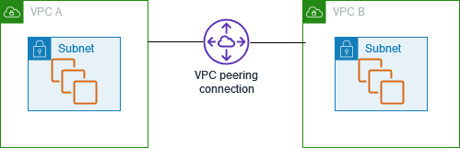

**3. VPC Peering**

**Purpose:**

Enables communication between instances in two VPCs.

VPCs in different AWS accounts can communicate with each other without using the internet, thanks to VPC Peering. Here’s a detailed explanation of how this works and the steps to set it up:

**VPC Peering Between Accounts**

**Overview:** VPC Peering allows you to establish a private network connection between two VPCs, regardless of whether they are in the same AWS account or different AWS accounts. The communication happens within AWS's private network, ensuring data transfer is secure and does not traverse the public internet.

**Steps to Set Up VPC Peering Between Accounts**

**1. Create a VPC Peering Connection**

**In the Requester Account:**

1. **Open the VPC Dashboard:**
   * Go to the AWS Management Console.
   * Navigate to the **VPC Dashboard**.
2. **Create a Peering Connection:**
   * Click on **Peering Connections** in the left-hand menu.
   * Click **Create Peering Connection**.
3. **Configure Peering Connection:**
   * **Peering Connection Name:** Enter a name (e.g., VPC-A-to-VPC-B).
   * **VPC (Requester):** Select the VPC from your account (VPC-A).
   * **VPC (Accepter):** Choose the option **Another account** and enter the AWS Account ID of the account that owns VPC-B.
   * **CIDR Block:** **Ensure that the CIDR blocks of VPC-A and VPC-B do not overlap.**
4. **Create Peering Connection:**
   * Click **Create Peering Connection**.

**In the Accepter Account:**

1. **Log In to the Accepter Account:**
   * The owner of the accepter account needs to log into their AWS account.
2. **Accept the Peering Request:**
   * Go to the **VPC Dashboard** in the accepter account.
   * Click on **Peering Connections**.
   * You will see the pending peering request. Select it and click **Actions** > **Accept Request**.

**2. Update Route Tables**

For both VPCs, you need to modify the route tables to enable traffic flow between them.

**In the Requester Account (VPC-A):**

1. **Open Route Tables:**
   * Go to the **Route Tables** section in the VPC Dashboard.
2. **Select the Route Table:**
   * Choose the route table associated with the subnet that needs to communicate with VPC-B.
3. **Add Route:**
   * Click on the **Routes** tab.
   * Click **Edit Routes** > **Add Route**.
   * **Destination:** Enter the CIDR block of VPC-B (e.g., 192.168.0.0/16).
   * **Target:** Select the peering connection you created.
   * Click **Save Changes**.

**In the Accepter Account (VPC-B):**

1. **Open Route Tables:**
   * Go to the **Route Tables** section in the VPC Dashboard.
2. **Select the Route Table:**
   * Choose the route table associated with the subnet that needs to communicate with VPC-A.
3. **Add Route:**
   * Click on the **Routes** tab.
   * Click **Edit Routes** > **Add Route**.
   * **Destination:** Enter the CIDR block of VPC-A (e.g., 10.0.0.0/16).
   * **Target:** Select the peering connection you created.
   * Click **Save Changes**.

**3. Update Security Groups**

To ensure that instances in both VPCs can communicate, adjust the security groups to allow inbound and outbound traffic between the VPCs.

**In the Requester Account (VPC-A):**

1. **Open Security Groups:**
   * Go to the **Security Groups** section in the VPC Dashboard.
2. **Select Security Group:**
   * Choose the security group associated with the instances that need access to VPC-B.
3. **Edit Inbound Rules:**
   * Click the **Inbound Rules** tab.
   * Click **Edit Inbound Rules** > **Add Rule**.
   * **Type:** Choose the protocol (e.g., HTTP, SSH).
   * **Type:** Choose **All ICMP - IPv4** or **Custom ICMP Rule** and specify **Echo Request** if you only want to allow pings.
   * **Source:** Enter the CIDR block of VPC-B (e.g., 192.168.0.0/16).
   * Click **Save Rules**.

**In the Accepter Account (VPC-B):**

1. **Open Security Groups:**
   * Go to the **Security Groups** section in the VPC Dashboard.
2. **Select Security Group:**
   * Choose the security group associated with the instances that need access to VPC-A.
3. **Edit Inbound Rules:**
   * Click the **Inbound Rules** tab.
   * Click **Edit Inbound Rules** > **Add Rule**.
   * **Type:** Choose the protocol (e.g., HTTP, SSH).
   * **Type:** Choose **All ICMP - IPv4** or **Custom ICMP Rule** and specify **Echo Request** if you only want to allow pings.
   * **Source:** Enter the CIDR block of VPC-A (e.g., 10.0.0.0/16).
   * Click **Save Rules**.

**4. Test Connectivity**

**Objective:** Verify that instances in VPC-A can communicate with instances in VPC-B.

**In VPC-A:**

1. **Launch an EC2 Instance:**
   * Ensure it is in a subnet with the updated route table and security group rules.
2. **SSH into the EC2 Instance:**
   * Use SSH or RDP, depending on the operating system.
3. **Ping an Instance in VPC-B:**
   * Run the command ping <private-ip-of-instance-in-VPC-B> or use other protocols to test connectivity.

**In VPC-B:**

1. **Launch an EC2 Instance:**
   * Ensure it is in a subnet with the updated route table and security group rules.
2. **SSH into the EC2 Instance:**
   * Use SSH or RDP, depending on the operating system.
3. **Ping an Instance in VPC-A:**
   * Run the command ping <private-ip-of-instance-in-VPC-A> or use other protocols to test connectivity.

**Note:** If pinging fails, check network ACLs and firewall settings in addition to route tables and security groups.

**Benefits and Considerations**

* **Benefits:**
  + **Security:** Traffic stays within the AWS network and doesn’t traverse the public internet.
  + **Cost-Effective:** No additional data transfer charges within the same region.
  + **Scalability:** Easily connect multiple VPCs using peering.
* **Considerations:**
  + **CIDR Overlap:** Ensure that VPC CIDR blocks do not overlap.
  + **Route Tables:** Properly configure route tables in both VPCs.
  + **Security Groups:** Adjust security group rules to allow necessary traffic.

By following these steps, you can enable seamless and secure communication between VPCs in different AWS accounts without using the internet.

**VPN (Virtual Private Network) vs Direct Connect**

Both VPN and AWS Direct Connect are methods for establishing secure and reliable connections between your on-premises infrastructure and AWS. Here's a comparison to help you understand their differences:

**VPN (Virtual Private Network)**

**Overview:**

* A VPN creates a secure, encrypted connection over the public internet. It uses protocols like IPsec (Internet Protocol Security) or SSL (Secure Sockets Layer) to secure the data in transit.

**Key Features:**

* **Cost-Effective:** Generally, VPNs are less expensive compared to Direct Connect.
* **Flexibility:** Can be set up quickly and requires no physical hardware. Useful for temporary or small-scale connectivity needs.
* **Security:** Encrypts data over the internet, which adds a layer of security.
* **Bandwidth:** Limited by internet bandwidth and potential congestion. Performance can vary based on internet conditions.
* **Setup:** Requires configuration of VPN gateways or VPN appliances on both ends.
* **Connection Type:** Uses a secure tunnel over the public internet to encrypt and protect data in transit.

**Use Cases:**

* Remote access for employees.
* Secure connections for smaller workloads or development environments.
* Temporary or ad-hoc connections.

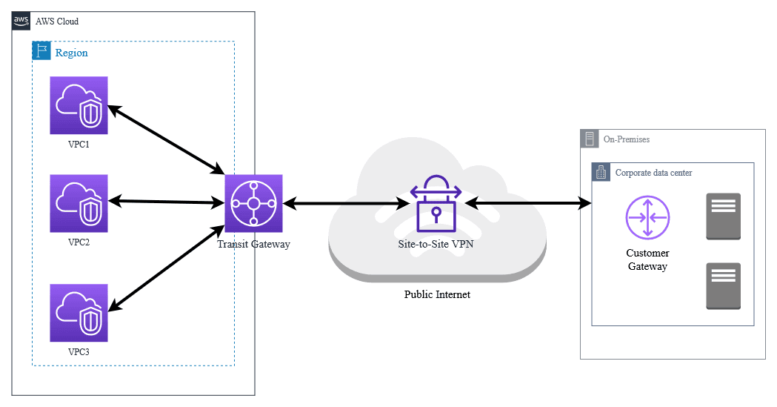

**AWS Direct Connect**

**Overview:**

* AWS Direct Connect provides a dedicated, private connection from your on-premises data center or office to AWS. This connection does not traverse the public internet.

**Key Features:**

* **Performance:** Offers higher and more consistent bandwidth compared to VPN. Low latency and predictable performance.
* **Security:** Data is transferred over a private network connection rather than the public internet, reducing exposure to external threats.
* **Cost:** Can be more expensive due to setup fees and ongoing charges. However, it can offer cost savings for high-volume data transfers.
* **Bandwidth:** Supports high-speed connections (1 Gbps, 10 Gbps, or even 100 Gbps), suitable for large-scale data transfer.
* **Setup:** Requires physical installation of a connection at a Direct Connect location or a partner location.
* **Connection Type:** Utilizes physical network cables to establish a dedicated, private line directly to AWS, providing a more reliable and controlled connection environment.

**Use Cases:**

* High-throughput applications and workloads.
* Large data migrations or frequent data transfers.
* Use cases requiring low latency and high reliability.

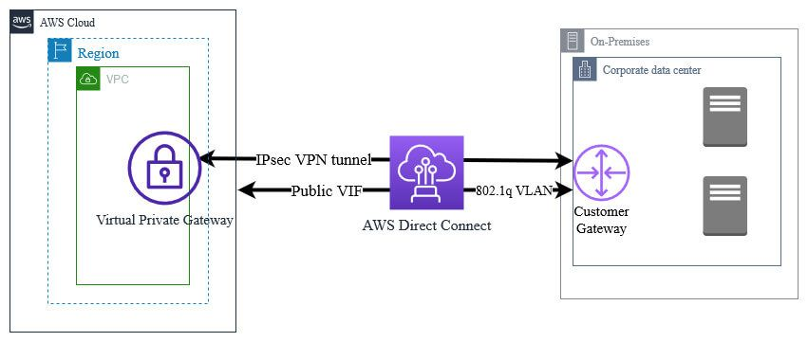

**Summary**

* **VPN** is generally better for scenarios where you need a cost-effective, flexible, and easy-to-implement solution for secure connections over the internet. It uses a secure tunnel over the public internet.
* **Direct Connect** is ideal for scenarios where performance, reliability, and large-scale data transfer are critical, and where you're willing to invest in a dedicated, private connection using physical network cables.

Your choice between VPN and Direct Connect depends on your specific needs regarding performance, security, and cost.

**1. Virtual Private Gateway (VGW)**

**Purpose:** A Virtual Private Gateway (VGW) allows you to securely connect your AWS Virtual Private Cloud (VPC) to your on-premises network using a VPN (Virtual Private Network). This connection is encrypted, which ensures that your data remains secure as it travels over the public internet.

**Key Features:**

* **IPsec VPN Connections:** Encrypts data sent over the internet, providing secure communication.
* **Site-to-Site VPN:** Connects your physical office network to your AWS VPC.

**Configuration Steps:**

1. **Create a Virtual Private Gateway:**
   * **Go to the VPC Dashboard:** In the AWS Management Console, navigate to the VPC Dashboard.
   * **Create Virtual Private Gateway:** Click on "Virtual Private Gateways" on the left menu, then click "Create Virtual Private Gateway."
   * **Provide Details:** Enter a name for the gateway and an ASN (Autonomous System Number). The ASN is a unique number that identifies your network in the context of BGP (Border Gateway Protocol) routing.
   * **Create:** Click "Create Virtual Private Gateway" to finish.
2. **Attach to a VPC:**
   * **Select the VGW:** Find the VGW you just created in the list.
   * **Attach to VPC:** Click "Actions," then "Attach to VPC."
   * **Choose Your VPC:** Select the VPC you want to connect to and click "Attach."
3. **Create and Configure a VPN Connection:**
   * **Create VPN Connection:** Go to "VPN Connections" in the VPC Dashboard and click "Create VPN Connection."
   * **Select VGW and Customer Gateway:** Choose the VGW you created. If you haven’t set up a Customer Gateway (your on-premises VPN device), you’ll need to do that next.
   * **Configure Routing:** Set up routing options (static or dynamic). Download the configuration file for your VPN device.
   * **Configure On-Premises Device:** Use the downloaded configuration file to set up your on-premises VPN device.

**2. Customer Gateway (CGW)**

**Purpose:** A Customer Gateway (CGW) represents your on-premises VPN device and acts as the endpoint for the VPN connection to AWS.

**Key Features:**

* **On-Premises Device Representation:** Identifies the public IP address of your VPN device.
* **Routing Support:** Allows for both static and dynamic routing, including BGP for dynamic routing.

**Configuration Steps:**

1. **Create a Customer Gateway:**
   * **Go to the VPC Dashboard:** In the AWS Management Console, navigate to the VPC Dashboard.
   * **Create Customer Gateway:** Click on "Customer Gateways" on the left menu, then click "Create Customer Gateway."
   * **Provide Details:** Enter the public IP address of your on-premises VPN device and other relevant details.
   * **Create:** Click "Create Customer Gateway."
2. **Configure VPN Connection:**
   * Follow the steps outlined in the VGW configuration to create and configure the VPN connection.

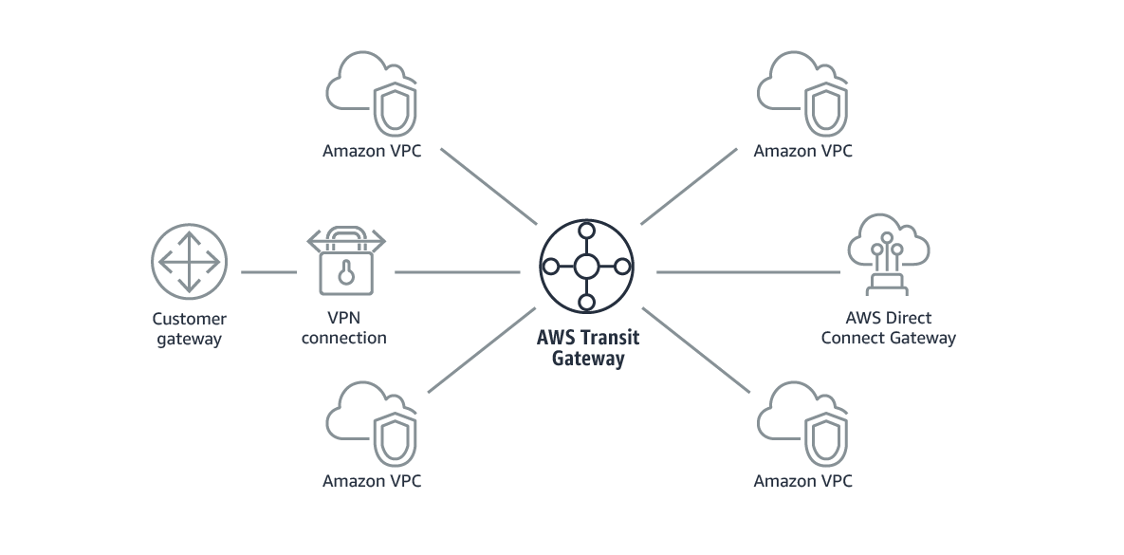

**Transit Gateway (TGW)**

**Purpose:** AWS Transit Gateway (TGW) is designed to simplify network management by providing a central hub to connect multiple VPCs and on-premises networks. This is especially useful for larger and more complex network architectures.

**Key Features:**

* **Hub-and-Spoke Model:** Connects multiple VPCs and on-premises networks through a single central gateway.
* **Inter-Region Connectivity:** Allows connection between VPCs in different AWS regions.
* **Simplifies Routing:** Manages and centralizes routing through the Transit Gateway.

**Configuration Steps:**

1. **Create a Transit Gateway:**
   * **Go to the VPC Dashboard:** In the AWS Management Console, navigate to the VPC Dashboard.
   * **Create Transit Gateway:** Click on "Transit Gateways" on the left menu, then click "Create Transit Gateway."
   * **Provide Details:** Enter a name for the gateway, configure ASN, and other settings.
   * **Create:** Click "Create Transit Gateway."
2. **Attach VPCs and On-Premises Networks:**
   * **Create Attachment:** Go to "Transit Gateway Attachments" and click "Create Transit Gateway Attachment."
   * **Select TGW and Networks:** Choose the Transit Gateway you created and select the VPCs or on-premises networks you want to attach.
   * **Create Attachment:** Click "Create Transit Gateway Attachment."
3. **Update Route Tables:**
   * **Update VPC Route Tables:** Modify the route tables in each VPC to direct traffic through the Transit Gateway.
   * **Configure TGW Route Tables:** Set up routing rules in the Transit Gateway’s route tables to manage traffic between attached networks.

**What are VPC Endpoints?**

VPC Endpoints let you connect your AWS resources (like EC2) to other AWS services (like S3) privately, without using the internet. You don’t need public IPs or a NAT Gateway. Instead, your traffic stays entirely within the AWS network, which is more secure and can reduce costs.

**Two Types of VPC Endpoints:**

1. **Interface Endpoints (AWS PrivateLink):**
   * Used for many AWS services, including **S3, DynamoDB, SNS**, and **CloudWatch**.
   * It creates a **network interface** inside your VPC that connects to the AWS service. You control this interface using **security groups**.
2. **Gateway Endpoints:**
   * Only for **S3** and **DynamoDB**.
   * It works by adding a special route in your **VPC’s route table** so that traffic to S3/DynamoDB is directed through the private connection, not the internet.

**When to Use VPC Endpoints:**

1. **Private Connectivity:** If you don’t want your EC2 instance to use the public internet to access services like S3.
2. **Security:** Keeping all data inside AWS ensures better protection, especially for sensitive information.
3. **Cost Saving:** VPC Endpoints help avoid the costs associated with public IPs, NAT Gateways, and internet traffic.
4. **Better Performance:** Since your data doesn’t go through the public internet, the connection is faster and has less delay (low latency).

**How to Set Up an Interface Endpoint for S3 (PrivateLink Method):**

Imagine you have an EC2 instance in a **private subnet** (which can’t access the internet) and you want it to access **S3**. Instead of setting up internet access, you can create a **VPC Interface Endpoint**.

**Steps:**

1. **Go to AWS VPC Console:**
   * In your AWS Management Console, go to the **VPC** service.
2. **Create an Endpoint:**
   * From the **left panel**, click **Endpoints** and then click **Create Endpoint**.
3. **Choose the AWS Service:**
   * Search for S3 in the service list and select it (com.amazonaws.<region>.s3, replace <region> with your AWS region, like us-east-1).
4. **Configure the Endpoint:**
   * Select the **VPC** where your EC2 instance is running.
   * Choose the **subnet** (private subnet) where you want to create the network interface (ENI).
   * Attach a **security group** to this interface that allows the necessary traffic.
5. **Create the Endpoint:**
   * Click **Create Endpoint**.
6. **Update Security Group Rules (Optional):**
   * If needed, update your EC2 instance’s security group to allow traffic to the S3 Interface Endpoint.
7. **Access S3 from EC2:**
   * Now, you can access S3 from your EC2 instance using the AWS CLI:

bash

Copy code

aws s3 ls s3://your-bucket-name

* + Since you used an Interface Endpoint, all the traffic stays private inside AWS.

**How to Set Up a Gateway Endpoint for S3 (Simple Method):**

If your use case is **only for S3** or **DynamoDB**, a **Gateway Endpoint** is a simpler and cheaper solution.

**Steps:**

1. **Go to AWS VPC Console:**
   * In your AWS Management Console, go to the **VPC** service.
2. **Create an Endpoint:**
   * From the **left panel**, click **Endpoints** and then click **Create Endpoint**.
3. **Select AWS Service:**
   * Choose **S3** (or DynamoDB).
4. **Choose VPC and Route Table:**
   * Select the **VPC** where your EC2 instance is located.
   * Choose the **route table** for the subnets where your EC2 instance is running. This updates the route table so that traffic going to S3 doesn’t use the internet but goes through the Gateway Endpoint.
5. **Create the Endpoint:**
   * Click **Create Endpoint**.
6. **Access S3 from EC2:**
   * Once this is set up, your EC2 instance can access S3 without using a NAT Gateway or internet access:

bash

Copy code

aws s3 ls s3://your-bucket-name

**Key Differences Between Interface and Gateway Endpoints:**

| **Feature** | **Interface Endpoint** | **Gateway Endpoint** |
| --- | --- | --- |
| **Used For** | Many AWS services (S3, SNS, etc.) | Only S3 and DynamoDB |
| **How it Works** | Creates a network interface (ENI) | Adds an entry in route table |
| **Complexity** | More setup needed (ENI, security) | Simpler, just updates route |
| **Cost** | Charges for using the ENI | No additional cost |

AWS PrivateLink is a service that enables you to privately connect your VPC to supported AWS services, your own services, or services hosted by other AWS customers, without using public IPs. This means that your traffic stays within the AWS network, improving security and potentially reducing latency.

Here’s a detailed breakdown of AWS PrivateLink, including how it works and how to set it up.

**How AWS PrivateLink Works**

1. **Private Connectivity:** AWS PrivateLink provides private connectivity between VPCs using interface endpoints. It does this by creating Elastic Network Interfaces (ENIs) in your VPC that are connected to the service you want to access.
2. **Service Providers and Consumers:**
   * **Service Providers:** AWS services or third-party services hosted on AWS that you want to access.
   * **Service Consumers:** Your VPCs or other VPCs that want to access the service securely.
3. **VPC Endpoint:** This is an ENI that provides a private IP address within your VPC. It acts as a gateway for your traffic to the AWS service or application.
4. **Private DNS:** PrivateLink can be configured to support private DNS names, meaning you can use standard DNS names for AWS services without needing to use public DNS names.

**Key Benefits of AWS PrivateLink**

1. **Increased Security:** Traffic between your VPC and the service stays within the AWS network and does not traverse the public internet, which reduces exposure to potential security risks.
2. **Simplicity:** No need to use NAT Gateways or internet gateways to access AWS services. Traffic is routed through the PrivateLink endpoint.
3. **Reduced Latency:** Since the traffic stays within the AWS network, it can lead to lower latency compared to accessing services over the internet.
4. **Cost Efficiency:** PrivateLink can reduce data transfer costs by avoiding charges associated with data transferred over the public internet.

**Setting Up AWS PrivateLink**

**1. Creating an Interface VPC Endpoint**

**Scenario:** You want to connect your VPC to an AWS service like S3 using AWS PrivateLink.

**Steps:**

1. **Open the VPC Dashboard:**
   * Log in to the [AWS Management Console](https://aws.amazon.com/console/).
   * Navigate to the **VPC** service.
2. **Create the Endpoint:**
   * In the left panel, select **Endpoints**.
   * Click **Create Endpoint**.
3. **Configure the Endpoint:**
   * **Service category:** Choose **AWS services**.
   * **Service Name:** Find and select the service you want to connect to (e.g., S3). It will be listed in the format com.amazonaws.<region>.service, such as com.amazonaws.us-east-1.s3.
   * **VPC:** Select the VPC where you want to create the endpoint.
4. **Set Up Subnets:**
   * Choose the subnet(s) where the endpoint will be created. This is where the ENI will reside.
5. **Configure Security Groups:**
   * Attach a security group to the endpoint. This security group should allow traffic from your VPC to the endpoint.
6. **Configure Private DNS:**
   * For most AWS services, you can enable private DNS so you can use the service’s standard DNS name.
7. **Review and Create:**
   * Review your settings and click **Create Endpoint**.
8. **Update Security Groups (if needed):**
   * Ensure that the security group attached to your resources (e.g., EC2) allows traffic to the endpoint’s security group.

**Testing:**

* Connect to an EC2 instance within your VPC and try to access the AWS service using its private DNS name (e.g., s3.amazonaws.com for S3).

**2. Setting Up a VPC Endpoint for a Private Service**

**Scenario:** You want to expose a private service running in your VPC to other VPCs using AWS PrivateLink.

**Steps:**

1. **Create a Network Load Balancer (NLB):**
   * Your service should be behind a Network Load Balancer to use PrivateLink.
2. **Create a VPC Endpoint Service:**
   * In the VPC Dashboard, select **Endpoint Services** from the left panel.
   * Click **Create Endpoint Service**.
   * Select the Network Load Balancer you created.
   * Optionally, enable private DNS names.
3. **Configure Permissions:**
   * Set up permissions to allow other VPCs to connect to your service.
4. **Share the Service Name:**
   * Provide the service name to the consumers who want to connect to your service.

**Testing:**

* The service consumers will create an interface endpoint in their VPC using the service name you shared.

**Example Use Case: Connecting to an S3 Bucket Using PrivateLink**

1. **Create an Interface Endpoint for S3:**
   * Follow the steps above to create an interface endpoint for S3.
2. **Verify Private Connectivity:**
   * From an EC2 instance within your VPC, run:

bash

Copy code

aws s3 ls s3://your-bucket-name

* + This should work without routing traffic over the public internet.

**Conclusion**

AWS PrivateLink provides a secure, simple, and cost-effective way to connect to AWS services or expose your services privately within the AWS network. By using interface endpoints, you can ensure that your traffic stays within the AWS network, enhancing security and potentially reducing costs.

**Note: - VPC flow logs in a separate document.**