**TRAVEL AND GUIDE MANAGEMENT SYSTEM**

Project submitted to the

SRM University – AP, Andhra Pradesh

for the partial fulfillment of the requirements to award the degree of

**Bachelor of Technology/Master of Technology**

In

**Computer Science and Engineering**

**School of Engineering and Sciences**

Submitted by

**Candidate Name**

**(APXXXXXXXXXXX)**

Under the Guidance of

**(Supervisor Name)**

**SRM University–AP**

**Neerukonda, Mangalagiri, Guntur**

**Andhra Pradesh – 522 240**

**[Month, Year]**

# Certificate

Date: 4-Dec-22

This is to certify that the work present in this Project entitled “**Travel and Guide management system**” has been carried out by **[Name of the Candidate]** under my/our supervision. The work is genuine, original, and suitable for submission to the SRM University – AP for the award of Bachelor of Technology in **School of Engineering and Sciences**.

**Supervisor**

(Signature)

Prof. / Dr. [Name]

Designation,

Affiliation.

**Co-supervisor**

(Signature)

Prof. / Dr. [Name]

Designation,

Affiliation.

# Acknowledgements

# Table of Contents

Certificate i

Acknowledgements iii

Table of Contents v

Abstract vii

List of Publications ix

Statement of Contributions xi

Abbreviations xiii

List of Tables xv

List of Figures xvii

List of Equations xix

1. Introduction 1

1.1 Heading 2 1

1.1.1 Heading 3 1

2. Methodology 3

2.1 Heading 2 3

2.1.1 Heading 3 3

3. Discussion 5

4. Concluding Remarks 7

5. Future Work 9

References 11

# Abstract

Travel and Guide Management System (TGMS ) Project deals with Travel planning and organizing the Guide system which is implemented using python and other python modules. I this project user will have the options to choose what he wants from the Travel company and user has the ability to choose the Travel guide and he has ability to choose the place which he wants to go and enjoy the tripe and user have a choose to choose the language of the guide and choose the guide by his name and age and experience and gits the final bill from the travel company.

Statement of Contributions (Optional)

As a team we contributed to this project

Name I: enter contribution

Name 2: enter contribution

Name 3: enter contribution

# Abbreviations

TGMS Travel and Guide Management System

**Introduction**

TGMS project helps to book the journey and guide according to the user choose which is implemented in python. A travel management system helps travel managers book, track, and analyze business travel. Typically, a travel management system refers to a platform that offers travel inventory, travel policies, and reporting, but this can also refer to the overall process of managing corporate travel.

Travel Management Company (TMC) is a business travel agency (such as Trip Actions) that helps organizations manage their travel programs. A TMC fulfills travel bookings, supports the organization's duty of care obligations, and identifies potential cost-savings opportunities.

## Interface.py

Interface .py is a python executable file in any compiler and its all about the TGMS Fronted look. This interface.py deals with the choose of the user and it works by match method which matches the user input to the match case and execute the required method which also imported from the file called main.py and creates a object according to the user choose and work and gives the output by the user interface of it. And clear visuals will be provided in the methodology.

## Main.py

Main.py is a module which is imported by the interface executable file which helps in the access the methods which is implemented according to the project description and the methods are public and the attributes of the class com is private and cant be accessed out of the class and the methods can be used if the runner python file which is imported the Main.py module and imported the com class to work with it in the project

# Methodology

Methods we used in TGMS



## Match Methodology in Interface

## 

## Display Methodology in Interface

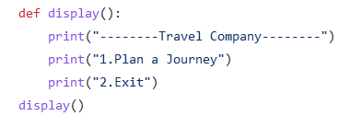

### 3.1 Costid(self, place)

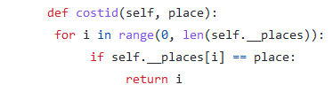

**3.2 Printcity(self, place)**

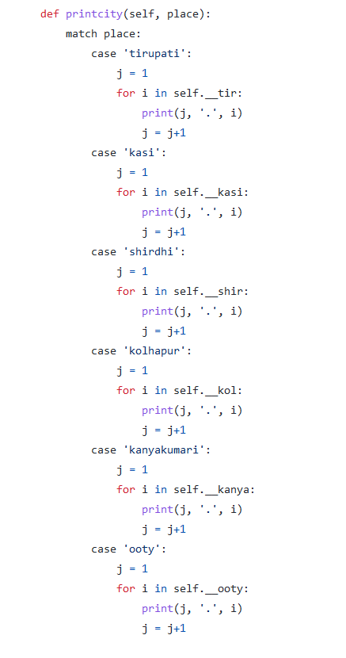

## Journey(self) Methodology

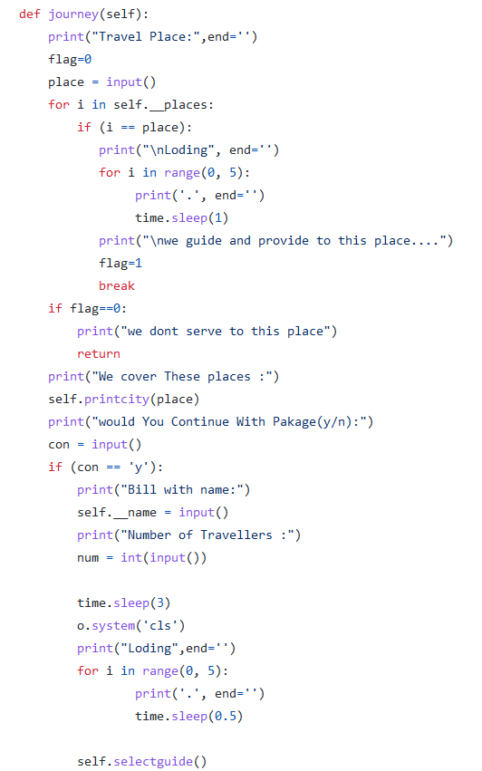

## Selectguide(self) Methodology

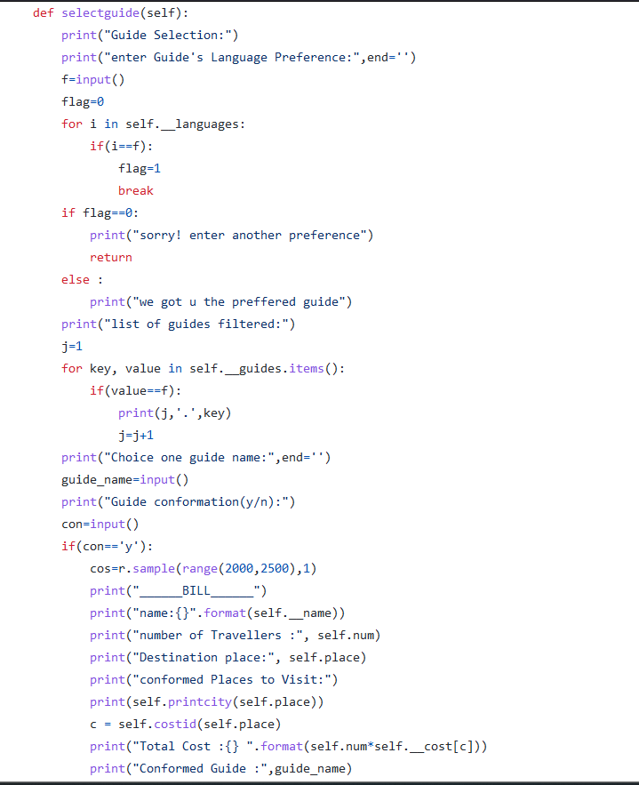

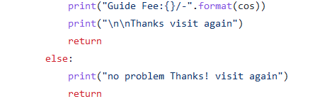

**Concluding Remarks**

In this project we provide security and safety of data which is provided by initializing all class attributes as private to access and use it

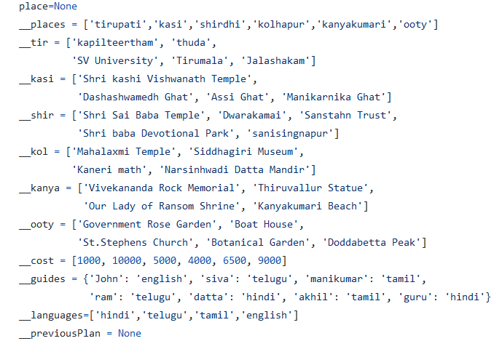

This project helps the industry to serve the user with a all promised applications and entities