**ABSTRACT**

Rent a Car Reservation System is a powerful web based system designed to meet the specific needs of rent-a-car owners looking for easy to use car rental software which lets you take and manage reservations directly on a website. The system being developed to handle the business needs of renting out vehicles to customers, maintaining records and data on vehicle fleet, operating the customer portal website, and reporting the state of the system to the company.

1. Admin

We create an admin who will have the database of the people who were registrating And we have to store in database using MYSQL ,SQL

2. Customer

In this first the customer will register with some form validations and after registering he /she will have a user id or password to login. In which we are going to provide the details of the car like which type of car, rents as per the selection of car.

3. Routes

According to the distance the fare charges will be displayed and if it is affordable they can click on ride now.

4. Feedback

Feedback how the customer felt about the journey. Is the car is on time or not. Comforts in the car and the Driver safely dropped or not.

**CONTENT**

* + 1. PROJECT DESCRIPTION
    2. MODULES DESCRIPTION
    3. SOFTWARE & HARDWAREREQUIREMENTS
    4. TECHNOLOGIES USED(HTML,CSS,JS,SERVLETS/JSP,JDBC,MYSQL)
    5. DATABASEDESIGN
    6. CODE
    7. OUTPUT SCREEN SHOTS
    8. CONCLUSION
    9. REFERENCES
    10. FUTURE SCOPE

**PROJECT DESCRIPTION:**

“RENT A CAR” Rent a Car Reservation System is a powerful web based system designed to meet the specific needs of rent-a-car owners looking for easy to use car rental software which lets you take and manage reservations directly on a website.

There is a database which is maintained in which all the names of customers with complete information is stored.

In “RENT A CAR” a customer can use his\her login online without any difficulty. He\She has to be registered first for his/her to book. Registration is mainly done by the system administrator for security reasons. The system Administrator registers the customers on a special site of the system visited by him only by simply filling a registration form to register customer. Citizens seeking registration are expected to contact the system administrator to submit their details. After the validity of them being citizens of India has been confirmed by the system administrator by comparing their details submitted with those in existing databases.

After registration, the customer is assigned a User ID with which he/she can use to log in the system and enjoy services provided by the system such as booking a car. If invalid/wrong details are submitted, then the customer is not registered to book.

1. **MODULE DESCRIPTION:**

1. Admin

We create an admin who will have the database of the people who were registrating And we have to store in database using MYSQL ,SQL

2. Customer

In this first the customer will register with some form validations and after registering he /she will have a user id or password to login. In which we are going to provide the details of the car like which type of car, rents as per the selection of car.

3. Feedback

Feedback how the customer felt about the journey. Is the car is on time or not. Comforts in the car and the Driver safely dropped or not.

1. **SOFTWARE & HARDWARE REQUIREMENTS:**

**SOFTWARE REQUIREMENTS:**

### **MYSQL DBMS-** It allows combination, extraction, manipulation and organization of data in the voters’ database. It is platform independent and therefore can be implemented and used across several such as Windows, Linux server and is compatible with various hardware mainframes. It is fast in performance, stable and provides business value at a low cost.

**NetBeans IDE 8.2-** The NetBeans IDE is an award-winning integrated development environment available for Windows, Mac, Linux, and Solaris. The NetBeans project consists of an open-source IDE and an application platform that enable developers to rapidly create web, enterprise, desktop, and mobile applications using the Java platform, as well as PHP, JavaScript and Ajax, Groovy and Grails, andC/C++.

The NetBeans project is supported by a vibrant developer community and offers extensive documentation and training resources as well as a diverse selection of third-party plugin.

**Web browsers**: Mozilla Firefox, Google chrome, Opera and Internet Explorer

**Reporting Tool:**i.e. through Data Report.

#### HARDWARE REQUIREMENTS:

* + **Microsoft Windows XP Professional SP3/Vista SP1/Windows 7 Professional:**

**Processor:** 800MHz Intel Pentium III or equivalent

**Memory:** 512 MB

**Disk space:** 750 MB of free disk space

#### TECHNOLOGIES USED(HTML,CSS,JS,SERVLETS/JSP,JDBC,MYSQL):

Here we use HTML,CSS,MYSQL,JSP in execution of this program.Let us see about them in detail.

**HTML:**

* + HTML stands for Hyper Text MarkupLanguage.
  + HTML describes the structure of Web pages usingmarkup.
  + HTML elements are the building blocks of HTMLpages.
  + HTML elements are represented bytags.
  + HTML tags label pieces of content such as "heading", "paragraph", "table", and soon.

#### CSS:

* + CSS stands for Cascading StyleSheets
  + CSS describes how HTML elements are to be displayed on screen, paper, or in othermedia
  + CSS saves a lot of work. It can control the layout of multiple web pages all atonce
  + External stylesheets are stored in CSSfiles.

**JSP:**

**JSP** technology is used to create dynamic web applications. **JSP** pages are easier to maintain then a **Servlet**. JSP pages are opposite of Servlets as a servlet adds HTML code inside Java code, while JSP adds Java code inside HTML using JSP tags. Everything a Servlet can do, a JSP page can also doit.

#### MYSQL:

MYSQL is a fast, easy-to-use RDBMS being used for many small and big businesses. MySQL is developed, marketed and supported by MySQL AB, which is a Swedish company. MySQL is becoming so popular because of many good reasons−

* + MySQL is released under an open-source license. So you have nothing to pay to useit.
  + MySQL is a very powerful program in its own right. It handles a large subset of the functionality of the most expensive and powerful databasepackages.
  + MySQL uses a standard form of the well-known SQL datalanguage.
  + MySQL works on many operating systems and with many languages including PHP, PERL, C, C++, JAVA,etc.
  + MySQL works very quickly and works well even with large datasets.
  + MySQL is very friendly to PHP, the most appreciated language for web development.
  + MySQL supports large databases, up to 50 million rows or more in a table. The default file size limit for a table is 4GB, but youcan increase this (if your operating system can handle it) to a theoretical limit of 8 million terabytes(TB).
  + MySQL is customizable. The open-source GPL license allows programmers to modify the MySQL software to fit their own specific environments.

#### DATABASE DESIGN :

In the database design we have to design a two tables for a registeration and feedback.

To store the data in the values of the particular table in the database.

**SOURCE CODE:**

<!DOCTYPE html>

<html>

<head>

<linkrel="stylesheet"href="https://maxcdn.bootstrapcdn.com/bootstrap/3.3.7/css/bootstrap.min.css">

<script src="https://ajax.googleapis.com/ajax/libs/jquery/3.2.1/jquery.min.js"></script>

<script src="https://maxcdn.bootstrapcdn.com/bootstrap/3.3.7/js/bootstrap.min.js"></script>

<style>

ul {

list-style-type: none;

margin: 0;

padding: 0;

overflow: hidden;

background-color: blue;

}

li {

float: left;

border-right:1px solid #bbb;

}

li:last-child {

border-right: none;

}

li a {

display: block;

color: white;

text-align: center;

padding: 14px 16px;

text-decoration: none;

}

li a:hover:not(.active) {

background-color: red;

}

.active {

background-color: white;

}

input[type=text] {

width: 130px;

box-sizing: border-box;

border: 2px solid #ccc;

border-radius: 4px;

font-size: 16px;

background-color: white;

background-image: url('searchicon.png');

background-position: 10px 10px;

background-repeat: no-repeat;

padding: 12px 20px 12px 40px;

-webkit-transition: width 0.4s ease-in-out;

transition: width 0.4s ease-in-out;

}

input[type=text]:focus {

width: 100%;

}

.dropbtn {

background-color: blue;

color: white;

padding: 16px;

font-size: 16px;

border: none;

cursor: pointer;

}

.conatainer {

height: 300px;

border: none;

}

.dropdown a:hover {background-color: #f1f1f1}

.show {display:block;}

</style>

</head>

<body>

<ul>

<li><a class="active" href="home.html">Home</a></li>

<li><a href="#services.html">Services</a></li>

<li><a href="#contact">Contact</a></li>

<li style="float:right"><a href="index.jsp">sign up</a></li>

<li style="float:right"><a href="registration.jsp">sign in</a></li>

<li style="float:right"><a href="about us.jsp">About</a></li>

<li> <input type="text" name="search" placeholder="Search.."></li>

</ul>

<div class="container">

<h2 align="center">RENT A CAR</h2>

<div id="myCarousel" class="carousel slide" data-ride="carousel" style="max-width:1050px" style="height:300px">

<!-- Indicators -->

<ol class="carousel-indicators">

<li data-target="#myCarousel" data-slide-to="0" class="active"></li>

<li data-target="#myCarousel" data-slide-to="1"></li>

<li data-target="#myCarousel" data-slide-to="2"></li>

</ol>

<!-- Wrapper for slides -->

<div class="carousel-inner">

<div class="item active">

<img src="benz.jpg" alt="IMAGE1" style="width:1750px;height:250px">

</div>

<div class="item">

<img src="carz.jpg" alt="IMAGE2" style="width:1750px;height:250px">

</div>

<div class="item">

<img src="lam.jpg" alt="IMAGE3" style="width:1750px;height:250px">

</div>

</div>

<!-- Left and right controls -->

<a class="left carousel-control" href="#myCarousel" data-slide="prev">

<span class="glyphicon glyphicon-chevron-left"></span>

<span class="sr-only">Previous</span>

</a>

<a class="right carousel-control" href="#myCarousel" data-slide="next">

<span class="glyphicon glyphicon-chevron-right"></span>

<span class="sr-only">Next</span>

</a>

</div>

</div>

<div align="center" >

<br><br>

<img src="lam.jpg" alt="no image" width="20%" height="20%">&nbsp; &nbsp; &nbsp; &nbsp; &nbsp; &nbsp; &nbsp; &nbsp; &nbsp; &nbsp; &nbsp; &nbsp;&nbsp; &nbsp;&nbsp;

<img src="Jaguar1.jpg" alt="no image" width="20%" height="25%" >&nbsp; &nbsp; &nbsp; &nbsp; &nbsp; &nbsp; &nbsp; &nbsp; &nbsp; &nbsp; &nbsp; &nbsp; &nbsp;

<img src="rcphantom.jpg" alt="no image" width="20%" height="20%"></div>

<br><br>

<a href="register.jsp"><center>To order your FAVOURITE CAR?Click Here...</center></a>

<br3>

</body>

</html>

HOME PAGE

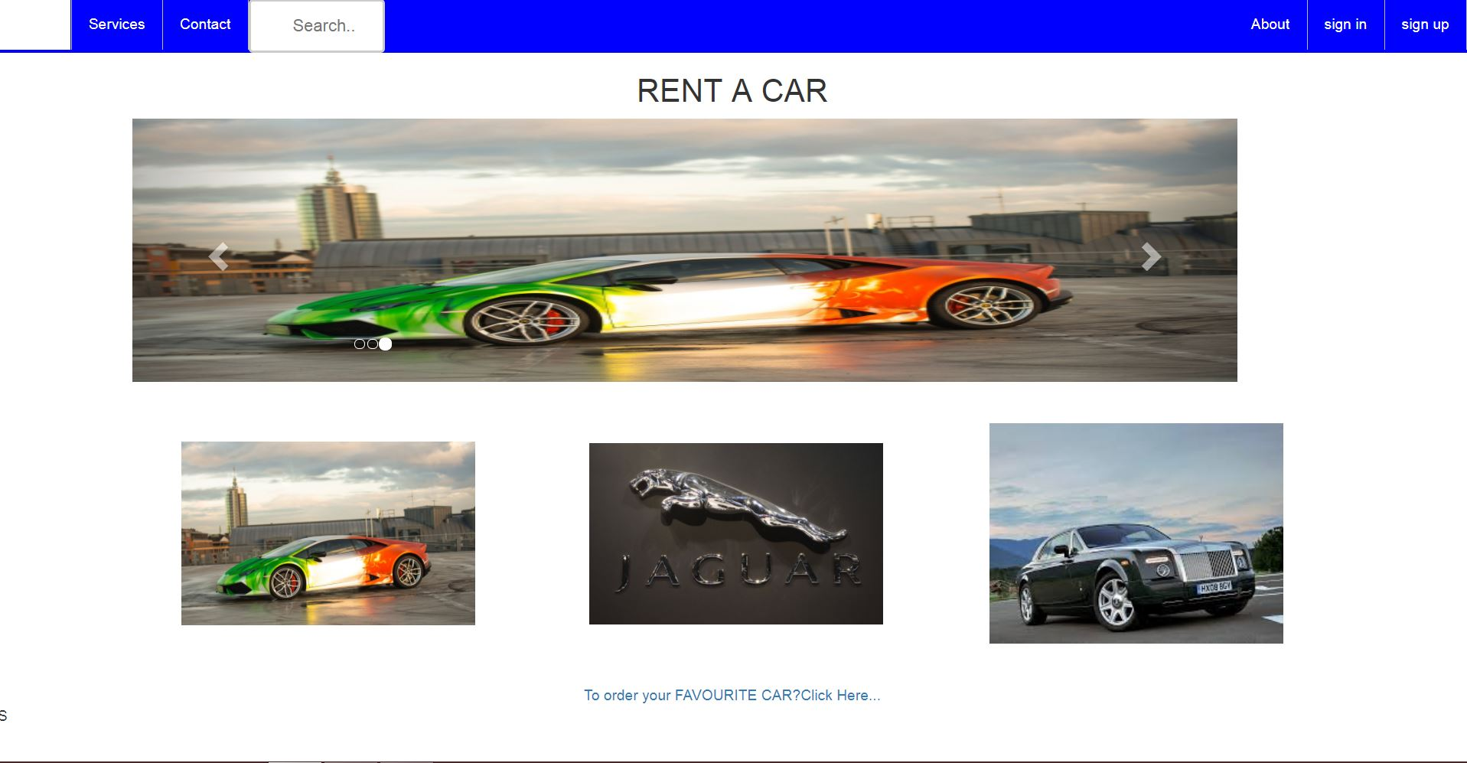

**about us.jsp**

<%@page contentType="text/html" pageEncoding="UTF-8"%>

<!DOCTYPE html>

<html>

<head>

<meta http-equiv="Content-Type" content="text/html; charset=UTF-8">

<title>about us</title>

</head>

<body>

<h1 align="center">HAI TO ALL !</h1>

<p> thsi an website about the car renting how we have renting a car using online registration</p>

<p> it is useful to all customers who are riding a car easily </p>

<br>

<center><B> <U> <h2>MANY ADVANTAGES</h2></U></B>

<br>

1.NO TAX BENIFITS(CHARGES)<br>

2.EASY TO DRIVE<br>

3. ALWAYS FULL CONDTIONAL CARS ARE AVAILABLE<br>

4.KEEP SMILE HAPPY JOURNEY<br>

<br>

</center>

</body>

</html>

**register.jsp**

<%@page contentType="text/html" pageEncoding="UTF-8"%>

<!DOCTYPE html>

<html>

<head>

<meta http-equiv="Content-Type" content="text/html; charset=UTF-8">

<title>klu</title>

</head>

<body>

<style>

body {

background-image: url("benz.jpg ");

}

</style>

<center>

<h1><marquee><strong><font color="white" >WELCOME TO CAR RENTAL<strong></h1></marquee></font>

<h4><font color="SKYBLUE" face="calibri">CLICK FOR REGISTRATION</h4></font><br>

<a href="cdetails.jsp"> Car Details </a>

</center>

</body>

</html>

**registration.jsp**

<html>

<head>

<title>CAR SERVICES</title>

<link rel="stylesheet" href="style.css">

</head>

<body>

<div class="loginBox">

<center>

<h2>Sign In</h2>

<form action="signin.jsp" method="POST">

<p>USER NAME</p>

<input type="text" name="username" placeholder="User Name">

<p>PASSWORD</p>

<input type="Password" name="password" placeholder="Password">

<inputtype="submit"name="signin"value="SignIn"> <br>

<a href="welcome.jsp">HOME</a>

</form>

</div>

</body>

</html>

**welcome.jsp**

<!DOCTYPE html>

<html>

<head>

<linkrel="stylesheet"href="https://maxcdn.bootstrapcdn.com/bootstrap/3.3.7/css/bootstrap.min.css">

<script src="https://ajax.googleapis.com/ajax/libs/jquery/3.2.1/jquery.min.js"></script>

<script src="https://maxcdn.bootstrapcdn.com/bootstrap/3.3.7/js/bootstrap.min.js"></script>

<style>

ul {

list-style-type: none;

margin: 0;

padding: 0;

overflow: hidden;

background-color: blue;

}

li {

float: left;

border-right:1px solid #bbb;

}

li:last-child {

border-right: none;

}

li a {

display: block;

color: white;

text-align: center;

padding: 14px 16px;

text-decoration: none;

}

li a:hover:not(.active) {

background-color: red;

}

.active {

background-color: white;

}

input[type=text] {

width: 130px;

box-sizing: border-box;

border: 2px solid #ccc;

border-radius: 4px;

font-size: 16px;

background-color: white;

background-image: url('searchicon.png');

background-position: 10px 10px;

background-repeat: no-repeat;

padding: 12px 20px 12px 40px;

-webkit-transition: width 0.4s ease-in-out;

transition: width 0.4s ease-in-out;

}

input[type=text]:focus {

width: 100%;

}

.dropbtn {

background-color: blue;

color: white;

padding: 16px;

font-size: 16px;

border: none;

cursor: pointer;

}

.conatainer {

height: 300px;

border: none;

}

.dropdown a:hover {background-color: #f1f1f1}

.show {display:block;}

</style>

</head>

<body>

<ul>

<li><a class="active" href="home.html">Home</a></li>

<li><a href="#services.html">Services</a></li>

<li><a href="#contact">Contact</a></li>

<li> <input type="text" name="search" placeholder="Search.."></li>

</ul>

<div class="container">

<h2 align="center">RENT A CAR</h2>

<div id="myCarousel" class="carousel slide" data-ride="carousel" style="max-width:1050px" style="height:300px">

<!-- Indicators -->

<ol class="carousel-indicators">

<li data-target="#myCarousel" data-slide-to="0" class="active"></li>

<li data-target="#myCarousel" data-slide-to="1"></li>

<li data-target="#myCarousel" data-slide-to="2"></li>

</ol>

<!-- Wrapper for slides -->

<div class="carousel-inner">

<div class="item active">

<img src="benz.jpg" alt="IMAGE1" style="width:1750px;height:250px">

</div>

<div class="item">

<img src="carz.jpg" alt="IMAGE2" style="width:1750px;height:250px">

</div>

<div class="item">

<img src="lam.jpg" alt="IMAGE3" style="width:1750px;height:250px">

</div>

</div>

<!-- Left and right controls -->

<a class="left carousel-control" href="#myCarousel" data-slide="prev">

<span class="glyphicon glyphicon-chevron-left"></span>

<span class="sr-only">Previous</span>

</a>

<a class="right carousel-control" href="#myCarousel" data-slide="next">

<span class="glyphicon glyphicon-chevron-right"></span>

<span class="sr-only">Next</span>

</a>

</div>

</div>

<div align="center" >

<br><br>

<img src="lam.jpg" alt="no image" width="20%" height="20%">

<img src="Jaguar1.jpg" alt="no image" width="20%" height="25%" >

<img src="rcphantom.jpg" alt="no image" width="20%" height="20%"></div>

<br><br>

<a href="register.html"><center>To order your FAVOURITE CAR?Click Here...</center></a>

<br3>

</body>

</html>

**cdetails.jsp**

<%@page contentType="text/html" pageEncoding="UTF-8"%>

<html>

<head><title> REGISTRATION</TITLE></head>

<body align="center" valign="center">

<center>

<form action="carreg.jsp" method="POST">

<label for="uname"> carName</label>

<input type="text" name="uname"/>

<br/>

<label for="text">customerlicense number</label>

<input type="text" name="clnum"/>

<br/>

<label for="date"> delivery date</label>

<input type="text" name="date"/>

<br/>

<label for="time">pickup time</label>

<input type="text" name="ptime"/>

<br/>

<label for="time">delivery time</label>

<input type="text" name="dtime"/>

<br/>

<label for="address"> Address</label>

<input type="text" name="address"/>

<br/>

<input type="submit" value="Submit"/>

</form>

</center>

</body>

</html>

cardetails.jsp

<%@page import="java.sql.Statement"%>

<%@page import="java.sql.DriverManager"%>

<%@page import="java.sql.Connection"%>

<%@page contentType="text/html" pageEncoding="UTF-8"%>

<!DOCTYPE html>

<html>

<head>

<meta http-equiv="Content-Type" content="text/html; charset=UTF-8">

<title>JSP Page</title>

</head>

<body>

<%

try{

String carname = request.getParameter("carname");

String clnumber = request.getParameter("clnum");

String dd = request.getParameter("date");

String ptime = request.getParameter("ptime");

String dtime = request.getParameter("dtime");

String Address = request.getParameter("address");

Class.forName("org.apache.derby.jdbc.ClientDriver");

Connection con=DriverManager.getConnection("jdbc:derby://localhost:1527/sample","app","app");

Statement st = con.createStatement();

st.executeUpdate("insert into cdetails values('"+carname+"','"+clnumber+"','"+dd+"','"+ptime+"','"+dtime+"','"+Address+"')");

out.println("you have successfully register");

}

catch(Exception e){

out.println(e);

}

%>

</body>

</html>

**REGISTER PAGE**

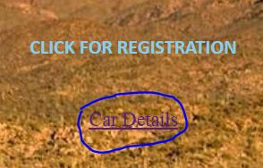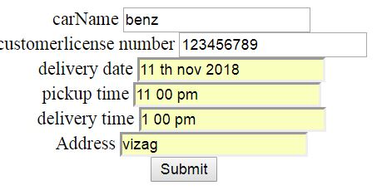

**singin.jsp**

<%@page import="java.sql.SQLException"%>

<%@page import="java.sql.PreparedStatement"%>

<%@page import="java.sql.ResultSet"%>

<%@page import="java.sql.Statement"%>

<%@page import="java.sql.DriverManager"%>

<%@page import="java.sql.Connection"%>

<%@page contentType="text/html" pageEncoding="UTF-8"%>

<!DOCTYPE html>

<html>

<head>

<meta http-equiv="Content-Type" content="text/html; charset=UTF-8">

<title>JSP Page</title>

</head>

<body>

<%

String username = request.getParameter("username");

String password = request.getParameter("password");

try {

Class.forName("org.apache.derby.jdbc.ClientDriver");

Connection con=DriverManager.getConnection( "jdbc:derby://localhost:1527/sample","app","app");

PreparedStatement ps = con.prepareStatement("Select * from reg where uname=? and pass=?");

ps.setString(1,username);

ps.setString(2,password);

ResultSet rs = ps.executeQuery();

if (rs.next()) {

RequestDispatcher rd=request.getRequestDispatcher("welcome.jsp");

rd.include(request,response);

//response.sendRedirect("welcome.jsp");

}

else {

out.println("Incorrect login credentials");

response.setHeader("Refresh","2;URL=home.html");

}

}

catch (Exception e) {

e.printStackTrace();

}

%>

</body>

</html>

SIGNUP PAGE

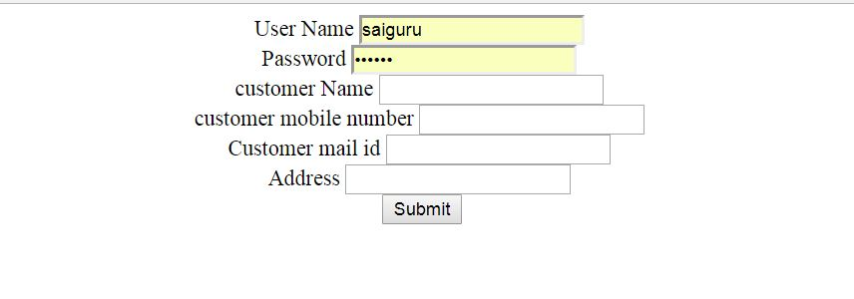

Sign in page

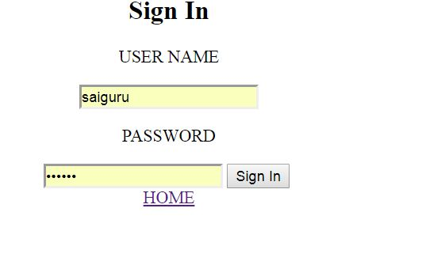

1. **CONCLUSION:**

This Online Rent A Car will manage the Customer information by which customer can login and use to book a car. The system will incorporate all features of booking system. There is a DATABASE which is maintained by the ADMIN in which all the details of customer is stored.

In this user who is register his/her information on the database and when he/she want to book he/she has to login by his id and password and can book for a rented car. Booking details stored in database and the result is displayed. By online booking rented cars saves the customer and admin time. It is very easy to use and less time consuming. It is very easy to debug.

**REFERENCES:**

[www.w3schools.com](http://www.w3schools.com)

[www.database](http://www.database) **connections.com**

**FUTURE SCOPE:**