**Program-1**

Student.java

**package** Springdemo;

**import** org.springframework.beans.factory.annotation.Autowired;

**public** **class** Student {

**private** **int** id;

**private** String name;

**private** String marks;

@Override

**public** String toString() {

**return** "Student [id=" + id + ", name=" + name + ", marks=" + marks + "]";

}

**public** **int** getId() {

**return** id;

}

**public** **void** setId(**int** id) {

**this**.id = id;

}

@Autowired

**public** String getname() {

**return** name;

}

**public** **void** setname(String name) {

**this**.name = name;

}

**public** String getmarks() {

**return** marks;

}

**public** **void** setmarks(String marks) {

**this**.marks = marks;

}

}

Test.java

package Springdemo;

import org.springframework.beans.factory.BeanFactory;

import org.springframework.beans.factory.xml.XmlBeanFactory;

import org.springframework.core.io.ClassPathResource;

import org.springframework.core.io.Resource;

public class Test {

public static void main(String[] args) {

Resource resource=new ClassPathResource("NewFile.xml");

BeanFactory factory=new XmlBeanFactory(resource);

Student s=(Student)factory.getBean("studentbean");

System.out.println(s);

}

}

NewFile.xml

<?xml version=*"1.0"* encoding=*"UTF-8"*?>

<beans

xmlns=*"http://www.springframework.org/schema/beans"*

xmlns:xsi=*"http://www.w3.org/2001/XMLSchema-instance"*

xmlns:p=*"http://www.springframework.org/schema/p"*

xsi:schemaLocation=*"http://www.springframework.org/schema/beans*

*http://www.springframework.org/schema/beans/spring-beans-3.0.xsd"*>

<bean id=*"studentbean"* class=*"Springdemo.Student"*>

<property name=*"id"* value=*"99"*></property>

<property name=*"name"* value=*"jogi"*></property>

<property name=*"marks"* value=*"100"*></property>

</bean>

</beans>

output

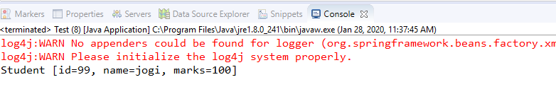

Program-2

Employee.java

**public** **class** Employee {

**private** String empName;

**private** **float** empSal;

**private** **int** empId;

**public** String getEmpName() {

**return** empName;

}

**public** **void** setEmpName(String empName) {

**this**.empName = empName;

}

**public** **float** getEmpSal() {

**return** empSal;

}

**public** **void** setEmpSal(**float** empSal) {

**this**.empSal = empSal;

}

**public** **int** getEmpId() {

**return** empId;

}

**public** **void** setEmpId(**int** empId) {

**this**.empId = empId;

}

}

EmployeeVO.java

**import** java.util.Date;

**import** javax.persistence.Entity;

**import** javax.persistence.GeneratedValue;

**import** javax.persistence.GenerationType;

**import** javax.persistence.Id;

**import** javax.persistence.Table;

**import** javax.persistence.Temporal;

**import** javax.persistence.TemporalType;

**import** org.springframework.format.annotation.DateTimeFormat;

@Entity

@Table

**public** **class** EmployeeVO {

**private** String password;

**public** String getPassword() {

**return** password;

}

**public** **void** setPassword(String password) {

**this**.password = password;

}

**public** Date getDoj() {

**return** doj;

}

**public** **void** setDoj(Date doj) {

**this**.doj = doj;

}

@Temporal(TemporalType.***DATE***)

@DateTimeFormat(pattern="yyyy-MM-dd")

**private** Date doj;

**private** String empName;

**private** **float** empSal;

**private** **long** mobile;

**public** **long** getMobile() {

**return** mobile;

}

**public** **void** setMobile(**long** mobile) {

**this**.mobile = mobile;

}

@Id

@GeneratedValue(strategy = GenerationType.***AUTO*** )

**private** **int** empId;

**public** String getEmpName() {

**return** empName;

}

**public** **void** setEmpName(String empName) {

**this**.empName = empName;

}

**public** **float** getEmpSal() {

**return** empSal;

}

**public** **void** setEmpSal(**float** empSal) {

**this**.empSal = empSal;

}

**public** **int** getEmpId() {

**return** empId;

}

**public** **void** setEmpId(**int** empId) {

**this**.empId = empId;

}

}

EmpController.java

**import** java.util.List;

**import** org.hibernate.Query;

**import** org.hibernate.Session;

**import** org.hibernate.SessionFactory;

**import** org.hibernate.Transaction;

**import** org.hibernate.boot.registry.StandardServiceRegistry;

**import** org.hibernate.boot.registry.StandardServiceRegistryBuilder;

**import** org.springframework.beans.factory.annotation.Autowired;

**import** org.springframework.stereotype.Controller;

**import** org.springframework.stereotype.Repository;

**import** org.springframework.transaction.annotation.Transactional;

**import** org.springframework.ui.Model;

**import** org.springframework.web.bind.annotation.ModelAttribute;

**import** org.springframework.web.bind.annotation.RequestMapping;

**import** org.springframework.web.bind.annotation.RequestMethod;

**import** org.springframework.web.bind.annotation.RequestParam;

**import** org.springframework.web.servlet.ModelAndView;

**import** oracle.net.aso.s;

@Controller

@Repository

@Transactional

**public** **class** EmpController {

@Autowired

**private** SessionFactory sessionFactory;

@RequestMapping("/date")

String dateTest(@ModelAttribute EmployeeVO vo) {

System.***out***.println("id is"+vo.getDoj());

System.***out***.println(vo.getEmpId());

**return** "FindEmp";

}

@RequestMapping("/viewAll")

String login(Model m) {

Query q=sessionFactory.openSession().createQuery("from EmployeeVO");//where empId=:Idno and mobile=:mob");

List<EmployeeVO> evol= (List<EmployeeVO>) q.list();

System.***out***.println(evol.size());

m.addAttribute("key", evol);

**return** "DispAll";

}

@RequestMapping("/login")

String login(@RequestParam("empID") **int** id,@RequestParam("mobile") **long** mobile,Model m) {

Query q=sessionFactory.openSession().createQuery("from EmployeeVO where empId=:Idno and mobile=:mob");

q.setParameter("Idno", id);

q.setParameter("mob", mobile);

EmployeeVO evo= (EmployeeVO) q.uniqueResult();

**if**(evo==**null**) {

m.addAttribute("key", "Please enter valid empId or mobile ");

**return** "Login";

}

**else**{

m.addAttribute("key", evo);

**return** "Home";

}

}

@RequestMapping("/find")

String search(@RequestParam("empID") **int** id, Model m) {

EmployeeVO evo= (EmployeeVO) sessionFactory.openSession().get(EmployeeVO.**class**,id);

**if**(evo==**null**) {

m.addAttribute("key", "Please enter valid id");

**return** "FindEmp";

}

**else**{

m.addAttribute("key", evo);

**return** "Disp";

}

}

@Transactional

@RequestMapping("/delete")

String delete(@RequestParam("empID") **int** id, Model m) {

Session session=sessionFactory.openSession();

Transaction transactional=session.beginTransaction();

EmployeeVO evo= (EmployeeVO) session.get(EmployeeVO.**class**,id);

**if**(evo==**null**) {

m.addAttribute("key", "Please enter valid id");

**return** "Delete";

}

**else**{

evo.setEmpId(id);

session.delete(evo);

transactional.commit();

m.addAttribute("deleteKey", id+"Deleted");

**return** "Home";

}

}

@RequestMapping(value="/SignUp",method = RequestMethod.***POST***)

ModelAndView register(@ModelAttribute EmployeeVO emp) {

Session session = sessionFactory.openSession();

Transaction t = session.beginTransaction();

**int** no=(**int**)sessionFactory.openSession().save(emp);

t.commit();

**return** **new** ModelAndView("Login");//

}

}

springhiber-servlet.xml

<?xml version=*"1.0"* encoding=*"UTF-8"*?>

<beans:beans

xmlns=*"http://www.springframework.org/schema/mvc"*

xmlns:xsi=*"http://www.w3.org/2001/XMLSchema-instance"*

xmlns:beans=*"http://www.springframework.org/schema/beans"*

xmlns:context=*"http://www.springframework.org/schema/context"*

xmlns:tx=*"http://www.springframework.org/schema/tx"*

xsi:schemaLocation=*"http://www.springframework.org/schema/mvc http://www.springframework.org/schema/mvc/spring-mvc.xsd*

*http://www.springframework.org/schema/beans http://www.springframework.org/schema/beans/spring-beans.xsd*

*http://www.springframework.org/schema/context http://www.springframework.org/schema/context/spring-context.xsd*

*http://www.springframework.org/schema/tx http://www.springframework.org/schema/tx/spring-tx-4.0.xsd"*>

<annotation-driven />

<!-- <resources mapping="/resources/**" location="/resources/" /> -->

<context:component-scan base-package=*"com.cs"* />

<beans:bean

class=*"org.springframework.web.servlet.view.InternalResourceViewResolver"*>

<beans:property name=*"prefix"* value=*"/"* />

<beans:property name=*"suffix"* value=*".jsp"* />

</beans:bean>

<beans:bean id=*"dataSource"*

class=*"org.apache.commons.dbcp.BasicDataSource"* destroy-method=*"close"*>

<beans:property name=*"driverClassName"*

value=*"oracle.jdbc.driver.OracleDriver"* />

<beans:property name=*"url"*

value=*"jdbc:oracle:thin:@localhost:1521:xe"* />

<beans:property name=*"username"* value=*"system"* />

<beans:property name=*"password"* value=*"system"* />

</beans:bean>

<beans:bean id=*"hibernate4AnnotatedSessionFactory"*

class=*"org.springframework.orm.hibernate4.LocalSessionFactoryBean"*>

<beans:property name=*"dataSource"* ref=*"dataSource"* />

<beans:property name=*"annotatedClasses"*>

<beans:list>

<beans:value>com.cs.EmployeeVO</beans:value>

</beans:list>

</beans:property>

<beans:property name=*"hibernateProperties"*>

<beans:props>

<beans:prop key=*"hibernate.dialect"*>org.hibernate.dialect.Oracle9Dialect

</beans:prop>

<beans:prop key=*"hibernate.hbm2ddl.auto"*>update</beans:prop>

<beans:prop key=*"hibernate.show_sql"*>true</beans:prop>

</beans:props>

</beans:property>

</beans:bean>

<tx:annotation-driven

transaction-manager=*"transactionManager"* />

<beans:bean id=*"transactionManager"*

class=*"org.springframework.orm.hibernate4.HibernateTransactionManager"*>

<beans:property name=*"sessionFactory"*

ref=*"hibernate4AnnotatedSessionFactory"* />

</beans:bean>

</beans:beans>

Springmvc-servlet.xml

<?xml version=*"1.0"* encoding=*"UTF-8"*?>

<beans xmlns=*"http://www.springframework.org/schema/beans"*

xmlns:xsi=*"http://www.w3.org/2001/XMLSchema-instance"*

xmlns:context=*"http://www.springframework.org/schema/context"*

xmlns:mvc=*"http://www.springframework.org/schema/mvc"*

xsi:schemaLocation=*"http://www.springframework.org/schema/beans http://www.springframework.org/schema/beans/spring-beans.xsd*

*http://www.springframework.org/schema/context http://www.springframework.org/schema/context/spring-context-4.3.xsd*

*http://www.springframework.org/schema/mvc http://www.springframework.org/schema/mvc/spring-mvc-4.3.xsd"*>

<context:component-scan base-package=*"com.cs"* />

<bean id=*"viewResolver"*

class=*"org.springframework.web.servlet.view.InternalResourceViewResolver"*>

<property name=*"prefix"* value=*"/"*></property>

<property name=*"suffix"* value=*".jsp"*></property>

</bean>

</beans>

<!-- <?xml version="1.0" encoding="UTF-8"?> <beans xmlns="http://www.springframework.org/schema/beans"

xmlns:xsi="http://www.w3.org/2001/XMLSchema-instance" xmlns:aop="http://www.springframework.org/schema/aop"

xmlns:context="http://www.springframework.org/schema/context" xmlns:jee="http://www.springframework.org/schema/jee"

xmlns:lang="http://www.springframework.org/schema/lang" xmlns:p="http://www.springframework.org/schema/p"

xmlns:tx="http://www.springframework.org/schema/tx" xmlns:util="http://www.springframework.org/schema/util"

xmlns:mvc="http://www.springframework.org/schema/mvc" xsi:schemaLocation="http://www.springframework.org/schema/beans

http://www.springframework.org/schema/beans/spring-beans-3.2.xsd http://www.springframework.org/schema/aop

http://www.springframework.org/schema/aop/spring-aop.xsd http://www.springframework.org/schema/context

http://www.springframework.org/schema/context/spring-context-3.0.xsd http://www.springframework.org/schema/jee

http://www.springframework.org/schema/jee/spring-jee.xsd http://www.springframework.org/schema/lang

http://www.springframework.org/schema/lang/spring-lang.xsd http://www.springframework.org/schema/tx

http://www.springframework.org/schema/tx/spring-tx-3.0.xsd http://www.springframework.org/schema/util

http://www.springframework.org/schema/util/spring-util.xsd http://www.springframework.org/schema/mvc

http://www.springframework.org/schema/mvc/spring-mvc-3.0.xsd"> <context:component-scan

base-package="com.cs" /> <bean class="org.springframework.web.servlet.view.InternalResourceViewResolver">

<property name="prefix" value="/"></property> <property name="suffix" value=".jsp"></property>

</bean> </beans> -->

Web.xml

<?xml version=*"1.0"* encoding=*"UTF-8"*?>

<web-app xmlns:xsi=*"http://www.w3.org/2001/XMLSchema-instance"*

xmlns=*"http://java.sun.com/xml/ns/javaee"*

xsi:schemaLocation=*"http://java.sun.com/xml/ns/javaee http://java.sun.com/xml/ns/javaee/web-app_2_5.xsd"*

id=*"WebApp_ID"* version=*"2.5"*>

<display-name>springwithhibernate</display-name>

<welcome-file-list>

<welcome-file>index.html</welcome-file>

<welcome-file>index.htm</welcome-file>

<welcome-file>index.jsp</welcome-file>

<welcome-file>default.html</welcome-file>

<welcome-file>default.htm</welcome-file>

<welcome-file>default.jsp</welcome-file>

</welcome-file-list>

<servlet>

<servlet-name>springhiber</servlet-name>

<servlet-class>org.springframework.web.servlet.DispatcherServlet</servlet-class>

<load-on-startup>1</load-on-startup>

</servlet>

<servlet-mapping>

<servlet-name>springhiber</servlet-name>

<url-pattern>*.cs</url-pattern>

</servlet-mapping>

<context-param>

<param-name>contextConfigLocation</param-name>

<param-value>WEB-INF/springmvc-servlet.xml</param-value>

</context-param>

</web-app>

DateCheck.jsp

<!DOCTYPE html>

<html>

<head>

<style>

*.submit* {

background: *#25A6E1*;

filter: *progid*: *DXImageTransform.Microsoft.gradient*( *startColorstr*=*'#25A6E1',*

*endColorstr*=*'#188BC0', GradientType*=*0)*;

padding: *3px 5px*;

color: *#fff*;

font-family: *'Helvetica Neue', sans-serif*;

font-size: *12px*;

border-radius: *10px*;

-moz-border-radius: *2px*;

-webkit-border-radius: *4px*;

border: *1px solid #1A87B9*

}

**table** {

font-family: *"Helvetica Neue", Helvetica, sans-serif*;

width: *50%*;

}

**tr** {

background: *SteelBlue*;

color: *white*;

}

**td,** **tr** {

border: *1px solid gray*;

width: *25%*;

text-align: *left*;

padding: *5px 10px*;

}

</style>

<meta charset=*"ISO-8859-1"*>

<title>Insert title here</title>

</head>

<body>

<form action=*"date.cs"*>

<table align=*"center"*>

<tr>

<td>Dob</td>

<td><input type=*"date"* name=*"doj"*></td>

</tr>

<tr>

<td></td>

<td><input type=*"submit"* value=*"Search"*></td>

</tr>

</table>

</form>

</body>

</html>

Delete.jsp

<!DOCTYPE html>

<html>

<head>

<style>

@import *url("mystyles.css")*;

</style>

<meta charset=*"ISO-8859-1"*>

<title>Insert title here</title>

</head>

<body>

<h1 align=*"center"*>

<font color=*"red"*>${key}</font>

</h1>

<form action=*"delete.cs"*>

<table align=*"center"*>

<tr>

<td>empId</td>

<td><input type=*"text"* name=*"empID"*></td>

</tr>

<tr>

<td></td>

<td><input type=*"submit"* value=*"Delete"*></td>

</tr>

</table>

</form>

</body>

</html>

Disp.jsp

<%@ page language=*"java"* contentType=*"text/html; charset=ISO-8859-1"*

pageEncoding=*"ISO-8859-1"*%>

<!DOCTYPE html>

<html>

<head>

<style>

@import *url("mystyles.css")*;

</style>

<meta charset=*"ISO-8859-1"*>

<title>Insert title here</title>

</head>

<body>

<table align=*"center"* border=*"10"* cellspacing=*"10"*>

<tr>

<td>${key.empId}</td>

<td>${key.empName}</td>

<td>${key.empSal}</td>

<td>${key.mobile}</td>

<td>${key.doj}</td>

</tr>

</table>

</body>

</html>

DispAll.jsp

<%@ page language=*"java"* contentType=*"text/html; charset=ISO-8859-1"*

pageEncoding=*"ISO-8859-1"*%>

<%@ taglib uri=*"http://java.sun.com/jsp/jstl/core"* prefix=*"sd"*%>

<!DOCTYPE html PUBLIC "-//W3C//DTD HTML 4.01 Transitional//EN" "http://www.w3.org/TR/html4/loose.dtd">

<html>

<head>

<style type=*"text/css"*>

@import *url("mystyles.css")*;

</style>

<meta http-equiv=*"Content-Type"* content=*"text/html; charset=ISO-8859-1"*>

<title>Insert title here</title>

</head>

<body bgcolor=*"cyan"*>

<h1 align=*"center"*>Trainers Info</h1>

<table>

<tr bgcolor=*"tomato"*>

<td bgcolor=*"tomato"*>EmpID</td>

<td bgcolor=*"tomato"*>EmpName</td>

<td bgcolor=*"tomato"*>Salary</td>

<td bgcolor=*"tomato"*>DOJ</td>

<td bgcolor=*"tomato"*>MobileNo</td>

</tr>

<sd:forEach var=*"emp"* items=*"*${key}*"*>

<tr>

<td>${emp.empId}</td>

<td>${emp.empName}</td>

<td>${emp.empSal}</td>

<td>${emp.doj}</td>

<td>${emp.mobile}</td>

</tr>

</sd:forEach>

</table>

<div id=*"trainer_data"*></div>

</body>

</html>

FindEmp.jsp

<!DOCTYPE html>

<html>

<head>

<style>

@import *url("mystyles.css")*;

/* .submit {

background: #25A6E1;

filter: progid: DXImageTransform.Microsoft.gradient( startColorstr='#25A6E1',

endColorstr='#188BC0', GradientType=0);

padding: 3px 5px;

color: #fff;

font-family: 'Helvetica Neue', sans-serif;

font-size: 12px;

border-radius: 10px;

-moz-border-radius: 2px;

-webkit-border-radius: 4px;

border: 1px solid #1A87B9

}

table {

font-family: "Helvetica Neue", Helvetica, sans-serif;

width: 50%;

}

tr {

background: SteelBlue;

color: white;

}

td, tr {

border: 1px solid gray;

width: 25%;

text-align: left;

padding: 5px 10px;

} */

</style>

<meta charset=*"ISO-8859-1"*>

<title>Insert title here</title>

</head>

<body>

<h1 align=*"center"*><font color=*"red"*>${key}</font></h1>

<form action=*"find.cs"*>

<table align=*"center"*>

<tr>

<td>UserName</td>

<td><input type=*"text"* name=*"empID"*></td>

</tr>

<!-- <tr>

<td>Dob</td>

<td><input type="date" name="doj"></td>

</tr> -->

<tr>

<td></td>

<td><input type=*"submit"* value=*"Search"*></td>

</tr>

</table>

</form>

</body>

</html>

Home.jsp

<%@ page language=*"java"* contentType=*"text/html; charset=ISO-8859-1"*

pageEncoding=*"ISO-8859-1"*%>

<!DOCTYPE html>

<html>

<head>

<style type=*"text/css"*>

@import *url("mystyles.css")*;

</style>

<meta charset=*"ISO-8859-1"*>

<title>Insert title here</title>

</head>

<body>

<table>

<tr>

<td><a href=*"viewAll.cs"*>Display All</a></td>

</tr>

<tr>

<td><a href=*"FindEmp.jsp"*>View My Data </a></td>

</tr>

<tr>

<td><a href=*"Delete.jsp"*>Delete Employee</a> <font color=*"red"*>${deleteKey}</font></td>

</tr>

</table>

</body>

</html>

Login.jsp

<!DOCTYPE html>

<html>

<head>

<script

src=*"https://ajax.googleapis.com/ajax/libs/angularjs/1.6.9/angular.min.js"*></script>

<style>

@import *url("mystyles.css")*;

</style>

<meta charset=*"ISO-8859-1"*>

<title>Insert title here</title>

</head>

<body>

<script>

**var** app = angular.module('myApp', []);

app.controller('validateCtrl', **function**($scope) {

$scope.empID = '001';

$scope.mobile = '9876543210';

});

</script>

<h1 align=*"center"*>

<font color=*"red"*>${key}</font>

</h1>

<form action=*"login.cs"* ng-app=*"myApp"* ng-controller=*"validateCtrl"*

name=*"myForm"* novalidate>

<table align=*"center"*>

<tr>

<td>empId</td>

<td><input type=*"text"* ng-model=*"empID"* name=*"empID"* required>

<span style="color: *black*"

ng-show=*"myForm.empID.$dirty && myForm.empID.$invalid"*> <span

ng-show=*"myForm.empID.$error.required"*>EmpID is required.</span>

</span></td>

</tr>

<tr>

<td>MobileNo</td>

<td><input type=*"text"* name=*"mobile"* ng-model=*"mobile"* required>

<span style="color: *black*"

ng-show=*"myForm.mobile.$dirty && myForm.mobile.$invalid"*> <span

ng-show=*"myForm.mobile.$error.required"*>MObile no is

required.</span>

</span></td>

</tr>

<tr>

<td></td>

<td><input type=*"submit"* style="bg-color: *green*" value=*"click"*

ng-disabled=*"myForm.empID.$dirty && myForm.empID.$invalid ||*

*myForm.mobile.$dirty && myForm.mobile.$invalid"*></td>

</tr>

</table>

</form>

</body>

</html>

Mystyle.css

@charset *"ISO-8859-1"*;

*.submit* {

background: *#800080*;

filter: *progid*: *DXImageTransform.Microsoft.gradient*( *startColorstr*=*'#25A6E1',*

*endColorstr*=*'#188BC0',* *GradientType*=*0)*;

padding: *3px* *5px*;

color: *#c0c0c0*;

font-family: *'Helvetica Neue',* *sans-serif*;

font-size: *20px*;

border-radius: *10px*;

-moz-border-radius: *2px*;

-webkit-border-radius: *4px*;

border: *1px* *solid* *#1A87B9*

}

**table** {

margin-left: *auto*;

margin-right: *auto*;

font-family: *"Helvetica Neue",* *Helvetica,* *sans-serif*;

width: *50%*;

}

**tr** {

background: *Purple*;

color: *white*;

}

**td,** **tr** {

border: *10px* *solid* *#808000*;

width: *25%*;

text-align: *center*;

padding: *10px* *10px*;

color: *white*;

}

**a**{

color: *white*;

text-decoration: *overline*;

}

SignUp.html

<!DOCTYPE html>

<html>

<head>

<script

src=*"https://ajax.googleapis.com/ajax/libs/angularjs/1.6.9/angular.min.js"*></script>

<style>

@import *url("mystyles.css")*;

**input***.ng-invalid* {

background-color: *pink*;

}

**input***.ng-valid* {

background-color: *yellow*;

}

</style>

<meta charset=*"ISO-8859-1"*>

<title>SignupForm</title>

</head>

<body ng-app=*""*>

<form action=*"SignUp.cs"* method=*"post"*>

<table align=*"center"*>

<tr>

<td>Mobile</td>

<td><input type=*"text"* ng-model=*"mobile"* required name=*"mobile"*></td>

</tr>

<tr>

<td>PassWord</td>

<td><input type=*"text"* name=*"passWord"* ng-model=*"passWord"*

required></td>

</tr>

<tr>

<td>EmpName</td>

<td><input type=*"text"* name=*"empName"* ng-model=*"empName"*

required></td>

</tr>

<tr>

<td>DoJ</td>

<td><input type=*"date"* name=*"doj"* ng-model=*"doj"* required></td>

</tr>

<tr>

<td>Salary</td>

<td><input type=*"text"* name=*"empSal"* ng-model=*"empSal"* required></td>

</tr>

<tr>

<td></td>

<td><input type=*"submit"* class=*"submit"* value=*"Register"*></td>

</tr>

</table>

</form>

</body>

</html>

Output: Sign Up Page

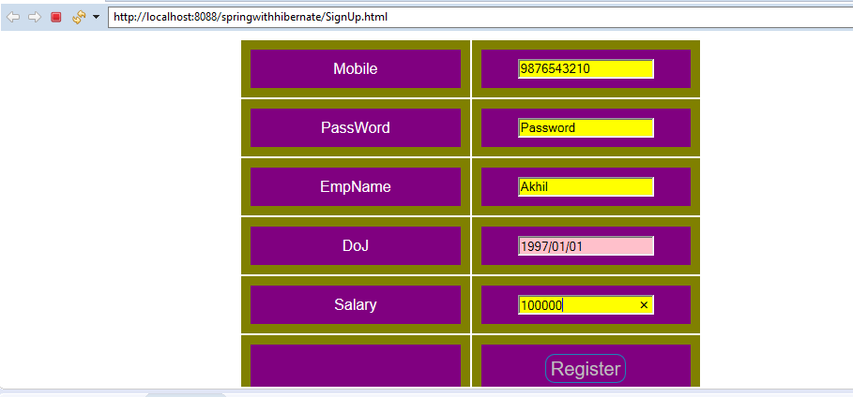

Login page

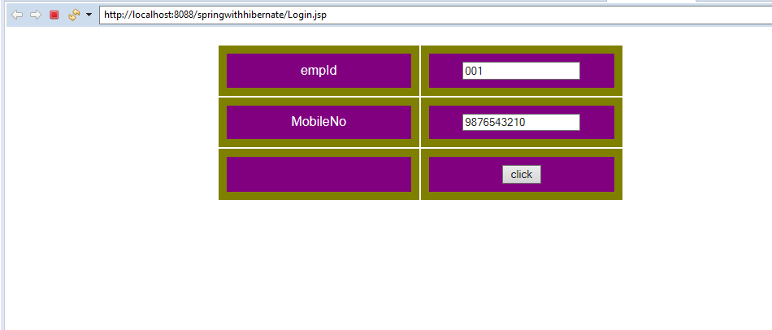

Log in page(fields are empty)

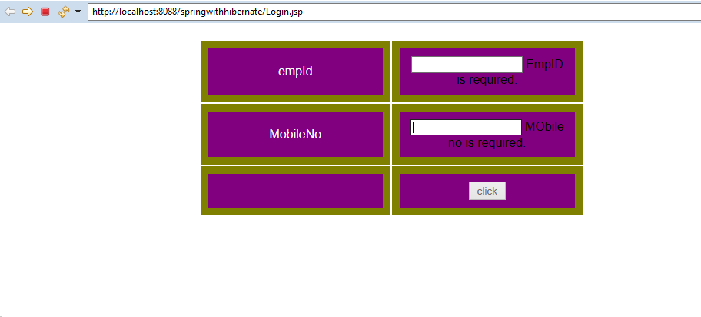

Homepage

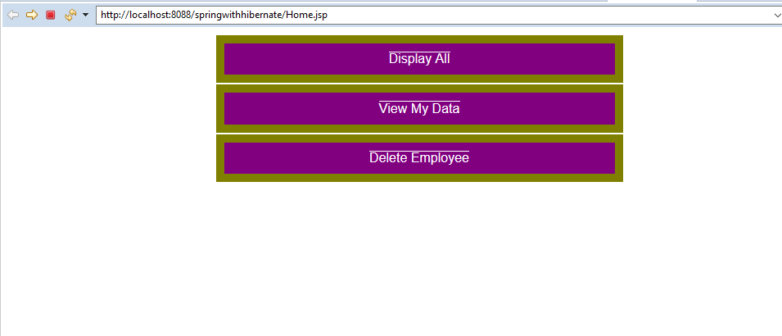

Delete page

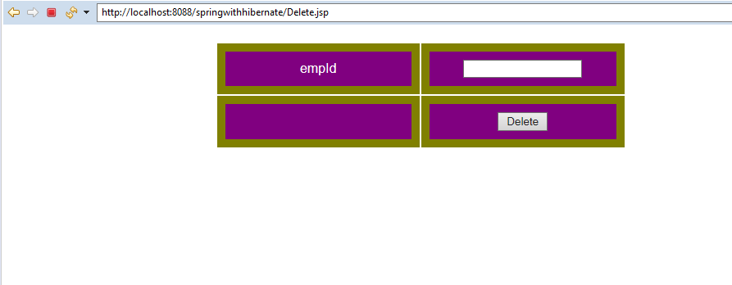

Find an Employee

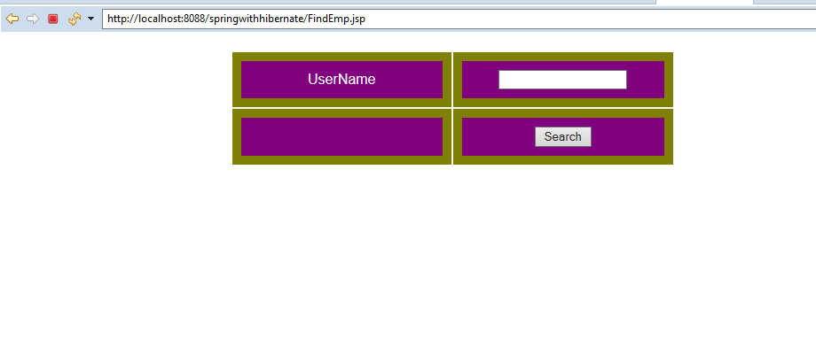

Program:3

<!DOCTYPE html>

<html>

<script src="http://ajax.googleapis.com/ajax/libs/angularjs/1.3.14/angular.min.js">

</script>

<head>

<style>

table {

width: 640px;

border-collapse: collapse;

border-spacing: 0;

background-color:#e91e63; color:black;}

div{border-style: none; border-width:3; border-color: white;}

td, th { border: 2px solid blue;padding: 10px;}

</style>

</head>

<body bgcolor=white>

<br/><br/><br/>

<center>

<h3>ANGULAR-JS EXAMPLE1</h3>

<h4>SIMPLE INTEREST CALCULATOR</h4>

</center>

<div ng-app="TestFirstApp" ng-controller="TestCtrl">

<table align="center">

<tr><td>PRINCIPAL AMOUNT: </td><td><input type="number" ng-model="amt" ></td></tr>

<tr><td>RATE : </td><td><input type="number" ng-model="rate"></td></tr>

<tr><td>TERMS : </td><td><input type="number" ng-model="terms"></td></tr>

<tr>

<td></td><td>

<font size=5>Simple Interest Amount: {{"$." + interestamt()}}</font>

</td>

<tr>

</table>

</div>

<script>

var app = angular.module('TestFirstApp', []);

app.controller('TestCtrl', function($scope) {

$scope.amt = 1000;

$scope.terms = 1;

$scope.rate= 10;

$scope.interestamt= function() {

return ($scope.amt*$scope.rate*$scope.terms)/100;

}; });

</script>

</body>

</html>

Output:

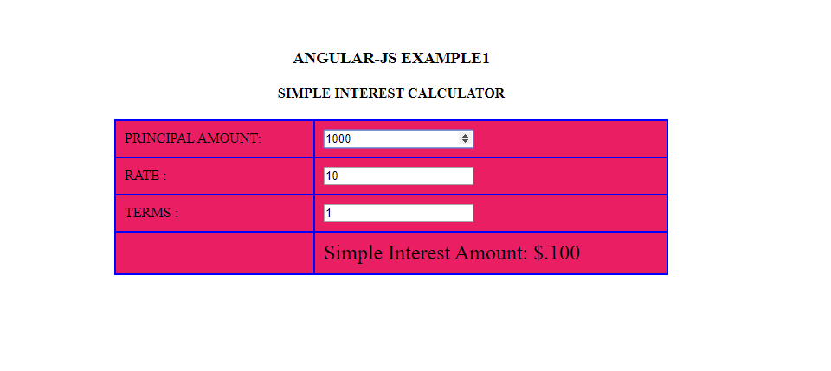

Program-4

Employee.java

package com.hcl.model;

import java.sql.Connection;

import java.sql.DriverManager;

import java.sql.ResultSet;

import java.sql.SQLException;

import java.sql.Statement;

public class Employee {

String empID;

String empName;

String desig;

String city;

public String getEmpID() {

return empID;

}

public void setEmpID(String empID) {

this.empID = empID;

}

public String getEmpName() {

return empName;

}

public void setEmpName(String empName) {

this.empName = empName;

}

public String getDesig() {

return desig;

}

public void setDesig(String desig) {

this.desig = desig;

}

public String getCity() {

return city;

}

public void setCity(String city) {

this.city = city;

}

public static Employee getEmployee(String empID) {

Employee e = new Employee();

String userid="jogi";

String password = "rao";

String url = "jdbc:oracle:thin:@localhost:1521/XE";

Connection con;

Statement stmt;

String qry;

ResultSet rs;

try {

Class.forName("oracle.jdbc.driver.OracleDriver");

con = DriverManager.getConnection(url, userid, password);

stmt= con.createStatement();

qry="SELECT * FROM HclEmp WHERE EmpID='" + empID + "'";

rs = stmt.executeQuery(qry);

e.setEmpID(empID);

if(rs.next()) {

e.setEmpName(rs.getString("EmpName"));

e.setDesig(rs.getString("Desig"));

e.setCity(rs.getString("City"));

} else {

e.setEmpName("not found");

e.setDesig("not found");

e.setCity("not found");

}

stmt.close();

con.close();

}

catch(java.lang.ClassNotFoundException ex) {

System.out.println("Oracle Driver not found");

}

catch(SQLException ex) {

System.err.println("SQLException: " + ex.getMessage());

}

return e;

}}

EmployeeController.java

**package** com.hcl.service;

**import** org.springframework.web.bind.annotation.PathVariable;

**import** org.springframework.web.bind.annotation.RequestMapping;

**import** org.springframework.web.bind.annotation.RequestMethod;

**import** org.springframework.web.bind.annotation.RestController;

**import** com.hcl.model.Employee;

@RestController

**public** **class** EmployeeController {

@RequestMapping(value = "/getemployee/{empID}", method = RequestMethod.***GET***)

**public** Employee getEmployee(@PathVariable("empID") String empID) {

Employee e = Employee.*getEmployee*(empID);

**return** e;

}

}

Dispatchet-servlet.xml

<?xml version=*"1.0"* encoding=*"UTF-8"*?>

<beans xmlns:mvc=*"http://www.springframework.org/schema/mvc"*

xmlns:xsi=*"http://www.w3.org/2001/XMLSchema-instance"*

xmlns=*"http://www.springframework.org/schema/beans"*

xmlns:context=*"http://www.springframework.org/schema/context"*

xmlns:tx=*"http://www.springframework.org/schema/tx"*

xsi:schemaLocation=*"http://www.springframework.org/schema/mvc http://www.springframework.org/schema/mvc/spring-mvc.xsd*

*http://www.springframework.org/schema/beans http://www.springframework.org/schema/beans/spring-beans.xsd*

*http://www.springframework.org/schema/tx http://www.springframework.org/schema/tx/spring-tx.xsd*

*http://www.springframework.org/schema/context http://www.springframework.org/schema/context/spring-context.xsd"*>

<context:component-scan base-package=*"com.hcl"* />

<mvc:annotation-driven/>

</beans>

emp1.jsp

<%@ page language=*"java"* contentType=*"text/html; charset=ISO-8859-1"*

pageEncoding=*"ISO-8859-1"*%>

<!DOCTYPE html PUBLIC "-//W3C//DTD HTML 4.01 Transitional//EN" "http://www.w3.org/TR/html4/loose.dtd">

<html>

<head>

<meta http-equiv=*"Content-Type"* content=*"text/html; charset=ISO-8859-1"*>

<title>Employee Search</title>

</head>

<body>

Emp ID: <input type=*'text'* id=*'empID'*/>

<input type=*'button'* value=*'get'* onclick='getEmployee();'/> <br/>

Name: <input type=*'text'* id=*'empName'* disabled/> <br/>

Designation: <input type=*'text'* id=*'desig'* disabled/> <br/>

City: <input type=*'text'* id=*'city'* disabled/> <br/>

<script>

**function** getEmployee() {

**var** empID = document.getElementById("empID").value

**var** xhttp = **new** XMLHttpRequest();

xhttp.onreadystatechange = **function**() {

**if** (**this**.readyState == 4 && **this**.status == 200) {

**var** emp = JSON.parse(**this**.responseText);

document.getElementById("empName").value = emp.empName;

document.getElementById("desig").value = emp.desig;

document.getElementById("city").value = emp.city;

}

};

xhttp.open("GET", "getemployee/" + empID , **true**);

xhttp.send();

}

</script>

</body>

</html>

emp2.jsp

<%@ page language=*"java"* contentType=*"text/html; charset=ISO-8859-1"*

pageEncoding=*"ISO-8859-1"*%>

<!DOCTYPE html PUBLIC "-//W3C//DTD HTML 4.01 Transitional//EN" "http://www.w3.org/TR/html4/loose.dtd">

<html>

<script src=*"http://ajax.googleapis.com/ajax/libs/angularjs/1.4.8/angular.min.js"*></script>

<body>

<div ng-app=*"EmpApp"* ng-controller=*"EmpController"*>

Emp ID: <input type=*"text"* ng-model=*"emp.empID"*>

<button ng-click=*"getEmp()"*> Search </button> <br/>

Name: {{emp.empName}} <br/>

Designation: {{emp.desig}} <br/>

City: {{emp.city}} <br/>

</div>

<script>

**var** app = angular.module('EmpApp', []);

app.controller('EmpController', **function**($scope,$http) {

$scope.emp = [];

$scope.getEmp = **function**() {

$http({

method : 'GET',

url : 'getemployee/' + $scope.emp.empID

}).then(**function** successCallback(response) {

$scope.emp = response.data;

// alert(response.data);

}, **function** errorCallback(response) {

alert("Data Error");

console.log(response.statusText);

});

};

});

</script>

</body>

</html>

web.xml

<?xml version=*"1.0"* encoding=*"UTF-8"*?>

<web-app xmlns:xsi=*"http://www.w3.org/2001/XMLSchema-instance"*

xmlns=*"http://xmlns.jcp.org/xml/ns/javaee"*

xsi:schemaLocation=*"http://xmlns.jcp.org/xml/ns/javaee*

*http://xmlns.jcp.org/xml/ns/javaee/web-app_3_1.xsd"*

version=*"3.1"*>

<display-name> SpringWebService </display-name>

<servlet>

<servlet-name>dispatcher</servlet-name>

<servlet-class>

org.springframework.web.servlet.DispatcherServlet

</servlet-class>

<load-on-startup>1</load-on-startup>

</servlet>

<servlet-mapping>

<servlet-name>dispatcher</servlet-name>

<url-pattern>/</url-pattern>

</servlet-mapping>

</web-app>

Output:

Create sql table:

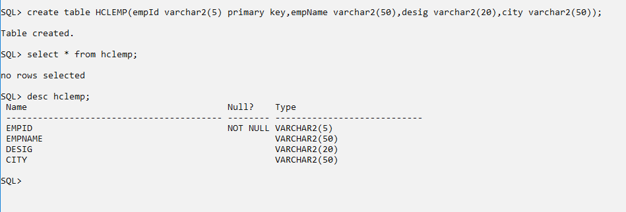

GET Details:

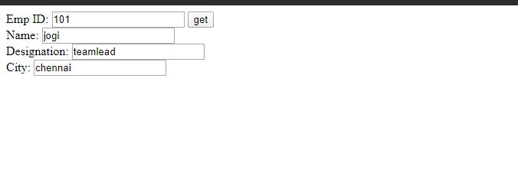

Sql output:

