**Boot Camp Day-1**

**Program 1: ASCII**

**Algorithm:**

Step 1:Start

Step 2: Read the I value

Step 3: Initializes the Variables

Step 4: Read I value

Step 5: Repeat the Steps Until it prints upto z value

5.1: initializes i=92

5.2 i<=122

Step 6:Display ASCII Values

Step 7:Stop

**CODE**

public class Ascii {

public static void main(String[] args)

{

int i;

for(i = 97; i <= 122; i++)

{

System.out.println(" " + i + "," );

}

}

}

**OUT PUT:-**

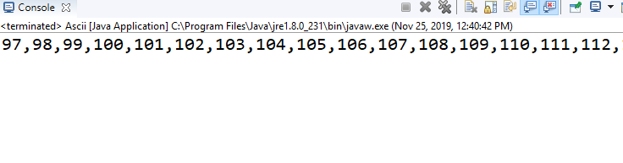

**Program 2:-Youngest and Oldest**

**Flow Chart:-**

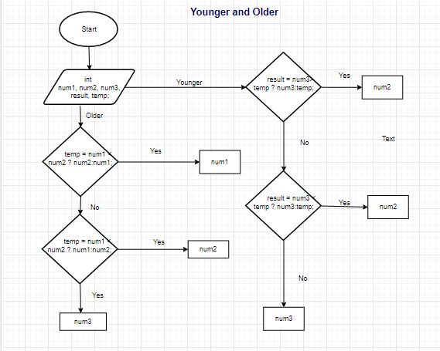

**CODE**

**import** java.util.Scanner;

**public** **class** Second{

**public** **static** **void** main(String[] args)

{

**int** num1, num2, num3, result, temp;

    Scanner scanner = **new** Scanner(System.***in***);

    System.***out***.print("");

    num1 = scanner.nextInt();

    System.***out***.print("");

    num2 = scanner.nextInt();

    System.***out***.print("");

    num3 = scanner.nextInt();

    scanner.close();

    temp = num1 < num2 ? num2:num1;

    result = num3>  temp ? num3:temp;

    System.***out***.println("Oldest friend:"+result+" Years");

    temp = num1 < num2 ? num1:num2;

    result = num3 < temp ? num3:temp;

    System.***out***.println("Youngest friend:"+result+" Years");

}

}

**OUT PUT:-**

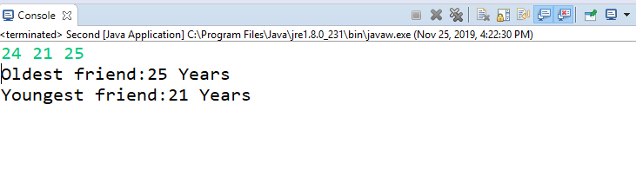

**Program 3-Apples**

import java.util.Scanner;  
public class Totalapples {  
 public static void main(String[] args) {  
  int xor, and, temp,n=0,m=0;  
  Scanner sc=new Scanner(System.in);  
  System.out.print("Number of apples:");  
  n=sc.nextInt();  
   
   System.out.print("Number of apples to be added:");  
   m=sc.nextInt();  
   
  and = n & m;  
  xor = n ^ m;  
  while(and != 0 )  
  {  
  and <<= 1;  
  temp = xor ^ and;  
  and &= xor;  
  xor = temp;  
  }  
  System.out.println("Total number of apples:" +xor);  
     
 }  
}

**OUT PUT:-**

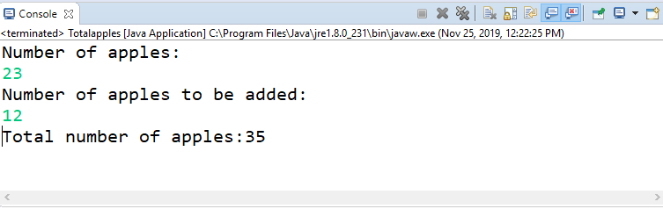

**Program 4: Average**

**import** java.util.Scanner;

**public** **class** Average {

**public** **static** **void** main(String[] args)

     {

**int** n,num,sum=0, i;

      Scanner input =**new** Scanner(System.***in***);

**for**(i=1;i<=5; i++)

            {

                 num=input.nextInt();

                 sum += num;

            }

**int** average=(**int**)sum/5;

         System.***out***.println(average);

     }

}

**OUT PUT:-**

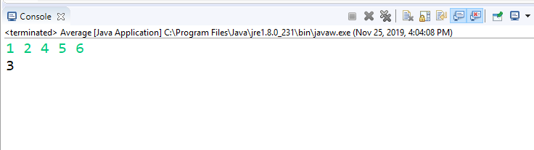

**Program 5:- Details**

import java.util.Scanner;  
  
class Details  
{  
public static void main(String args[])    
   {  
       String name, gender;  
       int age;  
       Scanner SC=new Scanner(System.in);  
       name= SC.next();  
       age=SC.nextInt();  
       gender=SC.next();  
       System.out.println("Name:"+name+", Age:"+age+" and "+"Gender:"+gender);  
                                   
   }  
}

**OUT PUT:-**

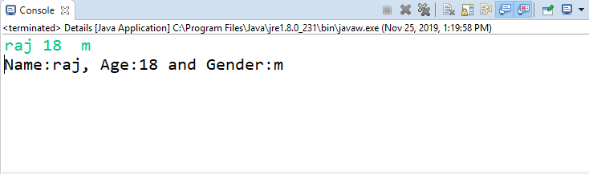

**Program 6:- Years**

import java.util.Scanner;

public class Years

{

public static void main(String args[])

{

int m, year, week, day;

Scanner s = new Scanner(System.in);

System.out.print("Enter the number of days:");

m = s.nextInt();

year = m / 365;

m = m % 365;

System.out.println("No. of years:"+year);

week = m / 7;

m = m % 7;

System.out.println("No. of weeks:"+week);

day = m;

System.out.println("No. of days:"+day);

}

}

**OUTPUT:-**

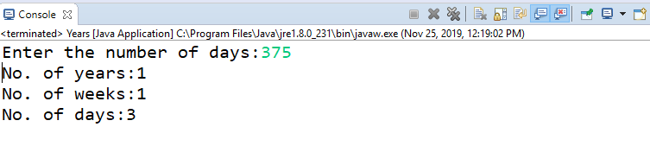

**Program 7:- Vowels and consonants**

**Algorithm**

**Step 1:** Start

**Step 2:** Declare Character type Variable ch

**Step 3**: Read the ch from the User

**Step 4 :** For ch, there are 10 possibilities for vowel we need to check i.e. a, e, i, o, u, A, E, I, O and U.

**Step 5**: Write all 10 possible cases for vowels and print "Vowel" for each  case

**Step 6:** If alphabet is not vowel then add a default case and print "Consonant".

**Step 7:** If the case is number than Print Invalid Alphabet

**Step 8:** Stop

**CODE:**

import java.util.Scanner;

public class Vowelsandconso {

public static void main(String[ ] arg)

{

boolean isVowel=false;;

Scanner scanner=new Scanner(System.in);

System.out.println("Input an alphabet : ");

char ch=scanner.next().charAt(0);

scanner.close();

switch(ch)

{

case 'a' :

case 'e' :

case 'i' :

case 'o' :

case 'u' :

case 'A' :

case 'E' :

case 'I' :

case 'O' :

case 'U' : isVowel = true;

}

if(isVowel == true) {

System.out.println("Input character is vowel");

}

else {

if((ch>='a'&&ch<='z')||(ch>='A'&&ch<='Z'))

System.out.println("Input Character is Consonant");

Else

System.out.println("Invalid data");

}

}

}

**OUTPUT:-**

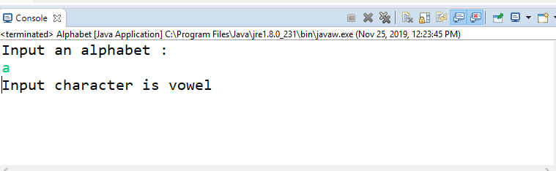

**OUT PUT :- For Invalid**

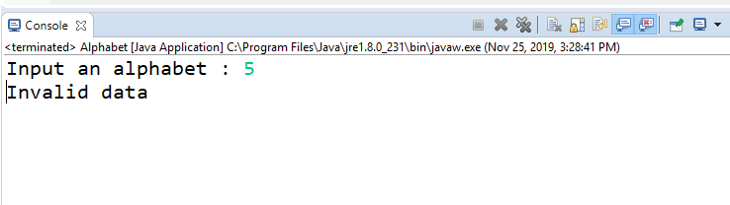

**Program 8:- Quotient and Remainder**

Public class Quotient and Remainder

{

public static void main(String args[]){

System.out.println("Command line arguments are: "+args[0]+" "+args[1]);

int dividend=Integer.parseInt(args[0]);

int divisor=Integer.parseInt(args[1]);

int quotient = dividend / divisor;

int remainder = dividend % divisor;

System.out.println("Quotient = " + quotient);

System.out.println("Remainder = " + remainder);

}

}

**OUTPUT:-**

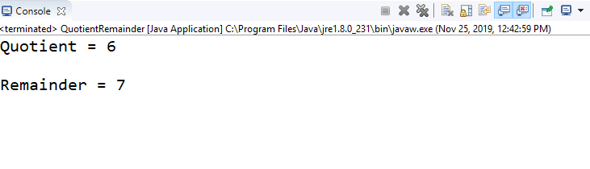

**Program 9:- Fibonacci Series**

import java.util.Scanner;

public class Fibanocci {

public static void main(String args[])

{

int n;

System.out.println("n=");

Scanner sc=new Scanner (System.in);

int a=1;

int b=0;

n=sc.nextInt();

for(int i=0;i<n;i++)

{

System.out.print(b);

b=a+b;

a=b-a;

if(i<=n-2)

{

System.out.print(" ");

}}}}

**OUTPUT:-**

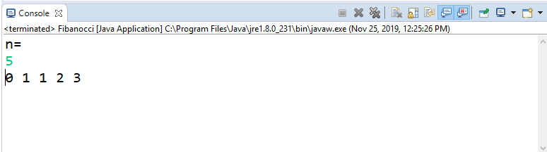

**Program 10:- Swap**

import java.util.Scanner;

public class Swap {

public static void main(String args[])

{

int x,y;

Scanner sc=new Scanner(System.in);

System.out.println("Input two integers: ");

x=sc.nextInt();

y=sc.nextInt();

System.out.println("Pre swap: "+x+" "+y);

x = x+y;

y=x-y;

x=x-y;

System.out.println("Post swap: " +x+" "+y);

}

}

**OUTPUT:-**

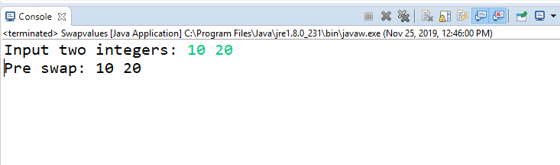

**Program 11:- While**

Compilation Error

* While should be declared in java. File.
* Incompatible Type: Double cannot be Converted to Boolean

**Program 12:- Armstrong Number**

import java.util.Scanner;  
  
public class Armstrong {  
    public static void main(String[] args) {  
    Scanner sc=new Scanner(System.in);  
    System.out.print("Input number is: ");  
     
        int number =sc.nextInt(), originalNumber, remainder, result = 0;  
        originalNumber = number;  
        while (originalNumber != 0)  
        {  
            remainder = originalNumber % 10;  
            result += Math.pow(remainder, 3);  
            originalNumber /= 10;  
        }

if(result == number)  
            System.out.println("Given number is an Armstrong");  
         
}  
}

**OUTPUT:-**

