Mini Ookla Network Speed-Test Validation
Six paired trials recorded — including the final trial where Mini Ookla selected server_03.

1. Objective
To compare Mini Ookla download-throughput readings against iperf3 receiver-side aggregate throughput under the team's test conditions.

2. Test setup and method
- Mini Ookla: 4 streams and configured duration of 5 seconds.
- iperf3 client command used by the team: iperf3 -c 10.56.66.133 -p 5201 -t 5 -P 4 -O 2.
- iperf3 server: Santosh's Windows laptop on port 5201; client: Aarav's Mac.
- The tests used the team's shared hotspot/network. Mini Ookla automatically selected a server per run.
- The sixth trial selected Mini Ookla server_03; previous trials selected server_01 or server_02.

3. Paired results
Trial | iperf3 receiver (Mbps) | Mini Ookla download (Mbps) | Mini Ookla upload (Mbps) | Latency (ms) | Server
1 | 167.0 | 151.22 | 124.89 | 10.39 | server_02
2 | 155.0 | 168.93 | 161.38 | 10.30 | server_01
3 | 190.0 | 131.41 | 131.07 | 9.15 | server_02
4 | 173.0 | 150.91 | 154.56 | 11.46 | server_01
5 | 92.5 | 99.60 | 82.10 | 10.85 | server_02
6 | 161.0 | 129.48 | 137.89 | 9.53 | server_03
Jitter (Trials 1–6): 2.31 ms, 1.75 ms, 1.53 ms, 2.25 ms, 2.01 ms, 1.32 ms.
Packet loss was reported as 0.00% in all six Mini Ookla screenshots.

4. Summary statistics
Metric | Value
Number of paired trials | 6
Mean iperf3 receiver throughput (Mbps) | 156.42
Mean Mini Ookla download throughput (Mbps) | 138.59
Mean signed difference, Mini Ookla minus iperf3 (Mbps) | -17.83
Mean absolute throughput difference (Mbps) | 24.84
Mean absolute percentage difference relative to iperf3 (%) | 14.88
Sample standard deviation: iperf3 (Mbps) | 33.54
Sample standard deviation: Mini Ookla (Mbps) | 24.03
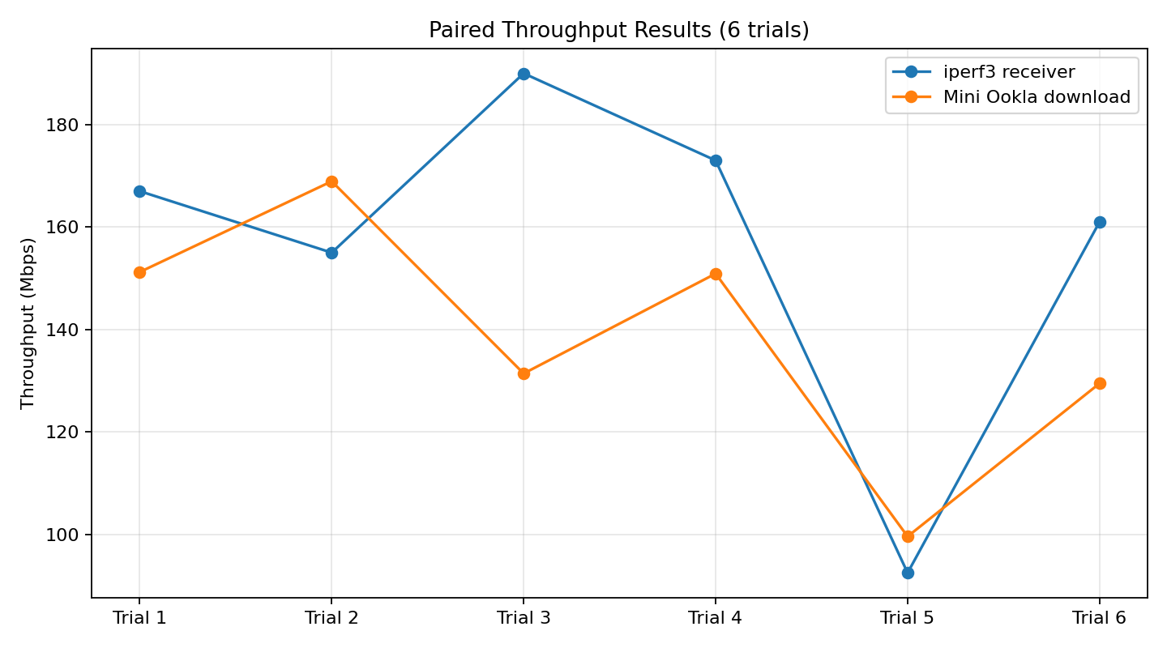
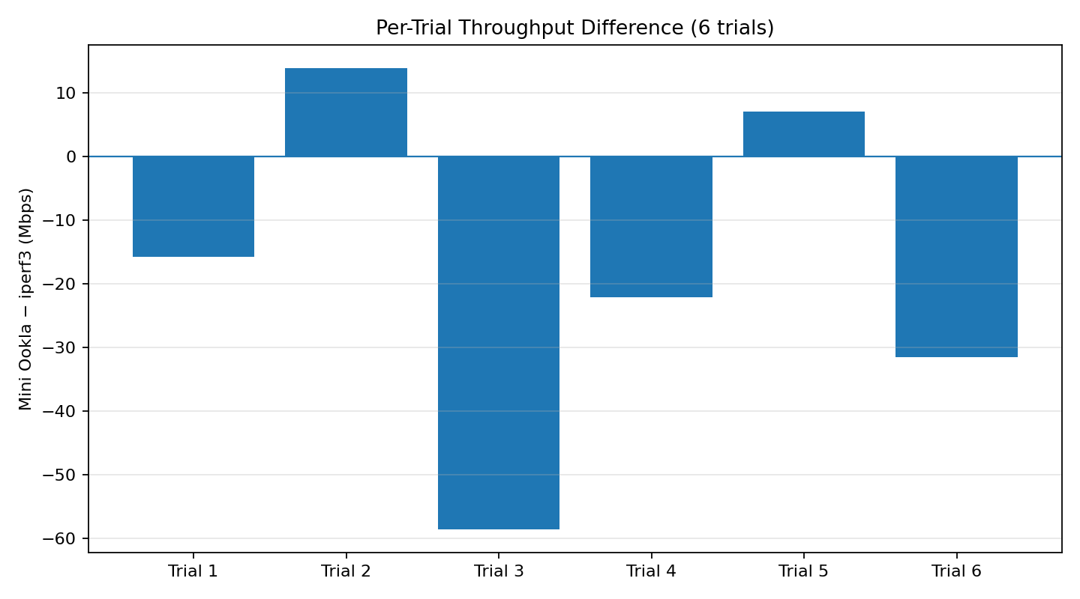

5. Interpretation and limitations
The six trials show variation in throughput across runs. Mini Ookla selected server_01, server_02, and server_03 during the experiment. Since server selection changed, the Mini Ookla endpoint was not identical in every trial; this is an important contextual factor when interpreting differences.
The supplied iperf3 logs mark the initial intervals as omitted, but the final receiver summary spans the full test duration (approximately 5.1–5.3 seconds). The throughput values in this report are the displayed final receiver [SUM] values, not a separately calculated post-ramp-up-only aggregate. Accordingly, the report does not claim that the two tools' measured windows are perfectly equivalent.
These results are descriptive observations from six short paired runs on a changing network. They should not be presented as a universal accuracy certification. The earlier 10-second trials and the single-stream connectivity check are excluded from this six-trial dataset.

6. Conclusion
Across six paired trials, mean iperf3 receiver throughput was 156.42 Mbps and mean Mini Ookla download throughput was 138.59 Mbps. The mean signed difference (Mini Ookla minus iperf3) was -17.83 Mbps, and the mean absolute difference was 24.84 Mbps. The observations provide an initial comparison of the two tools under the team's test conditions.

