|  |
| --- |
| References |
| <https://docs.github.com/en/authentication/connecting-to-github-with-ssh/generating-a-new-ssh-key-and-adding-it-to-the-ssh-agent> |
| [**https://www.youtube.com/watch?v=RGOj5yH7evk**](https://www.youtube.com/watch?v=RGOj5yH7evk) |

**Git Commands**

**Clone** – Bring a repository that is hosted somewhere like Github into a folder on your local machine

|  |
| --- |
| Git clone <project clone path> |

**Add** – track your files and changes in Git

**Commit** - save your friends in Git

**Push** – upload git commits to a remote repo, like Github

**Pull** – download changes from remote repo to your local machine.

**Clone project:**

|  |
| --- |
| https://github.com/saihari-lgr/sample.git |

* Using above command project will be cloned to local machine

|  |
| --- |
| ls -Force |

* Command to display all the files and folder in the repository including hidden folders.

|  |
| --- |
| Git status |

* Command used to get all the modified/added or deleted files.

**Add**

|  |
| --- |
| **git add .** (. Indicate include all files and folders)  **git index.html** (to include specific file)  PS D:\Sai\Work\git_Working_Directory\sample> git add .  PS D:\Sai\Work\git_Working_Directory\sample> git status  On branch main  Your branch is up to date with 'origin/main'.  Changes to be committed:  (use "git restore --staged <file>..." to unstage)  modified: README.md  new file: index.html |

**commit**

|  |
| --- |
| Git commit -m <title> -m <description>  <title> & <description> are optional  PS D:\Sai\Work\git_Working_Directory\sample> **git** **commit** -m "Added index.html" -m "just added to demonstrate"  [main ee6efff] Added index.html  2 files changed, 3 insertions(+)  create mode 100644 index.html |

Commit will save the changes in local repository; we need to push the code changes to git manually after commit

**Adding SSH Key to your Github Account**

1. Go to terminal, and execute the below command

|  |
| --- |
| ssh-**keygen** -t RSA -b 4096 -C [tom.jerry@gmail.com](mailto:tom.jerry@gmail.com)  Generating public/private RSA key pair.  Enter file in which to save the key (C:\Users\slandgey/.ssh/id_rsa): **sampleKey** |

After executing the above command, system will create two files in project working directory. One is .txt files and other .pub with file name which we provider.

|  |
| --- |
| **cat** sampleKey.pub |

Executing the above command, will display the SSH secret key.

|  |
| --- |
| ssh-rsa <hash key value>== [tom.jerry@gmail.com](mailto:tom.jerry@gmail.com) |

Key will start with ssh-rsa and end with the provided mail id.

1. After the key is generated, go to your git account Settings > SSH and GPG keys
2. Click on new key button and provide any name to your key and place the key value and save the key.

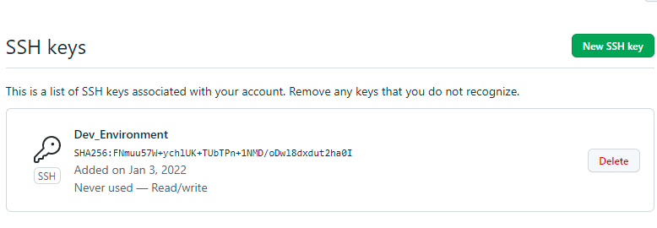

**Push**

|  |
| --- |
| git push origin main |

Above command will push code to the git repository main branch.

**Demo#** Creating project in local machine and taking code to git

1. Crated sample project in local path and added file “README.md”
2. git Add “README.md” -- file will get added locally
3. git commit -m “README.md” -m “Adding sample for demo” (providing title and description is optional”
4. git init (to initialize git repository). If no repository configure, we need to create a new repositor in github
5. git remote add origin <https://github.com/xxx-z/git_demo.git> (it will add the remote path for the local directory)
6. git remote -v (to display list of connected repositories)
7. git push origin master (to push the local code into git repository)

**git hub workflow v/s local git workflow**

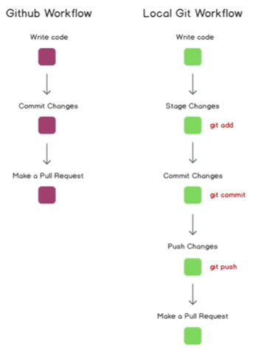

**Branching**

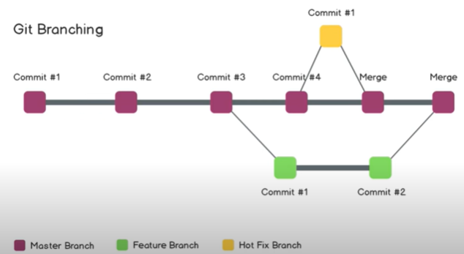

|  |
| --- |
| Git branch |

* command will list out the branches
* * indicate the current branch



**Create new branch**

|  |
| --- |
| Git checkout -b <branch name> |

-b indicates create a new branch

> git checkout -b TestBranch_1

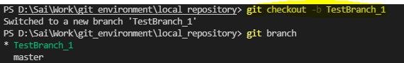

**Note**: git checkout <branch name> (without -b) use the change branches

* Git checkout TestBranch_1

