***Project Implementation:***

On completing the development part, we then ran the application one last time to verify all the functionalities and look for any bugs in it. The user interface of the application looks a bit like the one provided below.

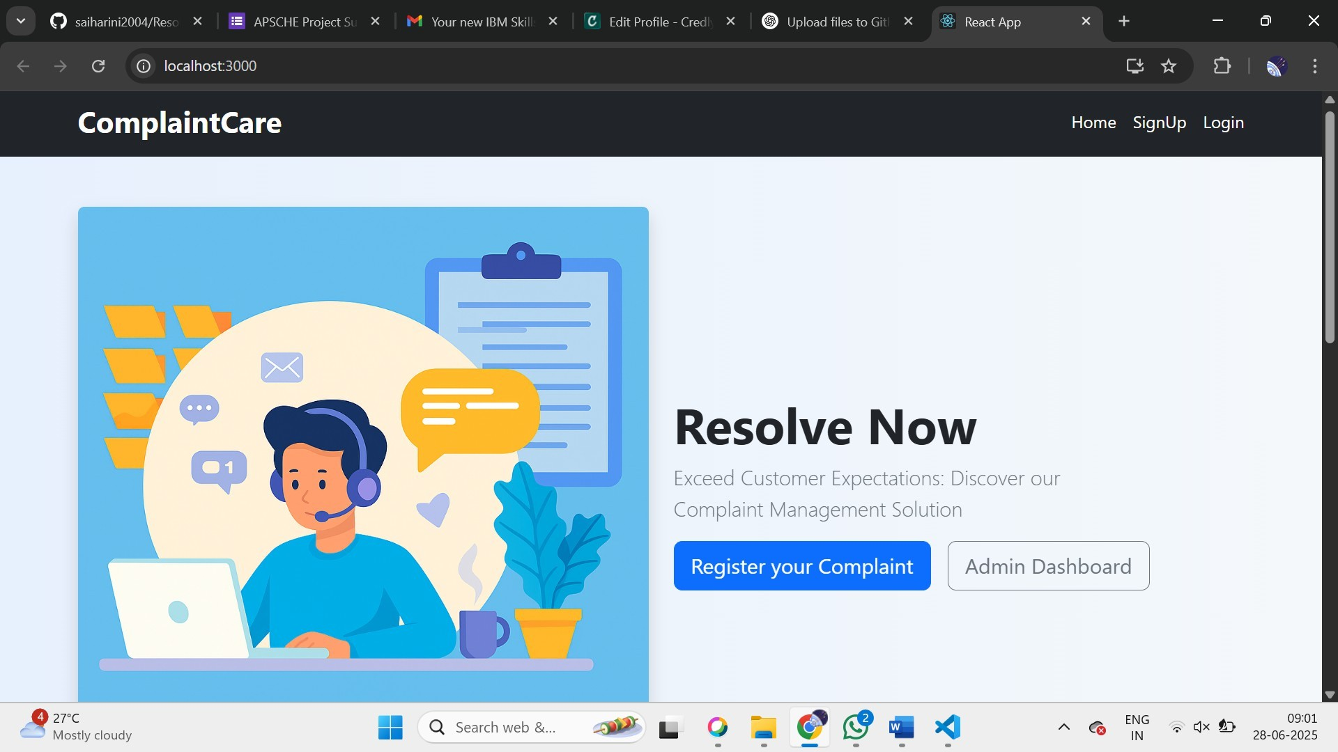**Landing page :**

**Sign up:**

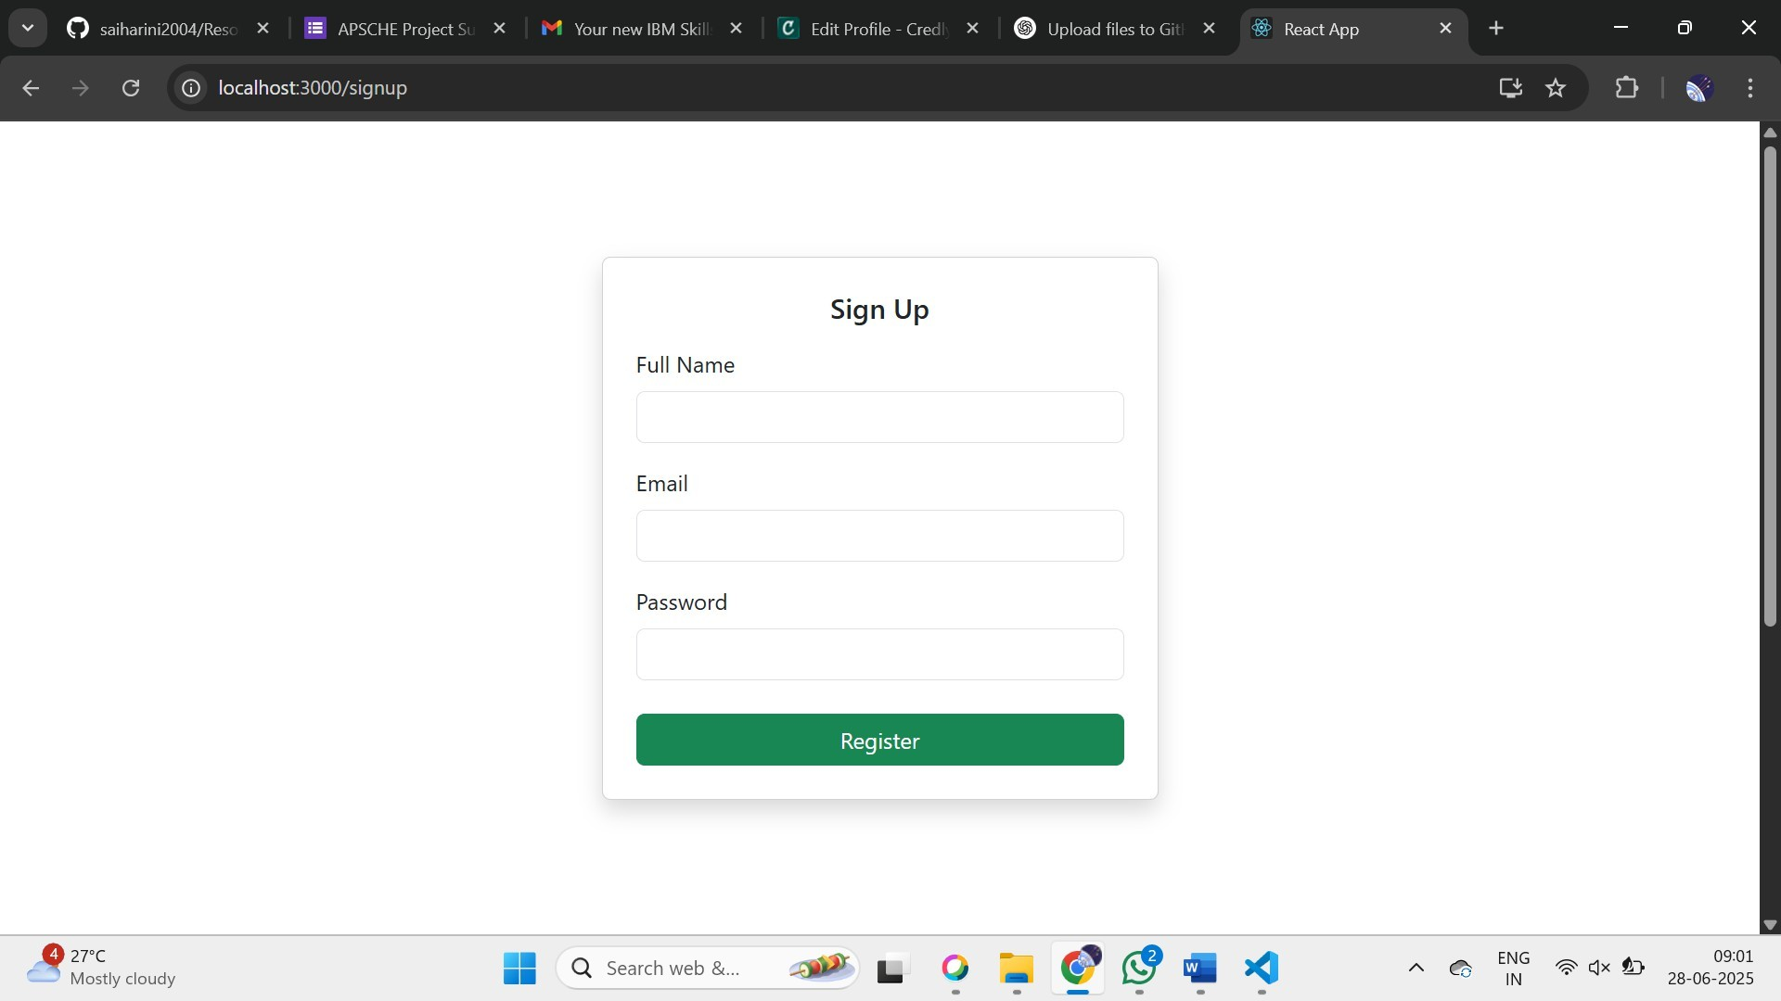

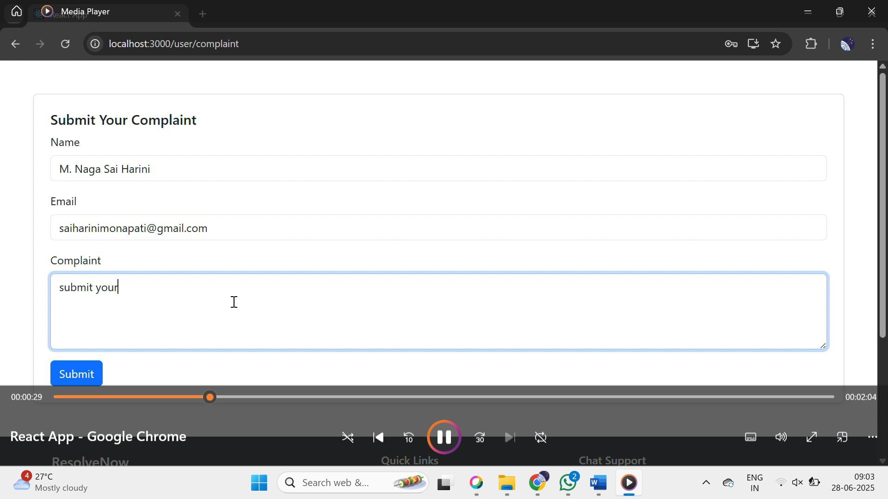**Complaint Submission:**

**Admin Control Panel:**

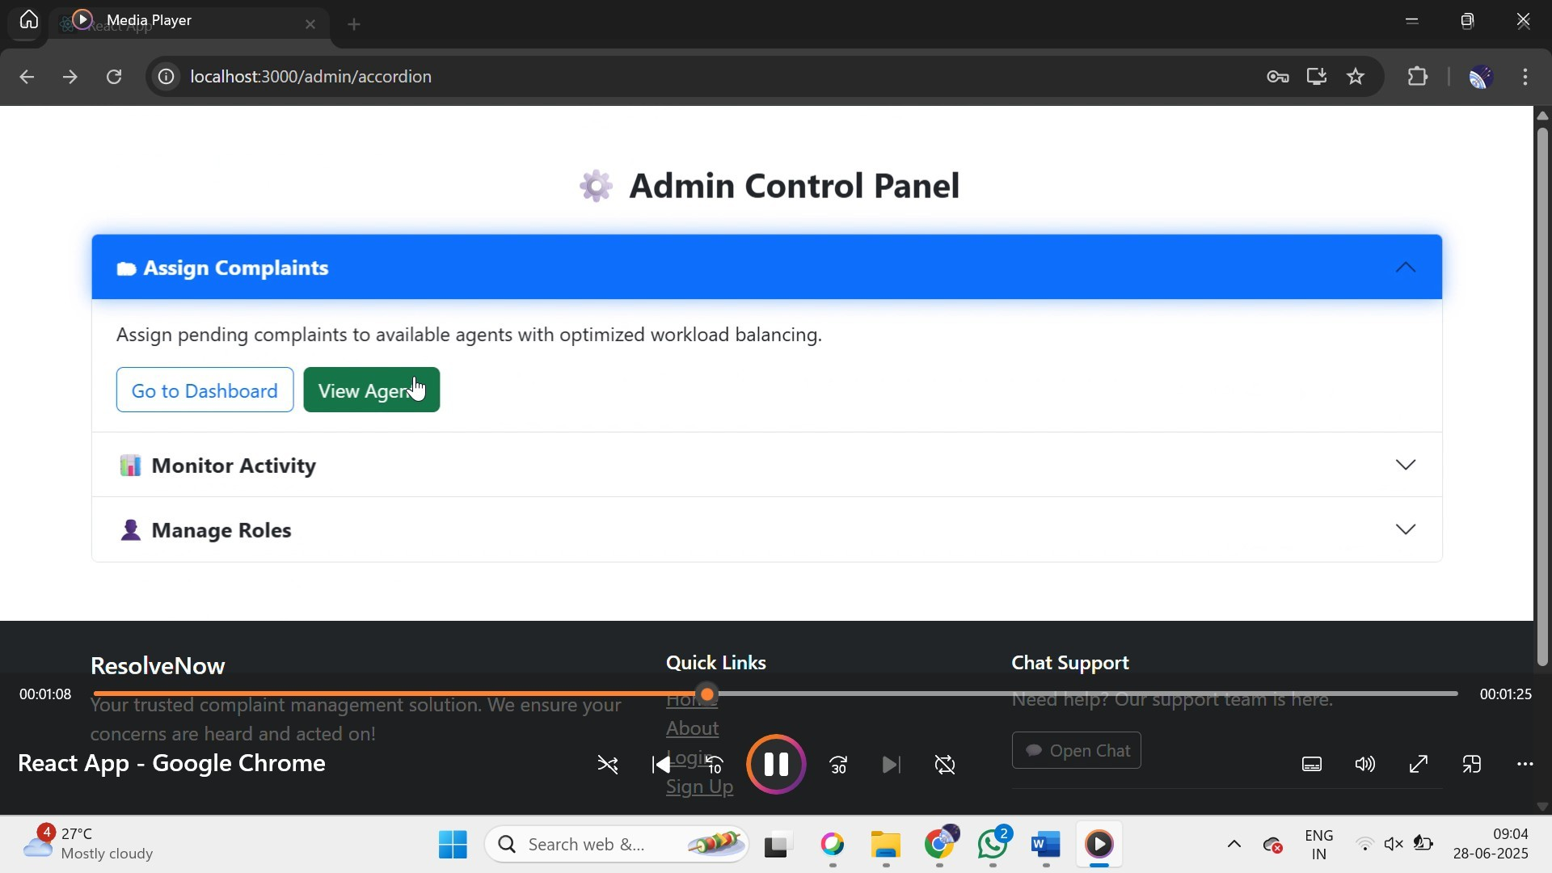

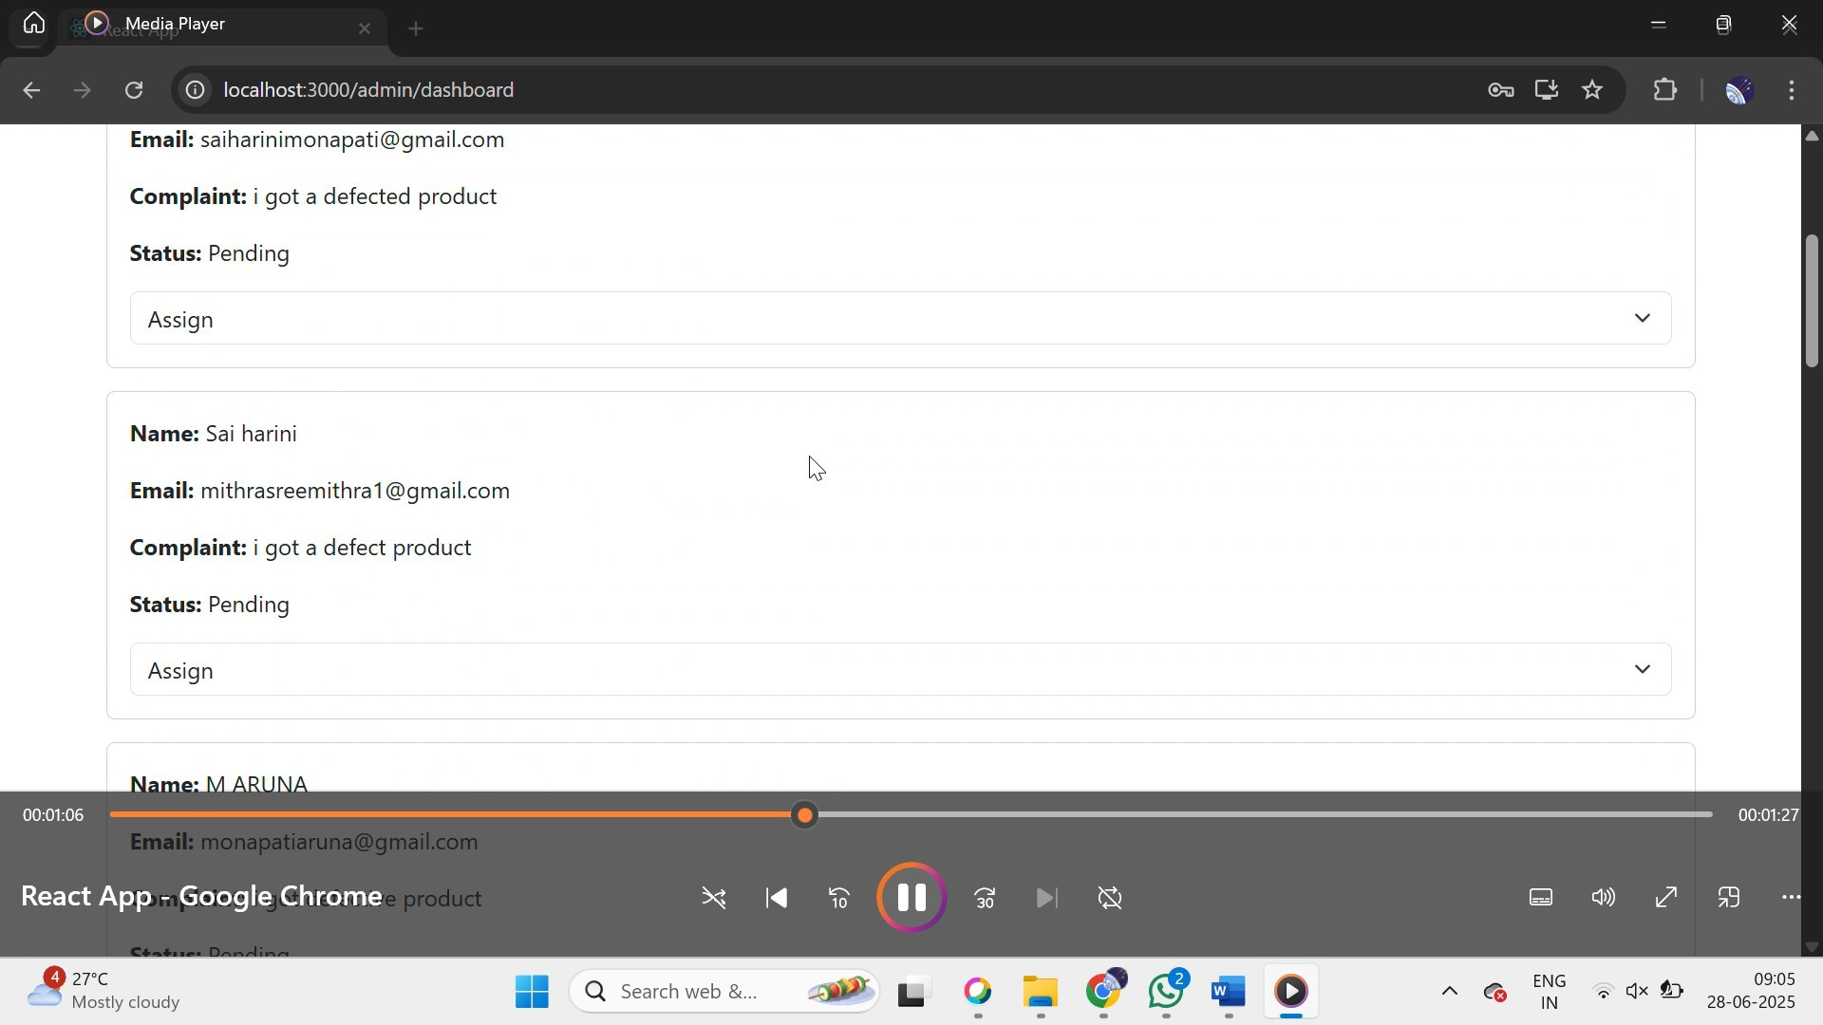**User Complaints :**

**All Info :**

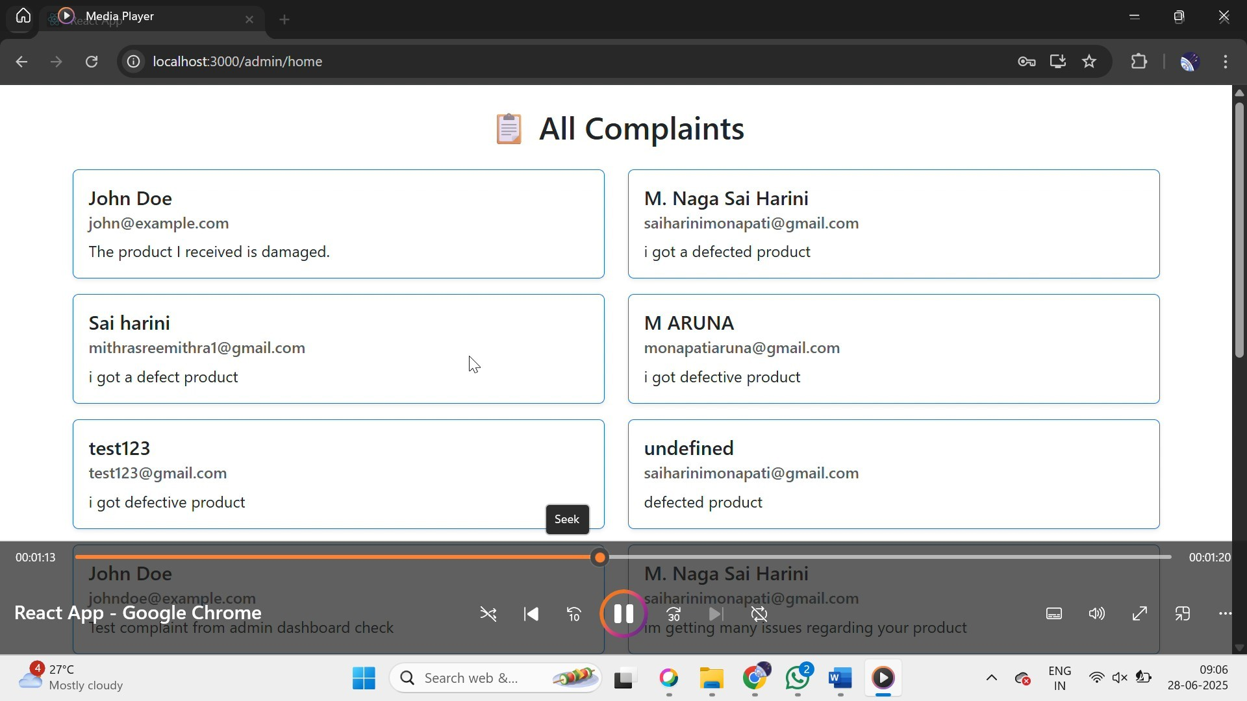

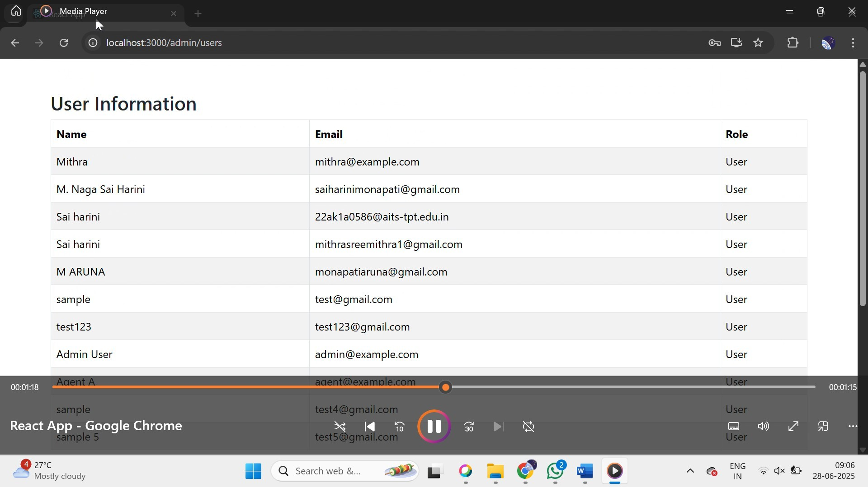**Role Management :**

**Complaint Status Tracking :**

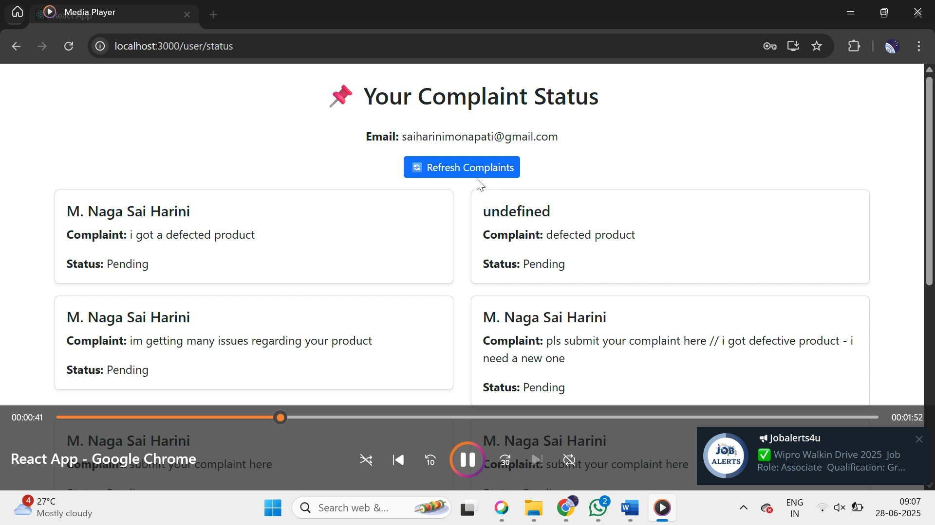

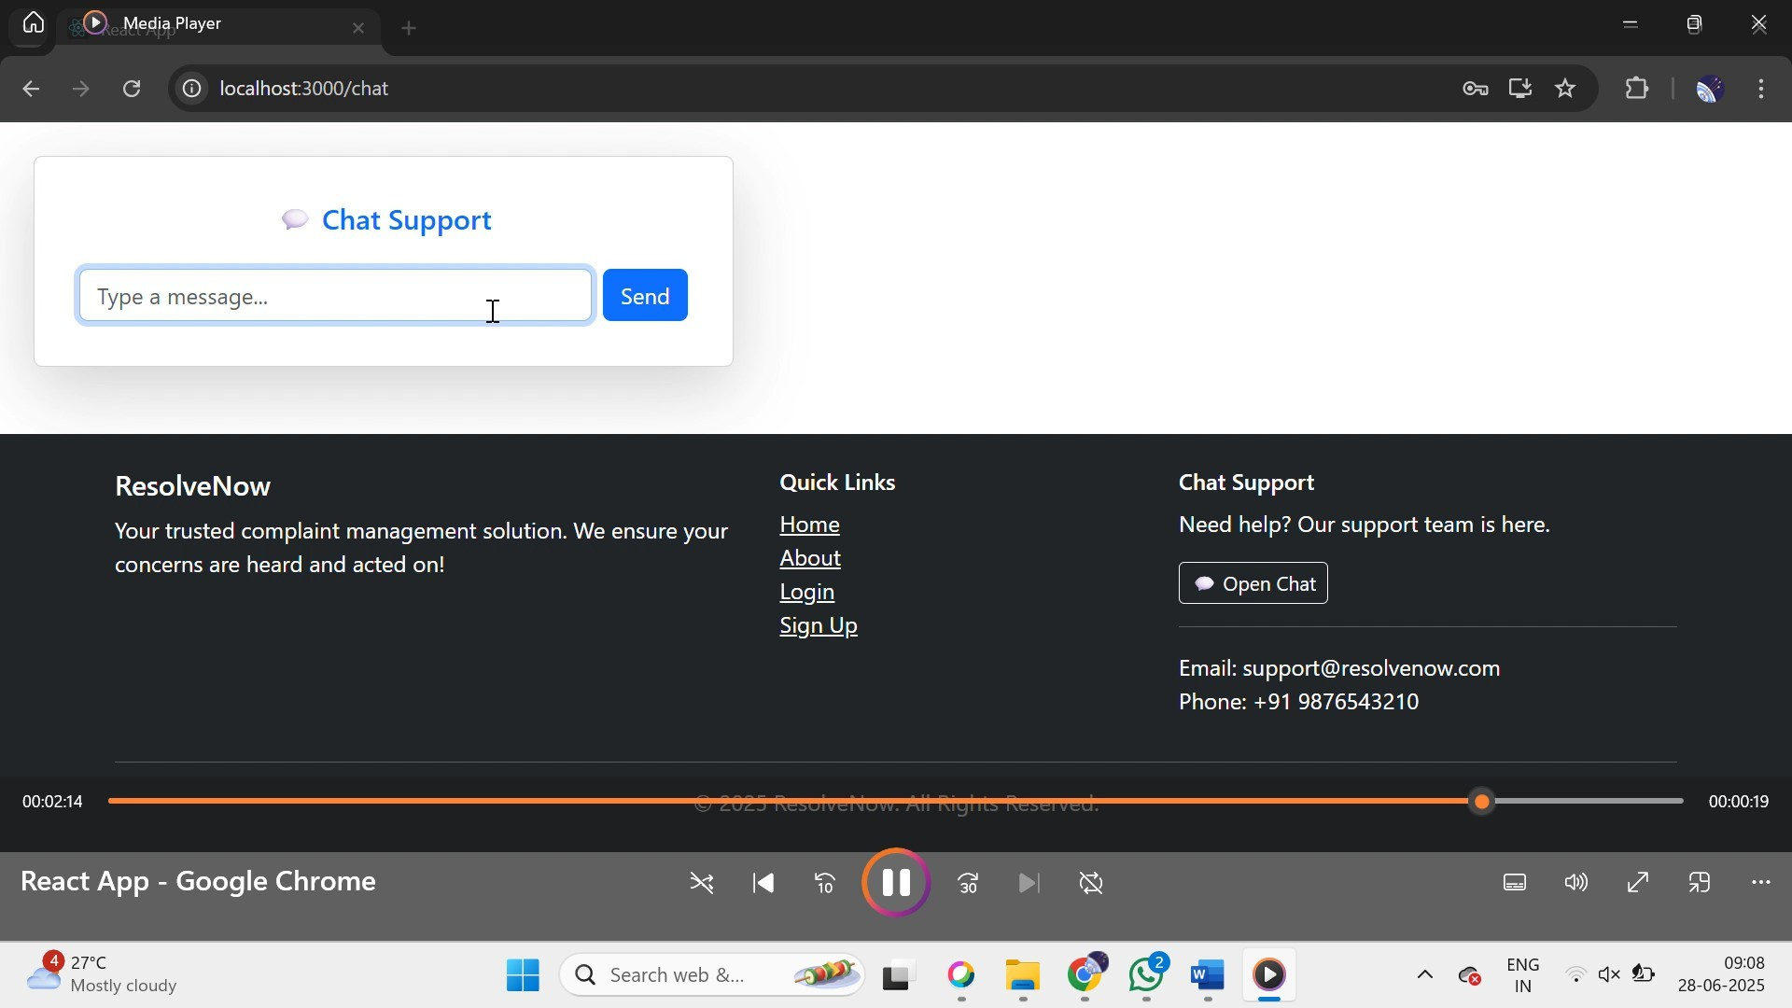**Chat Feature :**

**The demo of the Website is available at:**

<https://drive.google.com/file/d/1G2cTf2BuxorpKTX_ecIaIy-bQIfHEkAd/view?usp=sharing>