**DIET BHEEMUNIPATNAM**

**ASSESSMENT TEST**

**3rd class, Mathematics**

**(Max Marks:25) Time:60 minutes**

**Name of the student: Roll no:**

|  |  |  |  |  |  |  |
| --- | --- | --- | --- | --- | --- | --- |
| Academic  Standards | I | II | III | IV | V | Total |
| Max marks | 10 | 5 | 5 | 2 | 3 | 25 |
| Secured |  |  |  |  |  |  |
| Grade |  |  |  |  |  |  |

**Instructions**

1. This question paper contains 19 questions.
2. Attempt all the questions
3. **PROBLEM SOLVING (10M)**

**1)**Ramu is celebrating his birthday .His uncle gave 375 Rs. Ramu bought a toy with 125 Rs.His sister bought a doll of 75 Rs.Then,how much money with Ramu have?

2) There are 530 students in a school. Among them 245 are girls. How many boys are there? (2m)

3) What is the difference between 3 digit largest number and 2 digit largest number? (2M)

4)What will we get , if we subtract 22 from 256? (1M)

5)Choose the correct answer ( ½M)

2 8 9 a)8 b)3 c)0 d)1

(-) 9

2 8

6)358-134= (1/2 M)

a)333 b) 224 c) 745 d) 569

II) **REASONING AND PROOF**  (5M)

7) A book costs 50 rupees and A pen costs 10 rupees .Ramu gave 100 rupees to shopkeeper . Shopkeeper gave 40 rupees to Ramu . Did shopkeeper give correct amount to Ramu. (2 M)

8)243-119=? Ravi and Raju like this

Ravi Raju

2 4 3 2 4 3

(-)1 1 9 (-) 1 1 9

Who solved this problem correctly. Give reasons.(2M)

9)692 – 20 = 672

The above problem is correct/wrong. If the answer is wrong . Write the correct answer. (1M)

III)**COMMUNICATION (5M)**

10) There are 650 eggs in a school. In which ,579 eggs are used to serve in lunch. The remaining eggs are 71.

Write this statement by using mathematical symbol. ( 2M)

11)Subtract 245 from 500 (1M)

12)Write any subtraction problem related to real life? (1M)

13)Put the correct symbol >, < or = in the blank. (1/2M)

25 – 20 45 – 40

14) If 274 - = 256 Choose the correct answer. ( ) 1/2M

a) 24 b)23 c)25 d)26

IV.CONNECTION(2M)

15)Age of Lakshmi is 39 years. Her daughter , Rani’s age is 21 years less than her age. What is the

Age of Rani? 2M

V.REPRESENTATION( 3 M)

16)Representation of number in Abacus 3M

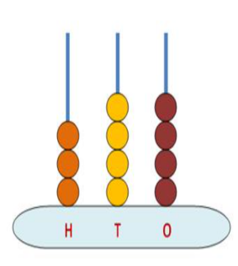 - 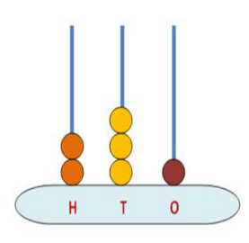 = 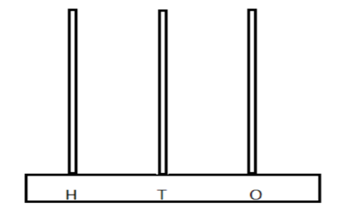

17) 11111111 - 11111 = Draw the remaining sticks in the given blank. 1M

18)

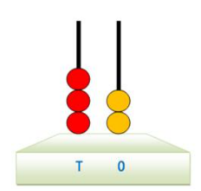 - 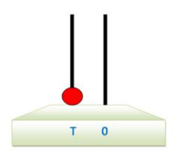 = 1/2M

19) 1111111111 1111111111 -1111 = 1/2M

a) 14 b) 18 c)16 d)19

\*\*\*\*\*\*\*\*\*\****ALL THE BEST***\*\*\*\*\*\*\*\*\*\*